Text A
What Is Resistance?
We know that certain materials such as copper have many free electrons. Other materials have fewer free electrons and substances such as glass, rubber, mica have practically no free electron movement therefore making good insulators. Between the extremes of good conductors such as silver and copper lay other conductors of reduced conducting ability, and they “resist” the flow of electrons hence the term resistance. ^{[1]}
The specific resistance of a conductor is the number of ohms(Ω).
Some examples on that basis are silver = 9.75Ω, copper = 10.55Ω, nickel = 53.0Ω and nichrome = 660Ω.
From this information we can deduce that for a voltage applied to a piece of nichrome wire , only around 10.55 / 660 = 0.016 of the amount of current will flow as opposed to the current flowing in the same size copper wire.
The unit of resistance is the Ω and 1Ω is considered the resistance of round copper wire, 0.001 “diameter, 0.88” (22.35mm) long at 32℉ (0℃).

1. Resistance in series and parallel
It follows if two such pieces of wire were connected end to end (in series) then the resistance would be doubled, on the other hand if they were placed side by side (in parallel) then the resistance would be halved!
This is a most important lesson about resistance. Resistors in series add together as R₁ + R₂ + R₃ + While resistors in parallel reduce by 1 / (1 / R₁ + 1 / R₂ + 1 / R₃ +) .
Consider three resistors of 10Ω, 22Ω, and 47Ω respectively. Added in series we get 10 + 22 + 47 = 79Ω. While in parallel we would get 1 / (1 / 10 + 1 / 22 + 1 / 47) = 5.997Ω.

2. Resistance and Power
Next we need to consider the power handling capability of our resistors. Resistors which are deliberately designed to handle and radiate large amounts of power are electric cooktops, ovens, radiators, electric jugs and toasters. ^{[2]} These are all made to take advantage of power handling capabilities of certain materials.
From Ohm’s Law we learnt that P = I × I × R that is, power equals the current squared times the resistance. Consider our example above of the three resistors in series providing a total resistance of 79Ω. If these resistors were placed across a 24V(voltages) power supply then the amount of current flowing, from Ohm’s Law, is I = V / R = 24 / 79 = 0.304A (amperes).
Using any of our power formulas we determine that 0.304A flowing through our 79Ω resistance dissipates a combined 7.3W(wattages) of power! Worse, because our resistors are of unequal value the power distribution will be unequal with the greater dissipation in the largest resistor. ^{[3]}
It follows as a fundamental rule in using resistors in electronic circuits that the resistor must be able to comfortably handle the power it will dissipate. A rule of thumb is to use a wattage rating of at least twice the expected dissipation.^{[4]}
Common resistors in use in electronics today come in power ratings of 0.25W, 0.5W, 1W and 5W. Other special types are available to order. Because of precision manufacturing processes it is possible to obtain resistors in the lower wattage ratings which are quite close in tolerance of their designated values. Typical of this type are the 0.25W range which exhibit a tolerance of plus / minus 2% of the value.
Resistors come in a range of values but the two most common are the E12 and E24 series. The E12 series comes in twelve values for every decade. The E24 series comes in twenty four values per decade.
E12 series – 10, 12, 15, 18, 22, 27, 33, 39, 47, 56, 68, 82
E24 series – 10, 11, 12, 13, 15, 16, 18, 20, 22, 24, 27, 30, 33, 36, 39, 43, 47, 51, 56, 62, 68, 75, 82, 91.
You will notice with the E12 values that each succeeding value falls within the plus / minus 10% of the previous values. This stems from the real old days when resistances were stated as within 20% tolerance (accuracy). Later values of plus / minus 5% tolerance led to the E24 range of resistance. Quite common today are 2% tolerance metal films types but for general purpose use we tend to stick to E12 values of resistance in either 1%, 2% or 5% tolerance.
Cost is the determining factor and many retailers now stock the 2% range of resistance as a standard to accommodate stocking levels and also at reasonably low cost.
As examples of say the “22” types from the E12 series we get 0.22, 2.2, 22, 220, 2 200, 22 000, 220 000 and 2 200 000 or eight decades of resistors.
In my opinion these ought to be referred to respectively as R22, 2R2, 22R, 220R, 2K2, 22K, 220K and 2M2. Here the R, K and M hold places where no decimal points are used to cause confusion.
Consider if I meant to write (in the old fashioned way) 2.2K in for a circuit value but forgot to type in the “K” so you just had 2.2, would the Circuit work? No! How easy is it for
you to read decimal points above.
Isn’t 2K2 easier to see as meaning 2 200Ω as against 2.2K? What If you didn’t see the decimal point in 2.2K? Couldn’t it be taken to mean 22kΩ or 22 000Ω? Now you know why I prefer to use 2K2 or 22K or 22R—no confusion.

3. Resistance color chart codes
Here in this large color chart is the resistance color code – learn the sequence forever.
BLACK, BROWN, RED, ORANGE, YELLOW, GREEN, BLUE, PURPLE, SILVER, WHITE.
I have accommodated two current color banding of resistances—four band and five band resistance color codes. It should be pretty self explanatory I hope.
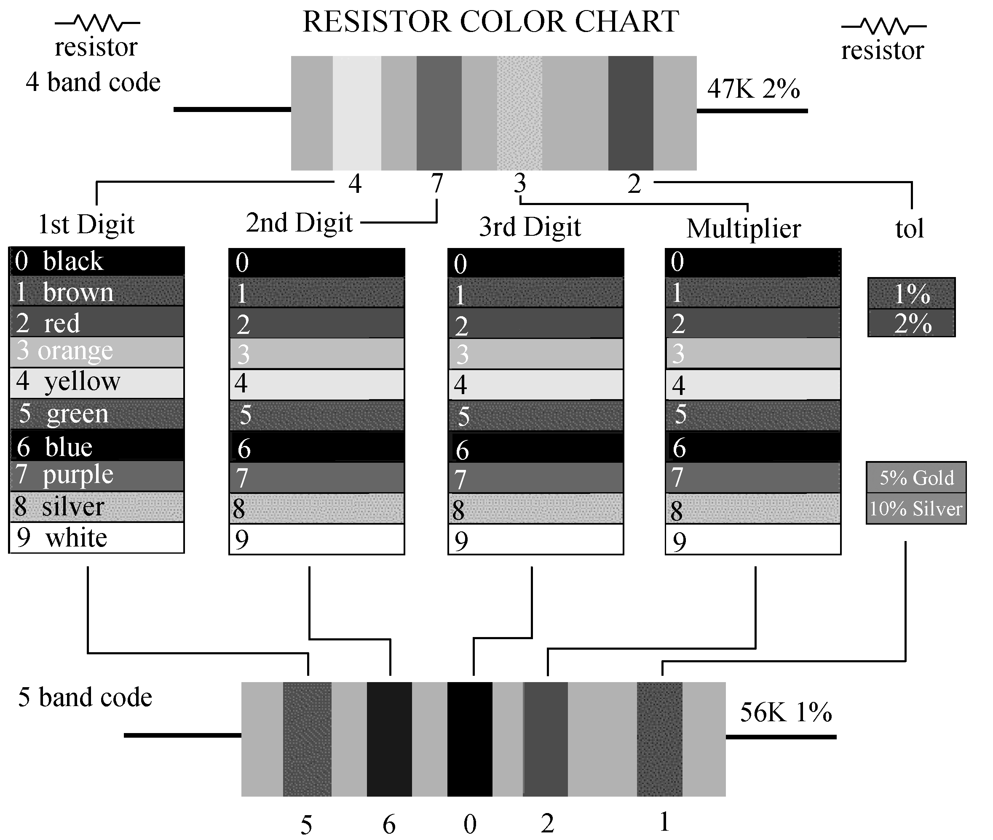
The five band code is more likely to be associated with the more precision 1% and 2% types. Your “garden variety”^{[5]} 5% general purpose types will be four band resistance codes.
New Words and Phrases
resistance | [] | n. 阻力，电阻，阻抗
copper | [] | n. 铜
mica | [] | n. 云母
insulator | [] | n. 绝缘体
conductor | [] | n. 导体
resist | [] | n. 阻抗
ohm | [] | n. 欧姆
nickel | [] | n. 镍
nichrome | [] | n. 镍铬合金
voltage | [] | n. 电压，伏特数
series | [] | n. 连续，串联
parallel | [] | n. 平行线，并联
halve | [] | vt. 二等分，平分
cooktop | [] | n. 炉灶
oven | [] | n. 烤箱
radiator | [] | n. 散热器，冰箱
jug | [] | n. 水壶
toaster | [] | n. 烤炉
capability | [] | n. 能力，性能，容量
material | [] | n. 材料，原料
ampere | [] | n. 安培
formula | [] | n. 公式，规则
dissipate | [] | n. 耗散  vt. 使……消散
distribution | [] | n. 分配，分发
dissipation | [] | n. 消散，分散
wattage | [] | n. 瓦特数
precision | [] | n. 精确
stem | [] | n. 茎，干
accuracy | [] | n. 精确性
confusion | [] | n. 混乱
accommodate | [] | vt. & vi. 容纳，使……适应
explanatory | [] | adj. 说明的，解释性的
between…and |  | 在……之间
on the other hand |  | 另一方面
take advantage of |  | 利用
close in |  | 包围，封闭
Notes
[1] Between the extremes of good conductors such as silver and copper lay other conductors of reduced conducting ability, and they “resist” the flow of electrons hence the term resistance.
本句是由and引导的一个并列句。在第一个句子中，主语是other conductors of reduced conducting ability，谓语是lay，between the extremes of good conductors such as silver and copper 是地点状语。such as是修饰good conductor。
[2] Resistors which are deliberately designed to handle and radiate large amounts of power are electric cooktops, ovens, radiators, electric jugs and toasters.
本句的主语是Resistors，定语从句which are deliberately designed to handle and radiate large amounts of power修饰Resistors。在该定语从句中，to handle and radiate large amounts of power是一个动词不定式短语，做目的状语，修饰谓语are designed。
[3] Worse, because our resistors are of unequal value the power distribution will be unequal with the greater dissipation in the largest resistor.
文中的Worse不可照字面理解为“更加糟糕的”，这里是用来表示程度的大小，即后面所说的内容比前面的还要更进一步。
[4] A rule of thumb is to use a wattage rating of at least twice the expected dissipation.
A rule of thumb是比喻说法，thumb（大拇指）表示“最棒”，翻译为“很重要的规则”。
[5] garden variety
注意作者使用了比喻的修辞方式。garden本意是“花园”，在这里用来表示色彩的变化，很生动。
Exercises
【Ex.1】根据课文内容，回答以下问题。
1) What is resistance?

2) How do the resistors connected in series and parallel?

3) What are the three Resistors of R₁，R₂，R₃ respectively added in series?

4) What kind of power handling capabilities of certain materials are the ovens and toasters. made?

5) How do we express resistors value, according to the author?

【Ex.2】根据下面的英文解释，写出相应的英文词汇。
英 文 解 释 | 词 汇
that is the degree to which a substance prevents the flow of an electric current through it
that is a material or covering which electricity, heat or sound cannot go through
that allow electricity or heat to go through
the standard unit of electrical resistance
the standard unit used to measure how strongly an electrical current is sent around an electrical system
two pieces of wire were connected end to end
two pieces of wire were connected side by side
the standard unit of measurement for the strength of an electrical current
a standard or accepted way of doing or making something, the items needed for it, or a mathematical rule expressed in a set of numbers and letters
the standard measure of electrical power
【Ex.3】把下列句子翻译为中文。
1) Resistors are used to control voltages and currents.

2) Resistors are components that have a predetermined resistance. Resistance determines how much current will flow through a component.

3) A very high resistance allows very little current to flow.

4) Sparks and lightning are brief displays of current flow through air. The light is created as the current burns parts of the air.

5) Metals have very low resistance.A low resistance allows a large amount of current to flow.

6) That is why wires are made of metal. They allow current to flow from one point to another point without any resistance. Wires are usually covered with rubber or plastic.

7) High voltage power lines are covered with thick layers of plastic to make them safe, but they become very dangerous when the line breaks and the wire is exposed and is no longer separated from other things by insulation.

8) Making the resistance higher will let less current flow so the volume goes down.

9) Variable resistors are also common components. They have a dial or a knob that allows you to change the resistance.

10) For example, a 500Ω variable resistor can have a resistance of anywhere between 0Ω and 500Ω.

【Ex.4】把下列短文翻译成中文。
Resistance is given in units of ohms(Ω). (Ohms are named after Mho Ohms who played with electricity as a young boy in Germany.) Common resistor values are from 100Ω to 100 000Ω. Each resistor is marked with colored stripes to indicate its resistance. To learn how to calculate the value of a resistor by looking at the stripes on the resistor.

【Ex.5】通过Internet查找资料，借助如“金山词霸”等电子词典和辅助翻译软件，完成以下技术报告。通过E-mail发送给老师，并附你收集资料的网址。
1）当前世界上有哪些最主要的电阻生产厂家以及有哪些最新型的产品（附各种最新产品的图片）。
2）当前世界上有哪些最主要的电容生产厂家以及有哪些最新型的产品（附各种最新产品的图片）。
Text B
What Is a Capacitor?
The letter C stands for capacitance. A capacitor is formed by two or more conductive parallel plates separated by an insulating material or dielectric. Typical dielectrics you will encounter are air, mica, ceramic or plastic.
Consider an air variable capacitor of the type used either as a trimmer or even the tuning element in a radio. It is merely two or more conductive plates separated by air —is this not so?
Go back to our inductors above, could not a similar description apply to them?
That is why inductors also have capacitance! We have also learnt a small piece of wire has inductance. This is why capacitors with leads etc. exhibit inductance.
At some point our inductor with its inherent capacitance (called stray) will resonate (you will learn about that later) and this is called its self resonant frequency. The same rule applies to capacitors. Mostly it is only the VHF and UHF aficionado who has to be greatly concerned about these properties. Stray capacitance is everywhere. Sometimes it can be used to advantage, usually you take it into account (that is another function of trimmers) but often it’s a monumental pain.
I said mostly—which means if you forget about it, then you can surely guarantee one day this property will bite you. That will be the day when you’re working on your pet project, which of course won’t work as expected and you don’t know why your theory doesn’t work out in the real world—another “gotcha”.
Stray capacitance in sloppy layouts can account for unexpected oscillations, no oscillations, different circuit responses and generally cause you to “become a victim of the bottle, eternally caught in the grip of the grape and, if you become like me, occasionally ruin an otherwise good keyboard with an even much better claret.”
Even the best of designs and careful layouts are affected. Not only stray capacitance but stray inductance can affect you. Try some high speed, double sided, digital PCB designs.
Back to capacitors. Apart from their uses in resonant circuits they are used as:
(1) DC blocking devices—A capacitor will pass AC or RF but not DC. That is often the function of coupling capacitors in circuits. The coupling capacitor will pass our required signal but block the DC supply from the previous stage e.g. 0.001μF (1 000pF or 1nF).
(2) supply by-pass capacitor —A capacitor used to pass AC or RF. Examples include by-pass of a DC supply to an emitter by-pass capacitor. When used on a DC supply line the capacitor shunts (shorts) to ground any unwanted AC or RF to avoid contamination of our supply e.g. 0.1μF (100 000pF or 100nF).
(3) reservoir by-pass capacitor —Used in the output of a DC rectifier to smooth out the power line AC pulses and as a reservoir between the charging pulses. Think of it as a big water storage tank. This is where you have the high value capacitors e.g. 10 000μF/63V (10 000U).
(4) emitter by-pass capacitor —In the case of an emitter by-pass our transistor may, as one example, be considered as two distinct models, one under DC conditions which sets up how we want the transistor to operate and another under AC or RF conditions e.g. as an amplifier. In this case our emitter by-pass capacitor merely makes any emitter resistor invisible for AC or RF purposes typical values might range from 2.2μF down to 0.1μF. (2U2 down to 100N)
Parallel plate capacitors have a formula for calculating capacitance
C = 0.22248 × K × (A/t)
where
C = capacitance in pF
K = dielectric constant (air = 1)
A = area of plates or dielectric
t = thickness of dielectric or spacing in the case of air variables.
(5) series or parallel capacitors—Series and parallel combinations calculate in an opposite fashion to inductors, i.e. parallel are
C_{total} = C₁ + C₂ + + C_{n}
and series are
C_{total} = {1/ [(1/C₁) + (1/C₂) + (1/C_{n})]}
Now here come some very useful formula. Using the one immediately above you should determine that a 22pF capacitor in series with a 15pF capacitor gives a total of 8.92pF. Go ahead do it! Check me out.
What if we had say 105pF already in circuit and needed to reduce it to say 56pF. A real world example might be say the only air variable capacitor available is one with a maximum of 105pF. What do you put in series to reduce the maximum to 56pF?
Did you know the formula above? For two capacitors in series, can become
C_{total} = [(C₁ × C₂ ) / (C₁ + C₂)]**
AND
C_{series} = [(C_{avail} × C_{wanted} ) / ( C_{avail} – C_{wanted})]
THEREFORE
C_{series} = [(105 × 56) / (105 – 56)] = 120pF
If you disbelieve me then check it out using ** above as a double check. Nifty eh! Write it in your exercise book. If that’s flash try this red-hot formula.
Suppose we want an oscillator to tune from 7.0MHz to 7.2MHz. Now if you don’t quite know what an oscillator is yet don’t worry. For reasons we will explore later on in the tutorials you will find that your capacitance must vary, for tuning purposes, in the direct ratio of the frequency ratio squared or C_{max} to C_{min} = (F_{high} / F_{low})². Eh what!
In this example our frequency ratio is F_{high} / F_{low} = 7.2 / 7.0 = 1.028 57. Our ratio must be squared so then it becomes (1.028 57 × 1.028 57) = 1.057 96. This must be our capacitance ratio i.e. C_{max} to C_{min} = 1.057 96.
Using the 105pF air variable capacitor is no help because it usually has a minimum of 10.5pF and that’s a ratio of 10:1. Assuming the 105pF, for the moment ***, is acceptable then apply this formula (which is quite difficult to do in HTML language the way I wanted to do it—so bear with me):
(C_{pad} + 105) / (C_{pad} + 10.5) = 1.057 96 / 1
What needs to be done is re-write that formula on a piece of paper using two lines and writing the division sign in the usual way, i.e. as an underlining of both C_{pad} +105 and 1.057 96. I hope everybody knows what I mean. Next we perform a simple algebraic function, we cross multiply so you should end up with
C_{pad} + 105 = (1.057 96 × C_{pad} ) + ( 1.057 96 × 10.5)
C_{pad} + 105 = (1.057 96 × C_{pad} ) + ( 11.108 58)
Then subtracting 1 times C_{pad} from each side as well as subtracting 11.108 58 from each side (in algebra what is done to one side of the equal sign must be done to the other side—I hope that’s clear also) we get
93.891 42 = 0.057 96 C_{pad} and dividing both sides by 0.057 96
C_{pad} = 1 619.93pF
Now firstly I accept the fact that the formula may be obscure for many people and if that is the case then I will re-write it as a graphic but including too many graphics can cause other problems. It is most important (to me anyway) that I make this as easy as possible for you.
Secondly the figure of 1 619.93pF above is most likely too high to use in the real world. Having said that let’s check our sums. We have 105pF max and 10.5pF min in parallel with 1 619.93pF which is the same as ( 105 + 1 620 ) / (10.5 + 1 620 ). This calculates out to 1.057 977: 1 which when applied to our tuning range would tune from 7.0MHz to 7.199 99MHz or what we set out to do. Remember our strays earlier. They would play havoc with this, so the 1 620pF would become in the real world 1 000pF + 560pF + 100pF trimmer ( i.e. 10—100pF).
I said earlier the 105pF was possibly acceptable ***.
Let’s go back and reduce it to say 33pF and redo our sums to get another C_{pad} value. Let me know your answer.
Some home brewers (hi-tech code word for building-it-yourself) advocate using a starting goal of 1pF per wavelength of frequency. e.g. 7.0MHz = 40m (approx.) = 40pF.
I must say I am not especially in love with that particular logic for many reasons which will become apparent as we become more deeply involved with filter and oscillator theory.

