Copyright Grant Letter

2003-4-28
Texas Instruments (Shanghai) Co., Ltd
11F,Novel Plaza, 128 Nanjing Road West,
Huangpu District, Shanghai 200003, P.R.C.

Mr. Hu Guangshu,

We are in possession of a copy of your book draft titled as appendix provided and [printed] by Tsinghua University Press, a book printer and publisher with a principal office located at Xue Yan Mansion, Tsinghua University, Beijing, 100084, P.R.C. (the “Book”), which contains certain copyrighted information (the “Information”) from the Texas Instruments TMS320 DSP series product databook.

As rightful owner of the information, we hereby give you permission to use the Information in the book on a non-exclusive basis provided that you place the following statement on the title page of the book.

“This book contains copyrighted material of Texas Instruments Incorporated, used herein with permission of the copyright owner. Errors introduced in the use or translations of the copyrighted material herein are solely the responsibility of the author or translator and are not the responsibility of Texas Instruments Incorporated. Any further use, modification, redistribution without the express approval of the copyright owner is strictly prohibited. This copyright authorization allows for reproduction only in printed and computer materials of the above-cited standards, on a regional scale and for an unlimited period of time. Should any of the copyrighted information fall under patent protection, this copyright authorization is not to be construed as an authorization to use and/or implement patent information without fulfilling attached obligations.”

Please also find enclosed some information regarding TI’s copyright and trademark policies, which we would request you to follow during the use of the Information.

Thank you for including TI technology in your teaching and scholarship. I welcome your call or E-mail if I can provide additional assistance.

Best Regards,

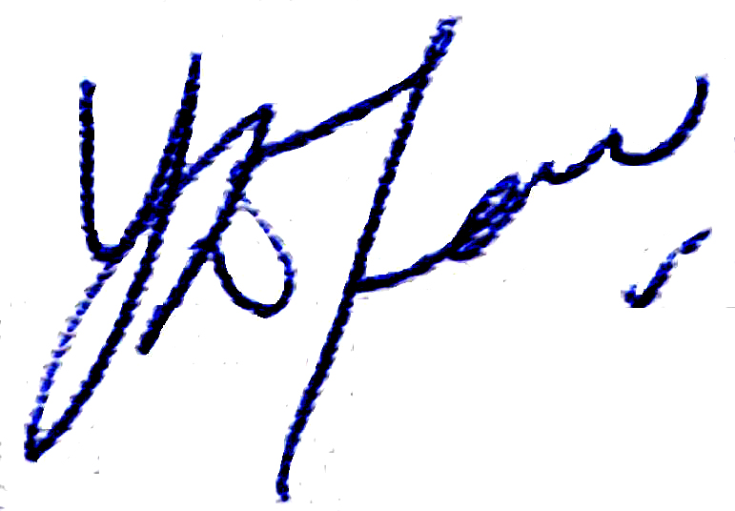
Eldon Teng
Director of Market Development
Texas Instruments Asia

