第一章 彼得·潘闯了进来
Chapter 1 Peter Breaks Through
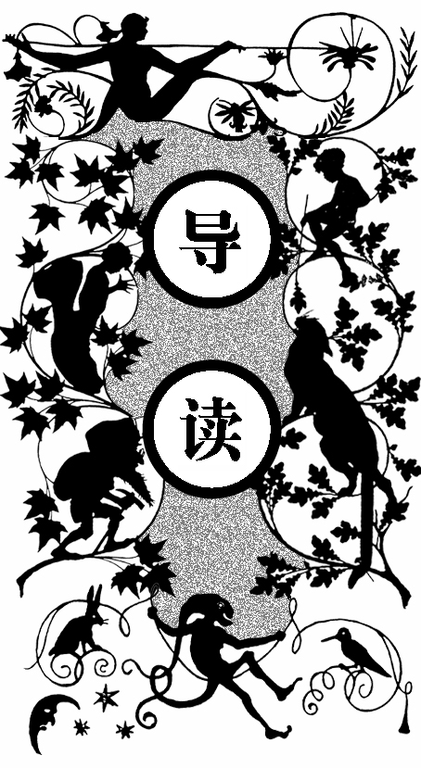
温蒂一家住在街上的14号房子里。温蒂的妈妈达林太太甜美可人，她那充满奇思妙想的头脑就像一个神秘的小盒子。达林先生自认为学问高深，谈起股票头头是道。达林夫妇一共有三个孩子，从大到小分别是：女儿温蒂、大儿子约翰、小儿子 迈克。
三个孩子的降生使达林先生发现他的预算开始变得紧张，但要强的他又不想输给邻居们，所以他还是请了个保姆——一条叫娜娜的干净的纽芬兰大狗。娜娜很是细心周到，每晚就睡在婴儿房的窝里，早晨护送孩子们上学。但达林先生还是担心邻居们会有闲言碎语。尽管如此，在那个叫彼得·潘的孩子到来之前，他们一家一直快乐幸福地生活在一起。
达林太太第一次听说彼得时是在给孩子们清洗头脑。清洗头脑是家长们经常做的事，当孩子们睡着后，达林太太把孩子们头脑中的东西一个个地拿出来，把好的念头整齐地叠在一起，把那些不好的、调皮的想法扔到一边，这样第二天孩子们就少了很多小坏念头。小孩的头脑中都有一个梦幻岛，每个人心中的岛又不大一样，不同孩子头脑中的岛上有着不一样的故事。但达林太太发现在三个孩子的头脑中都有彼得这个名字，很是困惑。她想起自己童年时也有一个叫彼得的孩子，据说他和仙子们住在一起。但达林太太现在已经有些记不清了，她只好去问温蒂，温蒂告诉妈妈彼得一

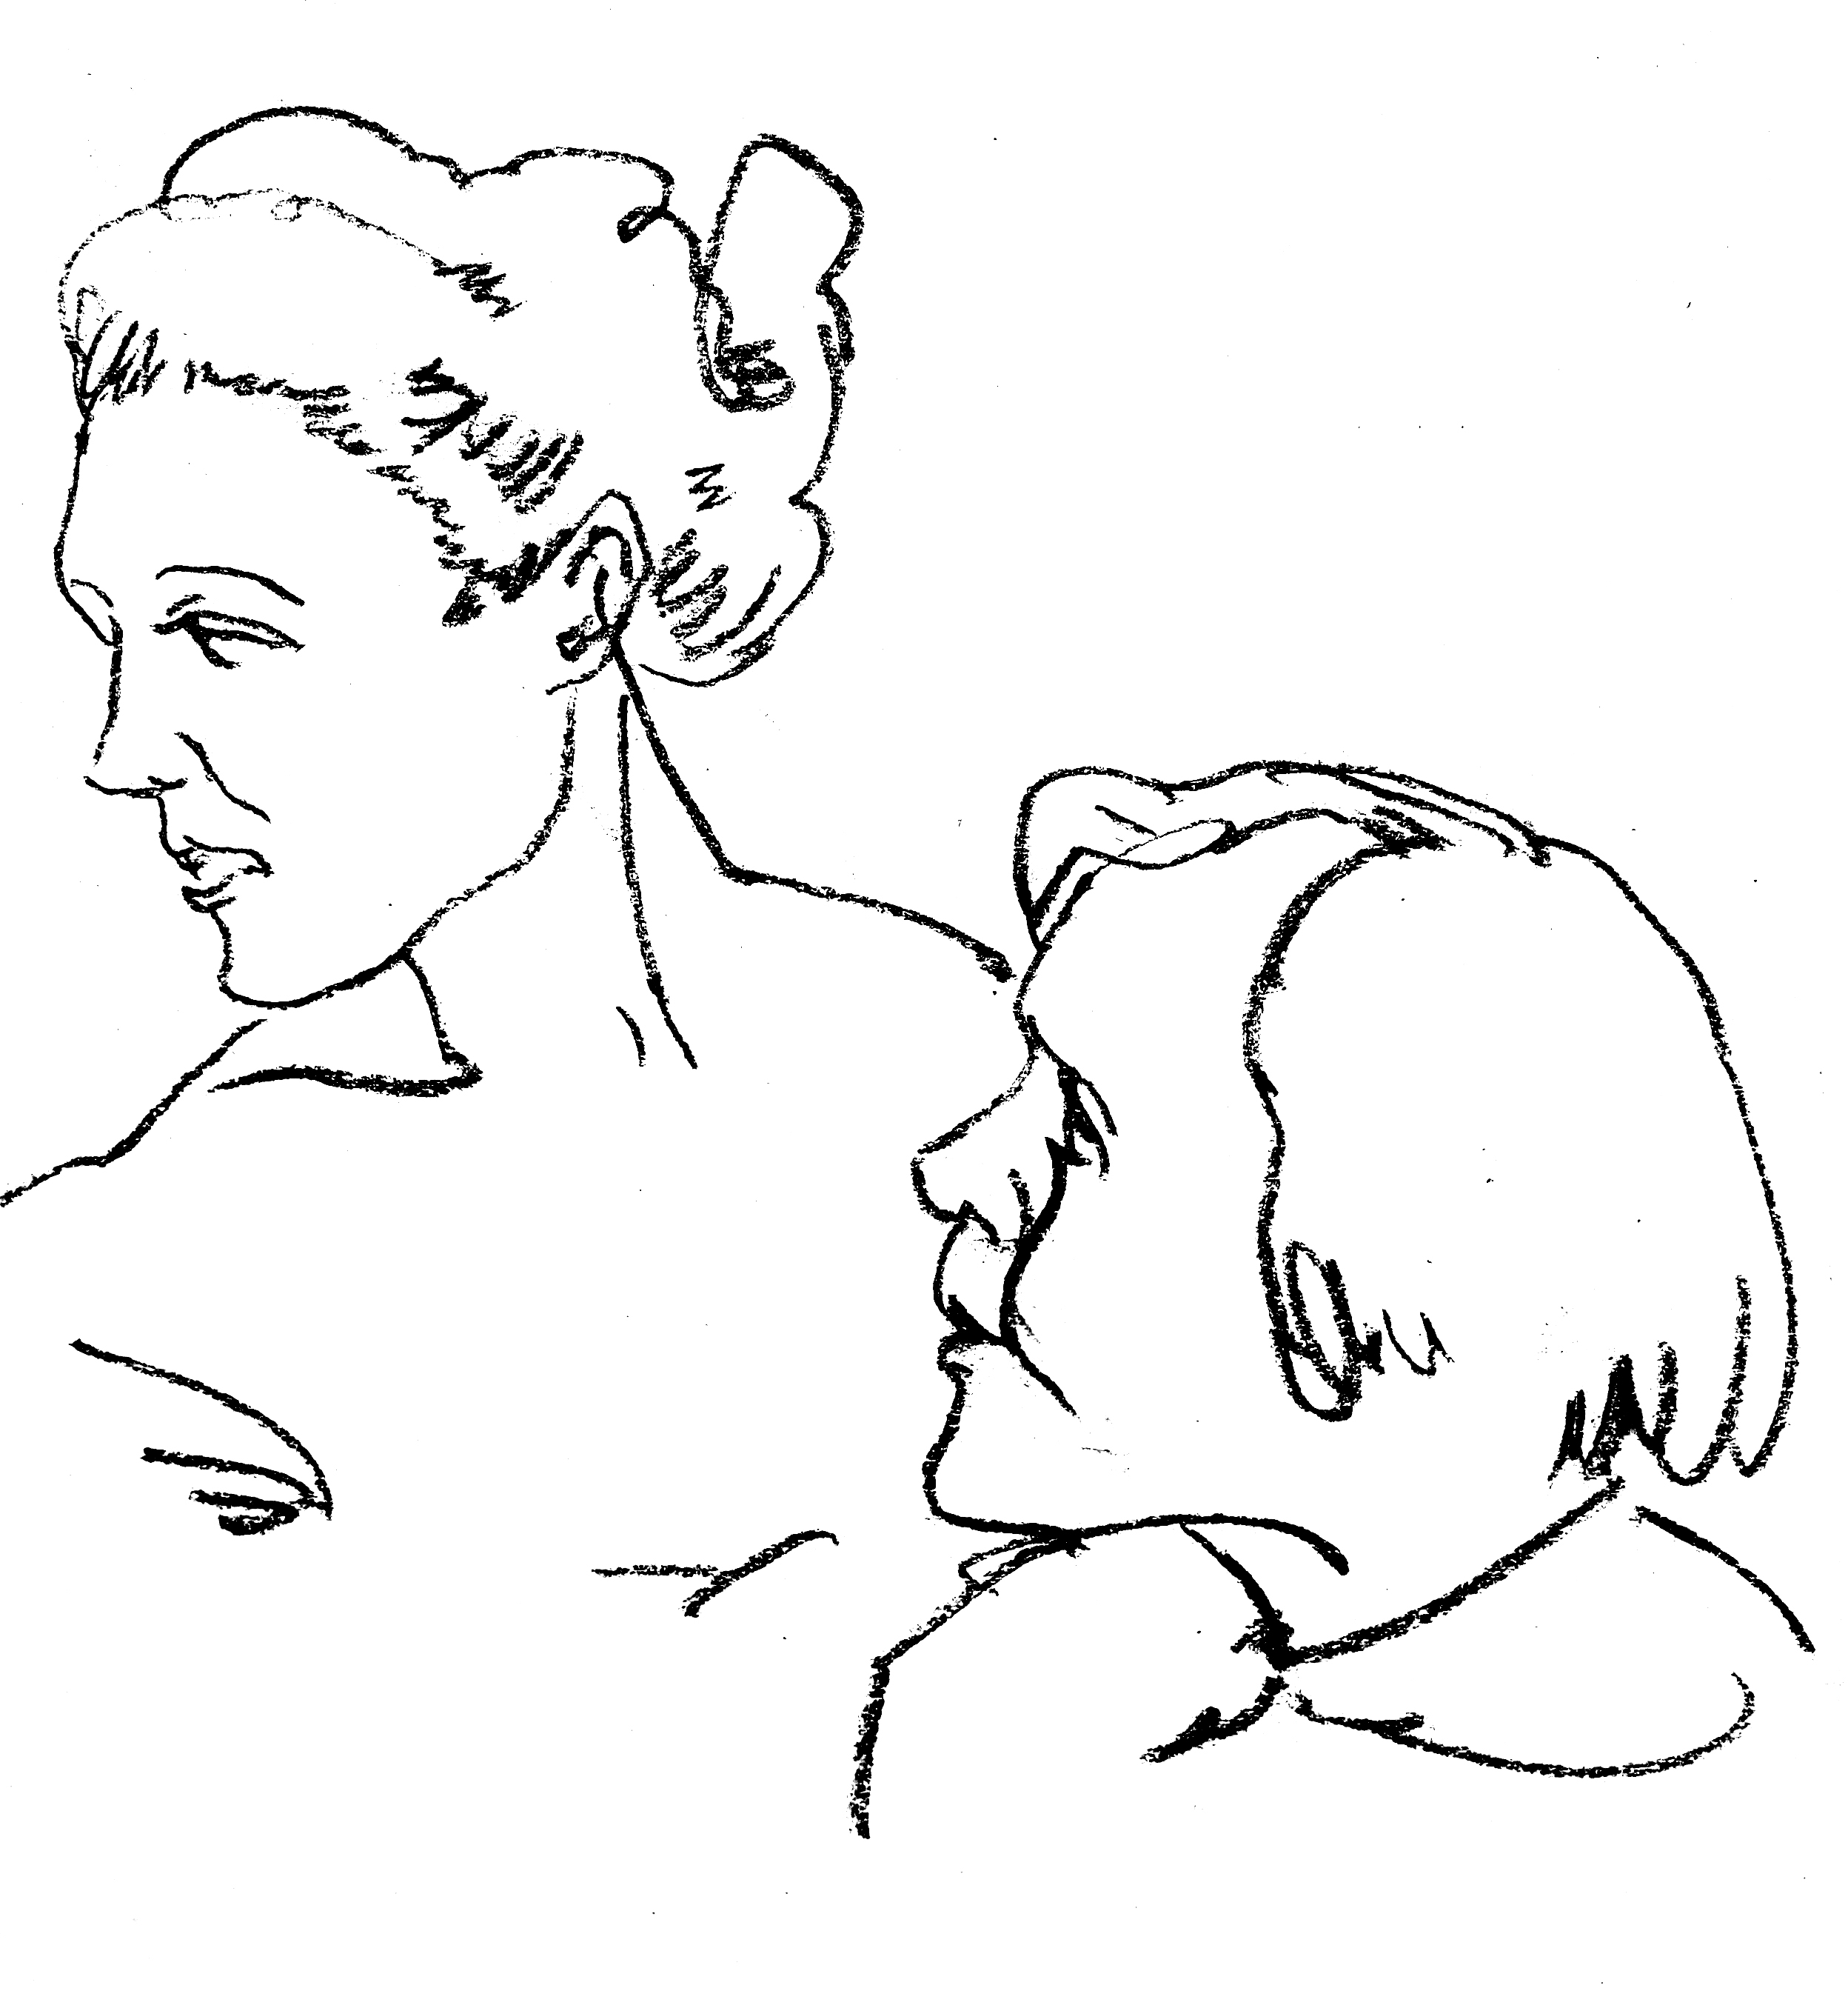
直没有长大。
一天温蒂告诉妈妈彼得晚上会来到婴儿室，她还说地板上的树叶就是证据。达林太太仍是半信半疑，认为是温蒂在做梦。
这天晚上，达林太太做了个梦，梦见梦幻岛就在眼前，一个陌生的男孩出现了。就在她做梦时，婴儿室的窗户被吹开了，一个男孩真的站在了地板上，他身上裹着枯叶，看到达林太太时，他咧开嘴露出一排珍珠般的小乳牙。

A
ll children, except one, grow up. They soon know that they will grow up, and the way Wendy knew was this. One day when she was two years old she was playing in a garden, and she plucked another flower and ran with it to her mother. I suppose she must have looked rather delightful, for Mrs. Darling put her hand to her heart and cried, “Oh, why can’t you remain like this for ever!” This was all that passed between them on the subject, but henceforth Wendy knew that she must grow up. You always know after you are two. Two is the beginning of the end.
Of course they lived at 14 (their house number on their street), and until Wendy came her mother was the chief one. She was a lovely lady, with a romantic mind and such a sweet mocking mouth. Her romantic mind was like the tiny boxes, one within the other, that come from the puzzling East, however many you discover there is always one more; and her sweet mocking mouth had one kiss on it that Wendy could never get, though there it was, perfectly conspicuous in the right-hand corner.
The way Mr. Darling won her was this: the many gentlemen who had been boys when she was a girl discovered simultaneously that they loved her, and they all ran to her house to propose to her except Mr. Darling, who took a cab and nipped in first, and so he got her. He got all of her, except the innermost box and the kiss. He never knew about the box, and in time he gave up trying for the kiss. Wendy thought Napoleon could have got it, but I can picture him trying, and then going off in a passion, slamming the door.
Mr. Darling used to boast to Wendy that her mother not only loved him but respected him. He was one of those deep ones who know about stocks and shares. Of course no one really knows, but he quite seemed to know, and he often said stocks were up and shares were down in a way that would have made any woman respect him.
Mrs. Darling was married in white, and at first she kept the books perfectly, almost gleefully, as if it were a game, not so much as a Brussels sprout was missing; but by and by whole cauliflowers dropped out, and instead of them there were pictures of babies without faces. She drew them when she should have been totting up. They were Mrs. Darling’s guesses.
Wendy came first, then John, then Michael.
For a week or two after Wendy came it was doubtful whether they would be able to keep her, as she was another mouth to feed. Mr. Darling was frightfully proud of her, but he was very honourable, and he sat on the edge of Mrs. Darling’s bed, holding her hand and calculating expenses, while she looked at him imploringly. She wanted to risk it, come what might, but that was not his way; his way was with a pencil and a piece of paper, and if she confused him with suggestions he had to begin at the beginning again.
“Now don’t interrupt,” he would beg of her.
“I have one pound seventeen here, and two and six at the office; I can cut off my coffee at the office, say ten shillings, making two nine and six, with your eighteen and three makes three nine seven, with five naught naught in my cheque-book makes eight nine seven—who is that moving?—eight nine seven, dot and carry seven—don’t speak, my own—and the pound you lent to that man who came to the door—quiet, child—dot and carry child—there, you’ve done it! —did I say nine nine seven? yes, I said nine nine seven; the question is, can we try it for a year on nine nine seven?”
“Of course we can, George,” she cried. But she was prejudiced in Wendy’s favour, and he was really the grander character of the two.
“Remember mumps,” he warned her almost threateningly, and off he went again. “Mumps one pound, that is what I have put down, but I daresay it will be more like thirty shillings—don’t speak—measles one five, German measles half a guinea, makes two fifteen six—don’t waggle your finger—whooping-cough, say fifteen shillings”—and so on it went, and it added up differently each time; but at last Wendy just got through, with mumps reduced to twelve six, and the two kinds of measles treated as one.
There was the same excitement over John, and Michael had even a narrower squeak; but both were kept, and soon, you might have seen the three of them going in a row to Miss Fulsom’s Kindergarten school, accompanied by their nurse.
Mrs. Darling loved to have everything just so, and Mr. Darling had a passion for being exactly like his neighbours; so, of course, they had a nurse. As they were poor, owing to the amount of milk the children drank, this nurse was a prim Newfoundland dog, called Nana, who had belonged to no one in particular until the Darlings engaged her. She had always thought children important, however, and the Darlings had become acquainted with her in Kensington Gardens, where she spent most of her spare time peeping into perambulators, and was much hated by careless nursemaids, whom she followed to their homes and complained of to their mistresses. She proved to be quite a treasure of a nurse. How thorough she was at bath-time, and up at any moment of the night if one of her charges made the slightest cry. Of course her kennel was in the nursery. She had a genius for knowing when a cough is a thing to have no patience with and when it needs stocking around your throat. She believed to her last day in old-fashioned remedies like rhubarb leaf, and made sounds of contempt over all this new-fangled talk about germs, and so on. It was a lesson in propriety to see her escorting the children to school, walking sedately by their side when they were well behaved, and butting them back into line if they strayed. On John’s footer (in England soccer was called football, footer for short) days she never once forgot his sweater, and she usually carried an umbrella in her mouth in case of rain. There is a room in the basement of Miss Fulsom’s school where the nurses wait. They sat on forms, while Nana lay on the floor, but that was the only difference. They affected to ignore her as of an inferior social status to themselves, and she despised their light talk. She resented visits to the nursery from Mrs. Darling’s friends, but if they did come she first whipped off Michael’s pinafore and put him into the one with blue braiding, and smoothed out Wendy and made a dash at John’s hair.
No nursery could possibly have been conducted more correctly, and Mr. Darling knew it, yet he sometimes wondered uneasily whether the neighbours talked.
He had his position in the city to consider.
Nana also troubled him in another way. He had sometimes a feeling that she did not admire him. “I know she admires you tremendously, George,” Mrs. Darling would assure him, and then she would sign to the children to be specially nice to father. Lovely dances followed, in which the only other servant, Liza, was sometimes allowed to join. Such a midget she looked in her long skirt and maid’s cap, though she had sworn, when engaged, that she would never see ten again. The gaiety of those romps! And gayest of all was Mrs. Darling, who would pirouette so wildly that all you could see of her was the kiss, and then if you had dashed at her you might have got it. There never was a simpler happier family until the coming of Peter Pan.
Mrs. Darling first heard of Peter when she was tidying up her children’s minds. It is the nightly custom of every good mother after her children are asleep to rummage in their minds and put things straight for next morning, repacking into their proper places the many articles that have wandered during the day. If you could keep awake (but of course you can’t) you would see your own mother doing this, and you would find it very interesting to watch her. It is quite like tidying up drawers. You would see her on her knees, I expect, lingering humorously over some of your contents, wondering where on earth you had picked this thing up, making discoveries sweet and not so sweet, pressing this to her cheek as if it were as nice as a kitten, and hurriedly stowing that out of sight. When you wake in the morning, the naughtiness and evil passions with which you went to bed have been folded up small and placed at the bottom of your mind and on the top, beautifully aired, are spread out your prettier thoughts, ready for you to put on.
I don’t know whether you have ever seen a map of a person’s mind. Doctors sometimes draw maps of other parts of you, and your own map can become intensely interesting, but catch them trying to draw a map of a child’s mind, which is not only confused, but keeps going round all the time. There are zigzag lines on it, just like your temperature on a card, and these are probably roads in the island, for the Neverland is always more or less an island, with astonishing splashes of colour here and there, and coral reefs and rakish-looking craft in the offing, and savages and lonely lairs, and gnomes who are mostly tailors, and caves through which a river runs, and princes with six elder brothers, and a hut fast going to decay, and one very small old lady with a hooked nose. It would be an easy map if that were all, but there is also first day at school, religion, fathers, the round pond, needle-work, murders, hangings, verbs that take the dative, chocolate pudding day, getting into braces, say ninety-nine, three-pence for pulling out your tooth yourself, and so on, and either these are part of the island or they are another map showing through, and it is all rather confusing, especially as nothing will stand still.
Of course the Neverlands vary a good deal. John’s, for instance, had a lagoon with flamingoes flying over it at which John was shooting, while Michael, who was very small, had a flamingo with lagoons flying over it. John lived in a boat turned upside down on the sands, Michael in a wigwam, Wendy in a house of leaves deftly sewn together. John had no friends, Michael had friends at night, Wendy had a pet wolf forsaken by its parents, but on the whole the Neverlands have a family resemblance, and if they stood still in a row you could say of them that they have each other’s nose, and so forth. On these magic shores children at play are for ever beaching their coracles (simple boat). We too have been there; we can still hear the sound of the surf, though we shall land no more.
Of all delectable islands the Neverland is the snuggest and most compact, not large and sprawly, you know, with tedious distances between one adventure and another, but nicely crammed. When you play at it by day with the chairs and table-cloth, it is not in the least alarming, but in the two minutes before you go to sleep it becomes very real. That is why there are night-lights.
Occasionally in her travels through her children’s minds Mrs. Darling found things she could not understand, and of these quite the most perplexing was the word Peter. She knew of no Peter, and yet he was here and there in John and Michael’s minds, while Wendy’s began to be scrawled all over with him. The name stood out in bolder letters than any of the other words, and as Mrs. Darling gazed she felt that it had an oddly cocky appearance.
“Yes, he is rather cocky,” Wendy admitted with regret. Her mother had been questioning her.
“But who is he, my pet?”
“He is Peter Pan, you know, mother.”
At first Mrs. Darling did not know, but after thinking back into her childhood she just remembered a Peter Pan who was said to live with the fairies. There were odd stories about him, as that when children died he went part of the way with them, so that they should not be frightened. She had believed in him at the time, but now that she was married and full of sense she quite doubted whether there was any such person.
“Besides,” she said to Wendy, “he would be grown up by this time.”
“Oh no, he isn’t grown up,” Wendy assured her confidently, “and he is just my size.” She meant that he was her size in both mind and body; she didn’t know how she knew, she just knew it.
Mrs. Darling consulted Mr. Darling, but he smiled pooh-pooh. “Mark my words,” he said, “it is some nonsense Nana has been putting into their heads; just the sort of idea a dog would have. Leave it alone, and it will blow over.”
But it would not blow over and soon the troublesome boy gave Mrs. Darling quite a shock.
Children have the strangest adventures without being troubled by them. For instance, they may remember to mention, a week after the event happened, that when they were in the wood they had met their dead father and had a game with him. It was in this casual way that Wendy one morning made a disquieting revelation. Some leaves of a tree had been found on the nursery floor, which certainly were not there when the children went to bed, and Mrs. Darling was puzzling over them when Wendy said with a tolerant smile:
“I do believe it is that Peter again!”
“Whatever do you mean, Wendy?”
“It is so naughty of him not to wipe his feet,” Wendy said, sighing. She was a tidy child.
She explained in quite a matter-of-fact way that she thought Peter sometimes came to the nursery in the night and sat on the foot of her bed and played on his pipes to her. Unfortunately she never woke, so she didn’t know how she knew, she just knew.
“What nonsense you talk, precious. No one can get into the house without knocking.”
“I think he comes in by the window,” she said.
“My love, it is three floors up.”
“Were not the leaves at the foot of the window, mother?”
It was quite true; the leaves had been found very near the window.
Mrs. Darling did not know what to think, for it all seemed so natural to Wendy that you could not dismiss it by saying she had been dreaming.
“My child,” the mother cried, “why did you not tell me of this before?”
“I forgot,” said Wendy lightly. She was in a hurry to get her breakfast.
Oh, surely she must have been dreaming.
But, on the other hand, there were the leaves. Mrs. Darling examined them very carefully; they were skeleton leaves, but she was sure they did not come from any tree that grew in England. She crawled about the floor, peering at it with a candle for marks of a strange foot. She rattled the poker up the chimney and tapped the walls. She let down a tape from the window to the pavement, and it was a sheer drop of thirty feet, without so much as a spout to climb up by.
Certainly Wendy had been dreaming.
But Wendy had not been dreaming, as the very next night showed, the night on which the extraordinary adventures of these children may be said to have begun.
On the night we speak of all the children were once more in bed. It happened to be Nana’s evening off, and Mrs. Darling had bathed them and sung to them till one by one they had let go her hand and slid away into the land of sleep.
All were looking so safe and cosy that she smiled at her fears now and sat down tranquilly by the fire to sew.
It was something for Michael, who on his birthday was getting into shirts. The fire was warm, however, and the nursery dimly lit by three night-lights, and presently the sewing lay on Mrs. Darling’s lap. Then her head nodded, oh, so gracefully. She was asleep. Look at the four of them, Wendy and Michael over there, John here, and Mrs. Darling by the fire. There should have been a fourth night-light.
While she slept she had a dream. She dreamt that the Neverland had come too near and that a strange boy had broken through from it. He did not alarm her, for she thought she had seen him before in the faces of many women who have no children. Perhaps he is to be found in the faces of some mothers also. But in her dream he had rent the film that obscures the Neverland, and she saw Wendy and John and Michael peeping through the gap.
The dream by itself would have been a trifle, but while she was dreaming the window of the nursery blew open, and a boy did drop on the floor. He was accompanied by a strange light, no bigger than your fist, which darted about the room like a living thing and I think it must have been this light that wakened Mrs. Darling.
She started up with a cry, and saw the boy, and somehow she knew at once that he was Peter Pan. If you or I or Wendy had been there we should have seen that he was very like Mrs. Darling’s kiss. He was a lovely boy, clad in skeleton leaves and the juices that ooze out of trees but the most entrancing thing about him was that he had all his first teeth. When he saw she was a grown-up, he gnashed the little pearls at her.

