1．到山上去
Up the Mountain
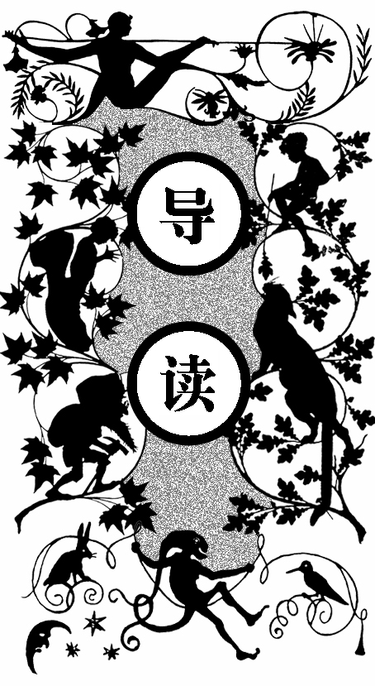
梅恩菲尔德是瑞士的一个小镇，坐落在大山脚下一个风光优美的山谷里。小镇背后有一条路蜿蜒地通到山上。六月里，来了一个年轻姑娘，带着一个大约只有五岁的小姑娘。天气已经很热了，小姑娘却还穿着两层外衣，还用一个红羊毛披肩围得严严实实，脸热得通红。年轻姑娘叫笛蒂，而小姑娘海蒂是她姐姐的女儿。走了一个多小时，她们来到半山腰的德里夫山村，这里是年轻姑娘的老家。她此行的目的是要把小姑娘带给住在山上的“阿尔姆大叔”，也就是小姑娘的爷爷抚养。她自己在德国找了一个工作，带着小姑娘很不方便。
这时，镇上有个女人巴贝尔和笛蒂认识，就跟她边走边聊。笛蒂提到要把海蒂交给大叔，巴贝尔就很替小女孩将来的生活担心。阿尔姆大叔一个人住在山上，过着几乎与世隔绝的生活。镇上的人们都不了解他，觉得他是个怪人，不愿与他交往。于是她们就聊起了阿尔姆大叔的过去。
阿尔姆大叔曾经拥有多莱姆斯最大的庄园。兄弟二人，他是哥哥，整日无所事事，酗酒、赌博，将家产挥霍光了。他的父母悲愤交加地离开了人世。弟弟离家出走，再无音信。后来，阿尔姆大叔也失踪了，只留下一些荒唐的事情作为人们茶后饭余的谈资。后来他被发现在那不勒斯当兵，之后的十五、二十年便没有了消息。有一天，他带着一个年幼的孩子突然回到多莱姆斯，想把孩子寄养在亲戚家，可是没有人愿意答理他。他很是

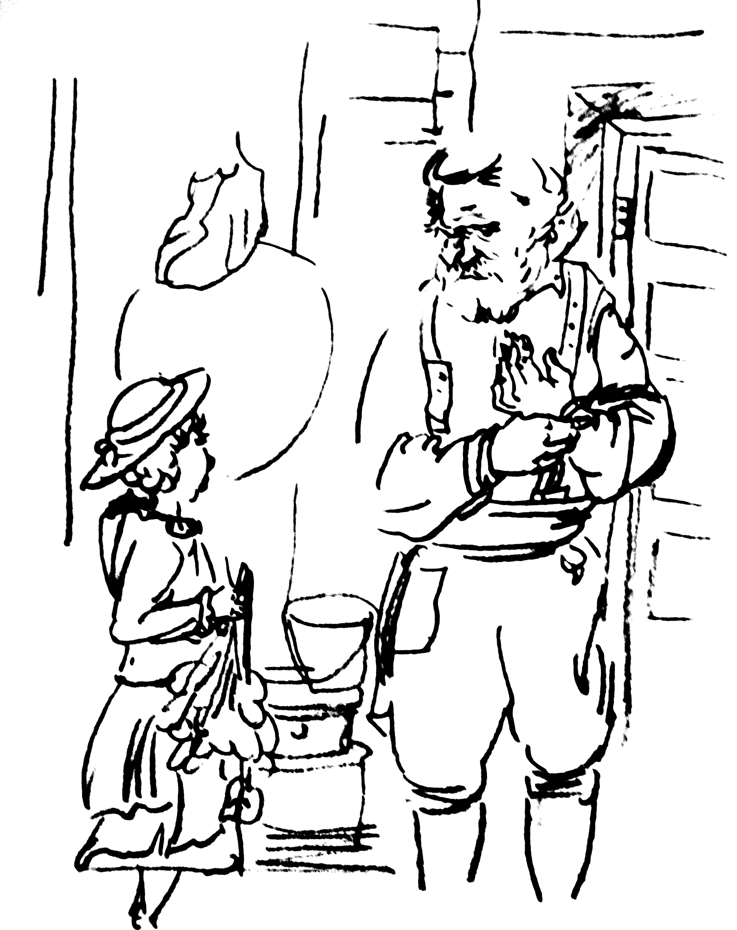
气愤，发誓再也不回多莱姆斯。从此他就带着这个叫图巴斯的孩子住在德里夫村。有人说他曾经在南部结过婚，但是不久妻子便死了。也有人说他是从那不勒斯逃回来的，因为他在那里杀过一个人。他积攒了一些钱，把图巴斯送到木匠那儿去当学徒。图巴斯是个好孩子，全村的人都喜欢他。后来他回到德里夫，娶了笛蒂的姐姐阿得蕾德，两人相亲相爱。两年后，图巴斯在帮人盖房的时候被木头砸中死了。阿得蕾德悲痛欲绝，几个星期之后也离开了人世。村里说这都是阿尔姆大叔年轻时所犯罪行的报应。阿尔姆大叔由此变得更加孤僻怪异，他搬到山上去住，再也不打算 下来。
就在她们聊天的时候，海蒂看到了一个牧羊的男孩，便跟着羊群爬上了山。男孩叫皮特，小山谷里的一个破旧的小木屋就是他的家。他爸爸也是个放羊的，在几年前伐木的时候遇到意外死了。妈妈叫布雷吉特。他还有个瞎眼的奶奶。皮特已经十一岁了，每天早上到德里夫村去召集各家的羊，领着羊群到山上牧草丰美的地方去，晚上又将羊群带回来，送回各家。每天他基本上很难见到其他的小孩子，山羊就是他的伙伴。
笛蒂跟巴贝尔聊完天才发现海蒂不见了，而这时海蒂正高高兴兴地跟着皮特牧羊。她脱掉了厚重的外套，好天气和美丽的景色使她开心起来。她感到自己像风一样自由，兴奋地到处乱跑。
笛蒂找回了海蒂，最终她们来到了阿尔姆大叔的小木屋前。海蒂被长胡子、浓眉毛的大叔吸引住了，冲上去说“爷爷，你好”。阿尔姆大叔很快明白了笛蒂的意图，他愤怒地叫笛蒂快滚。笛蒂飞快地跑了，但也开始有些良心不安。她答应过姐姐要好好照顾她的孩子。她安慰自己说，等多挣些钱就能为这个孩子做些什么。海蒂就这样被交给了爷爷。

T
he pretty little Swiss town of Mayenfeld lies at the foot of a mountain range, whose grim rugged peaks tower high above the valley below. Behind the town a footpath wintls gently up to the heights. The grass on the lower slopes is poor, but the air is fragrant with the scent of mountain flowers from the rich pasture land higher up.
One sunny June morning, a tall sturdy young woman was climbing up the path. She had a bundle in one hand and held a little girl about five years old by the other. The child’s sunburnt cheeks were flushed, which was not surprising, for though the sun was hot she was wrapped up as though it was mid-winter. It was difficult to see what she was like for she was wearing two frocks, one on top of the other, and had a large red scarf wound round and round her as well. She looked like some shapeless bundle of clothing trudging uphill on a pair of hobnailed boots.
After climbing for about an hour, they came to the little village of Dörfli, half way up the mountain. This was the woman’s old home, and people called to her from their houses all the way up the street. She did not say much in reply but went on her way without stopping until she reached the last home. There a voice from within hailed her. “Half a minute, Detie,” it said, “I’ll come with you, if you’re going any farther.”
Detie stood still, but the little girl slipped her hand free and sat down on the ground.
“Tired, Heidi ?” Detie asked her.
“No, but I’m very hot.” the child replied.
“We’ll soon be there. Just keep going, and see what long strides you can take, and we’ll arrive in another hour.”
At that moment a plump, pleasant-faced woman came out of the house and joined them. The little girl got up and followed as the two grown-ups went ahead, gossiping hard about people who lived in Dörfli or round about.
“Where are you going with the child, Detie?” the village woman asked after a while. “I suppose she’s the orphan your sister left ?”
“That’s right,’ Detie replied. ‘I’m taking her up to Uncle. She’ll have to stay with him now.”
“What, stay with Uncle Alp on the mountain? You must be crazy! How can you think of such a thing? But of course he’ll soon send you about your business if you suggest that to him.”
“Why should he? He’s her grandfather and it’s high time he did something for her. I’ve looked after her up to now, but I don’t mind telling you, I’m not going to turn down a good job like the one I’ve just been offered, because of her. Her grandfather must do his duty.”
“If he were like other people that might be all right,” retorted Barbie, “but you know what he is. What does he know about looking after a child, and such a young one too? She’ll never stand the life up there. Where’s this job you’re after?”
“In Germany,” said Detie. “A wonderful job with a good family in Frankfurt. Last summer they stayed in the hotel at Ragaz where I’ve been working as chambermaid. They had rooms on the floor I look after. They wanted to take me back with them then, but I couldn’t get away. Now they’ve come back and have asked me again. This time I’m certainly going.”
“Well, I’m glad I’m not that poor child,” said Barbie, throwing up her hands in dismay. “Nobody really knows what’s the matter with that old man, but he won’t have anything to do with anybody, and he hasn’t set foot in a church for years. When he does come down from the mountain, with his big stick in his hand-and that doesn’t happen often-everybody scuttles out of his way. They’re all scared stiff of him. He looks so wild with those bristling grey eyebrows and that dreadful beard. He’s not the sort of person one would want to meet alone on the mountain.”
“That’s as may be, but he’s got to look after his grandchild now, and if she comes to any harm that’ll be his fault, not mine.”
“I wonder what he’s got on his conscience to make him live all alone up there, and hardly ever show his face,” Barbie wondered. “There are all sorts of rumours, but I expect you know the whole story. Your sister must have told you plenty about him, didn’t she?”
“Yes, she did, but I’m not telling. If he heard I’d been talking about him, I should catch it all right.”
But Barbie did not mean to lose this excellent opportunity of getting to know more about the old man. She came from Prättigau, farther down the valley, and had only lived in Dörfii a short while, just since her marriage, so she still had much to learn about her neighbours. She was very anxious to know why the old man lived up on the mountain like a hermit, and why people were reluctant to talk about him as they did, freely enough, about everyone else. They didn’t approve of him, that much was certain, but they seemed afraid to say anything against him. And then, why was he always called “Uncle Alp”? He couldn’t be uncle to everyone in the village, but no one ever called him anything else, even Barbie used that name too. And here was her friend Detie, who was related to him and had lived all her life in Dörfli, until a year ago. Then her mother had died, and she had found a good job in a big hotel at Ragaz. She had come from there that morning with Heidi, with the help of a lift on a hay cart as far as Mayenfeld.
Now Barbie took her arm, and said coaxingly, “You could at least tell me how much of what they say is true, and how much only gossip. Come on now, do explain why he’s so against everyone, and why everyone is afraid of him. Has he always been like that?”
“That I can’t say for certain. I’m only twenty-six and he must be seventy or more, so I never knew him in his young days. All the same, if I could be sure that you wouldn’t pass it on to everyone in Präittigau, I could tell you plenty about him. He and my mother both came from Domleschg.”
“Go on, Detie, what do you take me for?” protested Barbie, half offended. “We aren’t such gossips as all that in Präittigau, and anyway I’m quite capable of holding my tongue when I want to. Do tell me. I promise not to pass it on.”
“All right then—but mind you keep your word !”
Detie glanced round to make sure that Heidi was not within earshot, but she was nowhere to be seen. She must have stopped following them some way back, and they had been too busy talking to notice. Detie stood still and looked in all directions. The path twisted and zigzagged down the mountainside, but she could see down it almost as far as Dörfli and there was nobody in sight anywhere along it.
“Ah, there she is,” cried Barbie suddenly, “can’t you see her ?” She pointed to a little figure far below. “Look, she’s climbing up the slopes with Peter and his goats. I wonder why he’s taking them up so late today. Well, he’ll keep an eye on her all right and you can get on with your story.”
“Peter needn’t bother himself,” said Detie. “She can look after herself, though she’s only five. She’s got all her wits about her. She knows how to make the best of things too, which is just as well, seeing that the old man’s got nothing now but his hut and two goats.”
“I suppose he was better off once ?” asked Barbie.
“I should just think he was. Why, he had one of the best farms in Domleschg. He was the elder son, with one brother, a quiet respectable fellow. But old Uncle wanted nothing but to ape the gentry and travel about all over the place. He got into bad company, and drank and gambled away the whole property. His poor parents died, literally died, of shame and grief when they heard of it. His brother was ruined too, of course. He took himself off, dear knows where, and nobody ever heard of him again. Uncle disappeared too. He had nothing left but a bad name. No one knew where he’d gone to, but after a while it came out that he had joined the army and was in Naples. Then no more was heard of him for twelve or fifteen years.” Detie was enjoying herself. “Go on,” Barbie cried breathlessly.
“Well, one day he suddenly reappeared in Domleschg with a young son, and wanted some of his relations to look after the boy. But he found all doors closed against him. Nobody wanted to have anything to do with him.”
“Whew!” came in a whistle from Barbie.
“He was so angry he vowed he would never set foot in the place again. So he came to Dörfli and settled down there with the boy, who was called Tobias. People thought he must have met and married his wife down in the south. Apparently she died soon afterwards, though nothing is known for certain. He had saved a little money, enough to apprentice his boy to a carpenter. Tobias was a good sort and everyone in the village liked him—but no one trusted the old man! It was said that he had deserted from the army at Naples, so as to avoid some trouble about killing a man-not in battle, you understand, but in a brawl. All the same we accepted him as a member of the family. His grandmother and my mother’s grandmother were sisters, so we called him Uncle, and as we’re related to almost everyone in Dörfli, one way or another, the whole village soon called him Uncle too. Then, when he went to live right up there on the moun-tain, it became Uncle Alp.”
“And what happened to Tobias?” Barbie asked eagerly.
“Give me a chance! I was just coming to that,” Detie snapped at her. “Tobias was apprenticed to a carpenter in Mels, but as soon as he had learnt his trade, he came home to Dörfli and married my sister Adelheid. They had always been fond of each other. They settled down very happily together as man and wife, but that didn’t last long. Only two years later he was killed by a falling beam while he was helping to build a house. Poor Adelheid got such a shock when she saw him carried home like that, that she fell ill with a fever, and never walked again. She had not been very strong before and used to have queer turns when it was hard to tell whether she was asleep or awake. She only survived him by a few weeks. That set tongues wagging of course. People said it was Uncle’s punishment for his mis-spent life. They told him so to his face, and the Pastor told him he ought to do penance to clear his conscience. That made him more angry than ever, and morose too. He wouldn’t speak to anyone after the Pastor’s visit, and his neighbours began to keep out of his way. Then one day we heard that he’d gone to live up on the mountain and wasn’t coming down any more. He’s actually stayed up there from that day to this, at odds with God and man, as they say. My mother and I took Adelheid’s baby girl to live with us. She was only about a year old when she was left an orphan. Then, when mother died last summer I wanted to get a job in the town, so I took Heidi up to Pfäffersdorf and asked old Ursula to look after her. I managed to get work in the town right through the winter, as I’m handy with my needle and there was always someone who wanted sewing or mending done. Then early this year that family from Frankfurt came again, the people I waited on last year; and now, as I told you, they want me to go back with them, and they’re leaving the day after tomorrow. It’s a first-rate job, I can tell you.”
“And you’re going to hand that child over to the old man, just like that? I’m surprised that you can even think of such a thing, Detie,” Barbie told her reproachfully.
“Well, what else can I do?” demanded Detie angrily. “I’ve done my best for her all these years, but obviously I can’t saddle myself with a five-year-old child on this job. Look, we’re half way up to Uncle’s now,” she went on. “Where are you going, Barbie?”
“I want to see Peter’s mother. She does spinning for me in the winter. So this is where I leave you. Goodbye, Detie, and good luck.”
Detie stood watching as Barbie went towards a little brown wooden hut sheltering in a small hollow a few yards from the path. It was so dilapidated that it was a good thing that it got some protection from the full force of the mountain gales. Even so, it must have been wretched to live in, as all the doors and windows rattled every time the wind blew and its rotten old beams creaked and shook. If it had been built in a more exposed position, it would certainly have been blown down into the valley long ago.
This was Peter the goatherd’s home. He was eleven, and every morning he went down to Dörfli to fetch the goats and drive them up to graze all day in the fragrant mountain meadows above. Then, in the evening, he brought them down again, leaping with them over the hillside almost as nimbly as they did. He always gave a shrill whistle through his fingers when he reached the village so that the owners could come and collect their animals. It was usually children who answered the call—not even the youngest was afraid of these gentle goats.
During the summer months this was the only chance Peter had of seeing other boys and girls. For the rest of the time, goats were his only companions. He spent very little time at home with his mother and his old blind grandmother who lived with them. He used to leave the hut very early, after bolting his breakfast of a piece of bread and a mug of milk, and he always stayed as long as possible with the children in Dörfli, so he only got back in time to gobble his supper and tumble straight into bed. His father had been the goatherd before him, but he had been killed several years ago, when felling a tree. His mother’s name was Bridget, but she was seldom called anything but ‘the goatherd’s mother’, and his grandmother was just Grannie to everyone, old and young alike.
For several minutes after Barbie had left her, Detie looked anxiously about for the two children with the goats, but there was no sign of them. She climbed a little farther up the path to get a better view and then stopped to look again. She was getting very impatient.
The children had strayed far away from the path, for Peter always went his own way up the mountain. What mattered was where his goats would find the best bushes and shrubs to nibble. At first Heidi had scrambled up after him, puffing and panting, for her load of clothes made climbing hard, hot work. She did not complain, but she looked enviously at Peter, running about so freely on bare feet, in comfortable trousers; and at the goats whose nimble little legs carried them so lightly up the steep slopes and over bushes and stones. Then suddenly she sat down and pulled off her boots and stockings. She unwound the thick red scarf and quickly unbuttoned her best dress, which Detie had made her wear on top of her everyday one, to save carrying it. She took off both dresses and stood there in nothing but a little petticoat, waving her bare arms in the air with delight. Then she laid all the clothes together in a neat pile and danced off to catch up with Peter and the goats. He had not noticed what she was doing, and when he caught sight of her running towards him like that, he smiled broadly. He looked back and saw the pile of clothing she had left on the grass, and grinned from ear to ear, but he said nothing. Heidi felt much happier, and free as air, and began to chatter away, asking him a string of questions. He had to tell her how many goats he had, where he was taking them, and what he was going to do when he got there. Presently they reached the hut and came within Detie’s view. As soon as she spotted them she called out shrilly:
“What on earth have you been doing, Heidi? What a sight you look! What have you done with your frocks? And the scarf? And those good new boots I bought you to come up here in, and the stockings I knitted for you? Wherever have you left them all ?”
Heidi calmly pointed to the place where she had undressed. “There they are,” she said. Her aunt could see something lying there, with a red spot on top, which was the scarf.
“Oh, you naughty little thing!” she cried crossly. “What on earth made you take your clothes off like that? What’s the meaning of it?”
“I didn’t need them,” replied Heidi, as if that were quite sufficient explanation.
“You stupid child, haven’t you any sense at all ?” scolded Detie. “And who do you think is going down to fetch them for you now? It would take me a good half hour. Peter, you run back and get them for me, and be quick about it. Don’t stand there gaping, as if you were rooted to the ground.”
“I’m late as it is,” said Peter. He made no attempt to move but stood with his hands in his pockets as he had done all the time Detie had been shouting at Heidi.
“Well, you won’t get very far, if you just stand there, staring,” said Detie. “Look here’s something for you.” She made her tone more persuasive, and held out a bright new coin. The sight of this stirred him to action, and he dashed off with giant strides down the steep slope. He snatched up the pile of clothes and was back with them in no time. Detie had to admit that he had earned his reward. He tucked the coin away, deep down in his pocket, with a very broad grin, for such riches did not often come his way.
“Now you carry the things up to Uncle’s for me. You’re going that way I know.” And Detie began to climb the steep path behind the goatherd’s hut.
Peter was quite willing and followed on her heels, holding the bundle under his left arm and swinging the stick he used for the goats in his right hand. It took nearly another hour to reach the high pasture where Uncle Alp’s hut stood on a little plateau. The little house was exposed to every wind that blew, but it also caught all the sunlight and commanded a glorious view tight down the valley. Three old fir trees with huge branches stood behind it. Beyond them the ground rose steeply to the top of the mountain. There was rich grazing land immediately above the hut, but then came a mass of tangled undergrowth, leading to bare and rugged peaks.
Uncle Alp had made a wooden seat and fixed it to the side of the hut looking over the valley. Here he was sitting peacefully, with his pipe in his mouth and his hands on his knees, as the little party approached. Peter and Heidi ran ahead of Detie for the last part of the way, and Heidi was actually the first to reach the old man. She went straight up to him and held out her hand. “Hallo, Grandfather,” she said.
“Hey, what’s that?” he exclaimed gruffly, staring searchingly at her as he took her hand. She stared back, fascinated by the strange-looking old man, with his long beard and bushy grey eyebrows. Meanwhile Detie came towards them, while Peter stood watching to see what would happen.
“Good morning, Uncle,” said Detie. “I’ve brought you Tobias’s daughter. I don’t suppose you recognize her as you haven’t seen her since she was a year old.”
“Why have you brought her here?” he demanded roughly. “And you be off with your goats,” he added to Peter. “You’re late, and don’t forget mine.” The old man gave him such a look that Peter disappeared at once.
“She’s come to stay with you, Uncle,” Detie told him, coming straight to the point. “I’ve done all I can for her these four years. Now it’s your turn.”
“My turn, is it?” snapped the old man, glaring at her. “And when she starts to cry and fret for you, as she’s sure to do, what am I supposed to do then?”
“That’s your affair,” retorted Detie. “Nobody told me how to set about it when she was left on my hands, a baby barely a year old. Goodness knows I had enough to do already, looking after Mother and myself. But now I’ve got to go away to a job. You’re the child’s nearest relative. If you can’t have her here, do what you like with her. But you’ll have to answer for it if she comes to any harm, and I shouldn’t think you’d want anything more on your conscience.”
Detie was really far from easy in her mind about what she was doing, which was why she spoke so disagreeably, and she had already said more than she meant to.
The old man got up at her last words. She was quite frightened by the way he looked at her, and took a few steps backward.
“Go back where you came from and don’t come here again in a hurry.” he said angrily, raising his arm.
Detie didn’t wait to be told twice. “Goodbye, then,” she said quickly. “Goodbye, Heidi,” and she ran off down the mountain, not stopping till she came to Dörfli. Here even more people called out to her than before, wanting to know what she had done with the child, whom they all knew.
“Where’s Heidi? What have you done with Heidi?” they cried from their doorways and windows.
Detie replied, more reluctantly each time, “She’s up at Uncle Alp’s. Yes, that’s what I said. She’s with Uncle Alp.” It made her uneasy to hear the women call back to her, from all sides, “How could you do it, Detie!” “Poor little mite!” “Fancy leaving that helpless little creature up there with that man!” Detie was thankful when she was out of earshot. She did not want to think about what she had done, for when her mother was dying, she had made Detie promise to look after the child. She comforted herself with the thought that she would be better able to do so if she took this job where she could earn good money, and hurried away as fast as she could from all those people who would try to make her change her mind.

