从地球到月球
From the Earth to the Moon

第一章 大炮俱乐部
Chapter 1 The Gun Club
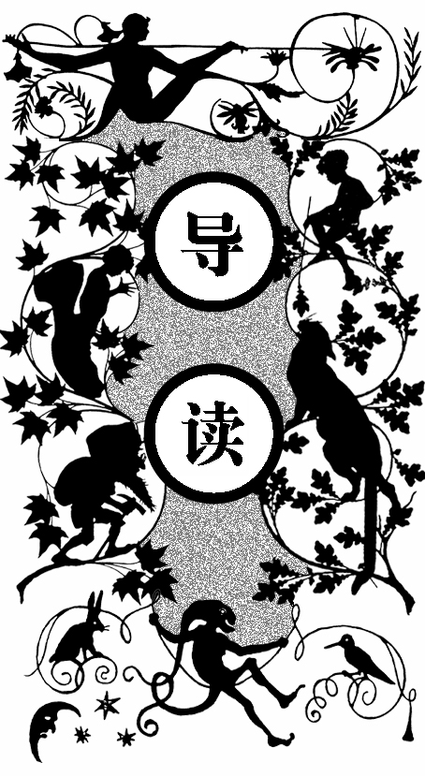
美国马里兰中部地区的巴尔的摩城，在南北战争期间成立了一个“大炮俱乐部”。
一些船东、商人跨出他们的柜台，成了军官甚至将军。他们在弹道科学上胜过欧洲并制造了一批超级大炮，受到了人们的崇拜。
这个俱乐部在有创意的情况下，凑足三个人，就选举出主席和两个秘书，有了第四人就当档案管理员，再有一个人就召开了全体大会，然后宣布俱乐部成立。
俱乐部成立一个月后就有一千八百三十三位正式会员和三万零五百六十五位通讯员。会员必须发明或改良过大炮或火器。
在大炮俱乐部的光荣册上，记载着失去生命的从士兵到将军以及伤残人的名字。在俱乐部会员中四个人不到两条胳膊，六个人只有两条腿。战争停止后，大炮俱乐部也冷清下来。
一天晚上，装着两条木腿的汤姆•亨特尔感到无聊得受不了，而失去 一条胳膊的比斯比更是感到那种热闹的日子一去不复返了，装着树胶脑壳的J．T．马斯顿对着早上刚完成的迫击炮设计感到没什么希望。
他们都渴望战争，都想去欧洲的战场上继续他们的试验，或者是找到打仗的理由。
J．T．马斯顿认为既然北美曾经属于英国，那么英国现在就可以属于美国。布隆斯利上校认为这很公平，J．T．马斯顿让他去和美国总统说，要不就别指望以后投他的票，并且如果不让自己的新型迫击炮在真正的战场上试验一下，就退出俱乐部到草原上隐居。屋里的人都积极响应。
这时他们收到俱乐部主席因贝•巴比康的通报，俱乐部将于本月五日召开会议，届时将发布大家感兴趣的问题。

uring the War of the Rebellion, a new and influential club was established in the city of Baltimore in the State of Maryland. It is well known with what energy the taste for military matters became developed among that nation of ship-owners, shopkeepers, and mechanics. Simple tradesmen jumped their counters to become extemporized captains, colonels, and generals, without having ever passed the School of Instruction at West Point; nevertheless, they quickly rivaled their compeers of the old continent, and, like them, carried off victories by dint of lavish expenditure in ammunition, money, and men.
D
But the point in which the Americans singularly distanced the Europeans was in the science of gunnery. Not, indeed, that their weapons retained a higher degree of perfection than theirs, but that they exhibited unheard-of dimensions, and consequently attained hitherto unheard-of ranges. In point of grazing, plunging, oblique, or enfilading, or point-blank firing, the English, French, and Prussians have nothing to learn; but their cannon, howitzers, and mortars are mere pocket-pistols compared with the formidable engines of the American artillery.
This fact need surprise no one. The Yankees, the first mechanicians in the world, are engineers-just as the Italians are musicians and the Germans metaphysicians- by right of birth. Nothing is more natural, therefore, than to perceive them applying their audacious ingenuity to the science of gunnery. Witness the marvels of Parrott, Dahlgren, and Rodman, The Armstrong, Palliser, and Beaulieu guns were compelled to bow before their transatlantic rivals.
Now when an American has an idea, he directly seeks a second American to share it. If there be three, they elect a president and two secretaries. Given four, the name a keeper of records, and the office is ready for work; five, they convene a general meeting, and the club is fully constituted. So things were managed in Baltimore. The inventor of a new cannon associated himself with the caster and the borer. Thus was formed the nucleus of the “Gun Club. ” In a single month after its formation it numbered 1, 833 effective members and 30, 565 corresponding members.
One condition was imposed as a unique one upon every candidate for admission into the association, and that was the condition of having designed, or (more or less) perfected a cannon; or, in default of a cannon, at least a firearm of some description. It may, however, be mentioned that mere inventors of revolvers, fire-shooting carbines, and similar small arms, met with little consideration. Artillerists always commanded the chief place of favor.
The estimation in which these gentlemen were held, according to one of the most scientific exponents of the Gun Club, was “proportional to the masses of their guns, and in the direct ratio of the square of the distances attained by their projectiles. ”
The Gun Club once founded, it is easy to conceive the result of the inventive genius of the Americans. Their military weapons attained colossal proportions, and their projectiles, exceeding the prescribed limits, unfortunately occasionally cut in two some unoffending pedestrians. These inventions, in fact, left far in the rear the timid instruments of European artillery.
It is but fair to add that these Yankees, brave as they have ever proved themselves to be, did not confine themselves to theories and formulae, but that they paid heavily, in propria personal, for their inventions. Among them were to be counted officers of all ranks, from lieutenants to generals; military men of every age, from those who were just making their debut in the profession of arms up to those who had grown old in the gun-carriage. Many had found their rest on the field of battle whose names figured in the “Book of Honor” of the Gun Club; and of those who made good their return the greater proportion bore the marks of their indisputable valor: crutches, wooden legs, artificial arms, steel hooks, caoutchouc jaws, silver craniums, platinum noses, were all to be found in the collection; and it was calculated by the great statistician Pitcairn that throughout the Gun Club there was not quite one arm between four persons and two legs between six.
Nevertheless, these valiant artillerists took no particular account of these little facts, and felt justly proud when the despatches of a battle returned the number of victims at ten-fold the quantity of projectiles expended.
One day, however- sad and melancholy day!-peace was signed between the survivors of the war; the thunder of the guns gradually ceased, the mortars were silent, the howitzers were muzzled for an indefinite period, the cannon, with muzzles depressed, were returned into the arsenal, the shot were repiled, all bloody reminiscences were effaced; the cotton-plants grew luxuriantly in the well-manured fields, all mourning garments were laid aside, together with grief; and the Gun Club was relegated to profound inactivity.
Some few of the more advanced and inveterate theorists set themselves again to work upon calculations regarding the laws of projectiles. They reverted invariably to gigantic shells and howitzers of unparalleled caliber. Still in default of practical experience what was the value of mere theories? Consequently, the clubrooms became deserted, the servants dozed in the antechambers, the newspapers grew mouldy on the tables, sounds of snoring came from dark corners, and the members of the Gun Club, erstwhile so noisy in their seances, were reduced to silence by this disastrous peace and gave themselves up wholly to dreams of a Platonic kind of artillery.
“This is horrible! ” said Tom Hunter one evening, while rapidly carbonizing his wooden legs in the fireplace of the smoking-room; “Nothing to do! Nothing to look forward to! What a loathsome existence! When again shall the guns arouse us in the morning with their delightful reports? ”
“Those days are gone by, ” said jolly Bilsby, trying to extend his missing arms. “It was delightful once upon a time! One invented a gun, and hardly was it cast, when one hastened to try it in the face of the enemy! Then one returned to camp with a word of encouragement from Sherman or a friendly shake of the hand from Medlellan. But now the generals are gone back to their counters; and in place of projectiles, they despatch bales of cotton. By Jove, the future of gunnery in America is lost! ”
“Ay! And no war in prospect! ” continued the famous James T. Maston, scratching with his steel hook his gutta-percha cranium. “Not a cloud on the horizon! And that too at such a critical period in the progress of the science of artillery! Yes, gentlemen! I who address you have myself this very morning perfected a model (plan, section, elevation, etc. ) of a mortar destined to change all the conditions of warfare ! ”
“No! Is it possible? ” replied Tom Hunter, his thoughts reverting involuntarily to a former invention of the Hon. J. T. Maston, by which, at its first trial, he had succeeded in killing three hundred and thirty-seven people.
“Fact! ” replied he. “Still, what is the use of so many studies worked out, so many difficulties vanquished? It’s mere waste of time! The New World seems to have made up its mind to live in peace; and our bellicose《Tribune》predicts some approaching catastrophes arising out of this scandalous increase of population. ”
“Nevertheless, ” replied Colonel Blomsberry, “they are always struggling in Europe to maintain the principle of nationalities. ”
“Well? ”
“Well, there might be some field for enterprise down there; and if they would accept our services—”
“What are you dreaming of? ” screamed Bilsby; “work at gunnery for the benefit of foreigners? ”
“That would be better than doing nothing here, ” returned the colonel.
“Quite so, ” said J. T. Matson; “but still we need not dream of that expedient. ”
“And why not? ” demanded the colonel.
“Because their ideas of progress in the Old World are contrary to our American habits of thought. Those fellows believe that one can’t become a general without having served first as an ensign; which is as much as to say that one can’t point a gun without having first cast it oneself ! ”
“Ridiculous! ” replied Tom Hunter, whittling with his bowie-knife the arms of his easy chair, “but if that be the case there, all that is left for us is to plant tobacco and distill whale-oil. ”
“What! ” roared J. T. Maston, “shall we not employ these remaining years of our life in perfecting firearms? Shall there never be a fresh opportunity of trying the ranges of projectiles? Shall the air never again be lighted with the glare of our guns? No international difficulty ever arise to enable us to declare war against some transatlantic power? Shall not the French sink one of our steamers, or the English, in defiance of the rights of nations, hang a few of our countrymen? ”
“No such luck, ” replied Colonel Blomsberry; “nothing of the kind is likely to happen; and even if it did, we should not profit by it. American susceptibility is fast declining, and we are all going to the dogs. ”
“It is too true, ” replied J. T. Maston, with fresh violence; “there are a thousand grounds for fighting, and yet we don’t fight. We save up our arms and legs for the benefit of nations who don’t know what to do with them! But stop-without going out of one’s way to find a cause for war-did not North America once belong to the English? ”
“Undoubtedly, ” replied Tom Hunter, stamping his crutch with fury.
“Well, then, ” replied J. T. Maston, “why should not England in her turn belong to the Americans? ”
“It would be but just and fair, ” returned Colonel Blomsberry.
“Go and propose it to the President of the United States, ” cried J. T. Maston, “and see how he will receive you. ”
“Bah! ” growled Bilsby between the four teeth which the war had left him; “that will never do ! ”
“By Jove! ” cried J. T. Maston, “he mustn’t count on my vote at the next election! ”
“Nor on ours, ” replied unanimously all the bellicose invalids.
“Meanwhile, ” replied J. T. Maston, “allow me to say that, if I cannot get an opportunity to try my new mortars on a real field of battle, I shall say good-by to the members of the Gun Club, and go and bury myself in the prairies of Arkansas ! ”
“In that case we will accompany you, ” cried the others.
Matters were in this unfortunate condition, and the club was threatened with approaching dissolution, when an unexpected circumstance occurred to prevent so deplorable a catastrophe.
On the morrow after this conversation every member of the association received a sealed circular couched in the following terms:
BALTIMORE, October 3. The president of the Gun Club has the honor to inform his colleagues that, at the meeting of the 5th instant, he will bring before them a communication of an extremely interesting nature. He requests, therefore, that they will make it convenient to attend in accordance with the present invitation.
Very cordially,
IMPEY BARBICANE, P. G. C.

第二章 巴比康主席的报告
Chapter 2 President Barbicane’s Communication
会议于十月五日晚八点在联邦广场二十一号大炮俱乐部举行。巨大的会议厅坐满了会员和通讯员，一个外国人出高价也没能进入大厅，而当地的知名人士和官员只好混在市民中在外面听消息。
大厅里陈列着粗大的迫击炮和一些火枪，让人大开眼界。主席和四个秘书坐在一端，他的转椅装在一个炮架上，铁皮桌子下面由六枚短炮身支撑，墨水瓶则是由火铳炮弹雕刻成的。桌子前面的长凳摆成封锁壕似的防御工事，上面坐着俱乐部 会员。
四十岁的因贝•巴比康沉着、冷静，做木材生意时发了财，战争后期做了炮业负责人，他用自己大胆丰富的想象力为大炮的试验做了很大的贡献。
八点整，巴比康站起来，首先亮明了观点。他认为虽然战争是不可能的，但自己已在近期制定了一个轰动世界的计划，要带领大家去征服月亮，使它加入到合众国来。
他又提到十七世纪有人吹嘘见到了月球人，以及一些作者写的月亮游记方面的书，还有一些天文学家虚构的利用望远镜看到月球上的一些动物及居民的情况，还提到一位鹿特丹人乘气球到达月球的幻想。
最后他又讲到曾有德国科学家建议派科学家去西伯利亚草原建立巨大的用反射灯线形成的几何图形，如果月球有人，他们会用类似的图形来回答，这样就能和月球居民交谈了。

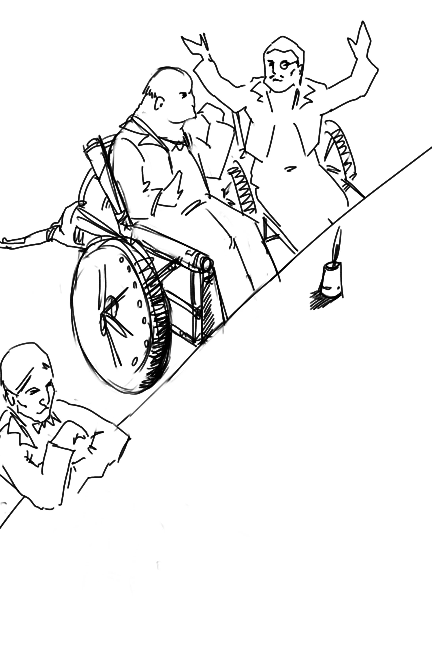

近几年，弹道学取得了很大的发展，利用一定的后座力可以将一颗炮弹送到月球上去。而只要炮弹的初速度达到每秒一万两千码，就可到达月球，他提议来做这件事情。

n the 5th of October, at eight p. m. , a dense crowd pressed toward the saloons of the Gun Club at No. 21 Union Square. All the members of the association resident in Baltimore attended the invitation of their president. As regards the corresponding members, notices were delivered by hundreds throughout the streets of the city, and, large as was the great hall, it was quite inadequate to accommodate the crowd of savants. They overflowed into the adjoining rooms, down the narrow passages, into the outer courtyards. There they ran against the vulgar herd who pressed up to the doors, each struggling to reach the front ranks, all eager to learn the nature of the important communication of President Barbicane; all pushing, squeezing, crushing with that perfect freedom of action which is so peculiar to the masses when educated in ideas of “self-government. ”
O
On that evening a stranger who might have chanced to be in Baltimore could not have gained admission for love or money into the great hall. That was reserved exclusively for resident or corresponding members; no one else could possibly have obtained a place; and the city magnates, municipal councilors, and “select men” were compelled to mingle with the mere townspeople in order to catch stray bits of news from the interior.
Nevertheless the vast hall presented a curious spectacle. Its immense area was singularly adapted to the purpose. Lofty pillars formed of cannon, superposed upon huge mortars as a base, supported the fine ironwork of the arches, a perfect piece of cast-iron lacework. Trophies of blunderbuses, matchlocks, arquebuses, carbines, all kinds of firearms, ancient and modern, were picturesquely interlaced against the walls. The gas lit up in full glare myriads of revolvers grouped in the form of lustres, while groups of pistols, and candelabra formed of muskets bound together, completed this magnificent display of brilliance. Models of cannon, bronze castings, sights covered with dents, plates battered by the shots of the Gun Club, assortments of rammers and sponges, chaplets of shells, wreaths of projectiles, garlands of howitzers- in short, all the apparatus of the artillerist, enchanted the eye by this wonderful arrangement and induced a kind of belief that their real purpose was ornamental rather than deadly.
At the further end of the saloon the president, assisted by four secretaries, occupied a large platform. His chair, supported by a carved gun-carriage, was modeled upon the ponderous proportions of a 32-inch mortar. It was pointed at an angle of ninety degrees, and suspended upon truncheons, so that the president could balance himself upon it as upon a rocking-chair, a very agreeable fact in the very hot weather. Upon the table (a huge iron plate supported upon six carronades) stood an inkstand of exquisite elegance, made of a beautifully chased Spanish piece, and a sonnette, which, when required, could give forth a report equal to that of a revolver. During violent debates this novel kind of bell scarcely sufficed to drown the clamor of these excitable artillerists.
In front of the table benches arranged in zigzag form, like the circumvallations of a retrenchment, formed a succession of bastions and curtains set apart for the use of the members of the club; and on this especial evening one might say, “All the world was on the ramparts” . The president was sufficiently well known, however, for all to be assured that he would not put his colleagues to discomfort without some very strong motive.
Impey Barbicane was a man of forty years of age, calm, cold, austere; of a singularly serious and self-contained demeanor, punctual as a chronometer, of imperturbable temper and immovable character; by no means chivalrous, yet adventurous withal, and always bringing practical ideas to bear upon the very rashest enterprises; an essentially New Englander, a Northern colonist, a descendant of the old anti Stuart Roundheads, and the implacable enemy of the gentlemen of the South, those ancient cavaliers of the mother country. In a word, he was a Yankee to the backbone.
Barbicane had made a large fortune as a timber merchant. Being nominated director of artillery during the war, he proved himself fertile in invention. Bold in his conceptions, he contributed powerfully to the progress of that arm and gave an immense impetus to experimental researches.
He was personage of the middle height, having, by a rare exception in the Gun Club, all his limbs complete. His strongly marked features seemed drawn by square and rule; and if it be true that, in order to judge a man’s character one must look at his profile, Barbicane, so examined, exhibited the most certain indications of energy, audacity, and sang-froid.
At this moment he was sitting in his armchair, silent, absorbed, lost in reflection, sheltered under his high-crowned hata kind of black cylinder which always seems firmly screwed upon the head of an American.
Just when the deep-toned clock in the great hall struck eight, Barbicane, as if he had been set in motion by a spring, raised himself up. A profound silence ensued, and the speaker, in a somewhat emphatic tone of voice, commenced as follows:
“My brave, colleagues, too long already a paralyzing peace has plunged the members of the Gun Club in deplorable inactivity. After a period of years full of incidents we have been compelled to abandon our labors, and to stop short on the road of progress. I do not hesitate to state, baldly, that any war which would recall us to arms would be welcome! ” (Tremendous applause! ) “But war, gentlemen, is impossible under existing circumstances; and, however we may desire it, many years may elapse before our cannon shall again thunder in the field of battle. We must make up our minds, then, to seek in another train of ideas some field for the activity which we all pine for. ”
The meeting felt that the president was now approaching the critical point, and redoubled their attention accordingly.
“For some months past, my brave colleagues, ” continued Barbicane, “I have been asking myself whether, while confining ourselves to our own particular objects, we could not enter upon some grand experiment worthy of the nineteenth century; and whether the progress of artillery science would enable us to carry it out to a successful issue. I have been considering, working, calculating; and the result of my studies is the conviction that we are safe to succeed in an enterprise which to any other country would appear wholly impracticable. This project, the result of long elaboration, is the object of my present communication. It is worthy of yourselves, worthy of the antecedents of the Gun Club; and it cannot fail to make some noise in the world. ”
A thrill of excitement ran through the meeting.
Barbicane, having by a rapid movement firmly fixed his hat upon his head, calmly continued his harangue:
“There is no one among you, my brave colleagues, who has not seen the Moon, or, at least, heard speak of it. Don’t be surprised if I am about to discourse to you regarding the Queen of the Night. It is perhaps reserved for us to become the Columbuses of this unknown world. Only enter into my plans, and second me with all your power, and I will lead you to its conquest, and its name shall be added to those of the thirty-six states which compose this Great Union. ”
“Three cheers for the Moon! ” roared the Gun Club, with one voice.
“The moon, gentlemen, has been carefully studied,” continued Barbicane; “her mass, density, and weight; her constitution, motions, distance, as well as her place in the solar system, have all been exactly determined. Selenographic charts have been constructed with a perfection which equals, if it does not even surpass, that of our terrestrial maps. Photography has given us proofs of the incomparable beauty of our satellite; all is known regarding the moon which mathematical science, astronomy, geology, and optics can learn about her. But up to the present moment no direct communication has been established with her.”
A violent movement of interest and surprise here greeted this remark of the speaker.
“Permit me, ” he continued, “to recount to you briefly how certain ardent spirits, starting on imaginary journeys, have penetrated the secrets of our satellite. In the seventeenth century a certain David Fabricius boasted of having seen with his own eyes the inhabitants of the moon. In 1649 a Frenchman, one Jean Baudoin, published a ‘Journey performed from the Earth to the Moon by Domingo Gonzalez’, a Spanish adventurer. At the same period Cyrano de Bergerac published that celebrated ‘Journeys in the Moon’ which met with such success in France. Somewhat later another Frenchman, named Fontenelle, wrote ‘The Plurality of Worlds, ’ a piece of work of its time. About 1835 a small treatise, translated from the New York American, related how Sir John Herschel, having been despatched to the Cape of Good Hope for the purpose of making there some astronomical calculations, had, by means of a telescope brought to perfection by means of internal lighting, reduced the apparent distance of the moon to eighty yards! He then distinctly perceived caverns frequented by hippopotami, green mountains bordered by golden lace-work, sheep with horns of ivory, a white species of deer and inhabitants with membranous wings, like bats. This brochure, the work of an American named Locke, had a great sale. But, to bring this rapid sketch to a close, I will only add that a certain Hans Pfaal, of Rotterdam, launching himself in a balloon filled with a gas extracted from nitrogen, thirty-seven times lighter than hydrogen, reached the moon after a passage of nineteen hours. This journey, like all previous ones, was purely imaginary; still, it was the work of a popular American author- I mean Edgar Poe! ”
“Cheers for Edgar Poe! ” roared the assemblage, electrified by their president’s words.
“I have now enumerated, ” said Barbicane, “the experiments which I call purely paper ones, and wholly insufficient to establish serious relations with the Queen of the Night. Nevertheless, I am bound to add that some practical geniuses have attempted to establish actual communication with her. Thus, a few years ago, a German geometrician proposed to send a scientific expedition to the steppes of Siberia. There, on those vast plains, they were to describe enormous geometric figures, drawn in characters of reflecting luminosity, among which was the proposition regarding the ‘square of the hypothenuse’, commonly called the ‘Ass’s Bridge’ by the French. ‘Every intelligent being, ’ said the geometrician, ‘ must understand the scientific meaning of that figure. The Selenites, do they exist, will respond by a similar figure; and, a communication being thus once established, it will be easy to form an alphabet which shall enable us to converse with the inhabitants of the moon. ’ So spoke the German geometrician; but his project was never put into practice, and up to the present day there is no bond in existence between the Earth and her satellite. It is reserved for the practical genius of Americans to establish a communication with the sidereal world. The means of arriving thither are simple, easy, certain, infallible-and that is the purpose of my present proposal.”
A storm of acclamations greeted these words. There was not a single person in the whole audience who was not overcome, carried away, lifted out of himself by the-speaker’s words !
Long-continued applause resounded from all sides.
As soon as the excitement had partially subsided, Barbicane resumed his speech in a somewhat graver voice.
“You know,” said he, “what progress artillery science has made during the last few years, and what a degree of perfection firearms of every kind have reached. Moreover, you are well aware that, in general terms, the resisting power of cannon and the expansive force of gunpowder are practically unlimited. Well! starting from this principle, I ask myself whether, supposing sufficient apparatus could be obtained constructed upon the conditions of ascertained resistance, it might not be possible to project a shot up to the moon?”
At these words a murmur of amazement escaped from a thousand panting chests; then succeeded a moment of perfect silence, resembling that profound stillness which precedes the bursting of a thunderstorm. In point of fact, a thunderstorm did peal forth, but it was the thunder of applause, or cries, and of uproar which made the very hall tremble. The president attempted to speak, but could not. It was fully ten minutes before he could make himself heard.
“Suffer me to finish, ” he calmly continued. “I have looked at the question in all its bearings, I have resolutely attacked it, and by incontrovertible calculations I find that a projectile endowed with an initial velocity of 12, 000 yards per second, and aimed at the moon, must necessarily reach it. I have the honor, my brave colleagues, to propose a trial of this little experiment.”

第三章 主席报告产生的影响
Chapter 3 Effect of the President’s Communication
主席的话产生了巨大的影响，人们欢呼着把他从座位上拉下来举在众人手中传递着，持续了好长时间。住在马里兰州的不同国籍的人也都激动地欢呼雀跃。
从八点到午夜使一位卖望远镜的商人发了财，而毫不客气的美国人因一个谈话中的炮弹已经成了月亮的征服者。
午夜后狂热的人们激情不减，喝着各种酒谈论着此事。而在美利坚其他城市的会员也得到了信息，举行了狂欢。
第二天，各种报刊都从不同学科等方面讨论着这个问题。大家都对此项计划信心十足，一些协会给大炮俱乐部发了贺信，并愿意提供实物和金钱支持。
几天后一个英国剧团宣布要上演《无事生非》而被市民认为是影射巴比康主席，便冲进剧院砸烂椅子，而识时务的经理则因改演《皆大欢喜》而大获成功。

t is impossible to describe the effect produced by the last words of the honorable president- the cries, the shouts, the succession of roars, hurrahs, and all the varied vociferations which the American language is capable of supplying. It was a scene of indescribable confusion and uproar. They shouted, they clapped, they stamped on the floor of the hall. All the weapons in the museum discharged at once could not have more violently set in motion the waves of sound. One need not be surprised at this. There are some cannoneers nearly as noisy as their own guns.
I
Barbicane remained calm in the midst of this enthusiastic clamor; perhaps he was desirous of addressing a few more words to his colleagues, for by his gestures he demanded silence, and his powerful alarum was worn out by its violent reports. No attention, however, was paid to his request. He was presently torn from his seat and passed from the hands of his faithful colleagues into the arms of a no less excited crowd.
Nothing can astound an American. It has often been asserted that the word “impossible” in not a French one. People have evidently been deceived by the dictionary. In America, all is easy, all is simple; and as for mechanical difficulties, they are overcome before they arise. Between Barbicane’s proposition and its realization no true Yankee would have allowed even the semblance of a difficulty to be possible. A thing with them is no sooner said than done.
The triumphal progress of the president continued throughout the evening. It was a regular torchlight procession. Irish, Germans, French, Scotch, all the heterogeneous units which make up the population of Maryland shouted in their respective vernaculars; and the “vivas”, “hurrahs”, and “bravos” were intermingled in inexpressible enthusiasm.
Just at this crisis, as though she comprehended all this agitation regarding herself, the moon shone forth with serene splendor, eclipsing by her intense illumination all the surrounding lights. The Yankees all turned their gaze toward her resplendent orb, kissed their hands, called her by all kinds of endearing names. Between eight o’clock and midnight one optician in Jones’-Fall Street made his fortune by the sale of opera-glasses.
Midnight arrived, and the enthusiasm showed no signs of diminution. It spread equally among all classes of citizens- men of science, shopkeepers, merchants, porters, chairmen, as well as “greenhorns”, were stirred in their innermost fibres. A national enterprise was at stake. The whole city, high and low, the quays bordering the Patapsco, the ships lying in the basins, disgorged a crowd drunk with joy, gin, and whisky. Every one chattered, argued, discussed, disputed, applauded, from the gentleman lounging upon the barroom settee with his tumbler of sherry-cobbler before him down to the waterman who got drunk upon his “knock-me-down” in the dingy taverns of Fell Point.
About two A. M., however, the excitement began to subside. President Barbicane reached his house, bruised, crushed, and squeezed almost to a mummy. Hercules could not have resisted a similar outbreak of enthusiasm. The crowd gradually deserted the squares and streets. The four railways from Philadelphia and Washington, Harrisburg and Wheeling, which converge at Baltimore, whirled away the heterogeneous population to the four corners of the United States, and the city subsided into comparative tranquility.
On the following day, thanks to the telegraphic wires, five hundred newspapers and journals, daily, weekly, monthly, or bi-monthly, all took up the question. They examined it under all its different aspects, physical, meteorological, economical, or moral, up to its bearings on politics or civilization. They debated whether the moon was a finished world, or whether it was destined to undergo any further transformation. Did it resemble the earth at the period when the latter was destitute as yet of an atmosphere? What kind of spectacle would its hidden hemisphere present to our terrestrial spheroid? Granting that the question at present was simply that of sending a projectile up to the moon, every one must see that that involved the commencement of a series of experiments. All must hope that some day America would penetrate the deepest secrets of that mysterious orb; and some even seemed to fear lest its conquest should not sensibly derange the equilibrium of Europe.
The project once under discussion, not a single paragraph suggested a doubt of its realization. All the papers, pamphlets, reports- all the journals published by the scientific, literary, and religious societies enlarged upon its advantages; and the Society of Natural History of Boston, the Society of Science and Art of Albany, the Geographical and Statistical Society of New York, the Philosophical Society of Philadelphia, and the Smithsonian of Washington sent innumerable letters of congratulation to the Gun Club, together with offers of immediate assistance and money.
From that day forward Impey Barbicane became one of the greatest citizens of the United States, a kind of Washington of science. A single trait of feeling, taken from many others, will serve to show the point which this homage of a whole people to a single individual attained.
Some few days after this memorable meeting of the Gun Club, the manager of an English company announced, at the Baltimore theatre, the production of “Much Ado about Nothing”. But the populace, seeing in that title an allusion damaging to Barbicane’s project, broke into the auditorium, smashed the benches, and compelled the unlucky director to alter his playbill. Being a sensible man, he bowed to the public will and replaced the offending comedy by “As You Like It”; and for many weeks he realized fabulous profits.

