第一章 自相矛盾的信件
Chapter 1 Contradictory Letters
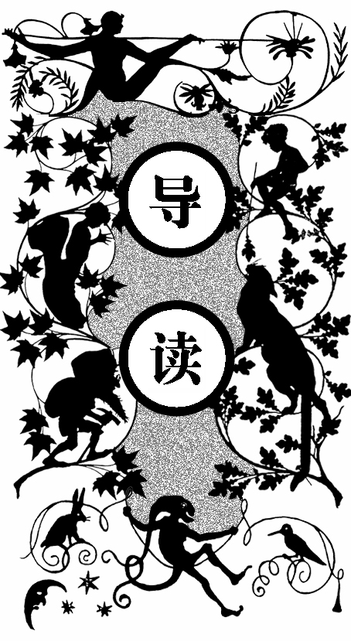
一天，詹姆斯·史塔尔工程师收到认识多年的前任工头西蒙·福特的信，让他次日到阿帕福伊尔煤矿多查特煤仓的耶鲁矿井，届时会告诉他一件他感兴趣的事。西蒙·福特的儿子哈利·福特将在码头等詹姆斯，并请他对邀请保密。
今年五十五岁的詹姆斯·史塔尔看上去只有 四十岁左右，他的业绩为同业工会带来了荣誉。他是苏格兰考古学家协会的主席，经常在《爱丁堡印 象》杂志发表署名文章，他还是一位实践家。
英国人给他们那辽阔的煤田起名为“黑印度”，这些煤田曾为英国创造了惊人的财富，并为王国做出了巨大的贡献。现在一些煤矿已经报废，阿帕福伊尔煤矿就是其中之一。十年前，这个矿报废后，拆除了所有设备，只留下一个长长的木梯能够下到耶鲁井里。
当年，詹姆斯·史塔尔和几千名矿工告别。当人群离开之后，工头西蒙·福特还留在那里，旁边站着他的儿子——一个十五岁的小伙子。
十年后，詹姆斯·史塔尔收到了西蒙·福特的信，邀请他立刻回到阿帕福伊尔煤矿。信上提到的那件使他感兴趣的事是什么呢？他猜不出来，是老头又发现了新矿脉？他想不会的。詹姆斯·史塔尔决定接受这个邀请。
但在接近晚上六点时，第三次邮班又送来了一封信。信纸是从笔记 本上撕下来的，纸已发黄，并且没有署名。只是告诉工程师去也没用，西蒙·福特的信已经失去了目标。

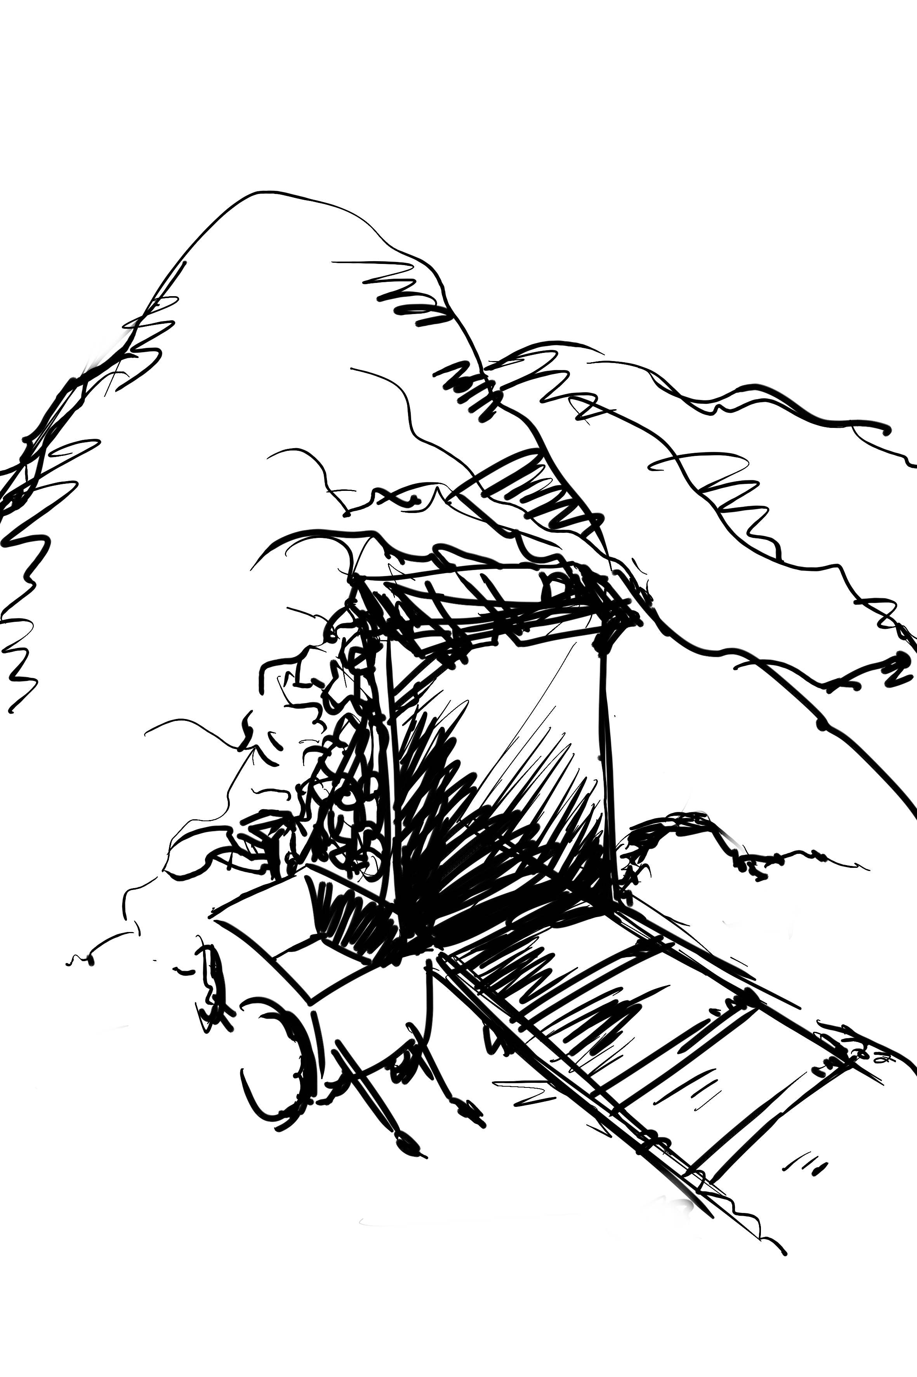

o Mr. J. R. Starr, Engineer, 30 Canongate, Edinburgh.
“T
“If Mr. James Starr will come tomorrow to the Aberfoyle coal-mines, Dochart pit, Yarrow shaft, a communication of an interesting nature will be made to him.
“Mr. James Starr will be awaited for, the whole day, at the Callander station, by Harry Ford, son of the old overman Simon Ford.
“He is requested to keep this invitation secret.”
Such was the letter which James Starr received by the first post, on the 3rd December, 18-, the letter bearing the Aberfoyle postmark, county of Stirling, Scotland.
The engineer’s curiosity was excited to the highest pitch. It never occurred to him to doubt whether this letter might not be a hoax. For many years he had known Simon Ford, one of the former foremen of the Aberfoyle mines, of which he, James Starr, had for twenty years, been the manager, or, as he would be termed in English coal-mines, the viewer. James Starr was a strongly-constituted-man, on whom his fifty-five years weighed no more heavily than if they had been forty. He belonged to an old Edinburgh family, and was one of its most distinguished members. His labors did credit to the body of engineers who are gradually devouring the carboniferous subsoil of the United Kingdom, as much at Cardiff and Newcastle, as in the southern counties of Scotland. However, it was more particularly in the depths of the mysterious mines of Aberfoyle, which border on the Alloa mines and occupy part of the county of Stirling, that the name of Starr had acquired the greatest renown. There, the greater part of his existence had been passed. Besides this, James Starr belonged to the Scottish Antiquarian Society, of which he had been made president. He was also included amongst the most active members of the Royal Institution; and the《Edinburgh Review》frequently published clever articles signed by him. He was in fact one of those practical men to whom is due the prosperity of England. He held a high rank in the old capital of Scotland, which not only from a physical but also from a moral point of view, well deserves the name of the Northern Athens.
We know that the English have given to their vast extent of coal-mines a very significant name. They very justly call them the “Black Indies,” and these Indies have contributed perhaps even more than the Eastern Indies to swell the surprising wealth of the United Kingdom.
At this period, the limit of time assigned by professional men for the exhaustion of coalmines was far distant and there was no dread of scarcity. There were still extensive mines to be worked in the two Americas. The manu-factories, appropriated to so many different uses, locomotives, steamers, gas works, &c. , were not likely to fail for want of the mineral fuel; but the consumption had so increased during the last few years, that certain beds had been exhausted even to their smallest veins. Now deserted, these mines perforated the ground with their useless shafts and forsaken galleries. This was exactly the case with the pits of Aberfoyle.
Ten years before, the last butty had raised the last ton of coal from this colliery. The underground working stock, traction engines, trucks which run on rails along the galleries, subterranean tramways, frames to support the shaft, pipes – in short, all that constituted the machinery of a mine had been brought up from its depths. The exhausted mine was like the body of a huge fantastically-shaped mastodon, from which all the organs of life have been taken, and only the skeleton remains.
Nothing was left but long wooden ladders, down the Yarrow shaft-the only one which now gave access to the lower galleries of the Dochart pit. Above ground, the sheds, formerly sheltering the outside works, still marked the spot where the shaft of that pit had been sunk, it being now abandoned, as were the other pits, of which the whole constituted the mines of Aberfoyle.
It was a sad day, when for the last time the workmen quitted the mine, in which they had lived for so many years. The engineer, James Starr, had collected the hundreds of workmen which composed the active and courageous population of the mine. Overmen, brakemen, putters, wastemen, barrowmen, masons, smiths, carpenters, outside and inside laborers, women, children, and old men, all were collected in the great yard of the Dochart pit, formerly heaped with coal from the mine.
Many of these families had existed for generations in the mine of old Aberfoyle; they were now driven to seek the means of subsistence elsewhere, and they waited sadly to bid farewell to the engineer.
James Starr stood upright, at the door of the vast shed in which he had for so many years superintended the powerful machines of the shaft. Simon Ford, the foreman of the Dochart pit, then fifty-five years of age, and other managers and overseers, surrounded him. James Starr took off his hat. The miners, cap in hand, kept a profound silence. This farewell scene was of a touching character, not wanting in grandeur.
“My friends,” said the engineer, “the time has come for us to separate. The Aberfoyle mines, which for so many years have united us in a common work, are now exhausted. All our researches have not led to the discovery of a new vein, and the last block of coal has just been extracted from the Dochart pit.” And in confirmation of his words, James Starr pointed to a lump of coal which had been kept at the bottom of a basket.
“This piece of coal, my friends,” resumed James Starr, “is like the last drop of blood which has flowed through the veins of the mine! We shall keep it, as the first fragment of coal is kept, which was extracted a hundred and fifty years ago from the bearings of Aberfoyle. Between these two pieces, how many generations of workmen have succeeded each other in our pits! Now, it is over! The last words which your engineer will address to you are a farewell. You have lived in this mine, which your hands have emptied. The work has been hard, but not without profit for you. Our great family must disperse, and it is not probable that the future will ever again unite the scattered members. But do not forget that we have lived together for a long time, and that it will be the duty of the miners of Aberfoyle to help each other. Your old masters will not forget you either.
When men have worked together, they must never be stranger to each other again.
We shall keep our eye on you, and wherever you go, our recommendations shall follow you. Farewell then, my friends, and may Heaven be with you!”
So saying, James Starr wrung the horny hand of the oldest miner, whose eyes were dim with tears. Then the overmen of the different pits came forward to shake hands with him, whilst the miners waved their caps, shouting, “Farewell, James Starr, our master and our friend!”
This farewell would leave a lasting remembrance in all these honest hearts. Slowly and sadly the population quitted the yard. The black soil of the roads leading to the Dochart pit resounded for the last time to the tread of miners’feet, and silence succeeded to the bastling life which had till then filled the Aberfoyle mines.
One man alone remained by James Starr. This was the overman, Simon Ford. Near him stood a boy, about fifteen years of age, who for some years already had been employed down below.
James Starr and Simon Ford knew and esteemed each other well. “Good-by, Simon,”said the engineer.
“Good-by, Mr. Starr,” replied the overman, “let me add, till we meet again!”
“Yes, till we meet again. Ford!” answered James Starr. “You know that I shall be always glad to see you, and talk over old times.”
“I know that, Mr. Starr.”
“My house in Edinburgh is always open to you.”
“It’s a long way off, is Edinburgh!” answered the man shaking his head. “Ay, a long way from the Dochart pit.”
“Along way, Simon? Where do you mean to live?”
“Even here, Mr. Starr! We’re not going to leave the mine, our good old nurse, just because her milk is dried up! My wife, my boy, and myself, we mean to remain faithful to her!”
“Good-by then, Simon,” replied the engineer, whose voice, in spite of himself, betrayed some emotion.
“No, I tell you, it’s till we meet again, Mr. Starr, and not Just ‘good-by,’ ” returned the foreman. “Mark my words, Aberfoyle will see you again!”
The engineer did not try to dispel the man’s illusion. He patted Harry’s head, again wrung the father’s hand, and left the mine.
All this had taken place ten years ago; but, notwithstanding the wish which the overman had expressed to see him again, during that time Starr had heard nothing of him. It was after ten years of separation that he got this letter from Simon Ford, requesting him to take without delay the road to the old Aberfoyle colliery.
A communication of an interesting nature, what could it be? Dochart pit. Yarrow shaft! What recollections of the past these names brought back to him! Yes, that was a fine time, that of work, of struggle,—the best part of the engineer’s life. Starr re-read his letter. He pondered over it in all its bearings. He much regretted that just a line more had not been added by Ford. He wished he had not been quite so laconic.
Was it possible that the old foreman had discovered some new vein? No! Starr remembered with what minute care the mines had been explored before the definite cessation of the works. He had himself proceeded to the lowest soundings without finding the least trace in the soil, burrowed in every direction. They had even attempted to find coal under strata which are usually below it, such as the Devonian red sandstone, but without result. James Starr had therefore abandoned the mine with the absolute conviction that it did not contain another bit of coal.
“No,” he repeated, “no! How is it possible that anything which could have escaped my researches, should be revealed to those of Simon Ford. However, the old overman must well know that such a discovery would be the one thing in the world to interest me, and this invitation, which I must keep secret, to repair to the Dochart pit!” James Starr always came back to that.
On the other hand, the engineer knew Ford to be a clever miner, peculiarly endowed with the instinct of his trade. He had not seen him since the time when the Aberfoyle colliery was abandoned, and did not know either what he was doing or where he was living, with his wife and his son. All that he now knew was, that a rendezvous had been appointed him at the Yarrow shaft, and that Harry, Simon Ford’s son, was to wait for him during the whole of the next day at the Callander station.
“I shall go, I shall go!” said Starr, his excitement increasing as the time drew near.
Our worthy engineer belonged to that class of men whose brain is always on the boil, like a kettle on a hot fire. In some of these brain kettles the ideas bubble over, in others they just simmer quietly. Now on this day, James Starr’s ideas were boiling fast.
But suddenly an unexpected incident occurred. This was the drop of cold water, which in a moment was to condense all the vapors of the brain. About six in the evening, by the third post, Starr’s servant brought him a second letter. This letter was enclosed in a coarse envelope, and evidently directed by a hand unaccustomed to the use of a pen. James Starr tore it open. It contained only a scrap of paper, yellowed by time, and apparently torn out of an old copy book.
On this paper was written a single sentence, thus worded:
“It is useless for the engineer James Starr to trouble himself, Simon Ford’s letter being now without object.”
No signature.

