第一部分 复 活
PART I Recalled to Life

第一章 时 代
Chapter 1 The Period
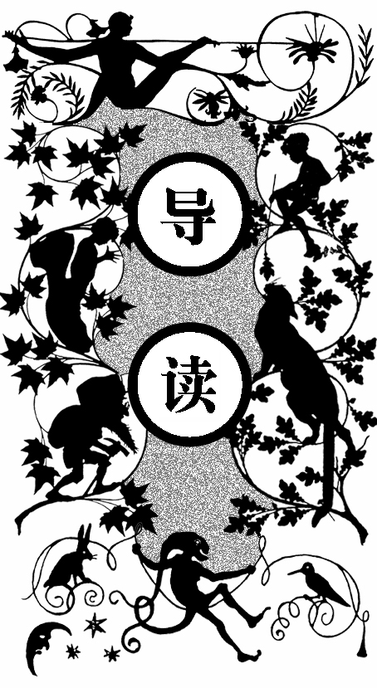
那是一个复杂的时代，有着人们向往的美好，有着最讨厌的丑恶，那是耶稣诞生的第一千七百七十五年。法兰西的整个社会正在逐步下滑，残酷的刑罚、麻木的人性充斥着整个社会；英格兰社会充满无处不在的混乱，商人变为强盗，抢劫、杀人肆无忌惮，连伦敦市的市长也被歹徒当众剥了个精光。大家以暴制暴，每天各种各样的罪犯遭到处置，无论罪行大小，有时候得到的都是同样严厉的惩罚。这样的事件层出不穷地发生着，普通老百姓在这样的社会里依然保持着自己的正常生活。

T WAS THE BEST OF TIMES, it was the worst of times, it was the age of wisdom, it was the age of foolishness, it was the epoch of belief, it was the epoch of incredulity, it was the season of Light, it was the season of Darkness, it was the spring of hope, it was the winter of despair, we had everything before us, we had nothing before us, we were all going direct to Heaven, we were all going direct the other way—in short, the period was so far like the present period, that some of its noisiest authorities insisted on its being received, for good or for evil, in the superlative degree of comparison only.
I
There were a king with a large jaw and a queen with a plain face, on the throne of England; there were a king with a large jaw and a queen with a fair face, on the throne of France. In both countries it was clearer than crystal to the lords of the State preserves of loaves and fishes, that things in general were settled for ever.
It was the year of Our Lord one thousand seven hundred and seventy-five. Spiritual revelations were conceded to England at that favoured period, as at this. Mrs Southcott had recently attained her five-and-twentieth blessed birthday of whom a prophetic private in the Life Guards had heralded the sublime appearance by announcing that arrangements were made for the swallowing up of London and Westminster. Even the Cock-lane ghost had been laid only a round dozen of years, after rapping out its messages, as the spirits of this very year last past (supernaturally deficient in originality) rapped out theirs. Mere messages in the earthly order of events had lately come to the English Crown and People, from a congress of British subjects in America: which, strange to relate, have proved more important to the human race than any communications yet received through any of the chickens of the Cock-lane brood.
France, less favoured on the whole as to matters spiritual than her sister of the shield and trident, rolled with exceeding smoothness down hill, making paper money and spending it. Under the guidance of her Christian pastors, she entertained herself, besides, with such humane achievements as sentencing a youth to have his hands cut off, his tongue torn out with pincers, and his body burned alive, because he had not kneeled down in the rain to do honour to a dirty procession of monks which passed within his view, at a distance of some fifty or sixty yards. It is likely enough that, rooted in the woods of France and Norway, there were growing trees, when that sufferer was put to death, already marked by the Woodman, Fate, to come down and be sawn into boards, to make a certain movable framework with a sack and a knife in it, terrible in history. It is likely enough that in the rough outhouses old some tillers of the heavy lands adjacent to Paris, there were sheltered from the weather that very day, rude carts, bespattered with rustic mire, snuffed about by pigs, and roosted in by poultry, which the Farmer, Death, had already set apart to be his tumbrils of the Revolution. But that Woodman and that Farmer, though they work unceasingly, work silently, and no one heard them as they went about with muffled tread: the rather, forasmuch as to entertain any suspicion that they were awake, was to be atheistical and traitorous.
In England, there was scarcely an amount of order and protection to justify much national boasting. Daring burglaries by armed men, and highway robberies, took place in the capital itself every night; families were publicly cautioned not to go out of town without removing their furniture to upholsterers’ warehouses for security; the highwayman in the dark was a City tradesman in the light, and, being recognised and challenged by his fellow- tradesman whom he stopped in his character of ‘the Captain’, gallantly shot him through the head and rode away; the mail was waylaid by seven robbers, and the guard shot three dead, and then got shot dead himself by the other four, ‘in consequence of the failure of his ammunition’: after which the mail was robbed in peace; that magnificent potentate, the Lord Mayor of London, was made to stand and deliver on Turnham Green, by one highwayman, who despoiled the illustrious creature in sight of all his retinue; prisoners in London gaols fought battles with their turnkeys, and the majesty of the law fired blunderbusses in among them, loaded with rounds of shot and ball; thieves snipped off diamond crosses from the necks of noble lords at Court drawing-rooms; musketeers went into St Giles’s, to search for contraband goods, and the mob fired on the musketeers, and the musketeers fired on the mob, and nobody thought any of these occurrences much out of the common was. In the midst of them, the hangman, ever busy and ever worse than useless, was in constant requisition; now, stringing up long rows of miscellaneous criminals; now, hanging a housebreaker on Saturday who had been taken on Tuesday; now, burning people in the hand at Newgate by the dozen, and now burning pamphlets at the door of Westminster Hall; today, taking the life of an atrocious murderer, and tomorrow of a wretched pilferer who had robbed a farmer’s boy of sixpence.

All these things, and a thousand like them, came to pass in and close upon the dear old year one thousand seven hundred and seventy-five. Environed by them, while the Woodman and the Farmer worked unheeded, those two of the large jaws, and those other two of the plain and the fair faces, trod with stir enough, and carried their divine rights with a high hand. Thus did the year one thousand seven hundred and seventy-five conduct their Greatnesses, and myriads of small creatures—the creatures of this chronicle among the rest— along the roads that lay before them.

第二章 邮 车
Chapter 2 The Mail
多佛大道将带领着我们见到第一位历史相关人物。这位人物正随着邮车一起上山，马车几次都差点倒退下去，痛苦地努力坚持着。四周弥漫着冰冷的空气，浓雾遮住了前行的道路，地面泥泞不堪，老马身上发出的臭气似乎也沾满了每个人身上。连同这位人物一起有三个人在邮车旁艰难地行走着，他们都把自己包裹得只剩下眼睛，让别人无法分辨出容貌。这里的人们对彼此从不轻易用心交谈，因为谁都有可能和强盗相勾结，在邮车后箱里放着装好子弹的手枪以防万一。马在鞭子的抽打下用力地挣扎着往上拉，最后终于到达了坡顶。
马停下来休息，赶车人看到远处一匹马快跑过来，他提醒人们注意，并且准备好手枪。周围瞬间显得异常安静，连心跳声似乎都能听到。当骑着马的人快要接近时，卫兵警告他立刻停止；那位骑士要求见贾维斯·罗瑞先生，这就是先前提到的那位人物。骑士似乎叫杰瑞，卫兵还是不太放心他，在小心的防范下骑士来到罗瑞先生身边，交给他一封信；罗瑞看完信，要求杰瑞帮忙传话——“死人复活了”。杰瑞带着奇怪的回答离开了，邮车再次重新上路。

T WAS THE DOVER ROAD THAT LAY, on a Friday night late in November, before the first of the persons with whom this history has business. The Dover road lay, as to him, beyond the Dover mail, as it lumbered up Shooter’s Hill. He walked uphill in the mire by the side of the mail, as the rest of the passengers did; not because they had the least relish for walking exercise, under the circumstances, but because the hill, and the harness, and the mud, and the mail, were all so heavy, that the horses had three times already come to a stop, beside once drawing the coach across the road, with the mutinous intent of taking it back to Blackheath. Reins and whip and coachman and guard, however, in combination, had read that article of war which forbad a purpose otherwise strongly in favour of the argument, that some brute animals are endued with Reason; and the team had capitulated and returned to their duty.
I
With drooping heads and tremulous tails, they mashed their way through the thick mud, floundering and stumbling between whiles, as if they were falling to pieces at the large joints. As often as the driver rested them and brought them to a stand, with a wary ‘Wo-ho! so-ho then!’ the near leader violently shook his head and everything upon it—like an unusually emphatic horse, denying that the coach could be got up the hill. Whenever the leader made this rattle, the passenger started, as a nervous passenger might, and was disturbed in mind.
There was a steaming mist in all the hollows, and it had roamed in its forlornness up the hill, like an evil spirit, seeking rest and finding none. A clammy and intensely cold mist, it made its slow way through the air in ripples that visibly followed and overspread one another, as the waves of an unwholesome sea might do. It was dense enough to shut out everything from the light of the coachlamps but these its own workings and a few yards of road; and the reek of the labouring horse steamed into it, as if they had made it all.
Two other passengers, besides the one, were plodding up the hill by the side of the mail. All three were wrapped to the cheek-bones and over the ears, and wore jackboots. Not one of the three could have said, from anything he saw, what either of the other two was like; and each was hidden under almost as many wrappers from the eyes of the mind, as from the eyes of the body, of his two companions. In those days, travellers were very shy of being confidential on short notice, for anybody on the road might be a robber or in league with robbers. As to the latter, when every posting-house and ale-house could produce somebody in ‘the Captain’s’ pay, ranging from the landlord to the lowest stable nondescript, it was the likeliest thing upon the cards. So the guard of the Dover mail thought to himself, that Friday night in November, one thousand seven hundred and seventy-five, lumbering up Shooter’s Hill, as he stood on his own particular perch behind the mail, beating his feet, and keeping an eye and a hand on the arm-chest before him, where a loaded blunderbuss lay at the top of six or eight loaded horse-pistols, deposited on a substratum of cutlasses.
The Dover mail was in its usual genial position that the guard suspected the passengers, the passengers suspected one another and the guard, they all suspected everybody else, and the coachman was sure of nothing but the horses; as to which cattle he could with a clear conscience have taken his oath on the two Testaments that they were not fit for the journey.
‘Wo-ho!’ said the coachman. ‘So, then! One more pull and you’re at the top and be damned to you, for I have had trouble enough to get you to it!—Joe!’
‘Halloa!’ the guard replied.
‘What o’clock do you make it, Joe?’
‘Ten minutes, good, past eleven.’
‘My blood!’ ejaculated the vexed coachman, ‘and not atop of Shooter’s yet! Tst! Yah! Get on with you!’
The emphatic horse, cut short by the whip in a most decided negative, made a decided scramble for it, and the three other horses followed suit. Once more, the Dover mail struggled on, with the jackboots of its passengers squashing along by its side. They had stopped when the coach stopped, and they kept close company with it. If any one of the three had had the hardihood to propose to another to walk on a little ahead into the mist and darkness, he would have put himself in a fair way of getting shot instantly as a highwayman.
The last burst carried the mail to the summit of the hill. The horses stopped to breathe again, and the guard got down to skid the wheel for the descent, and open the coach-door to let the passengers in.
‘Tst! Joe!’ cried the coachman in a warning voice, looking down from his box.
‘What do you say, Tom?’
They both listened.
‘I say a horse at a canter coming up, Joe.’
‘I say a horse at a gallop, Tom,’ returned the guard, leaving his hold of the door, and mounting nimbly to his place. ‘Gentlemen! In the king’s name, all of you!’
With this hurried adjuration, he cocked his blunderbuss, and stood on the offensive.
The passenger booked by this history’ was on the coachstep, getting in; the two other passengers were close behind him, and about to follow. He remained on the step, half in the coach and half out of it; they remained in the road below him. They all looked from the coachman to the guard, and from the guard to the coachman, and listened. The coachman looked back and the guard looked back, and even the emphatic leader pricked up his ears and looked back, without contradicting.
The stillness consequent on the cessation of the rumbling and labouring of the coach, added to the stillness of the night, made it very quiet indeed. The panting of the horses communicated a tremulous motion to the coach, as if it were in a state of agitation. The hearts of the passengers beat loud enough perhaps to be heard; but at any rate, the quiet pause was audibly expressive of people out of breath, and holding the breath, and having the pulses quickened by expectation.
The sound of a horse at a gallop came fast and furiously up the hill.
‘So-ho!’ the guard sang out, as loud as he could roar. ‘Yo there! Stand! I shall fire!’
The pace was suddenly checked, and, with much splashing and floundering, a man’s voice called from the mist, ‘Is that the Dover mail?’
‘Never you mind what it is!’ the guard retorted. ‘What are you?’
‘Is that the Dover mail?’
‘Why do you want to know?’
‘I want a passenger, if it is.’
‘What passenger?’
‘Mr Jarvis Lorry.’
Our booked passenger showed in a moment that it was his name. The guard, the coachman, and the two other passengers eyed him distrustfully.
‘Keep where you are,’ the guard called to the voice in the mist, ‘because, if I should make a mistake, it could never be set right in your lifetime. Gentleman of the name of Lorry answer straight.’
‘What is the matter?’ asked the passenger, then, with mildly quavering speech. ‘Who wants me? Is it Jerry?’
(‘I don’t like Jerry’s voice, if it is Jerry,’ growled the guard to himself. ‘He’s hoarser than suits me, is Jerry.’)
‘Yes, Mr. Lorry.’
‘What is the matter?’
‘A despatch sent after you from over yonder. T. and Co.’
‘I know this messenger, guard,’ said Mr Lorry, getting down into the road — assisted from behind more swiftly than politely by the other two passengers, who immediately scrambled into the coach, shut the door, and pulled up the window. ‘He may come close; there’s nothing wrong.’
‘I hope there ain’t, but I can’t make so, Nation sure of that,’ said the guard, in gruff soliloquy. ‘Hallo you!’
‘Well! And hallo you!’ said Jerry, more hoarsely than before.
‘Come on at a footpace! d’ye mind me? And if you’ve got holsters to that saddle o’ yourn, don’t let me see your hand go nigh’ em. For I’m a devil at a quick mistake, and when I make one it takes the form of Lead. So now let’s look at you.’
The figures of a horse and rider came slowly through the eddying mist, and came to the side of the mail, where the passenger stood. The rider stooped, and, casting up his eyes at the guard, handed the passenger a small folded paper. The rider’s horse was blown, and both horse and rider were covered with mud, from the hoofs of the horse to the hat of the man.
‘Guard!’ said the passenger, in a tone of quiet business confidence.
The watchful guard, with his right hand at the stock of his raised blunderbuss, his left at the barrel, and his eye on the horseman, answered curtly, ‘Sir.’
‘There is nothing to apprehend. I belong to Tellson’s Bank. You must know Tellson’s Bank in London. I am going to Paris on business. A crown to drink. I may read this?’
‘If so be as you’re quick, sir.’
He opened it in the light of the coach-lamp on that side, and read—first to himself and then aloud: ‘ “Wait at Dover for Mam’selle.” It’s not long, you see, guard. Jerry, say that my answer was, RECALLED TO LIFE.’
Jerry started in his saddle. ‘That’s a Blazing strange answer, too,’ said he, at his hoarsest.
‘Take that message back, and they will know that I received this, as well as if I wrote. Make the best of your way. Good night.’
With those words the passenger opened the coachdoor and got in; not at all assisted by his fellow-passengers, who had expeditiously secreted their watches and purses in their boots, and were now making a general pretence of being asleep. With no more definite purpose than to escape the hazard of originating any other kind of action.
The coach lumbered on again, with heavier wreaths of mist closing round it as it began the descent. The guard soon replaced his blunderbuss in his arm-chest, and, having looked to the rest of its contents, and having looked to the supplementary pistols that he wore in his belt, looked to a smaller chest beneath his seat, in which there were a few smith’s tools, a couple of torches, and a tinder-box. For he was furnished with that completeness that if the coach-lamps had been blown and stormed out, which did occasionally happen, he had only to shut himself up inside, keep the flint and steel sparks well off the straw, and get a light with tolerable safety and ease (if he were lucky) in five minutes.
‘Tom!’ softly over the coach-roof.
‘Hallo, Joe.’
‘Did you hear the message?’
‘I did, Joe.’
‘What did you make of it, Tom?’
‘Nothing at all, Joe.’
‘That’s a coincidence, too,’ the guard mused, ‘for I made the same of it myself.’
Jerry, left alone in the mist and darkness, dismounted meanwhile, not only to ease his spent horse, but to wipe the mud from his face, and shake the wet out of his hatbrim, which might be capable of holding about half a gallon. After standing with the bridle over his heavilysplashed arm, until the wheels of the mail were no longer within hearing and the night was quite still again, he turned to walk down the hill.

‘After that there gallop from Temple Bar, old lad, I won’t trust your fore-legs till I get you on the level,’ said this hoarse messenger, glancing at his mare. ‘“Recalled to life.” That’s a Blazing strange message. Much of that wouldn’t do for you Jerry! I say, Jerry! You’d be in a Blazing bad way, if recalling to life was to come into fashion, Jerry!’

第三章 夜 影
Chapter 3 The Night Shadows
每个人都有属于自己的那份别人无法理解的神秘。在这样的社会中，到了夜晚，一座座鬼魅的房屋、一个个神秘的人物，都充满了别人无法理解的秘密。无论是身份低微的马夫或是地位尊贵的国王首相，彼此总是难以猜测。
一位信使悠闲地在路上行走着，他戴着帽子，用条大围巾裹住了自己的下巴，他听到了杰瑞带回来的消息，很不明白这条“死人复活了”的消息到底意味着什么。他还要把这条消息转告给台尔森银行的高层。在这样的夜晚，有一张苍白的面孔总是出现在罗瑞先生的脑海中，多少次的询问都是得到相同的回答：这位老人被埋了十八年，早已放弃了活着出来的希望，除了在是否想见女儿这个问题上他总是捉摸不定之外。

WONDERFUL FACT to reflect upon, that every human creature is constituted to be that profound secret and mystery to every other. A solemn consideration, when I enter a great city by night, that every one of those darkly clustered houses encloses its own secret; that every room in every one of them encloses its own secret; that every beating heart in the hundreds of thousands of breasts there, is, if some of its imaginings, a secret to the heart nearest it! Something of the awfulness, even of Death itself, is referable to this. No more can I turn the leaves of this dear book that I loved, and vainly hope in time to read it all. No more can I look into the depths of this unfathomable water, wherein, as momentary lights glanced into it, I have had glimpses of buried treasure and other things submerged. It was appointed that the book should shut with a spring, for ever and for ever, when I had read but a page. It was appointed that the water should be locked in an eternal frost, when the light was playing on its surface, and I stood in ignorance on the shore. My friend is dead, my neighbour is dead, my love, the darling of my soul, is dead; it is the inexorable consolidation and perpetuation of the secret that was always in that individuality, and which I shall carry in mine to my life’s end. In any of the burial-places of this city through which I pass, is there a sleeper more inscrutable than it busy inhabitants are, in their innermost personally, to me, or than I am to them?
A
As to this, his natural and not to be alienated inheritance, the messenger on horseback had exactly the same possession as the King, the first Minister of State, or the richest merchant in London. So with the three passengers shut up in the narrow compass of one lumbering old mail-coach; the were mysteries to one another, as complete as if each had been in his own coach and six, or his own coach and sixty, with the breadth of a county between him and the next.
The messenger rode back at an easy trot, stopping pretty often at ale-houses by the way to drink, but evincing tendency to keep his own counsel, and to keep his hat cocked over his eyes. He had eyes that assorted very well with that decoration, being of a surface black, with no depth in the colour or form, and much too near together—as if they were afraid of being found out in something, singly, if they kept too far apart. They had a sinister expression, under an old cocked-hat like a three-cornered spittoon, and over a great muffler for the chin and throat, which descended nearly to the wearer’s knees. When he stopped for drink, he moved this muffler with his left hand, only while he poured his liquor in with his right; as soon as that was done, he muffled again.
No, Jerry, no!’ said the messenger, harping on one theme as he rode. ‘It wouldn’t do for you, Jerry. Jerry, you honest tradesman, it wouldn’t suit your line of business! Recalled—! Bust me if I don’t think he’d been a drinking!’
His message perplexed his mind to that degree that he was fain, several times, to take off his hat to scratch his head. Except on the crown, which was raggedly bald, he had stiff, black hair, standing jaggedly all over it, and growing down hill almost to his broad, blunt nose. It was so like smith’s work, so much more like the top of a strongly spiked wall than a head of hair, that the best of players at leap-frog might have declined him, as the most dangerous man in the world to go over.
While he trotted back with the message he was to deliver to the night watchman in his box at the door of Tellson’s Bank, by Temple Bar, who was to deliver it to greater authorities within, the shadows of the night took such shapes to him as arose out of the message, and took such shapes to the mare as arose out of her private topics of uneasiness. They seemed to be numerous, for she shied at every shadow on the road.
What time, the mail-coach lumbered, jolted, rattled, and bumped upon its tedious way, with its three fellow inscrutables inside. To whom, likewise, the shadows of the night revealed themselves, in the forms their dozing eyes and wandering thoughts suggested.
Tellson’s Bank had a run upon it in the mail. As the bank passenger —with an arm drawn through the leathera strap, which did what lay in it to keep him from pounding against the next passenger, and driving him into his corner, whenever the coach got a special jolt—nodded in his place, with half-shut eyes, the little coach-windows, and the coach-lamp dimly gleaming through them, and the bulky bundle of opposite passenger, becanle the bank, and did a grant stroke of business. The rattle of the harness was the chink of money, and more drafts were honoured in five minutes than even Tellson’s, with all its foreign and home connection, ever paid in thrice the time. Then the strong-rooms underground, at Tellson’s, with such of their valuable stores and secrets as were known to the passenger (and it was not a little that he knew about them), opened before him, and he went in among them with the great keys and the feebly-burning candle, and found them safe, and strong, and sound, and still, just as he had last seen them.
But, though the bank was almost always with him, and though the coach (in a confused way, like the presence of pain under an opiate) was always with him, there was another current of impression that never ceased to run, all through the night. He was on his way to dig some one out of a grave.
Now, which of the multitude of faces that showed themselves before him was the true face of the buried person, the shadows of the night did not indicate; but they were all the faces of a man of five-and-forty by years, and they differed principally in the passions they expressed, and in the ghastliness of their worn and wasted state. Pride, contempt, defiance, stubbornness, submission, lamentation, succeeded one another; so did varieties of sunken cheek, cadaverous colour, emaciated hands and figures. But the face was in the main one face, and every head was prematurely white. A hundred times the dozing passenger inquired of this spectre:
‘Buried how long?’
The answer was always the same: ‘Amost eighteen years.’
‘You had abandoned all hope of being dug out?’
‘Long ago.’
‘You know that you are recalled to life?’
‘They tell me so.’
‘I hope you care to live?’
‘I can’t say.’
‘Shall I show her to you? Will you come and see her?’
The answers to this question were various and contradictory. Sometimes the broken reply was, ‘Wait! It would kill me if I saw her too soon.’ Sometimes, it was given in a tender rain of tears, and then it was ‘Take me to her.’ Sometimes it was staring and bewildered, and then it was, ‘I don’t know her. I don’t understand.’
After such imaginary discourse, the passenger in his fancy would dig, and dig, dig—now, with a spade, now with a great key, now with his hands—to dig this wretched creature out. Got out at last, with earth hanging about his face and hair, he would suddenly fall away to dust. The passenger would then start to himself and lower the window, to get the reality of mist and rain on his cheek.
Yet even when his eyes were opened on the mist and rain, on the moving patch of light from the lamps, and the hedge at the roadside retreating by jerks, the night shadows outside the coach would fall into the train of the night shadows within. The real Banking-house by Temple Bar, the real business of the past day, the real strong-rooms, the real express sent after him, and the real message returned, would all be there. Out of the midst of them, the ghostly face would rise, and he would accost it again.
‘Buried how long?’
‘Almost eighteen years.’
‘I hope you care to live?’
‘I can’t say.’
Dig—dig—dig—until an impatient movement from one of the two passengers would admonish him to pull up the window, draw his arm securely through the leathern strap, and speculate upon the two slumbering forms, until his mind lost its hold of them, and they again slid away into the bank and the grave.
‘Buried how long?’
‘Almost eighteen years.’
‘You had abandoned all hope of being dug out?’
‘Long ago.’
The words were still in his hearing as just spoken—distinctly in his hearing as ever spoken words had been in his life—when the weary passenger started to the consciousness of daylight, and found that the shadows of the night were gone.
He lowered the window, and looked out at the rising sun. There was a ridge of ploughed land, with a plough upon it where it had been left last night when the horses were unyoked; beyond, a quiet coppice-wood, in which many leaves of burning red and golden yellow still remained upon the trees. Though the earth was cold and wet, the sky was clear, and the sun rose bright, placid, and beautiful.

‘Eighteen years!’ said the passenger, looking at the sun. ‘Gracious Creator of day! To be buried alive for eighteer years!’

第四章 准 备
Chapter 4 The Preparation
罗瑞先生跟随着邮车来到了多佛，他来到乔治王旅馆，像往常一样订了房间和理发匠。罗瑞先生在咖啡馆中等待着早餐，他穿着质地上乘的褐色长袜、白衬衫，头戴假发，看上去红光满面，但还是带着忧虑的神色。可能是长期身为台尔森银行的秘密业务处理人员，问题为别人忧患而造成的。等到早餐送来的时候，他吩咐仆人再准备一位小姐的 住宿。
早餐过后，罗瑞先生独自走到海滩上。这里到处弥漫着鱼腥味，一些渔船漂浮在海面上，周围散步的人还不少。黄昏时候，罗瑞先生从外面回来，他一直等待的马奈特小姐已经从伦敦到达。马奈特小姐急于要和他见面，她神色非常迷惘困惑；罗瑞先生还记得当时抱在怀里的小女孩，现在已经成了一位亭亭玉立的漂亮小姐了。在马奈特小姐的急切询问下，罗瑞先生提醒她要做好心理准备，他说明自己只是在执行一项业务工作，是一个客户的事情。他开始讲述了这个客户的事情：二十年前是他主持了这个客户的婚礼，这个家庭的全部事务都交给了台尔森银行；他在讲这个故事的途中一再强调自己只是业务员，是一部机器，没有任何私人情感。马奈特小姐觉得这是在讲述她父母亲的事情。当听到罗瑞先生说到她父亲仍然活着的消息时，她显然吓了一跳。在她的坚持下，罗瑞先生告诉她马奈特医生已经被找到，但是由于多年来的关押，差不多已经成为废人，并且忘记了以前的一切事情。目前正住在以前的一个仆人家。罗瑞先生表示现在想带着马奈特小姐前往看望她的父亲，希望她能够恢复马奈特医生的活力和希望，重要的是能够将他带

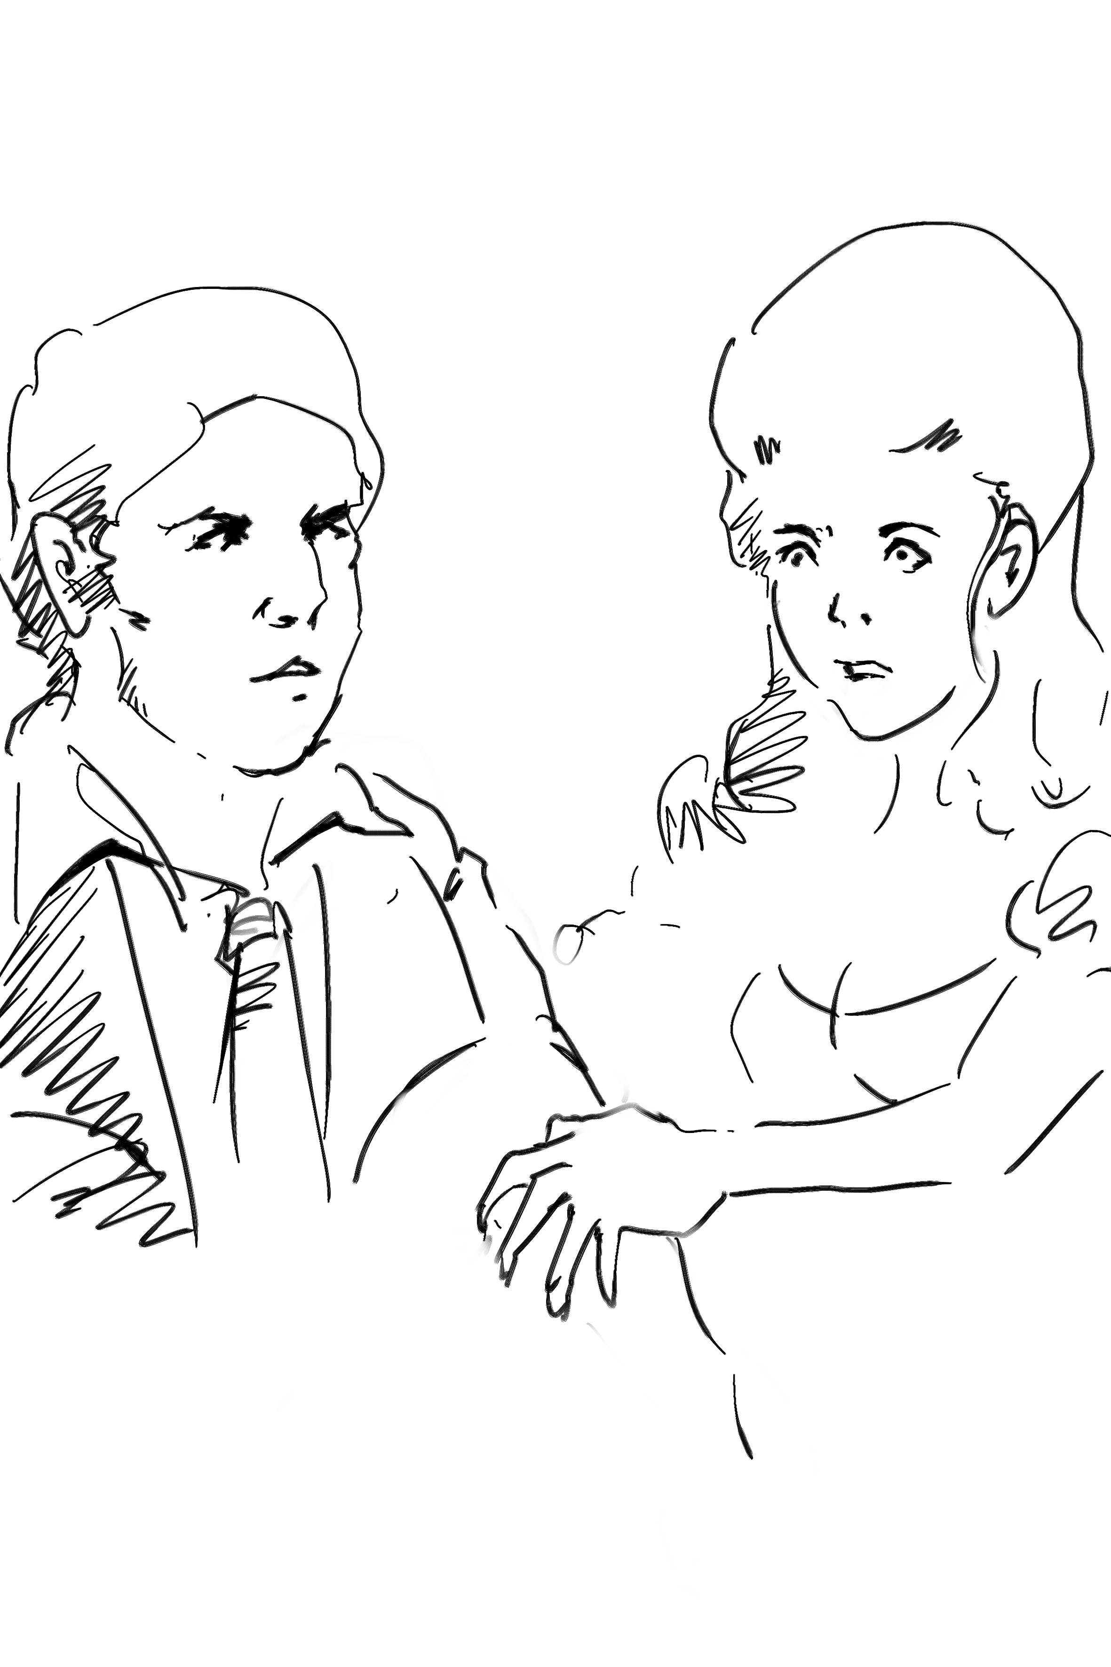

出法国。马奈特小姐被这一切震住了，她紧抓着罗瑞先生的手不肯放开，整个人没有任何表情，罗瑞先生只得大叫仆人来帮忙。
马奈特小姐的仆人全身都是红色，连头发都不例外。她愤怒地将罗瑞先生推到墙上，大声地叫人拿东西过来。面对小姐却异常温柔，很体贴地照顾着，罗瑞先生在旁边很尴尬，赶紧退到了一边。

HEN THE MAIL got successfully to Dover, in the course of the forenoon, the head drawer at the Royal George Hotel opened the coachdoor as his custom was. He did it with some flourish of ceremony, for a mail journey from London in winter was an achievement to congratulate an adventurous traveler upon.
W
By that time, there was only one adventurous traveller left to be congratulated; for the two others had been set down at their respective roadside destinations. The mildewy inside of the coach, with its damp and dirty straw, its disagreeable smell, and its obscurity, was rather like a larger dog-kennel. Mr Lorry, the passenger, shaking himself out of it in chains of straw, a tangle of shaggy wrapper, flapping hat, and muddy legs, was rather like a larger sort of dog.
‘There will be a packet to Calais, tomorrow, drawer?’
‘Yes, sir, if the weather holds and the wind sets tolerable fair. The tide will serve pretty nicely at about two in the afternoon, sir. Bed, sir?’
‘I shall not go to bed till night; but I want a bedroom, and a barber.’
‘And then breakfast, sir? Yes, sir. That way, sir, if you please. Show Concord! Gentleman’s valise and hot water to Concord. Pull off gentleman’s boots in Concord. (You will find a fine sea-coal fire, sir. ) Fetch barber to Concord. Stir about there, now, for Concord!’
The Concord bed-chamber being always assigned to passenger by the mail, and passengers by the mail being always heavily wrapped up from head to foot, the room had the odd interest for the establishment of the Royal George, that although but one kind of man was seen to go into it, all kinds and varieties of men came out of it. Consequently, another drawer, and two porters, and several maids and the landlady, were all loitering by accident at various points of the

