第 章
1

信息安全与风险管理
该领域包含的问题与下列主题有关：
- 安全管理责任
- 行政、技术和物理控制的区别
- 三大安全原则
- 风险管理与风险分析
- 安全策略
- 数据分类
- 安全意识培训

安全专业人士的责任远不止应对病毒和应对成为媒体头版头条的黑客消息那么简单。从表面上看，他们的日常工作很枯燥，但是却对保护公司免受入侵以避免其成为下一个头版头条至关重要。组织内部安全这一职责很复杂，因为它与每一个员工都息息相关，所以必须在全公司范围内对其进行管理。您要从管理的角度和业务的角度来理解安全问题，而不只是拘泥于技术细节，这无论是对参加CISSP考试还是履行你的本职工作都很重要。

1.1 问题
1. Which of the following best describes the relationship between CobiT and ITIL?
A. CobiT is a model for IT governance, whereas ITIL is a model for corporate governance.
B. CobiT provides a corporate governance roadmap, whereas ITIL is a customizable framework for IT service management.
C. CobiT defines IT goals, whereas ITIL provides the process-level steps on how to achieve them.
D. CobiT provides a framework for achieving business goals, whereas ITIL defines a framework for achieving IT service-level goals.
2. Jane has been charged with ensuring that clients’ personal health information is adequately protected before it is exchanged with a new European partner. What data security requirements must she adhere to?
A. HIPAA
B. NIST SP 800-66
C. Safe Harbor
D. European Union Principles on Privacy
3. Global organizations that transfer data across international boundaries must abide by guidelines and transborder information flow rules developed by an international organization that helps different governments come together and tackle the economic, social, and governance challenges of a globalized economy. What organization is this?
A. Committee of Sponsoring Organizations of the Treadway Commission
B. The Organisation for Economic Co-operation and Development
C. CobiT
D. International Organization for Standardization
4. Steve, a department manager, has been asked to join a committee that is responsible for defining an acceptable level of risk for the organization, reviewing risk assessment and audit reports, and approving significant changes to security policies and programs. What committee is he joining?
A. Security policy committee
B. Audit committee
C. Risk management committee
D. Security steering committee
5. As head of sales, Jim is the information owner for the sales department. Which of the following is not Jim’s responsibility as information owner?
A. Assigning information classifications
B. Dictating how data should be protected
C. Verifying the availability of data
D. Determining how long to retain data
6. Assigning data classification levels can help with all of the following except:
A. The grouping of classified information with hierarchical and restrictive security
B. Ensuring that nonsensitive data is not being protected by unnecessary controls
C. Extracting data from a database
D. Lowering the costs of protecting data
7. Which of the following is not included in a risk assessment?
A. Discontinuing activities that introduce risk
B. Identifying assets
C. Identifying threats
D. Analyzing risk in order of cost or criticality
8. Sue has been tasked with implementing a number of security controls, including antivirus and antispam software, to protect the company’s e-mail system. What type of approach is her company taking to handle the risk posed by the system?
A. Risk mitigation
B. Risk acceptance
C. Risk avoidance
D. Risk transference
9. The integrity of data is not related to which of the following?
A. Unauthorized manipulation or changes to data
B. The modification of data without authorization
C. The intentional or accidental substitution of data
D. The extraction of data to share with unauthorized entities
10. There are several methods an intruder can use to gain access to company assets. Which of the following best describes masquerading?
A. Changing an IP packet’s source address
B. Elevating privileges to gain access
C. An attempt to gain unauthorized access as another user
D. Creating a new authorized user with hacking tools
11. A number of factors should be considered when assigning values to assets. Which of the following is not used to determine the value of an asset?
A. The asset’s value in the external marketplace
B. The level of insurance required to cover the asset
C. The initial and outgoing costs of purchasing, licensing, and supporting the asset
D. The asset’s value to the organization’s production operations
12. Jill is establishing a companywide sales program that will require different user groups with different privileges to access information on a centralized database. How should the security manager secure the database?
A. Increase the database’s security controls and provide more granularity.

B. Implement access controls that display each user’s permissions each time they access the database.
C. Change the database’s classification label to a higher security status.
D. Decrease the security so that all users can access the information as needed.
13. As his company’s CISO, George needs to demonstrate to the Board of Directors the necessity of a strong risk management program. Which of the following should George use to calculate the company’s residual risk?
A. threats × vulnerability × asset value = residual risk
B. SLE × frequency = ALE, which is equal to residual risk
C. (threats × asset value × vulnerability) × control gap = residual risk
D. (total risk – asset value) × countermeasures = residual risk
14. Authorization creep is to access controls what scope creep is to software development. Which of the following is not true of authorization creep?
A. Users have a tendency to request additional permissions without asking for others to be taken away.
B. It is a violation of “least privilege.”
C. It enforces the “need-to-know” concept.
D. It commonly occurs when users transfer to other departments or change positions.
15. For what purpose was the COSO framework developed?
A. To address fraudulent financial activities and reporting
B. To help organizations install, implement, and maintain CobiT controls
C. To serve as a guideline for IT security auditors to use when verifying compliance
D. To address regulatory requirements related to protecting private health information
16. Susan, an attorney, has been hired to fill a new position at Widgets Inc. The position is Chief Privacy Officer (CPO). What is the primary function of her new role?
A. Ensuring the protection of partner data
B. Ensuring the accuracy and protection of company financial information
C. Ensuring that security policies are defined and enforced
D. Ensuring the protection of customer, company, and employee data
17. Jared plays a role in his company’s data classification system. In this role, he must practice due care when accessing data and ensure that the data is used only in accordance with allowed policy while abiding by the rules set for the classification of the data. He does not determine, maintain, or evaluate controls, so what is Jared’s role?
A. Data owner
B. Data custodian
C. Data user
D. Information systems auditor
18. Risk assessment has several different methodologies. Which of the following official risk methodologies was not created for the purpose of analyzing security risks?
A. FAP
B. OCTAVE
C. ANZ 4360
D. NIST SP 800-30
19. Which of the following is not a characteristic of a company with a security governance program in place?
A. Board members are updated quarterly on the company’s state of security.
B. All security activity takes place within the security department.
C. Security products, services, and consultants are deployed in an informed manner.
D. The organization has established metrics and goals for improving security.
20. Michael is charged with developing a classification program for his company. Which of the following should he do first?
A. Understand the different levels of protection that must be provided.
B. Specify data classification criteria.
C. Identify the data custodians.
D. Determine protection mechanisms for each classification level.
21. There are four ways of dealing with risk. In the graphic that follows, which method is missing and what is the purpose of this method?
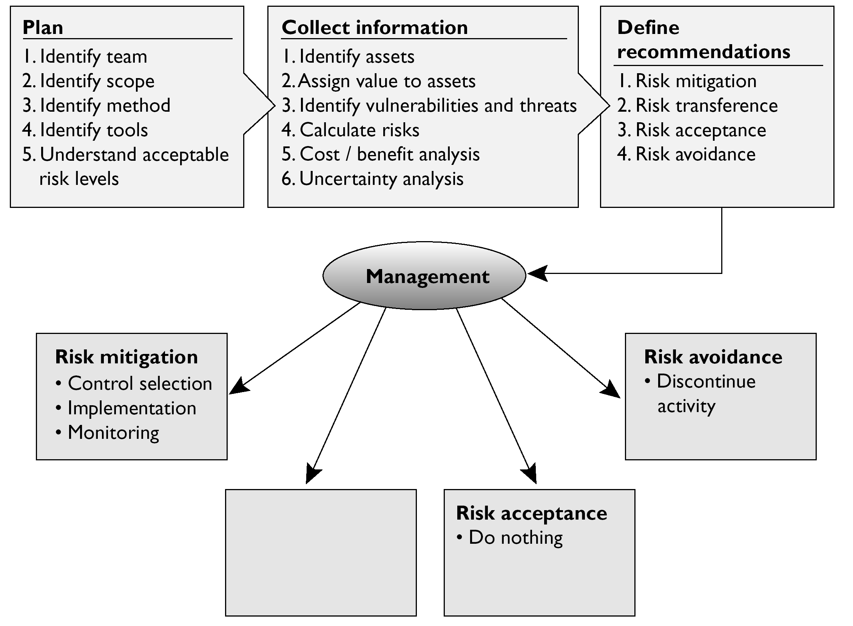
A. Risk transference. Share the risk with other entities.
B. Risk reduction. Reduce the risk to an acceptable level.
C. Risk rejection. Accept the current risk.
D. Risk assignment. Assign risk to a specific owner.
22. The following graphic contains a commonly used risk management scorecard. Identify the proper quadrant and its description.
A. Top-right quadrant is high impact, low probability.
B. Top-left quadrant is high impact, medium probability.
C. Bottom-left quadrant is low impact, high probability.
D. Bottom-right quadrant is low impact, high probability.
23. What are the three types of policies that are missing from the following graphic?
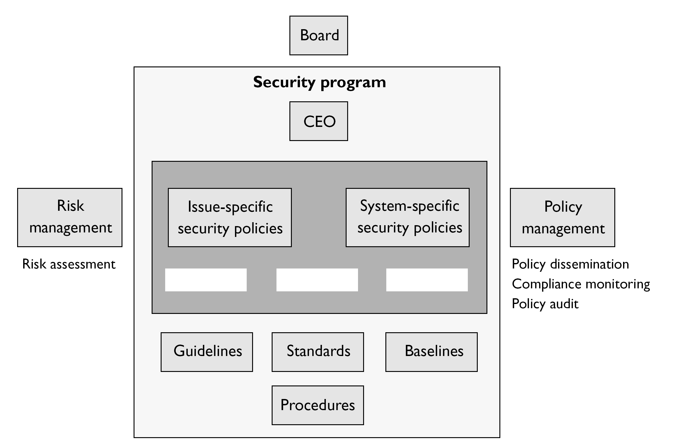
A. Regulatory, Informative, Advisory
B. Regulatory, Mandatory, Advisory
C. Regulatory, Informative, Public
D. Regulatory, Informative, Internal Use
24. List in the proper order from the table on the top of the next page the learning objectives that are missing and their proper definitions.
A. Understanding, recognition and retention, skill
B. Skill, recognition and retention, skill
C. Recognition and retention, skill, understanding
D. Skill, recognition and retention, understanding
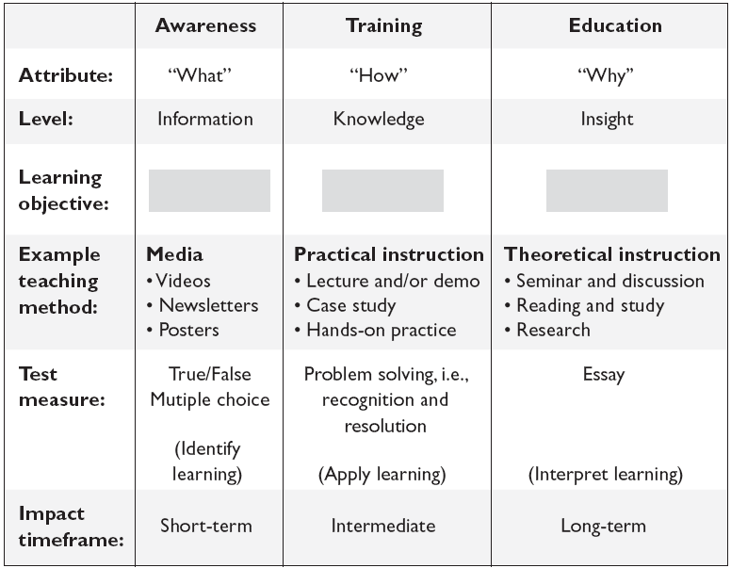
25. What type of risk analysis approach does the following graphic provide?
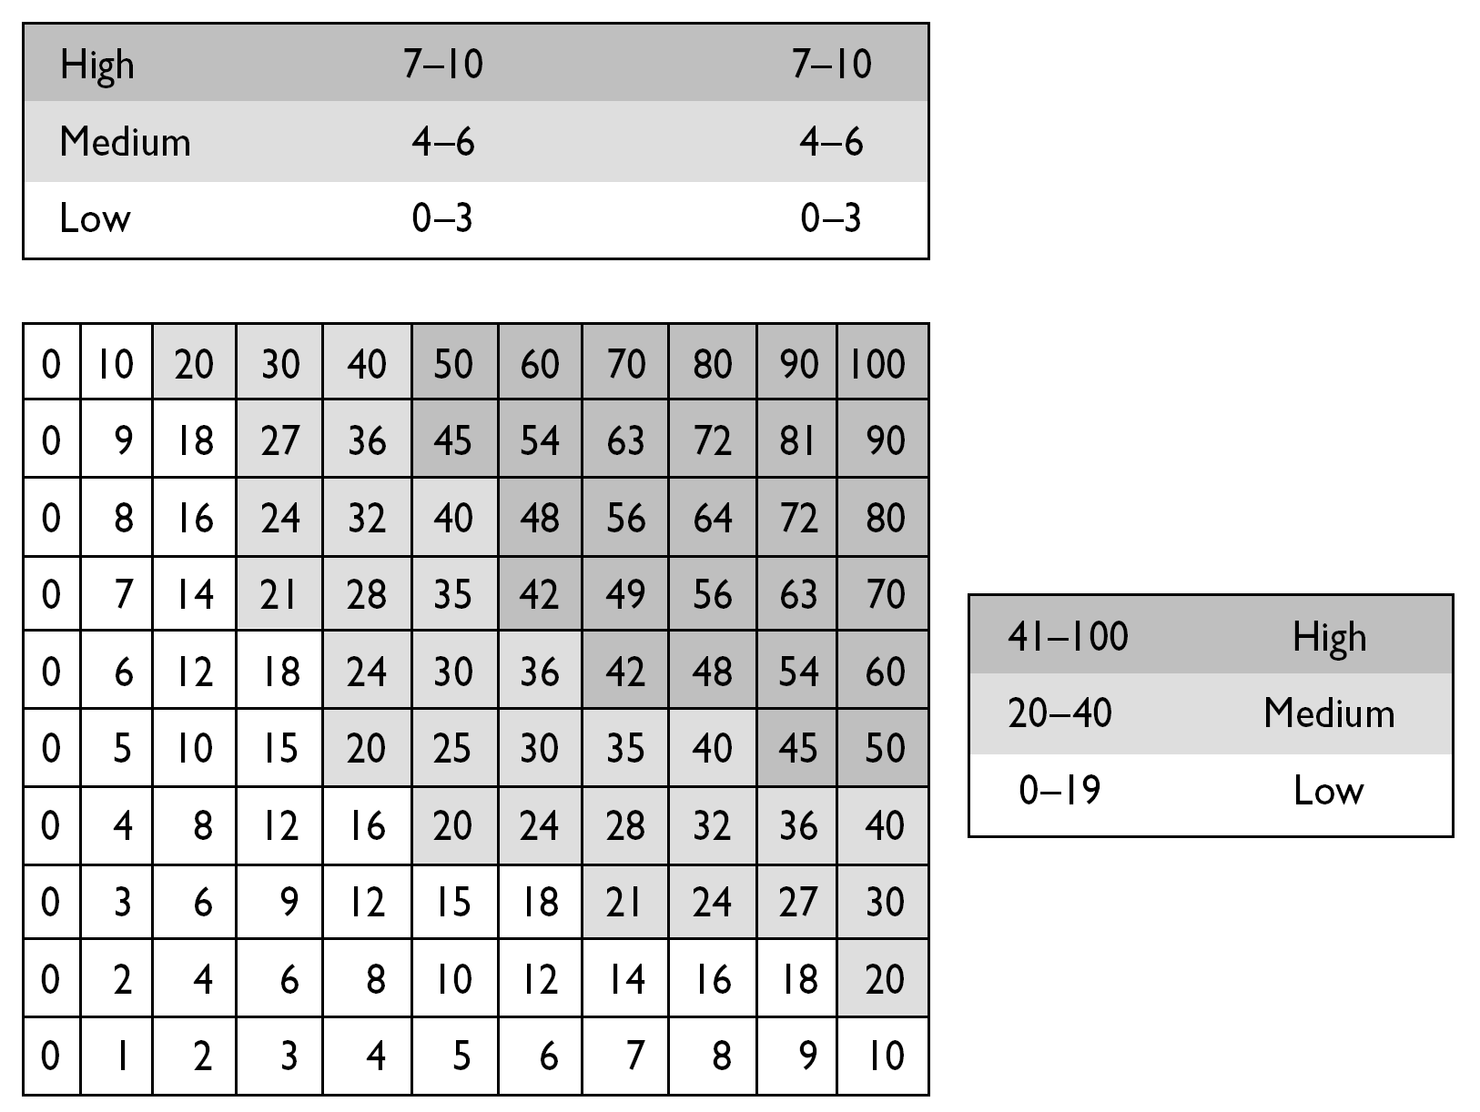
A. Quantitative
B. Qualitative
C. Operationally Correct
D. Operationally Critical

1.2 答案
1. C
2. C
3. B
4. D
5. C
6. C
7. A
8. A
9. D
10. C
11. B
12. A
13. C
14. C
15. A
16. D
17. C
18. C
19. B
20. A
21. A
22. D
23. A
24. C
25. B

1.3 答案解析
1. Which of the following best describes the relationship between CobiT and ITIL?
A. CobiT is a model for IT governance, whereas ITIL is a model for corporate governance.
B. CobiT provides a corporate governance roadmap, whereas ITIL is a customizable
framework for IT service management.
C. CobiT defines IT goals, whereas ITIL provides the process-level steps on how to
achieve them.
D. CobiT provides a framework for achieving security goals, whereas ITIL defines a
framework for achieving IT service-level goals.
√ C. 信息及相关技术的控制目标(Control Objectives for Information and related Technology，CobiT)是由信息系统审计与控制协会(Information Systems Audit and Control Association，ISACA)以及信息技术治理协会(IT Governance Institute，ITGI)开发的一个IT治理控制框架。该框架定义了控制目标应该为正确管理IT并确保IT能够满足业务需求服务，而不只是为满足具体的安全需求服务。信息技术基础结构库(Information Technology Infrastructure Library，ITIL)是公认的信息技术服务管理标准和最佳的实践指南。ITIL作为一个可定制的框架，提供了一系列目标和实现这些目标所必需的一般活动以及为完成这些既定目标所需的每一个活动的输入和输出值。从本质上讲，CobiT解决“实现什么”的问题而ITIL解决“如何实现”的问题。
× A不正确。CobiT是IT治理模型，但ITIL不是公司治理模型。实际上，全国虚假财务报告委员会下属的发起组织委员会(Committee of Sponsoring Organizations of the Treadway Commission，COSO)是一种公司治理模型。CobiT来源于COSO框架。可以认为CobiT是实现众多COSO目标的方法，但仅限于从IT的角度来讲。为了实现CobiT中提出的诸多目标，组织可以使用ITIL，因为它可以提供实现IT服务管理目标的流程步骤。
× B不正确。如前所述，CobiT可以用作IT治理模型，却不可以用作公司治理模型。COSO是公司治理模型。答案的后半部分是正确的。ITIL是一个可定制的IT服务管理框架，有一系列有关该框架的书籍或在线资源可供查阅。
× D不正确。因为CobiT定义了控制目标应该为正确管理IT并确保IT能够满足业务需求服务，而不只是为满足具体的安全需求服务。ITIL提供了实现与业务需求有关的IT服务管理目标的步骤。之所以创建ITIL，是因为组织越来越多地依赖于用信息技术去满足业务需求。
2. Jane has been charged with ensuring that clients’ personal health information is adequately protected before it is exchanged with a new European partner. What data security requirements must she adhere to?
A. HIPAA
B. NIST SP 800-66
C. Safe Harbor
D. European Union Principles on Privacy
√ C. 安全港协议(Safe Harbor)是美国与欧盟签订的协议，其目的是协调美国数据隐私惯例与欧盟更为严格的隐私管控，防止信息意外泄露和损失。该协议对想从欧洲输入、输出隐私数据的实体必须如何保护该数据进行了概括。通过确认遵守该协议，与欧盟国家各实体合作的美国公司能更快捷、便利地传输数据。
× A不正确。《健康保险易移植性和可问责性法案》(Health Insurance Portability and Accountability Act，HIPAA)并不是专门针对与欧洲实体实现信息共享这一目的而制定的数据保护法案。HIPAA提供了在美国国内处理机密医疗信息时如何确保信息安全、完整和保密的框架。美国联邦法规也对应该如何管理创建、访问、共享或销毁医疗信息的设备的安全问题做了规定。
× B不正确。《实施健康保险可携性及责任性法案安全规定的介绍性资源指南》(NIST SP 800-66)是一种风险评估方法。它并没有指出具体的数据隐私要求。NIST SP 800-66的确适用于医疗保健。它最初旨在医疗保健领域实施并推行，HIPAA客户可用其帮助实现合规性。
× D不正确。因为欧盟对隐私的保护原则(European Union Principles on Privacy)是欧盟严格的保护私人信息的法律基础。这些原则并非是专门针对与美国公司交换信息而出台，也不是应美国公司要求而制定。该原则包含与使用和传输敏感信息有关的6个领域的内容。欧洲各国都必须严格遵守这些原则。
3. Global organizations that transfer data across international boundaries must abide by guidelines and transborder information flow rules developed by an international organization that helps different governments come together and tackle the economic, social, and governance challenges of a globalized economy. What organization is this?
A. Committee of Sponsoring Organizations of the Treadway Commission
B. The Organisation for Economic Co-operation and Development
C. CobiT
D. International Organization for Standardization
√ B. 几乎每个国家都有关于什么是私人信息以及应该如何保护这些私人信息的规定。随着数字和信息时代的到来，各国差异性的法律条文已经开始阻碍国际贸易。因此，经济合作与发展组织(Organisation for Economic Co-operation and Development，OECD)为各国制定了指导原则，从而使大家可以遵循相同的法规来正确地保护信息。
× A不正确。因为COSO成立于1985年，其目的是为美国虚假财务报告委员会(National Commission on Fraudulent Financial Reporting)提供赞助。该组织研究欺骗性财务报告及成因。其缩写形式COSO指的是一种公司合作治理模型，它从战略层面、公司文化和财务会计原则等方面来处理IT问题。
× C不正确。CobiT是一个定义了控制目标的框架。即控制目标应该为正确管理IT并确保IT能够满足业务需求服务。它是一个国际开放型标准，为控制敏感信息和保护敏感信息的安全提供要求和参考框架。
× D不正确。国际标准化组织(International Organization for Standardization，ISO)是一个国际标准制定机构，其成员由来自国家标准化组织的代表组成。其目的是建立全球标准。然而，它的标准却不包括如何保护信息在跨国传输过程中的隐私。例如，一些标准涉及质量控制，另一些标准涉及保险和安全。
4. Steve, a department manager, has been asked to join a committee that is responsible for defining an acceptable level of risk for the organization, reviewing risk assessment and audit reports, and approving significant changes to security policies and programs. What committee is he joining?
A. Security policy committee
B. Audit committee
C. Risk management committee
D. Security steering committee
√ D. Steve加入的是一个负责在公司范围内就棘手的战略安全问题作出决策的安全督导委员会。该委员会成员应该遍及整个公司，并且至少每季度召开一次会议。除了题中所列出的职责外，该委员会还负责制定明确的愿景说明，配合与支持该组织业务目标的实现。在实现组织业务目标的过程中，它应该为保护信息的机密性、完整性和可用性目标提供支持。反过来，这个愿景说明应该得到使命声明的支持，该使命声明为应用于组织并且促使其实现业务目标的流程提供支持和定义。
× A不正确。安全策略委员会是由高层管理者选出的负责制定安全策略的组织。通常情况下，高层管理者承担这个职责，除非他们把该职责委托给董事会或委员会。安全策略规定了安全在组织内的作用。它们可以是针对整个组织，也可以是针对具体问题或具体系统而制定。安全督导委员会并不直接制订策略，而是对可行策略进行审核和核准。
× B不正确。审计委员会的目标是在董事会、管理层、内部审计人员和外部审计人员之间提供独立、开放的沟通。它的职责包括控制该公司内部系统，参与和进行独立审计以及执行内部审计功能。该审计委员会会把其发现结果报告给安全督导委员会，但不负责监管和核准任何安全计划。
× C不正确。风险管理委员会的目的是从整体上了解该组织所面临的风险并且协助高层管理者把风险降低到可接受的程度。该委员会不负责监管安全计划。安全督导委员会通常会把涉及信息安全的发现结果报告给风险管理委员会。风险管理委员会必须研究整体的业务风险，而不只是IT安全风险。
5. As head of sales, Jim is the information owner for the sales department. Which of the following is not Jim’s responsibility as information owner?
A. Assigning information classifications
B. Dictating how data should be protected
C. Verifying the availability of data
D. Determining how long to retain data
√ C. 核实数据可用性是所列职责中唯一一个不属于数据所有者所应承担的职责。相反，这是数据管理员的职责。数据管理员也负责维护和保护数据所有者委派保护的数据。这包括定期完成数据备份、恢复备份媒介中的数据、保留活动记录和履行公司制订的策略、原则和标准中对信息安全与数据的保护要求。数据所有者比数据管理员的工作级别高一级。数据所有者通常会这样说：“这些数据需要保证其完整性、可用性和机密性—— 去做吧。”然后数据管理员必须执行这些命令并且进行控制，确保它们正常工作。
× A不正确。因为数据所有者Jim负责对信息进行分类(该问题问的是Jim不负责哪一项)。
× B不正确。因为像Jim这样的数据所有者负责决定如何保护数据。数据所有者拥有着对数据进行保护的组织职责，并且需要为在保护组织信息资产方面出现的任何疏忽承担责任。这就意味着Jim必须决定保护信息的方式，并确保数据管理员(该角色通常由IT或者安全人员承担)执行这些决定。
× D不正确。判断信息保留多长时间的职责属于数据所有者。数据所有者还负责决定谁能访问这些信息并确保访问权得以正确使用。他自己可以核准访问请求，也可以把这个职能委派给业务部门经理，而业务部门经理则根据数据所有者制定的用户访问标准来核准访问请求。
6. Assigning data classification levels can help with all of the following except:
A. The grouping of classified information with hierarchical and restrictive security
B. Ensuring that nonsensitive data is not being protected by unnecessary controls
C. Extracting data from a database
D. Lowering the costs of protecting data
√ C. 数据分类并不包括从数据库中提取数据。然而，数据分类可以用来决定谁拥有访问权限，可以读写存储在数据库中的数据。每一个分类都应该有单独的有关如何访问、使用和销毁数据的处理要求和程序。例如，在公司中，机密信息可能只能由高级管理人员访问。审计过程应该非常详细并且需要每日监督其结果，可能需要消磁程序或清零程序以清除这些数据。另外，公开信息可由所有员工访问，因此不需要使用特殊的审计或者销毁方法。
× A不正确。分配数据分类级别有助于对分类信息分出层级和限制性安全组别。例如，属于同一类别的数据可以分在一个组，并且配以相同的有关信息访问、使用和销毁的处理要求和程序。
× B不正确。分配数据分类标签可帮助确保非敏感数据得到必要的控制保护。数据分类直接确保不同级别的敏感数据得到必要的控制保护。这个答案答得陷阱重重，因为用了好几个否定词。所以一定要仔细阅读问题和选项。
× D不正确。数据分类有助于确保数据得到最具成效的保护。保护和维护数据是有成本的，重要的是把这些钱花费在真正需要保护的信息上面。例如，归类为机密级别的数据与公开数据相比可能需要额外的访问控制来限制访问。它可能也需要进行额外的审计和监管。这些措施用于汽水公司的专有配方上是合适的，然而同样的措施用于汽水公司的雇员目录上却是一种资源的浪费。
7. Which of the following is not included in a risk assessment?
A. Discontinuing activities that introduce risk
B. Identifying assets
C. Identifying threats
D. Analyzing risk in order of cost or criticality
√ A. 引入风险的中断活动是一种通过规避来应对风险的方式。例如，在企业中围绕着即时通信(Instant Message，IM)的使用存在有许多风险。如果一家公司因为没有足够的业务需要用到IM而决定不允许进行IM活动，那么禁止使用这一服务就是一个规避风险的例子。风险评估不包括实施类似这样的对策。
× B不正确。确定资产是风险评估的一部分。题目让判断哪一项不属于风险评估的内容，所以这个选项不正确。为了判定资产的价值，必须首先确定资产。资产确定和资产估值也是风险管理的重要任务。

× C不正确。识别威胁是风险评估的一部分，题目让判断哪一项不属于风险评估的内容，所以这个选项不正确。存在利用漏洞而产生威胁的可能性，即存在风险。如果没有威胁，也就不会有风险。风险使得开发的脆弱性、威胁以及可能性与所产生的商业影响紧密地联系在一起。
× D不正确。按成本或临界状态来分析风险是风险评估流程的一部分，题目让判断哪一项不属于风险评估的内容，所以这个选项不正确。风险评估研究和量化公司面临的风险。必须卓有成效地应对风险。了解该风险的严重性有助于组织确定如何有效地处理风险。
8. Sue has been tasked with implementing a number of security controls, including antivirus and antispam software, to protect the company’s e-mail system. What type of approach is her company taking to handle the risk posed by the system?
A. Risk mitigation
B. Risk acceptance
C. Risk avoidance
D. Risk transference
√ A. 应对风险有四个基本方法：转移风险、规避风险、降低风险和接受风险。通过实施诸如安装防病毒和防垃圾软件这样的安全控制，Sue旨在降低由公司电子邮件系统所带来的风险。这也叫做风险减少，即把风险降到一个可接受的程度。除了使用IT安全控制和对策之外，还可以通过改进程序、改变环境、设置威胁障碍、实施早期检测方法以便在威胁一出现时即阻截它从而减少它们可能带来的破坏性等方法来降低风险。
× B不正确。风险接受不包括在一些保护措施或者对策上花费金钱，例如防病毒软件。接受风险意味着公司了解它所面临的风险级别和破坏所造成的潜在成本，并且决定不采取任何对策而接受风险。许多公司在成本/收益比表明对策的成本远远超过风险可能造成的损失的成本时便接受风险。
× C不正确。风险规避包括中断引起风险的活动，而在这个案例中，Sue的公司选择继续使用电子邮件。如果风险大于该活动的业务需求，则公司会选择中断这些会带来风险的活动。例如，公司会选择屏蔽掉一些部门的社会媒体网站，因为它们有降低员工工作效率的风险。
× D不正确。风险转移是指和另外一个实体共同承担风险，如购买保险从而把一些风险转移给保险公司。公司可以选择各种保险来保护自己的资产。如果公司认为总风险或者剩余风险太高而不能承受，便可以购买保险。
9. The integrity of data is not related to which of the following?
A. Unauthorized manipulation or changes to data
B. The modification of data without authorization
C. The intentional or accidental substitution of data
D. The extraction of data to share with unauthorized entities
√ D. 提取数据与未经授权的实体共享属于机密性问题，不属于完整性问题。机密性确保在数据处理的每个节点都执行必要的保密措施从而防止未授权的信息泄露。在传输的过程及到达目的地的那一刻，数据均位于网络内部的系统和设备上，此时，这种机密性保护措施应该发挥作用。另一方面，完整性是表明数据不可被未授权的主体进行更改或操纵的原则。
× A不正确。完整性与对信息进行未授权的操纵或更改有关。当任何未授权的修改受到阻止时即保证了数据的完整性。硬件、软件和沟通机制必须协调一致以正确维护和处理数据，从而把数据传输到预定目的地而不受意外更改。应该保护系统和网络不受外界干扰和污染。
× B不正确。不经授权的数据修改与完整性有关。完整性是指保护数据不会被用户或其他未经授权的系统更改。
× C不正确。故意的或意外的替代数据与完整性有关。完整性保证了数据未经没有授权的实体修改的同时，也保证了这些信息和系统的精确性和可靠性。坚持完整性原则的环境可以防止攻击者在系统内安装病毒、逻辑炸弹或后门从而损坏或替代数据。用户通常会由于错误(尽管内部用户也可能会有恶意行为)而影响一个系统或者其数据的完整性。例如，用户可能在一个数据处理应用程序中输入不正确的数值从而导致结果是收取客户3000美元而不是300美元。
10. There are several methods an intruder can use to gain access to company assets. Which of the following best describes masquerading?
A. Changing an IP packet’s source address
B. Elevating privileges to gain access
C. An attempt to gain unauthorized access as another user
D. Creating a new authorized user with hacking tools
√ C. 伪装攻击是试图通过假冒授权用户的方法来获取授权访问。攻击者通常利用其进行钓鱼攻击，这种方法很早以前就存在了。例如，1996年，黑客冒充美国在线(AOL)的工作人员给受害者发送信息，向他们索要密码以核实正确的账单信息或者核实美国在线的账户信息。今天，钓鱼者通常伪装成大型金融公司和像亚马逊(Amazon.com)和易趣(eBay.com)这样的知名网络实体。伪装是主动攻击的行为，因为攻击者通常是主动采取行动而不是坐等收集信息。
× A不正确。改变IP数据包的源地址是一个伪装实例，而不是伪装的定义。IP欺骗是在数据包内提交虚假信息的行为，从而达到欺骗其他系统和隐藏消息源的目的。这通常是黑客攻击者的行为，因为这样他们的身份才不会被成功识破。
× B不正确。提升特权不属于伪装攻击。提升特权通常是在入侵者成功渗入某系统之后采取的下一步。但它与就攻击者的真实身份欺骗用户或系统没有直接关系。
× D不正确。伪装攻击通常是指冒充攻击者试图访问的系统中已经存在的一个授权用户的攻击行为。然后，这些攻击者通常会在受损的系统上试图创建一个新的授权用户账户，但是在此之前必须伪装攻击成功。
11. A number of factors should be considered when assigning values to assets. Which of the following is not used to determine the value of an asset?
A. The asset’s value in the external marketplace
B. The level of insurance required to cover the asset
C. The initial and outgoing costs of purchasing, licensing, and supporting the asset
D. The asset’s value to the organization’s production operations
√ B. 涵盖这些资产所需的保险额度不属于为资产分配价值时要考虑的内容。实际上是反过来的：即了解资产的价值后，组织能够更加容易地确定为这些资产购买多大的保险额度。事实上，了解资产的价值是了解应该使用什么安全机制和应该投多少资金来保护这些资产的第一步。资产估值也能够帮助公司进行有效的成本/收益分析，了解究竟什么地方存在风险和如何遵循法律和法规要求。
× A不正确。资产在外部市场的价值是确定资产价值时应该考虑的因素。它应该也包括这些资产相对于竞争对手的价值或者说其他人对此资产愿意支付的价值。
× C不正确。购买、经营和保养资产的最初和后续成本是确定资产成本和价值时应该考虑的因素。该资产对于企业来讲必须直接产生成本-效益。如果维护这些资产的保养要求超出了对这个资产的商业需求，那么它的价值将会下降。
× D不正确。这个因素在确定资产价值时应该予以考虑。如果该资产有一段时间不可用，那么该组织生产运营的资产价值可以用以确定该组织的成本。与此同时，除了应该考虑资产不可用的情况下经营活动和生产活动受到的影响外，还应该考虑资产在组织中的用途和作用。如果该资产有助于经营活动，则它是有价值的，关键是计算出价值有多大。
12. Jill is establishing a companywide sales program that will require different user groups with different privileges to access information on a centralized database. How should the security manager secure the database?
A. Increase the database’s security controls and provide more granularity.
B. Implement access controls that display each user’s permissions each time they access the database.
C. Change the database’s classification label to a higher security status.
D. Decrease the security so that all users can access the information as needed.
√ A. 在这种情况下，保证数据库安全的最好方法是增加控制和分配高细粒度的权限。这些措施会确保客户不会滥用他们的特权从而维护信息的机密性。细粒度权限为网络管理员和安全专业人士赋予了对他们负责保护的资源以额外的控制权，更为精细的权限分配可以使得他们能够给其他人分配所需的较为精确的访问权限。
× B不正确。在每个用户每次访问数据库时都显示权限的访问控制是控制的方法之一。但不是完整的处理用户访问完整数据库信息的方式。这可能只是增加数据库安全控制的方法之一，它仅仅是一个方法，还需要更多其他方法辅助。
× C不正确。数据库中信息的分类级别是之前就根据它的机密性、完整性和可用性级别确定好的。这些级别不会仅仅因为有更多的用户需要访问这些数据而改变。因此，当有更多的用户或群体需要访问这些信息时，都不用提高或降低信息的分类级别。提高分类级别只会意味着一小部分用户可以访问该数据库。

× D不正确。这样做会使数据面临风险。如果降低安全级别从而使所有的用户都可以按需访问该数据库，那么拥有较低特权的用户将能够访问具有较高分类级别的数据。较低的安全级别同时也意味着入侵者可以更加容易地侵入数据库。如答案C中所说，数据的分类级别不会仅仅因为需要访问数据的用户的数量增加或减少而改变。
13. As his company’s CISO, George needs to demonstrate to the Board of Directors the necessity of a strong risk management program. Which of the following should George use to calculate the company’s residual risk?
A. threats × vulnerability × asset value = residual risk
B. SLE × frequency = ALE, which is equal to residual risk
C. (threats × asset value × vulnerability) × control gap = residual risk
D. (total risk – asset value) × countermeasures = residual risk
√ C. 实施防护措施把总风险降到一个可接受的程度。然而，任何系统或环境都不是100%安全，每采取一个对策总是会相应地产生一些风险。在采取防护措施之后继续存在的风险叫做剩余风险(residual risk)。剩余风险不同于总风险，总风险指的是公司在选择不采取任何防护措施的情况下所面临的总的风险数量。总风险可以计算出来，其公式是：威胁×脆弱性×资产价值=总风险。计算剩余风险的公式为：(威胁×脆弱性×资产价值)×控制差距=剩余风险。控制差距是指控制所不能提供的保护的数量。
× A不正确。威胁×脆弱性×资产价值不等于剩余风险。这是计算总风险的公式。总风险是公司在没有采取任何防护措施或行动以降低整体风险的情况下所面临的风险。总风险可以通过采取安全保障措施或实施对策来减少，使得公司仅面临剩余风险——即安全措施实施之后剩下的风险。
× B不正确。单一损失期望(single loss expectancy，SLE)×频率(frequency)是计算年度损失期望(annualized loss expectancy，ALE)的公式，从而可以据此了解利用脆弱性而产生的威胁的总数和对业务造成的影响结果。频率是指威胁的年发生比率(annual rate of occurrence，ARO)。ALE不等于剩余风险。ALE指一种具体的威胁类型在一年内对公司可能造成的损失成本是多少。了解这个威胁发生的真正概率和该威胁引起的损失折合多少钱对于确定应该花费多少钱来尝试抵制那个威胁非常重要。
× D不正确。这是一个干扰选项。风险评估中没有这样一个公式。实际是：威胁×脆弱性×资产价值=总风险。(威胁×脆弱性×资产价值)×控制差距=剩余风险。
14. Authorization creep is to access controls what scope creep is to software development. Which of the following is not true of authorization creep?
A. Users have a tendency to request additional permissions without asking for others to be taken away.
B. It is a violation of “least privilege”.
C. It enforces the “need-to-know” concept.
D. It commonly occurs when users transfer to other departments or change positions.
√ C. 知其所需(need-to-know)原则是基于这样的理念，即用户只会被给予为完成其工作职责所需要的资源的访问权限。如果没有明确地说明允许访问，那么它应该就是禁止访问。与其把访问权给予所有人，然后再基于“知其所需”把特权剥夺，倒不如开始什么也不给，然后在“知其所需”的基础上增加特权。授权蔓延与这个概念相反。它是指随着时间的推移，访问权逐渐累积，尤其指对用户不需要知道的数据。
× A不正确。本选项正确地描述了授权蔓延的原因，而问题问的是哪一项不正确。授权蔓延的出现往往是由于用户总是要求获得额外的访问权而又不允许剥夺其他的访问权。结果是，用户拥有着比真实所需多得多的访问权限。太多用户对公司资产拥有太多的访问特权会给公司带来很大的风险。
× B不正确。授权蔓延违背了“最小特权”原则，而这个问题问的是哪一项不正确。最小特权原则规定用户应该只被给予其完成工作任务所需的最小特权。对用户账户执行最小特权原则应该是一个持续进行的工作，即应该审核每个用户的访问权限从而确保公司不会使自己面临风险。
× D不正确。这一项正确地描述出授权蔓延的原因，而这个问题问的是哪一项不正确。当用户调至其他部门或者更换了职位，他们往往被分配更多的访问权限—— 远远多于他们完成工作所需的权限。这些权限通常是基于他们原来的权限之上增加的，对资源的访问权太大会过于危险。
15. For what purpose was the COSO framework developed?
A. To address fraudulent financial activities and reporting
B. To help organizations install, implement, and maintain CobiT controls
C. To serve as a guideline for IT security auditors to use when verifying compliance
D. To address regulatory requirements related to protecting private health information
√ A. COSO是全国虚假财务报告委员会下属的发起组织委员会(Committee of Sponsoring Organizations of the Treadway Commission)的英文缩写。该组织成立于1985年，其目的是为美国虚假财务报告委员会(National Commission on Fraudulent Financial Reporting)提供赞助。后者研究欺骗性财务报告和导致产生这些报告的原因。因此，COSO框架的开发目的根本上是为了应对金融欺诈活动和报告。基本上说，COSO有助于确保上市公司在向证券交易委员会(Security Exchange Commission，SEC)报告他们的财务信息时披露真实数据，而不是做假账。
× B不正确。COSO先于CobiT，因此，COSO并非是为帮助组织安装、实施和维护CobiT控制而制定的。CobiT来源于COSO框架，提供了一个从IT角度实现许多COSO目标的方法。COSO是一个战略层面的公司治理模型，而CobiT是运营层面的IT治理模型。
× C不正确。COSO并非是IT安全审计人员的指导原则。而来源于COSO框架，并且定义了控制目标应该是为了正确地管理IT并且确保IT为业务需要服务的CobiT，通常是安全审计人员使用的指南。它规定了执行摘要、管理准则、框架、控制目标、实施工具、审计指南等。大多数规定和审计原则都是基于CobiT框架而建立的。
× D不正确。COSO的制定并非是为了处理与私人健康信息有关的监管要求。然而，NIST SP 800-66是一个旨在医疗保健领域或其他管制行业实施的风险评估方法。
16. Susan, an attorney, has been hired to fill a new position at Widgets Inc. The position is Chief Privacy Officer (CPO). What is the primary function of her new role?
A. Ensuring the protection of partner data
B. Ensuring the accuracy and protection of company financial information
C. Ensuring that security policies are defined and enforced
D. Ensuring the protection of customer, company, and employee data
√ D. 首席隐私官(Chief Privacy Officer，CPO)这一职位是针对组织日益增多的保护各种各样数据的要求而创建的。CPO负责保证顾客、公司和员工数据的安全，让公司免于法律诉讼(理想状况)，不至于成为头版头条新闻。因此，CPO直接负责制定如何收集、保护和发布第三方数据的政策。CPO通常由律师承担，直接面对首席安全官(Chief Security Officer，CSO)。
× A不正确。保护合作伙伴的数据信息仅仅是CPO负责保护的所有数据的一个小小的子集。CPO们负责保证顾客、公司和员工数据的安全。合作伙伴的数据是CPO负责保护的众多类型的数据的一种。除此之外，CPO负责了解公司的供应商、合作伙伴和其他第三方如何保护本公司的敏感信息。公司经常需要审核其他方(因为他们有需要保护的数据的备份)的安全保护工作。
× B不正确。维护金融信息的精确是数据所有人——首席财务官(Chief Financial Office，CFO)的职责。CFO负责公司的账户和金融活动以及该组织的整体金融结构。CPO负责帮助确保这些数据的保密性，但不是精确性。金融信息同样也是CPO负责保护的所有数据类型中的一个小子集。
× C不正确。定义和实施安全策略是高级管理者的职责，通常该职责被委派给首席信息安全官(Chief Information Security Officer，CISO)或者CSO，而不是CPO。安全策略概述了组织内部的安全角色。CPO与策略有关的职责是帮助制定数据保护策略，包括如何收集、保护和向第三方发布数据等。
17. Jared plays a role in his company’s data classification system. In this role, he must practice due care when accessing data and ensure that the data is used only in accordance with allowed policy while abiding by the rules set for the classification of the data. He does not determine, maintain, or evaluate controls, so what is Jared’s role?
A. Data owner
B. Data custodian
C. Data user
D. Information systems auditor
√ C. 任何经常使用数据执行相关工作任务的个体都是数据用户。用户必须拥有在他们职位范围内履行职责所必需的访问数据的权限，他们有责任遵守安全运营程序从而确保这些数据对于其他人的机密性、完整性和可用性。这意味着用户必须十分谨慎并严格遵循安全策略和数据分类规则。
× A不正确。数据所有者拥有着更高级别的数据保护责任。他们负责对信息分类、定期审核分类级别和把数据保护职责委派给数据管理员。数据所有者通常是组织中的一个经理或执行官，负责保护公司的信息资产。
× B不正确。数据管理员负责实施和维护数据所有者指派的安全控制工作。换句话说，数据管理员是为保护这些数据而实施控制的技术管理员。其职责包括做备份、存储数据、实施和维护对策以及监管控制措施。
× D不正确。信息系统审计人员负责评估控制措施。在对这些措施进行评估之后，审计人员向管理层报告，说明这套可接受的组织风险级别和其发现之间的匹配程度。这与使用这些数据或者使用时小心谨慎之间没有关系。
18. Risk assessment has several different methodologies. Which of the following official risk methodologies was not created for the purpose of analyzing security risks?
A. FAP
B. OCTAVE
C. ANZ 4360
D. NIST SP 800-30
√ C. 尽管ANZ 4360可以用来分析安全风险，但它却不是为此目的而创建的。它是一个比其他诸如NIST和OCTAVE等风险评估方法应用更广泛的风险管理方法。后两者专注于IT威胁和信息安全风险。ANZ 4360可以用来了解一个公司的金融、资本、人员安全和业务决策风险。
× A不正确。没有正式的FAP风险分析方法。这是一个干扰选项。
× B不正确。OCTAVE专注于IT威胁和信息安全风险。OCTAVE旨在应用于人们在其组织内部管理和进行信息安全风险评估之时。组织的员工有权确定最好的安全评估方法。
× D不正确。NIST SP 800-30是专门针对IT威胁以及它们与信息安全风险的关系的风险评估指南。它主要专注于系统。数据是从网络、安全评估实践和组织内部的人们中收集起来的。然后，这些数据会用作800-30文档中列出的风险分析步骤中的输入值。
19. Which of the following is not a characteristic of a company with a security governance program in place?
A. Board members are updated quarterly on the company’s state of security.
B. All security activity takes place within the security department.
C. Security products, services, and consultants are deployed in an informed manner.
D. The organization has established metrics and goals for improving security.
√ B. 如果所有的安全活动都发生在安全部门内部，那么安全工作则是封闭的，没有贯穿整个组织。在一个实施了安全治理项目的公司内，安全职责渗透到整个组织中，从执行官开始沿着命令链自上而下地渗透。常见的情况是，业务部门的管理者负责实施他们具体业务部门的风险管理活动。除此之外，员工为他们参与的任何恶意或无意的安全违规行为负责。

× A不正确。安全治理是董事会和组织内部的管理人员执行的一整套责任和做法，其目的是指明战略方向、确保目标实现、保证风险得以正确管理和确保人们负责任地使用组织资源。安全治理项目到位的组织具备一个了解安全重要性、注意组织安全和意外情况的董事会。
× C不正确。安全治理是集产品、人员、培训、流程等安全成分于一体的统一系统。因此，安全治理项目到位的组织会购买和部署安全产品、托管服务，并在知情的方式下聘请安全顾问。这些产品、服务和顾问也会不断受到审核以确保他们能基于成本产生效益。
× D不正确。安全治理需要绩效考核和监督机制。安全治理项目到位的组织会不断审核它的流程，包括安全在内，从而达到持续改进的目的。另一方面，缺乏安全治理项目的组织会在没有分析它的绩效的情况下前行，从而重复地犯相似的错误。
20. Michael is charged with developing a classification program for his company. Which of the following should he do first?
A. Understand the different levels of protection that must be provided.
B. Specify data classification criteria.
C. Identify the data custodians.
D. Determine protection mechanisms for each classification level.
√ A. Michael在开始制定他公司的分类方案之前，必须了解必须提供的不同的保护级别有哪些。只有这样他才能制定出必需的分类级别以及它们的标准。一种公司可能只选择使用两层分类法，而另外一种公司则可能选择使用更多层。不管怎样，当制定分类级别时，应该牢记，太多或者太少的分类级别都会致使分类无效。各分类级别的标准应该没有重叠，并且应该同时为数据和软件制定分类级别。
× B不正确。确定分类级别之后数据分类标准方能制定。数据所有者参照分类标准了解具体数据应该分配何种类别。如果类别是桶的话，标准将帮助数据所有者确定每组数据应该被放进哪个桶里。
× C不正确。因为确定了分类级别、制定了数据如何分类的标准并且数据所有者确定了数据管理员负责哪类数据之后才需要指定该管理员。请记住，数据管理员负责实施和维护数据所有者分派的控制措施。
× D不正确。确定分类级别本身基于其所需的不同的保护程度之后才能制定每个分类级别的保护机制。对每个类别实施的控制类型取决于管理和安全团队制定的数据所需的保护等级。
21. There are four ways of dealing with risk. In the graphic that follows, which method is missing and what is the purpose of this method?
A. Risk transference. Share the risk with other entities.
B. Risk reduction. Reduce the risk to an acceptable level.
C. Risk rejection. Accept the current risk.
D. Risk assignment. Assign risk to a specific owner.
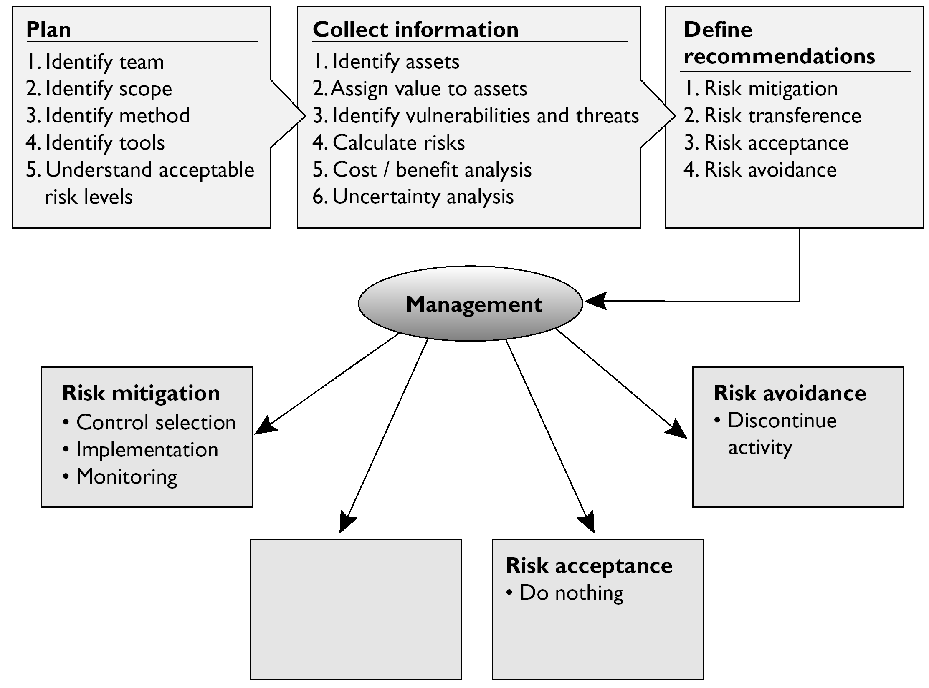
√ A. 一旦公司了解了它所面对的总风险和剩余风险的数量，它必须决定如何应对这些风险。应对风险由4个基本方法：转移风险、规避风险、减少风险和接受风险。公司可以选择多种保险来保护自己的资产。如果公司认为总风险或者剩余风险太高而应对不了，便可以购买保险，这样就把风险转移给了保险公司。
× B不正确。另外一个方式是减少风险，减到一个可接受的程度以继续进行业务。安装防火墙、培训、入侵检测/保护系统都是减少风险的方法。风险减少就是指风险降低，表中已经列明。
× C不正确。公司绝对不应该拒绝风险。拒绝风险意味着拒绝应对风险。风险通常会对业务带来负面影响，如果不正确应对的话，那么公司将不得不应对诸如生产资源损失、法律义务问题或者对声誉带来负面影响的问题。因此，通过转移、规避、减少和接受风险的方法来适当应对识别出来的风险很重要。
× D不正确。委派某人应对某一个具体的风险，这不属于应对风险的方法。即使把风险指派给一个具体的实体去应对，其仍需要采用转移、规避、减少或接受风险的方法。
22. The following graphic contains a commonly used risk management scorecard. Identify the proper quadrant and its description.
A. Top-right quadrant is high impact, low probability.
B. Top-left quadrant is high impact, medium probability.
C. Bottom-left quadrant is low impact, high probability.
D. Bottom-right quadrant is low impact, high probability.
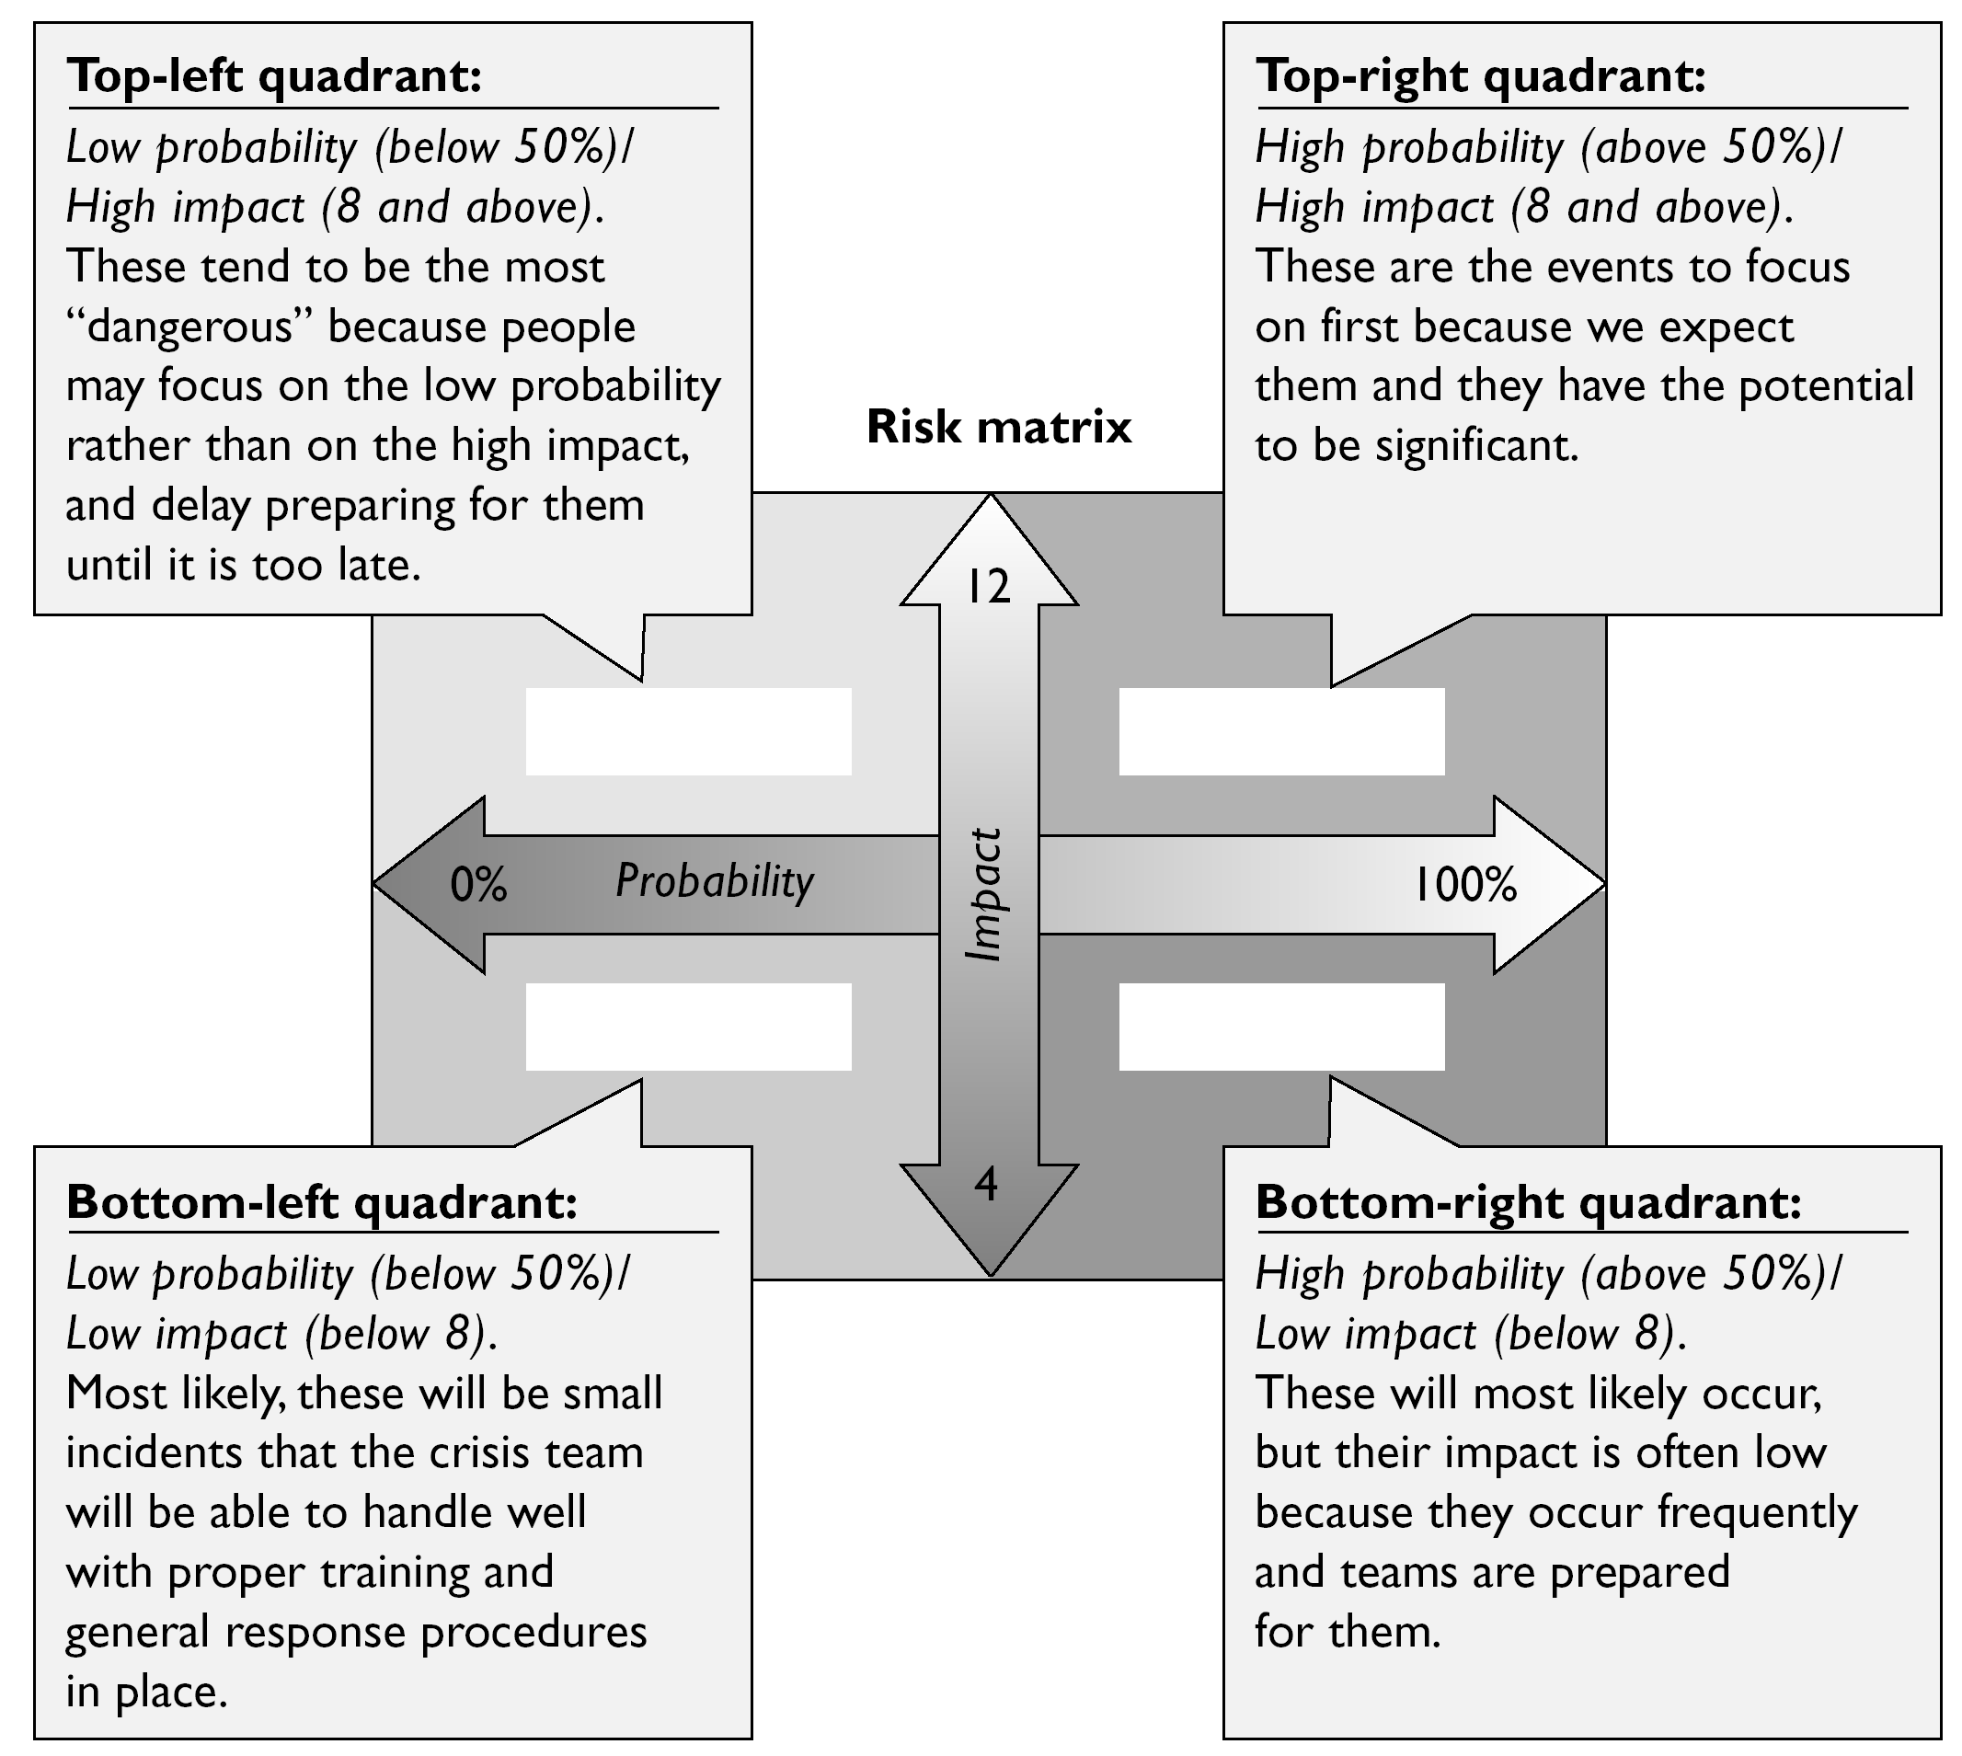
√ D. 右下象限指影响低但出现概率高的风险。这意味着某些特定的威胁利用某些特定的脆弱性的可能性高。尽管这些风险出现得很频繁，但他们对业务造成的影响却很低。在这四个象限中，位于该象限中的风险应该在应对了另外两个位置较高的象限中的风险之后再处理。例如，感染了用户工作站的病毒就属于这个象限的风险。因为病毒很普遍，所以这意味着这种风险发生的概率高。但这只是一个用户工作站而不是生产系统，所以影响低。
× A不正确。右上象限指影响高且出现频率高的风险。这意味着某些特定的威胁利用某些特定的脆弱性的可能性高。这些风险出现得很频繁，而且他们对业务造成的影响也很高。在这四个象限中，位于该象限中的风险应该首先应对。例如，损坏内部邮件服务器的攻击者就属于这个象限的风险。如果不采取正确的应对措施，那么这个风险出现的概率会很高。既然内部邮件服务器是整个公司都会赖以使用的资源，所以其业务影响很大。
× B不正确。左上象限指影响高但出现概率低的风险。这意味着某些特定的威胁利用某些的特定的脆弱性的可能性低。这些风险出现的频率低，并且业务影响低。在这四个象限中，该象限的风险应该在应对了右上象限中的风险之后再应对。例如，黑客放弃攻击内部DNS服务器就属于该类型的风险。如果有面对外部的DNS服务器和一台DMZ，那么攻击者成功访问内部DNS服务器的可能性将很低。但是一旦其成功访问，就会对业务造成很高的影响，因为所有系统都依赖于该资源。
× C不正确。左下象限指的是影响低、出现概率低的风险。这意味着某些特定的威胁利用某些特定的脆弱性的可能性低。这些风险出现的频率低，对业务造成的影响也低。在这四个象限中，该象限的风险应该在处理完其他3个象限的风险之后再采取应对措施。例如，一个几乎不用的遗留文件服务器失败和脱机就属于这个类型的风险。因为用户不常使用它，所以它对业务造成的影响很低。如果采取正确的应对措施的话，这种风险出现的概率也很低。
23. What are the three types of policies that are missing from the following graphic?
A. Regulatory, Informative, Advisory
B. Regulatory, Mandatory, Advisory
C. Regulatory, Informative, Public
D. Regulatory, Informative, Internal Use
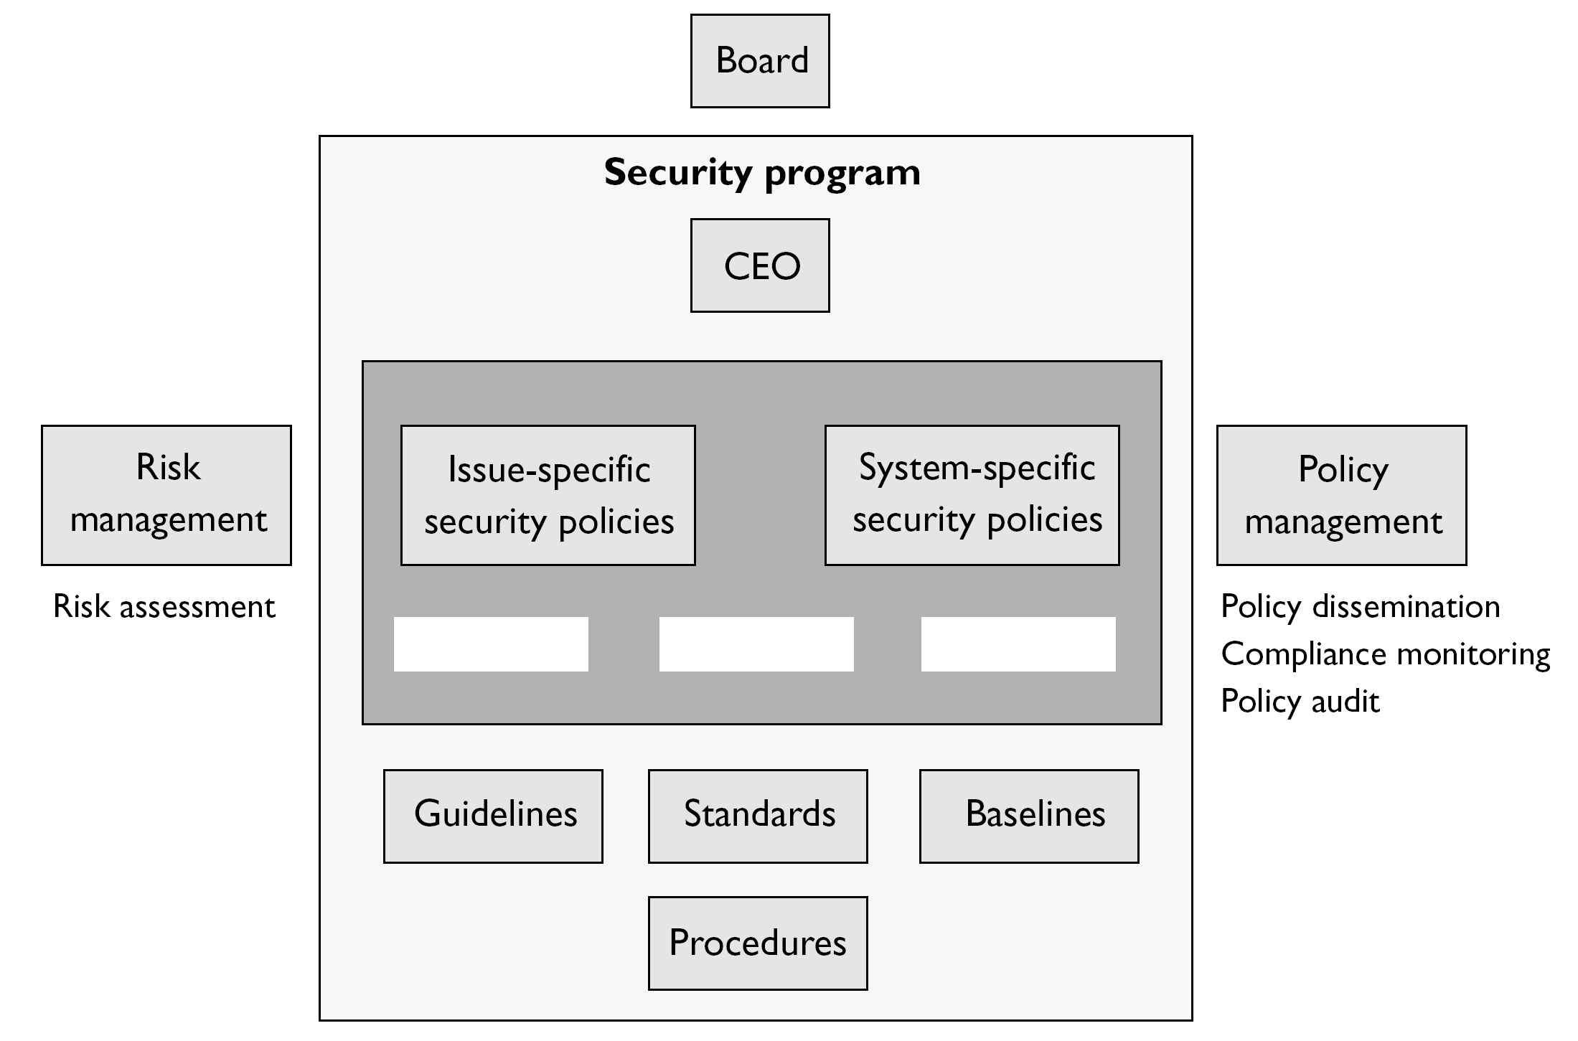
√ A. 规章式策略可确保组织遵循特定行业法规规定的标准。这些标准对于一种行业类型来讲是非常详细和具体的，用于金融机构、医疗设施、公共事业和其他受政府监管的行业。信息式策略向雇员提供特定主题。它不是强制执行的策略，而是向人们提供与公司相关的信息或知识。它可以解释公司如何与合作伙伴交流或者提供公司的目标和任务以及提供一个整体的适用于不同形势的报告结构。建议式策略向员工强烈建议在公司内部应该有什么行为、不应该有什么行为。它也概略说明了如果员工不遵循既定的行为或活动会有什么后果。例如，该类型策略可以用来描述如何处理医疗信息、金融交易或者如何处理机密信息等。
× B不正确。强制不属于策略类型，这是一个干扰项。
× C不正确。公开不属于策略类型，这是一个干扰项。
× D不正确。内部使用也不是策略类型，这是一个干扰项。
24. List in the proper order from the table that follows the learning objectives that are missing and their proper definitions.
A. Understanding, recognition and retention, skill
B. Skill, recognition and retention, skill
C. Recognition and retention, skill, understanding
D. Skill, recognition and retention, understanding
√ C. 意识培训及其相关内容提醒员工与保护公司资产有关的责任。培训提供了从事具体任务和职责所需的技能。教育提供了管理技能和制定决策能力。
× A不正确。培训和教育的不同类型与所列结果不对应。如今，不少公司会花大量金钱购买安全设备和技术，但是他们通常会忽略一个事实，即必须培训员工如何使用这些设备和技术。没有这样的培训，用于减少威胁的投资便会白白浪费，而公司依然不安全。
× B不正确。培训和教育的不同类型与所列结果不对应。不同的角色需要不同类型的培训或教育。对于公司的安全来说，有技能的员工是最关键的组成部分之一。
× D不正确。培训和教育的不同类型与所列结果不对应。安全意识培训项目一般来讲至少要为三种人而创建：管理人员、职员和技术人员。各种意识培训必须专门针对特定的人员制定，从而确保这一特定人员组能理解其具体职责、责任和预期。

25. What type of risk analysis approach does the following graphic provide?
A. Quantitative
B. Qualitative
C. Operationally Correct
D. Operationally Critical
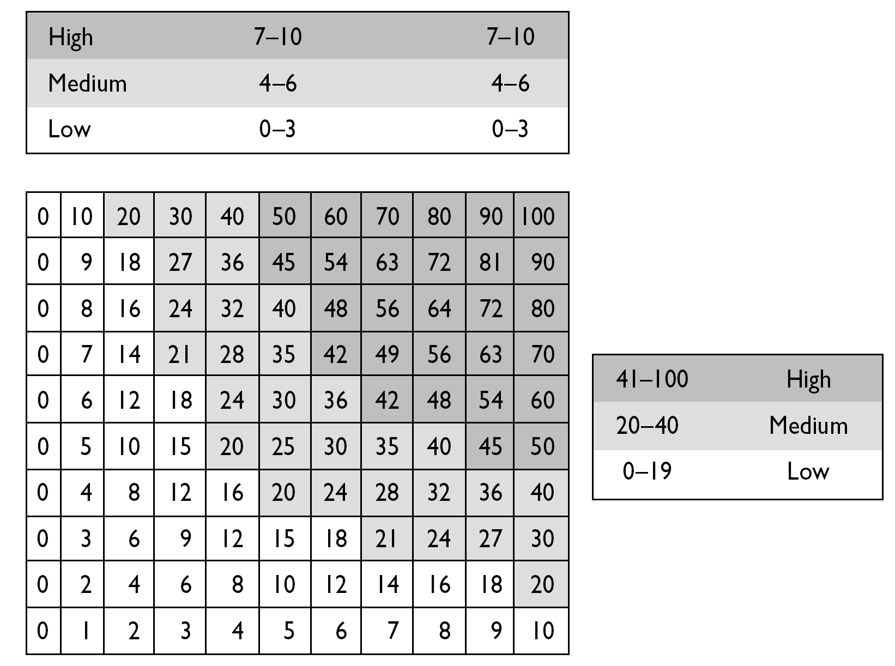
√ B. 定性风险分析方法并不是为风险或损失确定货币价值。相反，定性方法分析风险可能出现的不同情况，然后按程度将威胁分成等级，并根据意见来分析可能采取的不同对策的有效性。定性分析技术包括判断、最佳实践、直觉和经验。这个图表是定性分析方法使用的等级排列系统，而不是百分比和资金量。
× A不正确。定量风险分析方法试图给风险分析流程的所有组成部分分配百分比和资金量。这些组成部分可能包括防护成本、资产价值、业务影响、威胁频率、防护效果、开发可能性，等等。如果所有这些都被赋予一定的数值，那么这个过程就可以说是定量的。把这个分析过程中的每一个组成部分(资产价值、威胁频率、脆弱性的程度、冲击损失、防护成本、防护效果、不确定性和概率项目)赋予一定数值，然后输入进公式当中，便可确定出总风险和剩余风险。
× C不正确。没有这种正式的风险分析方法。这是一个干扰项。
× D不正确。没有这种正式的风险分析方法。这是一个干扰项。

