CHAPTER 1 INTRODUCTION TO THE INFORMATION SYSTEM (IT)

1.1 ABOUT INFORMATION SYSTEMS
When you think of a microcomputer, perhaps you think of just the equipment itself. That is, you think of the monitor or the keyboard. Yet, there is more to it than that. The way to think about a microcomputer is as part of an information system. An information system has five parts: people, procedures, software, hardware and data (See Figure 1-1).
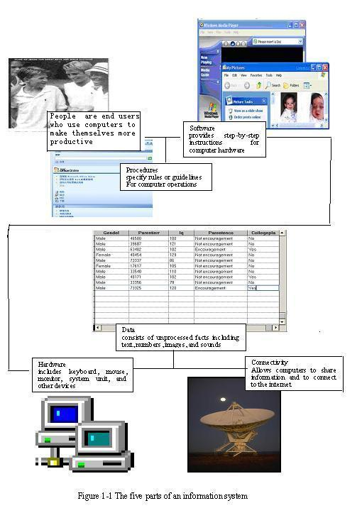
Figure 1-1 The five parts of an information System
People: It is easy to overlook people as one of the five parts of an information system. Yet this is what microcomputers are all about-making people, end users like you, more productive ^{[1]}.
Although easy to overlook, people are surely the most important part of any information system. Our lives are touched every day by computers and information system. Many times the contact is direct and obvious, such as when we create documents using a word processing program or when we connect to the Internet. Other times, the contact is not as obvious.
Procedures: The rules or guidelines for people to follow when using software, hardware, and data are procedures. These procedures are typically documented in manuals written by computer specialists. Software and hardware manufacturers provide manuals with their products. These manuals are provided either in printed or electronic form.
Software: A program consists of the step-by-step instructions that tell the computer how to do its work ^{[2]}. Software is another name for a program or programs. The purpose of software is to convert data (unprocessed facts) into information (processed facts). For example, a payroll program would instruct the computer to take the number of hours you worked in a week(data) and multiply it by your pay rate(data) to determine how much you are paid for the week (information) ^{[3]}.
Hardware: The equipment that processes the data to create information is called hardware. It includes the system unit, keyboard, mouse, monitor, and other devices. Hardware is controlled by software.
Data: The raw, unprocessed facts, including text, numbers, images, and sounds, are called data. Processed data yields information. Using the previous example of a payroll program, the data(number of hours worked and pay rate) is processed (multiplied) to yield information (weekly pay).
Almost all of today’s computer systems add an additional part to the information system. This part, called connectivity, allows computers to connect and to share information. These connections, including Internet connections, can be by telephone lines, by cable, or through the air ^{[4]}. Connectivity allows users to greatly expand the capability and usefulness of their information systems.
NOTES
[1] this is 后面是表语从句， making people more productive 为分词短语作状语， end users like you 为同位语。
[2] that 引导的是定语从句，修饰instructions，此从句中又包含由 how引导的宾语从句。
[3] the computer to take…and multiply…为复合宾语；you worked…为定语从句，修饰hours; to determine…为目的状语。
[4] through the air指无线连接。
KEYWORDS
information system 信息系统
microcomputer 微型计算机，微机
monitor 监视器
keyboard 键盘
procedure 工（程）序，作业，过程，方法，规程
software 软件
hardware 硬件
data 数据
word processing program 字处理程序
Internet 因特网
instruction 指令
system unit 系统部件
mouse 鼠标
text 文本
image 图像
connectivity 连通（性）
share 共享
connection 连接
cable 电缆
EXERCISES
Multiple choices.
1. The following elements are belong to an information system _________.
a. procedures b. desk c. people d. hardware
2. Today anyone does not live without information system as the following examples illustrate: __________.
a. We send a letter using E-mail system b. We go shopping at the supermarket
c. We talk face to face d. We watch movies on the Internet
3. Procedures are _________ for people to follow when using software, hardware and data.
a. programs b. guidelines c. regulations d. rules
4. Software is _________.
a. also called as program
b. a program consisted of step-by-step instructions
c. one kind of language
d. generally purchased in some sort of a physical package
5. Hardware includes _________.
a. system unit b. system software c. printer d. monitor
6. Data include _________.
a. processed facts
b. unprocessed facts
c. sounds
d. number
7. Information is _________.
a. processed facts b. unprocessed facts
c. message d. physical object
8. Connectivity _________.
a. is the seventh part of a information system
b. allows computers to share information
c. includes Internet connections
d. allows users to greatly expand their capability

1.2 COMPUTER ORGANIZATION
1. Computer Organization
A computer is a programming, electronic device that accepts input, performs operations or processing on the data, and outputs and stores the results. Because it is programmable, the instructions—called the program—tell the computer what to do. The relationships between these four main computer operations (input, processing, output, and storage) are shown in Figure 1-2.
Figure1-2 Basic operations within a computer
The corresponding devices to perform these tasks are input devices, processing devices, output devices, and storage devices.
1) Input Devices
An input device is any piece of equipment that supplies materials (input) to the computer. The most common input devices are the keyboard and mouse (see Figure 1-3). Other possibilities include image and bar-code scanners, joysticks, touch screens, digital cameras, electronic pens, fingerprint readers, and microphones. Input devices for a stereo system might be a CD player and antenna.
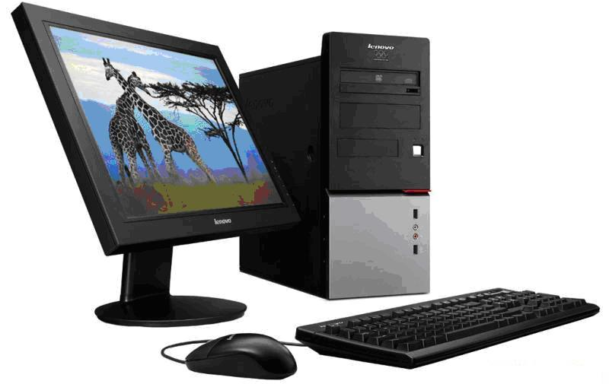
Figure 1-3 Hardware of a computer system
2) Processing Derices
The heart of any computer system is the central processing unit (CPU), located inside the computer’s main box or system unit.
A processor is composed of two functional units—a control unit and an arithmetic/logic unit—and a set of special workspaces called registers.
Figure 1-4 depicts its structure, in which the Internal CPU Interconnection provides communication among the Control Unit, ALU，and register.
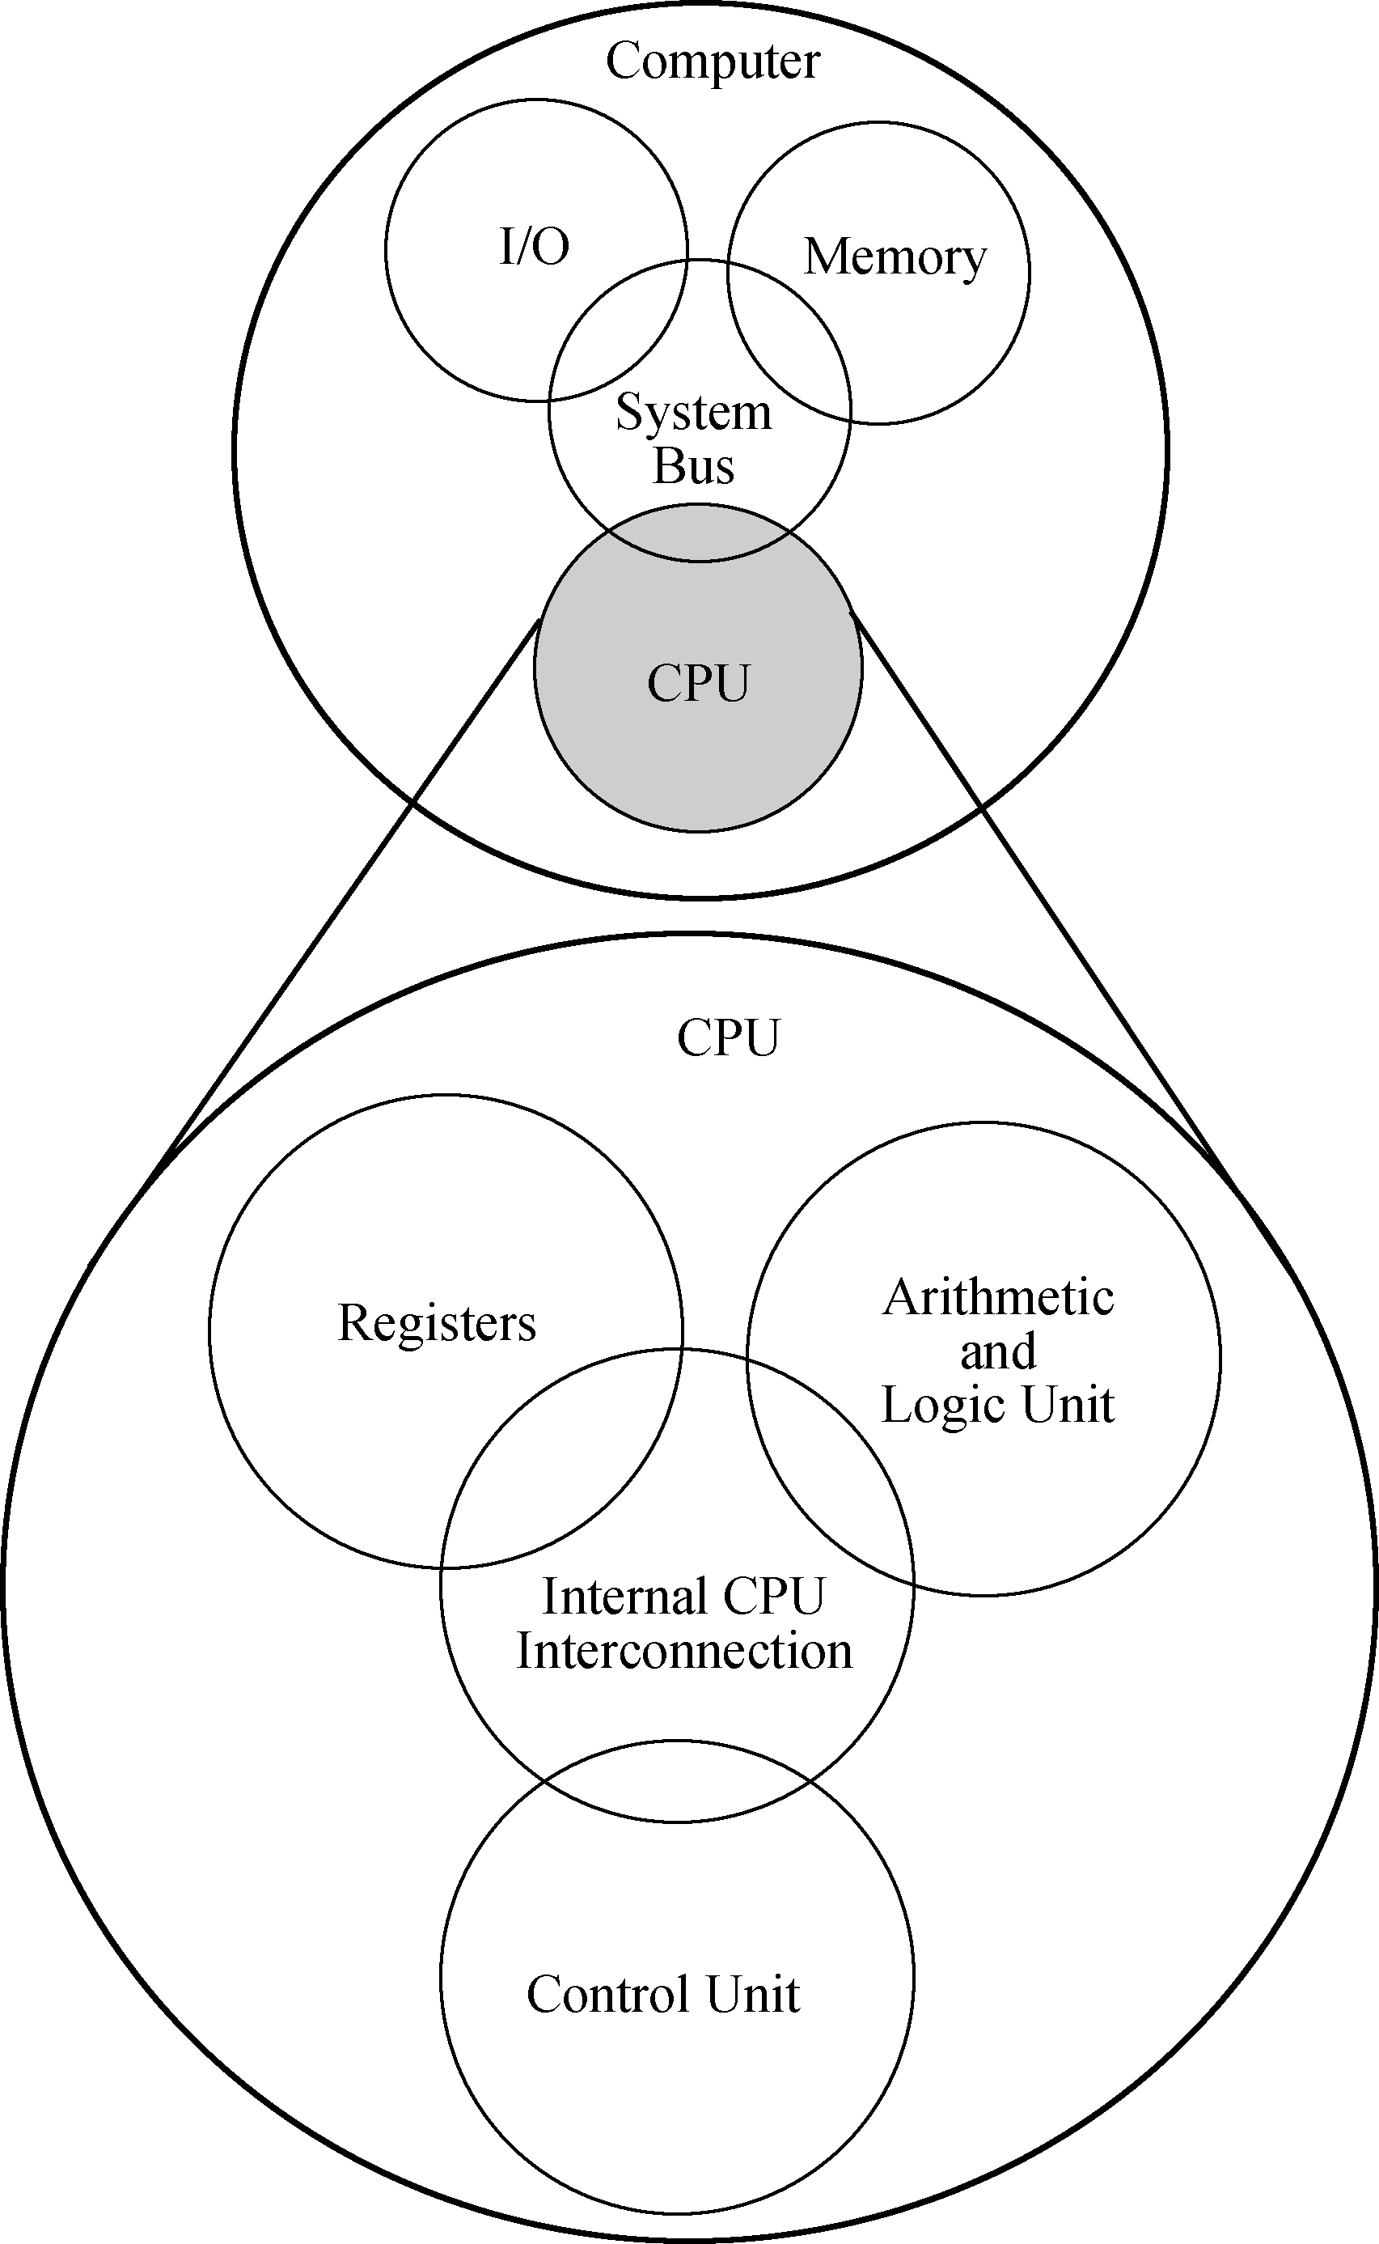
Figure1-4 Central Processing Unit (CPU)
The control unit is the functional unit that is responsible for supervising the operation of the entire computer system.
The control unit fetches instructions from memory and determines their types or decodes them. It then breaks each instruction into a series of simple small steps or actions. By doing this, it controls the step-by-step operation of the entire computer system.
The arithmetic and logic unit (ALU) is the functional unit that provides the computer with logical and computational capabilities. Data are brought into the ALU by the control unit, and the ALU performs whatever arithmetic or logic operations are required to help carry out the instruction ^{[1]}.
A register is a storage location inside the processor. Registers in the control unit are used to keep track of the overall status of the program that is running. Control unit registers store information such as the current instruction, the location of the next instruction to be executed, and the operands of the instruction ^{[2]}. In the ALU, registers store data items that are added, subtracted, multiplied, divided, and compared. Other registers store the results of arithmetic and logic operations.
3) Output Devices
Like input units, output devices are instruments of interpretation and communication between humans and computer systems of all sizes. These devices take output results from the CPU in machine-coded form and convert them into a form that can be used (a) by people (e.g. a printed and/or displayed report) or (b) as machine input in another processing cycle ^{[3]}.
In personal computer systems, display screen and desktop printers are popular output devices. Larger and faster printers, many online workstations, and magnetic tape drives are commonly found in larger systems.
4) Storage Devices
Storage is a computer section used primarily for storing information such as instructions, programs and data.
There are two types in storage devices, one is the memory (sometimes called as primary storage), another is the secondary storage. Primary storage is located within the system unit that houses the CPU and other components ^{[4]}. Secondary storages include the storage media and drives, We will describe them in section 3.3 of this textbook.
2. Types of Computer
There are four types of computers: supercomputers, mainframe computers, minicomputers, and microcomputers.
(1) Supercomputers are the most powerful type of computer. These machines are special high-capacity computers used by very large organizations. IBM’s Blue Gene is considered by many to be the fastest computer in the world.
(2) Mainframe computers occupy specially wired, air-conditioned rooms. Although not nearly as powerful as supercomputers, mainframe computers are capable of great processing speeds and data storage ^{[5]}. For example, insurance companies use mainframes to process information about millions of policyholders.
(3) Minicomputers, also known as midrange computers, are refrigerator-sized machines. Medium-sized companies or departments of large companies typically use them for specific purposes. For example, production departments use minicomputers to monitor certain manufacturing processes and assembly-line operations.
(4) Microcomputers are the least powerful, yet the most widely used and fastest-growing, type of computer. There are four types of microcomputers: desktop, notebook, tablet PC, and handheld computers (See Figure 1-5).

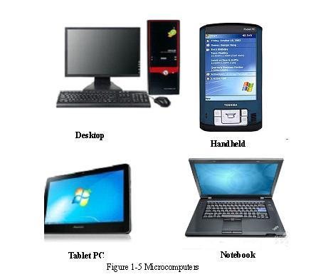
Desktop Handheld
Tablet PC Notebook
Figure 1-5 Microcomputers
NOTES
[1] 这是一个and连接的并列句。后一个分句中的 whatever是关系代词，引导后面的宾语从句。
[2] 长句中such引导的同位语中有三个并列的宾语。
[3] 由and连接的并列句，后一句中 that引导的定语从句修饰 form。
[4] that引导的定语从句，修饰 system unit；house为动词，原意为“留宿”、“收容”，此处为“含有”、“包含”之意。
[5] Although引导的是让步状语从句。
KEYWORDS
programmable 可编程的
input 输入
output 输出
store，storage 存储，存储器
bar-code 条形码
scanner 扫描仪
joystick 操纵杆
touch screen 触摸屏
digital camera 数字（码）相机
electronic pen 电子笔
fingerprint reader 指纹阅读器
stereo system 立体系统
CD（Compact Disk） 高密度磁盘，光盘，激光唱盘
player 播放器
CPU（Central Processing Unit） 中央处理器
main box 主机箱
control unit 控制器，控制部件
arithmetic and logic unit (ALU) 算术／逻辑部件
register 寄存器
memory 存储器
decode 译码
operand 操作数
communication 通信
machine-coded 机器编码
display screen 显示屏
desktop printer 台式打印机
online 在线，联机
workstation 工作站
magnetic tape drive 磁带驱动器
primarily storage 主存储器
secondary storage 二级存储器
supercomputer 超级计算机
mainframe computer 大型计算机
minicomputer 小型计算机
desktop computer 台式计算机
notebook computer 笔记本电脑
tablet PC 平板式个人电脑
handheld computer 手持计算机
EXERCISES
Match the following terms to the appropriate definitions.
1. ______ Computer.
2. ______ Instructions.
3. ______ basic operations within a computer.
4. ______ Input device.
5. ______ CPU.
6. ______ Registers.
7. ______Control unit.
8. ______ ALU.
9. ______Output device.
10. ______ Storage.
11. ______ Supercomputers.
12. ______ Mainframe computers.
13. ______ Minicomputers.
14. ______ Microcomputers.
a. a computer section stored instructions, programs and data
b. the most widely used and fastest-growing computers
c. input, processing, storage, and output
d. supervises the operation of the entire computer system
e. fhave great processing speeds and data storage
f. a programming electronic device
g. instrument of interpretation and communication between human and computer systems
h. tell the computer what to do
i. the heart of any computer system
j. has logical and computational capabilities
k midrange computers
l. the most powerful type of computer
m. storage location inside the processor
n. supplies materials to the computer

1.3 COMPUTER SOFTWARE
As already mentioned, the term computer software refers to the programs or instructions used to tell the computer hardware what to do. Software is generally purchased in some sort of a physical package. Such a software package may consist of the program, as well as instructional and help materials, on CD or DVD discs, printed operating instructions and user manuals, and a printed license to use the software—all or some of which are inside a shrink-wrapped box or plastic case. ^{[1]} You can buy software in a store, through mail order, or over the Internet. If you download the software from the Internet, you won’t receive a physical package. Instead, the components (program, license, user’s manual, and so forth) are downloaded directly to your computer in an electronic format.
Computers use two basic types of software: Application software and system software. Application software helps you perform a specific task. System software refers to the operating systems and all utility programs that manage computer resources at a low level.^{[2]} Figuratively speaking, application software sits on top of system software. Without the operating system and system utilities, the computer cannot run any application program.
1. Application Software
Application Software is widely referred to as productivity software. Application software is comprised of programs designed for an end user. Some of the more commonly application programs are word processors, database systems, presentation systems, spreadsheet programs, and desktop publishing programs. Some other application categories are as follows:
Education, home, and personal software—reference, entertainment, personal finance, calendars, e-mail, browsers.
Multimedia software—authoring, animation, music, video and sound capturing and editing, virtual reality, Web site development.
Workgroup computing software—calendars and scheduling, e-mail, browsers, electronic conferencing, project management.
2. System Software
System software is a group of programs that coordinate and control the resources and operations of a computer system. System software enables the many components of the computer system to communicate. There are three categories of system software: operating systems, utilities, and language translators.
3. Operating System
Operating systems provide an interface between the user or application program and the computer hardware. There are many brands and versions of operating system software. Each of these is designed to work with one or more particular processors. For example, an operating system like Windows is designed to work with a processor made by Intel. Many IBM PC compatible computers contain this brand of processor. Most Macintosh computers contain a processor manufactured by Motorola. The Windows operating system does not work with this Motorola processor.
4. Utilities
Utility programs help you perform housekeeping chores. You use these programs to complete specialized tasks related to managing the computer’s resources, file management, and so forth. Some utility programs are part of the operating system, and others are self-contained programs.^{[3]} Some examples of utility program functions are as follows:
You format a disk—a disk formatting utility provides the instructions to the computer on how to do this.
You copy a file from the hard drive to a floppy disk—the file management utility provides the instructions to the computer.
You do a backup of the hard drive—you use the backup utility.
5. Language Translators
Language Translators convert English-like software programs into machine language that the computer can understand. Vista Multimedia hires a programmer to write a software program to inventory all of the items in the store.^{[4]} The programmer writes the program statements using a programming language called Visual Basic. A program statement directs the computer to perform a specified action.
The computer, however, cannot read the Visual Basic programming statements because they are written in a language that we understand. This is where the language translator takes over.^{[5]} The translator changes each of the Visual Basic programming statements into machine language. A single statement in a high-level language can represent several machine-language instructions. Now the statements can be executed and the Vista Multimedia inventory can be processed.
NOTES
[1] 长句。句中介词of的宾语为多个并列，最后all or some of which引导的是非限定性定语从句。
[2] low level软件是指软件层次结构中的最底层的软件，通常是对硬件进行操作的。
[3] self-contained program；自包含程序。
[4] Vista Multimedia为一公司名。
[5] where 引导的是表语从句，take over 接收，占领，此处表明语言翻译器起作用。
KEYWORDS
software package 软件包
mail order 邮购
download 下载
application software 应用软件
system software 系统软件
operating system 操作系统
utility program 实用程序，公用程序
productivity software 生产力软件
end user 最终（终端，直接）用户
presentation system 表示系统
database system 数据库系统
spreadsheet 电子数据表，电子表格
word processor 文字处理器，字处理程序
desktop publishing 桌面出版
browser 浏览器
authoring 创作，编辑
animation 动画
sound capturing 声音捕捉
virtual reality 虚拟现实
workgroup computing software 工作组处理软件
language translator 语言翻译器（程序）
copy 拷贝，复制
backup 备份
machine language 机器语言
Visual Basic 可视Basic语言，简称VB
EXERCISES
True/False.
1. Generally, a software we bought in a store is on CDs or DVDs discs.
2. You will receive a physical package if you download a software from the Internet.
3. There are two basic types of software in the computers.
4. System software helps you perform a specific task.
5. All utility programs belong to the application software.
6. With the operating system and system utilities, the computer can run any application program.
7. Personal finance software is one of application software.
8. A computer system is controlled by its operating system.
9. There are four categories of system software.
10. Operating system is designed to work with one or more particular processors.
11. Windows operating system is designed to work with a processor made by Motorola.
12. Utility programs help you to manage the computer’s resources.
13. Using a application program, you can format a disk.
14. A computer can understand a English-like program without language translator.
15. A single statement in a high-level language can represent several machine language instructions.
16. Computer software refers to the programs or instructions used to tell the computer hardware what to do.

1.4 THE INTERNET
The Internet is the largest and most well known computer network in the world. It is technically a network of networks, since an individual user connects to a network set up by their access provider or Internet service provider (ISP), which in turn is connected to a larger network, which may be connected to an even larger network ^{[1]}. All together, this network of networks is referred as the Internet. Since all the networks on the Internet are interconnected, any computer with Internet access can communicate with any other computer on the Internet, regardless of the ISP used.
1. The Domain Name Service (DNS)
The Domain Name System (DNS) was created to centralize the task of making changes to the network name to address assignments and to automate the task of performing the translation functions^{[2]}. In the early days of the Internet, a central location (SRI NIC at Stanford Research Institute in Melo Park, California) was responsible for maintaining a HOSTS file that contained the name of every host on the Internet along with its address ^{[3]}. Administrators had to communicate changes to SRI NIC, and these changes were incorporated into the file periodically. Of course, this meant that the file then had to be distributed to every single host so that it could have the updated version ^{[4]}.
DNS uses a hierarchical distributed architecture that is spread across many computers throughout the Internet. A root server holds information about top level domains (such as .com, .edu, and .gov), and each domain throughout the Internet has a domain name server that is responsible for the computer names and addresses used in that domain ^{[5]}. Client computers query DNS servers when they need to get the address for a hostname. If the local DNS knows the address, it returns it to the client computer. If it does not, it sends the query up the chain of DNS servers until a DNS server is found that can resolve the name, provided that it is indeed a valid name ^{[6]}.
The topmost entry in the DNS hierarchy is called the root domain and its represented by the period character (.). Underneath this root domain are the top-level directories that fall into two groups: geographical and organizational. Geographical domains are used to specify specific countries. For example, .au for Australia and .cn for China. Under each of the geographical domains, you can find organizational domains.
Organizational domains you might be familiar with include the following ^{[7]}:
(1) com Used for commercial organizations.
(2) edu Used for educational institutions.
(3) gov Used for U.S. Government entities.
(4) mil Used for U.S. military organizations.
(5) Int International organizations.
(6) net Used for Network organizations such as Internet service providers.
(7) org Used for nonprofit organizations.
(8) arpa Used for inverse address lookups.
The structure of the Domain Name System is similar to an inverted tree. In Figure 1-6 you can see that at the top is the root domain with the com through cn domains underneath ^{[8]}. Under the com domain are individual business organizations that each their own domain. Under any particular domain, there can be sub-domains.
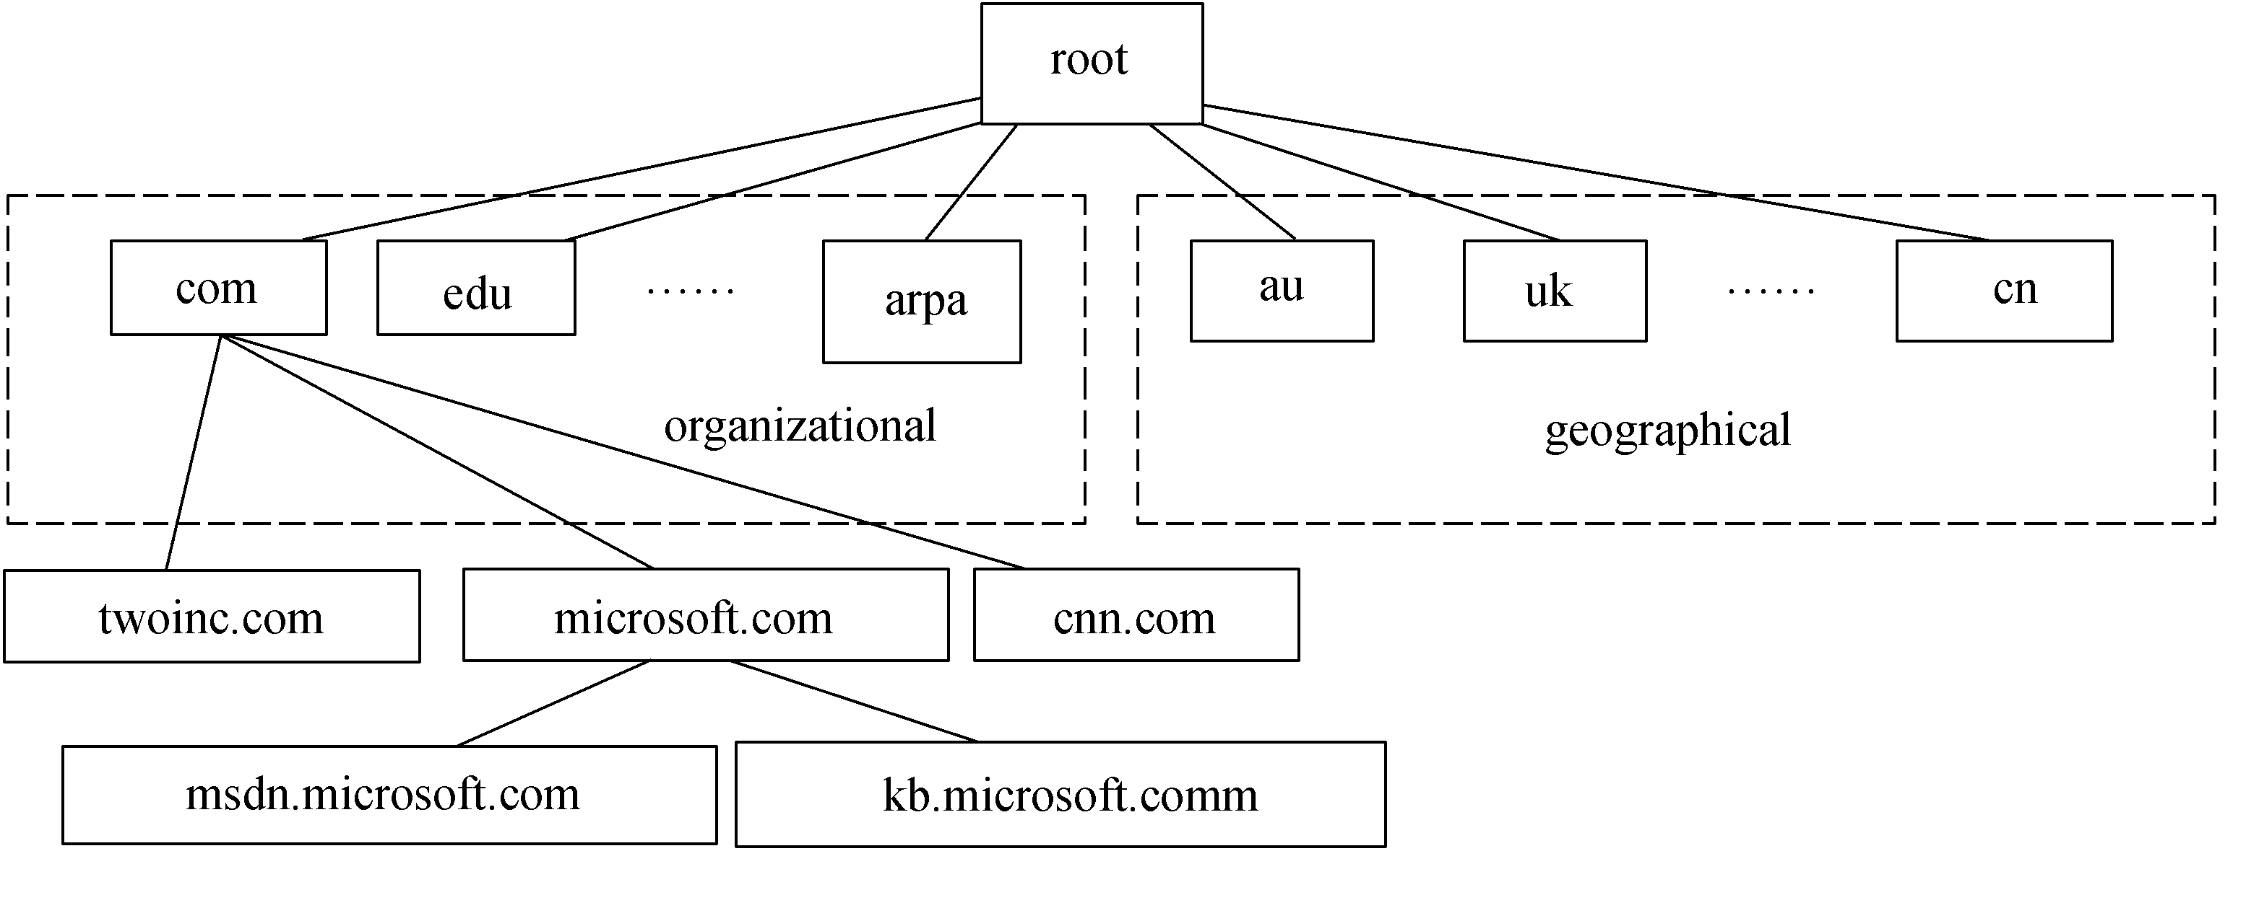
Figure 1-6 Domain Name System is a distributed, hierarchical structure
2. Connecting To The Internet
1) Dial-Up Connections
Dial-Up Connections usually work over regular telephone lines. To connect to the Internet your modem (or other appropriate interface device) dials up and connects to a modem attached to your ISP’s computer.^{[9]} While you are connected, your PC is assigned a temporary IP address for the current session.^{[10]} At the end of each Internet session, you disconnect from your ISP’s computer to allow another user to connect in your place.^{[11]} Standard dial-up Internet service uses a conventional dial-up modem rated at a maximum data transfer rate of 56kbps.
2) ADSL Connection
Another type of dial-up connection is ADSL which is the most common way to access the Internet today. Sometimes ADSL is called as broadband accessing, because it provides more wider bandwidth than that the regular modem provides.
ADSL was first developed in the 1980s the telecommunications industry’s answer to the cable industry’ request to support video on demand. In the middle 1990s, however, it was quickly recognized as a viable technology to enable access to high-speed services such as the Internet.^{[12]} ADSL delivers asymmetric transmission rates typically up to 9Mbps downstream (from the CO to the premises) and 16kbps to 640kbps upstream (from the premises to the CO) as shown in Figure1-7. Like all copper transmission systems, the higher the bit rate, the shorter the range. A limitation of ADSL transmission is distance: It can only be used within three miles of a telephone switching station, and the speed degrades as the distance gets closer and closer to the three-mile limit.
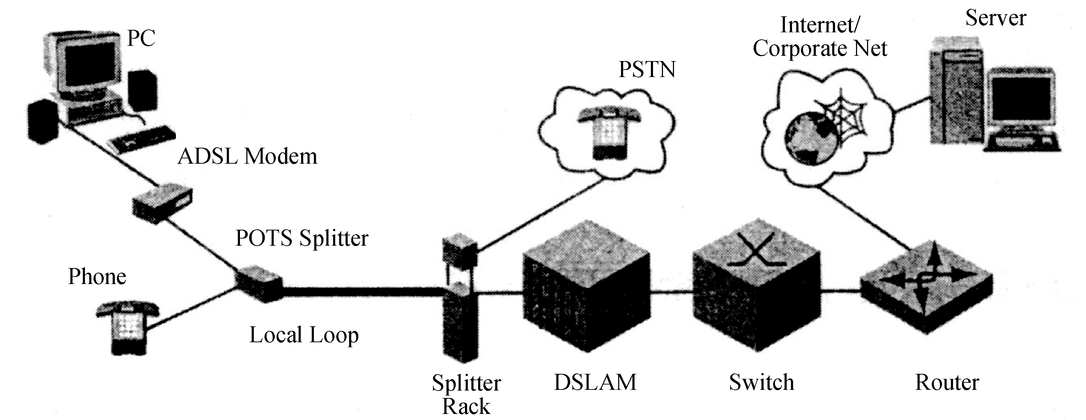
Figure 1-7 ADSL architecture
3) HFC Technology
HFC technology is base on existing cable television (cable TV or CATV) technology. Originally, cable TV systems were based on coaxial cable facilities from an MSO to a customer premises and used a tree topology. Most of these systems have been upgraded to HFC, by which the signal is brought to a fiber node via a pair of optical fibers and then distributed via coaxial cable to customers, as illustrated in Figure1-8.^{[13]} At the head end, signals from various sources, such as traditional satellite services, analog and digital services using WAN, and Internet service provider (ISP) services using private backbone network, are multiplexed and converted up from an electrical (radio frequency) signal to an optical signal.^{[14]}
Communication is one way on the optical fiber; each of a pair of optical fibers from the head end to the fiber node carries one-way traffic in opposite directions. The optical signal is converted down to RF at the fiber node and travels over the coaxial cable in a duplex mode. The signal going from the head end to the customer premises is called a downstream signal or a forward path signal. The signal going from the customer premises to the head end is called an upstream signal or a reverse path signal.
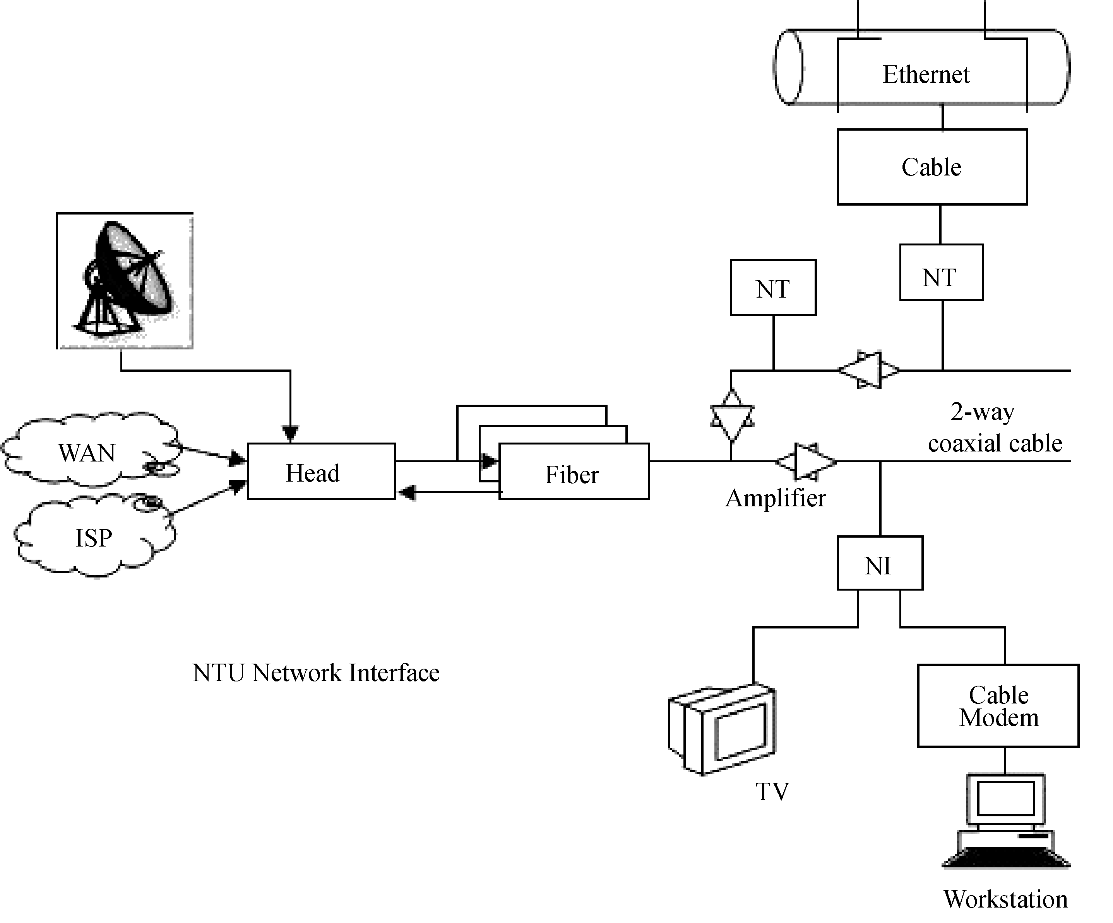
Figure 1-8 An HFC network
4) Dedicated Connection
Unlike dial-up connections that only connect to your ISP’s computer when you need to access the Internet, dedicated connections keep you continually connected to the Internet. With a dedicated connection, your PC is typically issues a static (non-changing) IP address to be used to transfer data back and forth via the Internet.
Types of dedicated Internet connections include connecting through a school or office LAN, as well as ADSL, cable, satellite, and fixed wireless connections.
5) Wireless Connection
Wireless connections do not use a solid substance to connect sending and receiving devices. Rather, they use the air itself. Primary technologies used for wireless connections are infrared, broadcast radio, microwave, satellite and mobile wireless connections.
(1) Infrared: Infrared uses infrared light waves to communicate over short distances. It is sometimes referred to as line-of-sight communication because the light waves can only travel in a straight line. This requires that sending and receiving devices must be in clear view of one another without any obstructions blocking that view. One of the most common applications is to transfer data and information from a portable device such as a notebook computer or PDA to a desktop computer.
(2) Broadcast radio: Broadcast radio uses radio signals to communicate with wireless devices. For example, cellular telephones and many Web-enabled devices use broadcast radio to place telephone calls and/or to connect to the Internet ^{[15]}. Some end users connect their notebook or handheld computers to a cellular telephone to access the Web from remote locations. Most of these Web-enabled devices follow a standard known as Wi-Fi (wireless fidelity). This wireless standard is widely used to connect computers to each other and to the Internet.
(3) Microwave: Microwave communication uses high-frequency radio waves. Like infrared, microwave communication provides line-of-sight communication because microwaves travel in a straight line. Because the waves can be transmitted only over relatively short distances, thus, microwave is a good medium for sending data between buildings in a city or on a large college campus.
Bluetooth is a short-range wireless communication standard that uses microwaves to transmit data over short distances of up to approximately 33 feet. Unlike traditional microwaves, Bluetooth does not require line-of-sight communication. Rather, it users radio waves that can pass through nearby walls and other nonmetal barriers.
(4) Satellite: Satellite can be used to send and receive large volumes of data. Uplink is a term relating to sending data to a satellite. Downlink refers to receiving data from a satellite. The major drawback to satellite communication is that bad weather can sometimes interrupt the flow of data.
One of the most interesting applications of satellite communications is for global positioning. A network of 24 satellites owned and managed by the Defense Department continuously sends location information to earth. Global positioning system (GPS) devices use that information to uniquely determine the geographical location of the device.
(5) Mobile Wireless Connection: Unlike satellite and fixed wireless connections, which use a cable to connect the modem to some type of fixed transceiver, mobile wireless connections allow the device to be moved from place to place. Consequently, most handheld PCs and other mobile devices (like Web-enable cell phones) use a mobile wireless connection and access the Internet through the same wireless network as cell phones and messaging devices.
NOTES
[1] 长句。句首 It代表 Internet; since引导的是原因状语从句，而从句中又包含两个由 which引导的非限定性定语从句。
[2] to centralize…and to automate…为状语，后面都有介词短语作定语，分别修饰两个the task。此句说明DNS的功能是将网络中的主机名翻译成它的IP地址。
[3] HOSTS文件，也是用于将主机名或者正式域名解析为相关的IP地址的，功能与 DNS一样，只不过 HOSTS比 DNS出现得早。在20世纪70年代，Internet前身 ARPANET时期，只有几百台主机在网上，使用 HOSTS完全可以。后来随着 Internet的出现，并且很快扩展到全世界，早已用 DNS取代HOSTS了。
[4] 第一个that引导的是宾语从句；后面的 so that引导的是目的状语从句。
[5] 最高层的域名是顶级域名，以行业为顶级域名的如.com(商业)，.edu（教育）等是指美国本土的，其他则以国家和地区为顶级域名，如cn(中国)，.hk（香港）等。
[6] 句中it代表local DNS, until引导的时间状语从句中，that can resolve…为定语从句，修饰DNS server。provided…为状语，其中从属连接词that引导的是宾语从句，从句中it为先行代词，真正的主语为a valid name。
[7] you might be familiar with 为定语从句，修饰domains。
[8] that引导的是宾语从句，句中 at the top为主语； with the com through cn domains 为状语，underneath 副词，在底下之意。
[9] your modem dials up为主动语态，实际上是对modem进行拨号。后一个modem 是ISP机器上的。attached to…分词短语作定语。
[10] While引导的是时间状语从句，为被动语态，实际上是完成了连接之后，由ISP给该PC机指派一个临时IP地址。
[11] in your place 指你所使用的IP地址，此句与上一句的意思紧密相关。
[12] to enable…为实际主语，it为先行主语。
[13] by which引导的是非限定性定语从句。
[14] 长句。主句为signals…are multiplexed and …，中间插入了由such as 引导的同位语。
[15] cellular telephone 即移动电话。
KEYWORDS
access provider 访问提供商，接入提供商
ISP (Internet Service Provider ) 因特网服务提供商
DNS (Domain Name System ) 域名系统
domain name service 域名服务
host 主机
top level domain 顶级域
domain name server 域名服务器
client 客户
root domain 根域
sub-domain 子域
dial-up 拨号
modem 调制解调器
interface device 接口设备
IP（Internet Protocol） 网际协议，网间协议，互联网协议
transfer rate 传输速率
ADSL（Asymmetric Digital Subscriber Line） 非对称数字用户线
broadband 宽（频）带
VOD (Video On Demand) 视频点播
downstream 下行，顺流，下游
upstream 上行，逆流，上游
CO（Central Office） 中心（交换）局
HFC（Hybrid Fiber Coax） 混合光纤同轴电缆（网）
CATV（Cable Television ） 有线电视
（Co-Axial Television） 同轴电缆电视
（Common Antenna Television） 共用天线电视
tree topology 树形拓扑
optical fiber 光纤，光缆
head end 头端器，数据转发器
WAN（Wide Area Network） 广域网
backbone network 主（管）干网
RF (Radio Frequency) 射频
node 节点
duplex 双工
dedicated connection 专线连接
LAN（Local Area Network） 局域网
satellite 卫星
wireless 无线
infrared 红外线
microwave 微波
line-of-sight communication 视距通信
portable device 便携设备
PDA(Personal Digital Assistant) 个人数字助理
Cellular telephone, cell phone 蜂窝电话
Web 万维网
end user 最终用户
Wi-Fi (Wireless Fidelity) 无线保真度（无线局域网）联盟
uplink 上行链路
downlink 下行链路
global positioning 全球定位
EXERCISES
Multiple choices.
1. The Internet is __________.
a. a network of networks
b. a public network
c. the largest and most well known computer network in the world
d. a private network
2. DNS is _________.
a. an abbreviation for Domain Name System
b. used to translate network name to address assignments
c. used at SRI NIC only
d. the successor of HOSTS file
3. DNS has ________.
a. a flat distributed architecture b. a root server
c. a hierarchical distributed architecture d. many root servers
4. Top-level domains in the DNS _________.
a. have two groups
b. have three groups
c. are located on the second layer of a similar inverted tree
d. don’t include domain name of China
5. Following device belongs to the one of dial-up connection _________.
a. HFC b. modem
c. dedicated line device d. ADSL
6. When we use a dial-up connection to access the Internet, we need .
a. a TV cable b. a regular telephone line
c. a modem d. a temporary IP address
7. ADSL works at a rate of .
a. asymmetric transmission
b. symmetric transmission
c. asymmetric transmission with 9Mb/s downstream
d. asymmetric transmission with 16k～64kbps upstream
8. We can find the following facilities in an HFC system .
a. optical fiber b. coaxial cable
c. cable modem d. head end
9. With the dedicated connection to connect the Internet we should .
a. use dial-up connection b. keep a continual connection
c. use a static IP address d. keep a temporary connection
10. Following technologies are used for wireless communication: __________.
a. mobile wireless connection b. microwave
c. satellite d. broadcast radio
11. Infrared connection is used for ________.
a. long distance communication
b. short distance communication
c. line-of-sight communication
d. transferring data between a notebook computer and a desktop computer in one room
12. Using broadcast radio connection, we should use ________.
a. Wi-Fi standard
b. Web-enable devices
c. mobile telephones
d. handheld computers
13. Bluetooth ________.
a. is one type of microwave communication
b. requires line-of-sight communication
c. can pass through nonmetal barriers
d. can be used to transmit data over short distance of up to approximately 10 meters
14. Satellite communication has ________.
a. an uplink and a downlink
b. a limitation of its application as bad weather can interrupt the flow of data
c. an interesting application which is GPS
d. the capability for sending and receiving large volumes of data
15. Mobile wireless connection _________.
a. should be used to connect fixed devices
b. should be used to connect mobile devices
c. can be used to access Internet
d. allows the device to be moved from place to place

