第一章 我的第一个家
Chapter 1 My Early Home
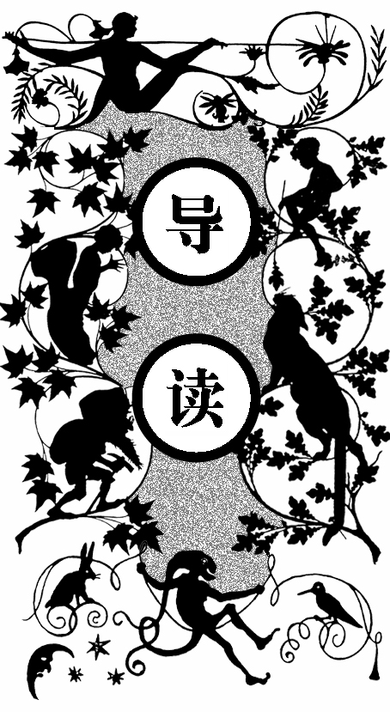
在一个牧场里，有一个池塘，池塘边上栽着一些柳树。小黑马白天在妈妈身边奔跑，天热了就在树荫下休息。
牧场有六匹小马驹，他们经常奔跑，有时边跑边相互撕咬，而且还踢人。一天，小黑马的妈妈告诉他：那些小马驹以后都是拉大车的，没学过礼仪，但他是有教养的，要做一匹彬彬有礼的好马，不能咬人和踢人。
小黑马的主人对他很好，经常给他些好吃的。一天，一个叫迪克的小男孩翻过篱笆摘黑莓吃，然后用石子和树枝赶他们玩。这一切都被在隔壁的主人看到了，他跳过来抓着迪克的胳膊打了他一耳光，并将他开除了。牧场照看马匹的老丹尼尔和主人一样和善，小黑马的日子过得 很好。

he first place that I can well remember was a large pleasant meadow with a pond of clear water in it. Some shady trees leaned over it, and rushes and water-lilies grew at the deep end. Over the hedge on one side we looked into a plowed field, and on the other we looked over a gate at our
T

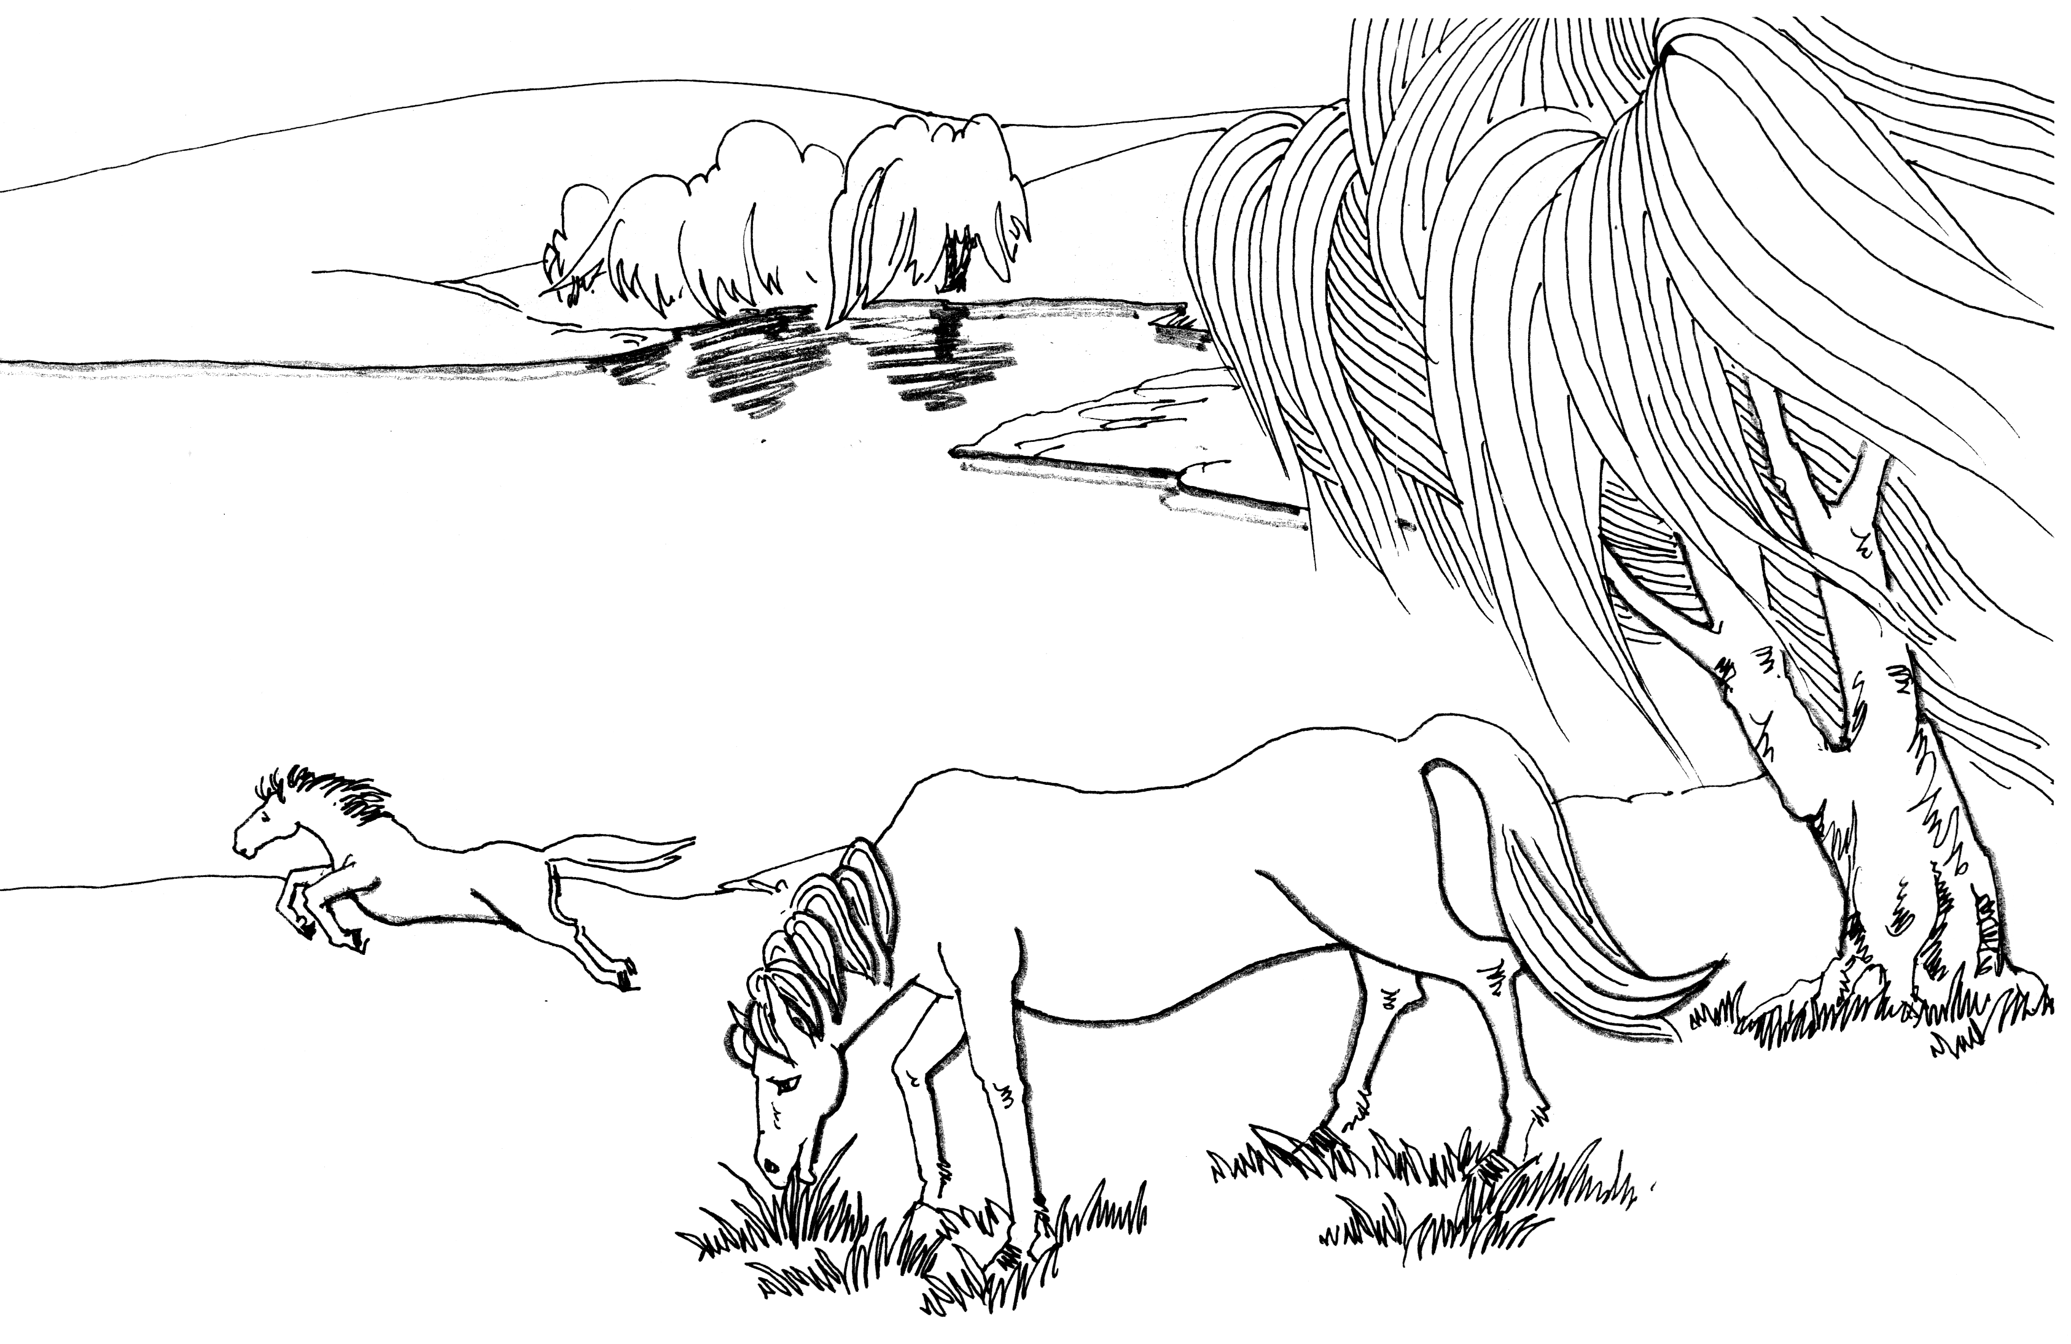
黑马驹在妈妈身边奔跑
master’s house, which stood by the roadside; at the top of the meadow was a grove of fir trees, and at the bottom a running brook overhung by a steep bank.
While I was young I lived upon my mother’s milk, as I could not eat grass. In the daytime I ran by her side, and at night I lay down close by her. When it was hot we used to stand by the pond in the shade of the trees, and when it was cold we had a nice warm shed near the grove.
As soon as I was old enough to eat grass my mother used to go out to work in the daytime, and come back in the evening.
There were six young colts in the meadow besides me; they were older than I was; some were nearly as large as grown-up horses. I used to run with them, and had great fun; we used to gallop all together round and round the field as hard as we could go. Sometimes we had rather rough play, for they would frequently bite and kick as well as gallop.
One day, when there was a good deal of kicking, my mother whinnied to me to come to her, and then she said: “I wish you to pay attention to what I am going to say to you. The colts who live here are very good colts, but they are cart-horse colts, and of course they have not learned manners. You have been well-bred and well-born; your father has a great name in these parts, and your grandfather won the cup two years at the Newmarket races; your grandmother had the sweetest temper of any horse I ever knew, and I think you have never seen me kick or bite. I hope you will grow up gentle and good, and never learn bad ways; do your work with a good will, lift your feet up well when you trot, and never bite or kick even in play.”
I have never forgotten my mother’s advice; I knew she was a wise old horse, and our master thought a great deal of her. Her name was Duchess, but he often called her Pet.
Our master was a good, kind man. He gave us good food, good lodging, and kind words; he spoke as kindly to us as he did to his little children. We were all fond of him, and my mother loved him very much. When she saw him at the gate she would neigh with joy, and trot up to him. He would pat and stroke her and say, “Well, old Pet, and how is your little Darkie?” I was a dull black, so he called me Darkie; then he would give me a piece of bread, which was very good, and sometimes he brought a carrot for my mother. All the horses would come to him, but I think we were his favorites. My mother always took him to the town on a market day in a light gig.
There was a plowboy, Dick, who sometimes came into our field to pluck blackberries from the hedge. When he had eaten all he wanted he would have what he called fun with the colts, throwing stones and sticks at them to make them gallop. We did not much mind him, for we could gallop off; but sometimes a stone would hit and hurt us.
One day he was at this game, and did not know that the master was in the next field; but he was there, watching what was going on; over the hedge he jumped in a snap, and catching Dick by the arm, he gave him such a box on the ear as made him roar with the pain and surprise. As soon as we saw the master we trotted up nearer to see what went on.
“Bad boy!” he said, “bad boy! to chase the colts. This is not the first time, nor the second, but it shall be the last. There—take your money and go home; I shall not want you on my farm again.” So we never saw Dick any more. Old Daniel, the man who looked after the horses, was just as gentle as our master, so we were well off.

第二章 打 猎
Chapter 2 The Hunt
在小黑马还不到两岁的时候，一天，他和几匹马驹正在吃草，一匹年龄大的马驹听到有猎犬叫，便跑到高处，小黑马的妈妈和另一匹马也在附近站着。妈妈说他们发现野兔了，一些猎狗叫着冲进旁边的麦苗地里，后面跟着一些骑着马的猎人。
他们看到一只惊慌的野兔朝树林奔去，后面有猎狗和猎人追着。野兔没有冲过密实的篱笆，最后被猎狗捉到了。猎人从后面骑马赶来，将猎狗赶走，拎起了还在流血的野兔。
这时，小溪边有两匹马倒下了，马上的人有一个在水中站了起来、另一个躺在那里没动。小黑马的妈妈说那人的脖子摔断了，他们认为那是罪有应得。
妈妈让他们不要那么说，虽然她也认为一些人为了一点猎物，毁掉了庄稼，毁了好多马，并且也常常伤到自己是不应该的。
这时，很多人向骑马人走去，他是乡绅唯一的儿子小乔治·葛登。人们将他抬回家，有人去找医生，有人去找兽医。兽医看了看马儿又摇了摇头，然后有人拿枪结束了马的性命。
没过几天，小葛登也进了墓地——他为了一只兔子而丢了性命。

efore I was two years old a circumstance happened which I have never forgotten. It was early in the spring; there had been a little frost in the night, and a light mist still hung over the woods and meadows. I and the other colts were feeding at the lower part of the field when we heard, quite in the distance, what sounded like the cry of dogs. The oldest of the colts raised his head, pricked his ears, and said, “There are the hounds!” and immediately cantered off, followed by the rest of us to the upper part of the field, where we could look over the hedge and see several fields beyond. My mother and an old riding horse of our master’s were also standing near, and seemed to know all about it.
B
“They have found a hare,” said my mother, “and if they come this way we shall see the hunt.”
And soon the dogs were all tearing down the field of young wheat next to ours. I never heard such a noise as they made. They did not bark, nor howl, nor whine, but kept on a “yo! yo, o, o! yo! yo, o, o!” at the top of their voices. After them came a number of men on horseback, some of them in green coats, all galloping as fast as they could. The old horse snorted and looked eagerly after them, and we young colts wanted to be galloping with them, but they were soon away into the fields lower down; here it seemed as if they had come to a stand; the dogs left off barking, and ran about every way with their noses to the ground.
“They have lost the scent,” said the old horse; “perhaps the hare will get off.”
“What hare?” I said.
“Oh! I don’t know what hare; likely enough it may be one of our own hares out of the woods; any hare they can find will do for the dogs and men to run after;” and before long the dogs began their “yo! yo, o, o!” again, and back they came altogether at full speed, making straight for our meadow at the part where the high bank and hedge overhang the brook.
“Now we shall see the hare,” said my mother; and just then a hare wild with fight rushed by and made for the woods. On came the dogs; they burst over the bank, leaped the stream, and came dashing across the field followed by the huntsmen. Six or eight men leaped their horses clean over, close upon the dogs. The hare tried to get through the fence; it was too thick, and she turned sharp round to make for the road, but it was too late; the dogs were upon her with their wild cries; we heard one shriek, and that was the end of her. One of the huntsmen rode up and whipped off the dogs, who would soon have torn her to pieces. He held her up by the leg tom and bleeding, and all the gentlemen seemed well pleased.
As for me, I was so astonished that I did not at first see what was going on by the brook; but when I did look there was a sad sight; two fine horses were down, one was struggling in the stream, and the other was groaning on the grass. One of the riders was getting out of the water covered with mud, the other lay quite still.
“His neck is broke,” said my mother.
“And serve him right, too,” said one of the colts.
I thought the same, but my mother did not join with us.
“Well, no,” she said, “you must not say that; but though I am an old horse, and have seen and heard a great deal, I never yet could make out why men are so fond of this sport; they often hurt themselves, often spoil good horses, and tear up the fields, and all for a hare or a fox, or a stag, that they could get more easily some other way; but we are only horses, and don’t know.”
While my mother was saying this we stood and looked on. Many of the riders had gone to the young man; but my master, who had been watching what was going on, was the first to raise him. His head fell back and his arms hung down, and every one looked very serious. There was no noise now; even the dogs were quiet, and seemed to know that something was wrong. They carried him to our master’s house. I heard afterward that it was young George Gordon, the squire’s only son, a fine, tall young man, and the pride of his family.
There was now riding off in all directions to the doctor’s, to the farrier’s, and no doubt to Squire Gordon’s, to let him know about his son. When Mr. Bond, the farrier, came to look at the black horse that lay groaning on the grass, he felt him all over, and shook his head; one of his legs was broken. Then some one ran to our master’s house and came back with a gun; presently there was a loud bang and a dreadful shriek, and then all was still; the black horse moved no more.
My mother seemed much troubled; she said she had known that horse for years, and that his name was “Rob Roy”; he was a good horse, and there was no vice in him. She never would go to that part of the field afterward.
Not many days after we heard the church-bell tolling for a long time, and looking over the gate we saw a long, strange black coach that was covered with black cloth and was drawn by black horses; after that came another and another and another, and all were black, while the bell kept tolling, tolling. They were carrying young Gordon to the churchyard to bury him. He would never ride again. What they did with Rob Roy I never knew; but it was all for one little hare.

第三章 我开始接受训练
Chapter 3 My Breaking in
小黑马越长越漂亮，前额上长着一颗好看的白星，浑身的毛又黑又亮。他四岁时，葛登老爷来看了看，认为小黑马要是能好好调教，将来会很出色的。
于是，第二天，主人就开始驯服他，让他学会背马鞍、带笼头，接着学习驮人、拉车，并且要保持安静，不能乱踢、乱咬，要习惯被人牵着在田野上静静地走来走去，还得让他咬一个马嚼子，但主人也会时不时地给他一把燕麦作为奖励。主人在老丹尼尔的帮助下给他背上了马鞍，并用燕麦奖励他。小黑马习惯后，主人便骑到他的背上在草地上走，慢慢地小黑马也适应了。
主人又给他钉马掌、戴马具，之后把他送到邻近一个挨着铁路的牧场里，和一些牛羊关在一起。在那里他第一次听到火车的怪叫声，看到那些牛羊还在那里安静地吃草，慢慢地小黑马也习惯了。
小黑马的主人善解人意，经常让他和妈妈一起出工，跟妈妈学习，不像有些凶残的主人。小黑马认为：那样的人不值得为他效忠。妈妈希望小黑马将来能到一个善良人的手里。

was now beginning to grow handsome; my coat had grown fine
I

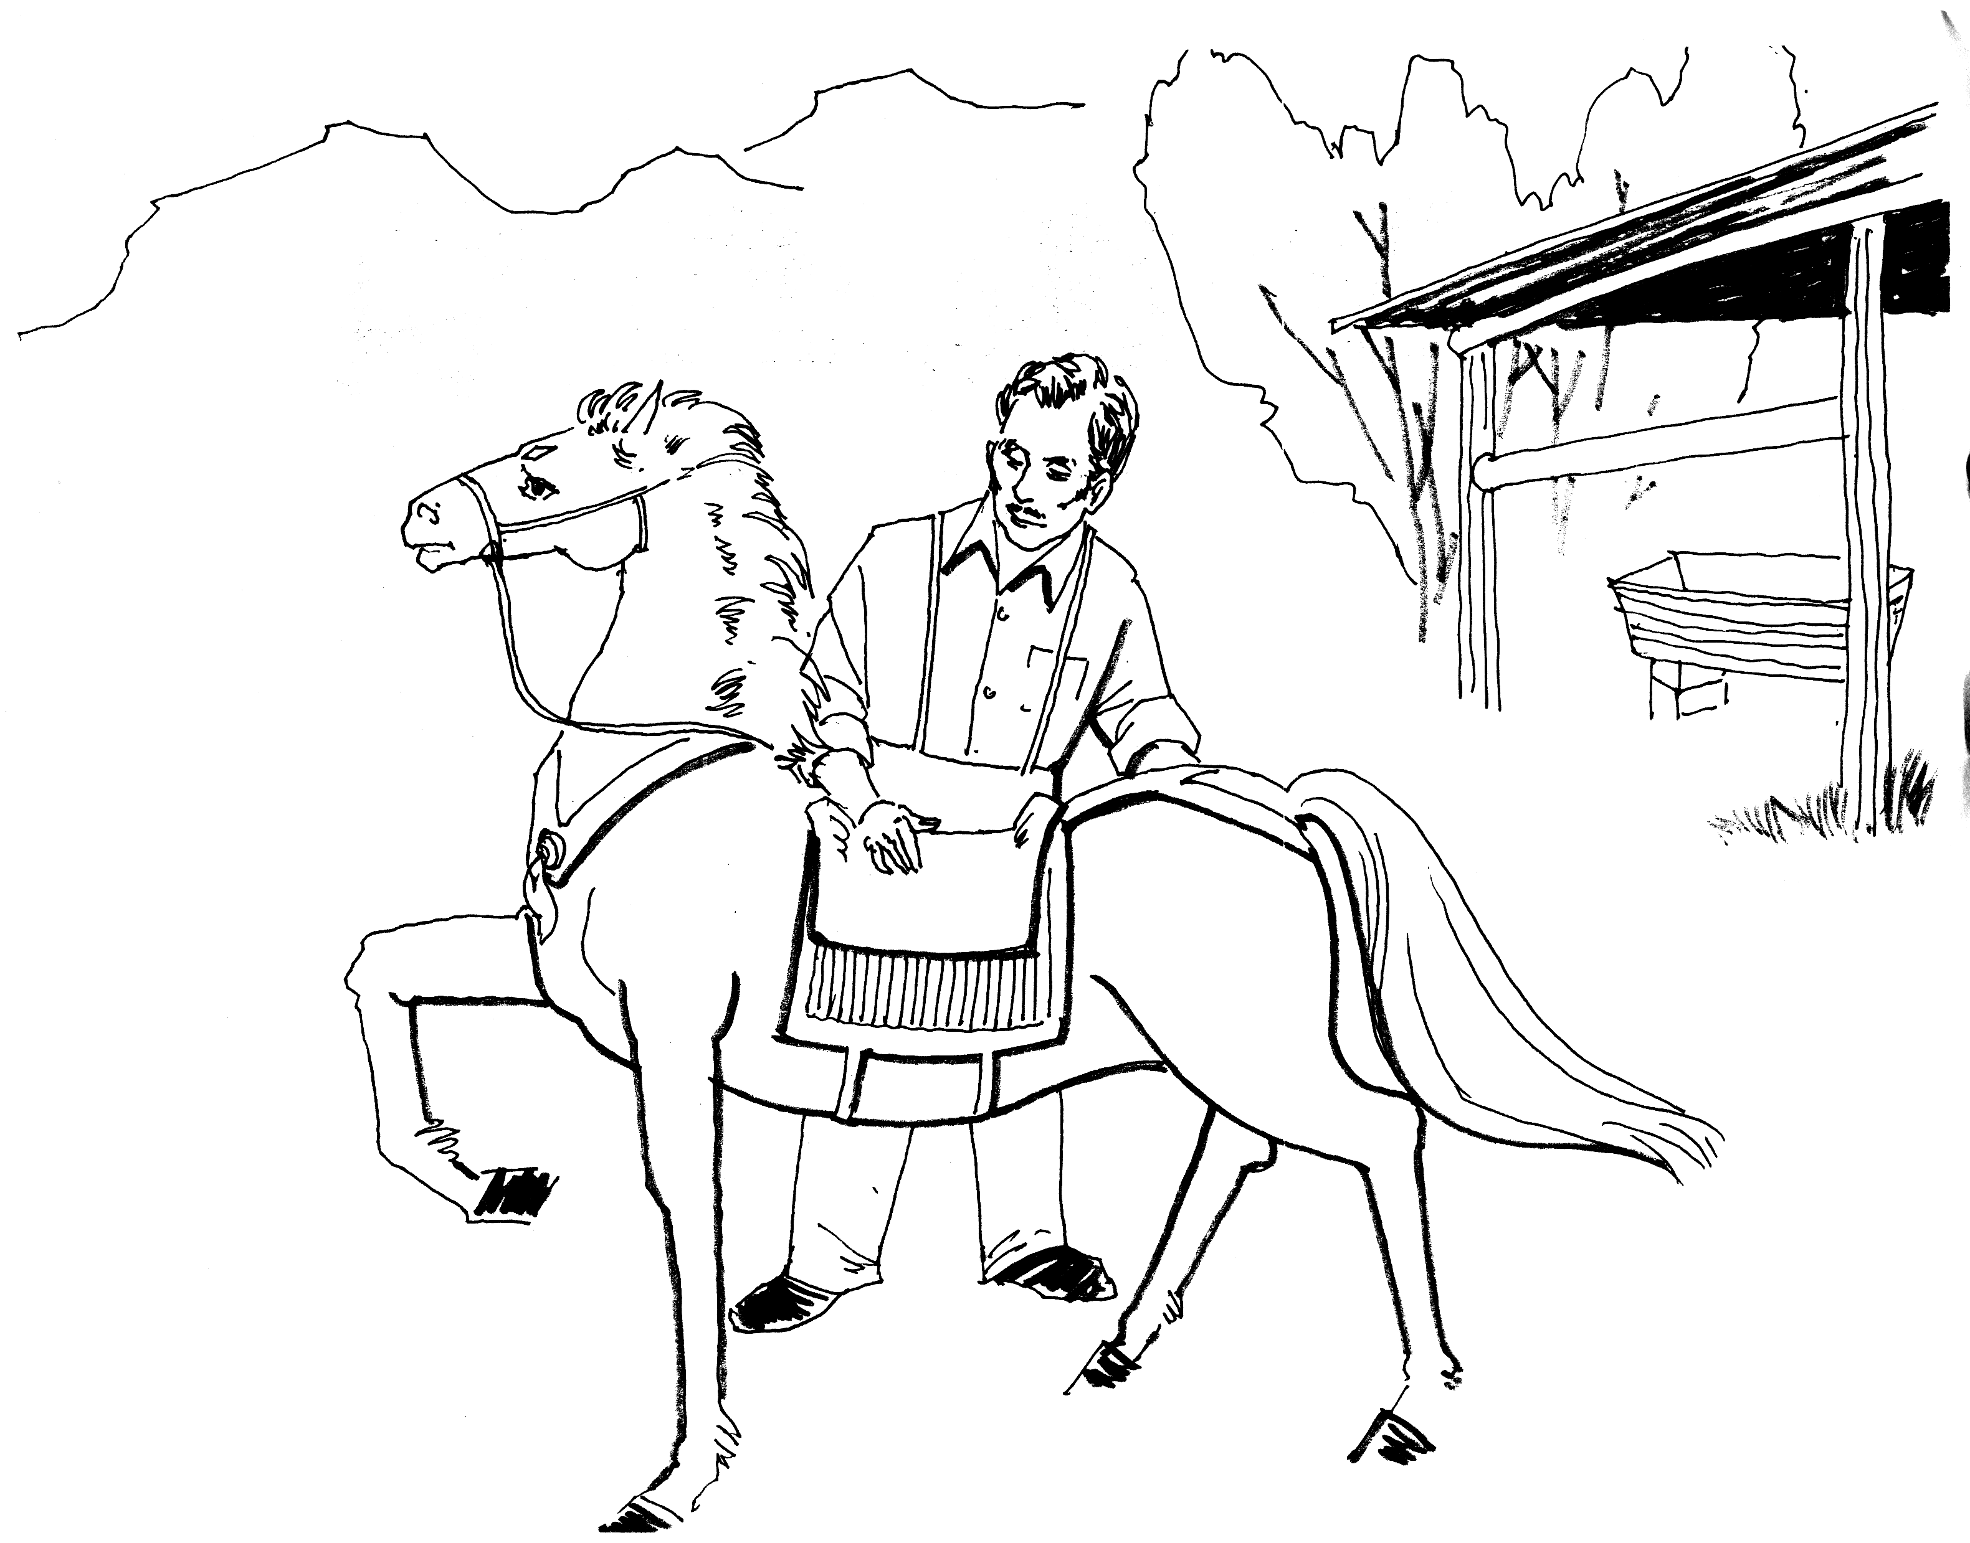
主人开始驯练黑马驹
and soft, and was bright black. I had one white foot and a pretty white star on my forehead. I was thought very handsome; my master would not sell me till I was four years old; he said lads ought not to work like men, and colts ought not to work like horses till they were quite grown up.
When I was four years old Squire Gordon came to look at me. He examined my eyes, my mouth, and my legs; he felt them all down; and then I had to walk and trot and gallop before him. He seemed to like me, and said, “when he has been well broken in he will do very well.” My master said he would break me in himself, as he should not like me to be frightened or hurt, and he lost no time about it, for the next day he began.
Every one may not know what breaking in is, therefore I will describe it. It means to teach a horse to wear a saddle and bridle, and to carry on his back a man, woman or child; to go just the way they wish, and to go quietly. Besides this he has to learn to wear a collar, a crupper, and a breeching, and to stand still while they are put on; then to have a cart or a chaise fixed behind, so that he cannot walk or trot without dragging it after him; and he must go fast or slow, just as his driver wishes. He must never start at what he sees, nor speak to other horses, nor bite, nor kick, nor have any will of his own; but always do his master’s will, even though he may be very tired or hungry; but the worst of all is, when his harness is once on, he may neither jump for joy nor lie down for weariness So you see this breaking in is a great thing.
I had of course long been used to a halter and a headstall, and to be led about in the fields and lanes quietly, but now I was to have a bit and bridle; my master gave me some oats as usual, and after a good deal of coaxing he got the bit into my mouth, and the bridle fixed, but it was a nasty thing! Those who have never had a bit in their mouths cannot think how bad it feels; a great piece of cold hard steel as thick as a man’s finger to be pushed into one’s mouth, between one’s teeth, and over one’s tongue, with the ends coming out at the corner of your mouth, and held fast there by straps over your head, under your throat, round your nose, and under your chin; so that no way in the world can you get rid of the nasty hard thing; it is very bad! yes, very bad! at least I thought so; but I knew my mother always wore one when she went out, and all horses did when they were grown up; and so, what with the nice oats, and what with my master’s pats, kind words, and gentle ways, I got to wear my bit and bridle.
Next came the saddle, but that was not half so bad; my master put it on my back very gently, while old Daniel held my head; he then made the girths fast under my body, patting and talking to me all the time; then I had a few oats, then a little leading about; and this he did every day till I began to look for the oats and the saddle. At length, one morning, my master got on my back and rode me round the meadow on the soft grass. It certainly did feel queer; but I must say I felt rather proud to carry my master, and as he continued to ride me a little every day I soon became accustomed to it.
The next unpleasant business was putting on the iron shoes; that too was very hard at first. My master went with me to the smith’s forge, to see that I was not hurt or got any fright. The blacksmith took my feet in his hand, one after the other, and cut away some of the hoof. It did not pain me, so I stood still on three legs till he had done them all. Then he took a piece of iron the shape of my foot, and clapped it on, and drove some nails through the shoe quite into my hoof, so that the shoe was firmly on. My feet felt very stiff and heavy, but in time I got used to it.
And now having got so far, my master went on to break me to harness; there were more new things to wear. First, a stiff heavy collar just on my neck, and a bridle with great side-pieces against my eyes called blinkers, and blinkers indeed they were, for I could not see on either side, but only straight in front of me; next, there was a small saddle with a nasty stiff strap that went right under my tail; that was the crupper. I hated the crupper; to have my long tail doubled up and poked through that strap was almost as bad as the bit. I never felt more like kicking, but of course I could not kick such a good master, and so in time I got used to everything, and could do my work as well as my mother.
I must not forget to mention one part of my training, which I have always considered a very great advantage. My master sent me for a fortnight to a neighboring farmer’s, who had a meadow which was skirted on one side by the railway. Here were some sheep and cows, and I was turned in among them.
I shall never forget the first train that ran by. I was feeding quietly near the pales which separated the meadow from the railway, when I heard a strange sound at a distance, and before I knew whence it came—with a rush and a clatter, and a puffing out of smoke—a long black train of something flew by, and Was gone almost before I could draw my breath. I turned and galloped to the further side of the meadow as fast as I could go, and there I stood snorting with astonishment and fear. In the course of the day many other trains went by, some more slowly; these drew up at the station close by, and sometimes made an awful shriek and groan before they stopped. I thought it very dreadful, but the cows went on eating very quietly, and hardly raised their heads as the black frightful thing came puffing and grinding past.
For the first few days I could not feed in peace; but as I found that this terrible creature never came into the field, or did me any harm, I began to disregard it, and very soon I cared as little about the passing of a train as the cows and sheep did.
Since then I have seen many horses much alarmed and restive at the sight or sound of a steam engine; but thanks to my good master’s care, I am as fearless at railway stations as in my own stable.
Now if any one wants to break in a young horse well, that is the way.
My master often drove me in double harness with my mother, because she was steady and could teach me how to go better than a strange horse. She told me the better I behaved the better I should be treated, and that it was wisest always to do my best to please my master; “but,” said she, “there are a great many kinds of men; there are good thoughtful men like our master, that any horse may be proud to serve; and there are bad, cruel men, who never ought to have a horse or dog to call their own. Besides, there are a great many foolish men, vain, ignorant, and careless, who never trouble themselves to think; these spoil more horses than all, just for want of sense; they don’t mean it, but they do it for all that. I hope you will fall into good hands; but a horse never knows who may buy him, or who may drive him; it is all a chance for us; but still I say, do your best wherever it is, and keep up your good name.”

第四章 波特韦克庄园
Chapter 4 Birtwick Park
五月初，小黑马被葛登老爷家的一个人带走了，来到波特韦克村旁葛登老爷家的庄园。庄园里有四个围栏。第一个围栏很宽敞，马在里面不用上绳索，因而叫自由围栏，其余的围栏也不错。
马夫将他安排在了第一个围栏中，给了他一些燕麦，然后拍了拍他就走了。他吃完燕麦就和旁边一匹又小又肥的灰马打招呼。灰马仔说自己叫乐腿，不希望邻居乱踢乱咬；前面围栏里的一匹栗色母马埋怨小黑马把她逼出了原本属于她的围栏。小黑马表示自己没逼迫任何人，是马夫将他安排在这里的，并说他已经四岁了，从来没有和别的马发生过口角，希望和大家好好相处。
下午，那匹母马出去后，乐腿告诉小黑马：母马叫生姜，喜欢咬人，曾将詹姆斯的胳膊咬出血。生姜认为大家都对她不好，所以养成了咬人的坏习惯。其实约翰是最好的马夫，詹姆斯这男孩也很好，生姜不能住在这个围栏里完全是她自己造成的。

t this time I used to stand in the stable and my coat was brushed every day till it shone like a rook’s wing. It was early in May, when there came a man from Squire Gordon’s, who took me away to the hall. My master said, “Good-by, Darkie; be a good horse, and always do your best.” I could not say “good-by”, so I put my nose into his hand; he patted me kindly, and I left my first home. As I lived some years with Squire Gordon, I may as well tell something about the place.
A
Squire Gordon’s park skirted the village of Birtwick. It was entered by a large iron gate, at which stood the first lodge, and then you trotted along on a smooth road between clumps of large old trees; then another lodge and another gate, which brought you to the house and the gardens. Beyond this lay the home paddock, the old orchard, and the stables. There was accommodation for many horses and carriages; but I need only describe the stable into which I was taken; this was very roomy, with four good stalls; a large swinging window opened into the yard, which made it pleasant and airy.
The first stall was a large square one, shut in behind with a wooden gate; the others were common stalls, good stalls, but not nearly so large; it had a low rack for hay and a low manger for corn; it was called a loose box, because the horse that was put into it was not tied up, but left loose, to do as he liked. It is a great thing to have a loose box.
Into this fine box the groom put me; it was clean, sweet, and airy. I never was in a better box than that, and the sides were not so high but that I could see all that went on through the iron rails that were at the top.
He gave me some very nice oats, he patted me, spoke kindly, and then went away.
When I had eaten my corn I looked round. In the stall next to mine stood a little fat gray pony, with a thick mane and tail, a very pretty head, and a pert little nose.
I put my head up to the iron rails at the top of my box, and said, “How do you do? What is your name?”
He turned round as far as his halter would allow, held up his head, and said, “My name is Merrylegs. I am very handsome; I carry the young ladies on my back, and sometimes I take our mistress out in the low chair. They think a great deal of me, and so does James. Are you going to live next door to me in the box?”
I said, “Yes.”
“Well, then,” he said, “I hope you are good-tempered; I do not like any one next door who bites.”
Just then a horse’s head looked over from the stall beyond; the ears were laid back, and the eye looked rather ill-tempered. This was a tall chestnut mare, with a long handsome neck. She looked across to me and said: “So it is you who have turned me out of my box; it is a very strange thing for a colt like you to come and turn a lady out of her own home.”
“I beg your pardon,” I said, “I have turned no one out; the man who brought me put me here, and I had nothing to do with it; and as to my being a colt, I am turned four years old and am a grown-up horse. I never had words yet with horse or mare, and it is my wish to live at peace.”
“Well,” she said, “we shall see. Of course, I do not want to have words with a young thing like you.” I said no more.
In the afternoon, when she went out, Merrylegs told me all about it.
“The thing is this,” said Merrylegs. “Ginger has a bad habit of biting and snapping; that is why they call her Ginger, and when she was in the loose box she used to snap very much. One day she bit James in the arm and made it bleed, and so Miss Flora and Miss Jessie, who are very fond of me, were afraid to come into the stable. They used to bring me nice things to eat, an apple or a carrot, or a piece of bread, but after Ginger stood in that box they dared not come, and I missed them very much. I hope they will now come again, if you do not bite or snap.”
I told him I never bit anything but grass, hay, and corn, and could not think what pleasure Ginger found it.
“Well, I don’t think she does find pleasure,” says Merrylegs; “it is just a bad habit; she says no one was ever kind to her, and why should she not bite? Of course, it is a very bad habit; but I am sure, if all she says be true, she must have been very ill-used before she came here. John does all he can to please her, and James does all he can, and our master never uses a whip if a horse acts right; so I think she might be good-tempered here. You see,” he said, with a wise look, “I am twelve years old; I know a great deal, and I can tell you there is not a better place for a horse all round the country than this. John is the best groom that ever was; he has been here fourteen years; and you never saw such a kind boy as James is; so that it is all Ginger’s own fault that she did not stay in that box.”

第五章 良好的开端
Chapter 5 A Fair Start
小黑马的驯马师叫约翰·曼利，已经成家，并且有了一个小孩，住在离马厩很近的驯马师房里。
第二天，小黑马被带到院里洗刷得干干净净，这时老爷过来说原准备今天骑骑他的，但有别的事，就让约翰带他四处走走。于是，他被带上了马鞍，约翰骑着他一会儿慢跑，一会儿快跑。在回庄园时，碰到了葛登老爷和夫人。约翰告诉老爷，小黑马很棒，遇到什么情况也不惊慌。老爷决定明天骑一下试试。
第二天，主人骑着他跑了一圈，回来后对夫人说很喜欢这匹马，他们两个商量给小黑马起名叫“黑骏马”。
后来，詹姆斯·霍华德告诉约翰老爷和夫人：给他起了名字叫“黑骏马”。黑骏马从他俩的谈话中知道，原来狩猎时被打死的罗伯·罗伊是他的兄弟。
几天后，他和生姜一起拉车。生姜很卖力，并且配合得很好，约翰从不往他俩身上打鞭子。几次合作后，他们成了好朋友。
他和乐腿很快也成了好朋友，他们住在同一个马厩里。在另一个马厩里，有一匹叫正义的杂色短肥马，是用来单骑或拉货车的，还有一匹叫奥利弗先生、上了年纪的棕色狩猎马，现在已不干活了，主人喜欢骑着他在庄园里跑。

