1．寻找金色尾毛的鸟
The Quest of the Bird with the Golden Tail
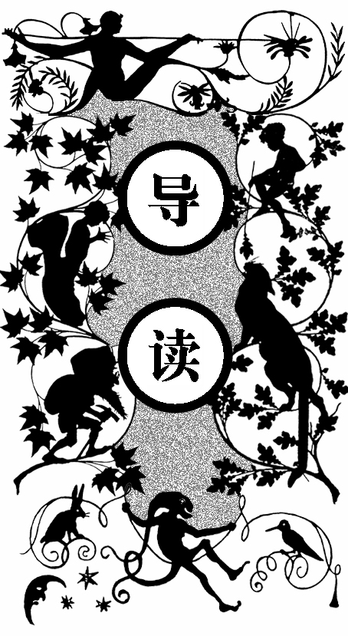
很久以前，圣费斯切托王国有一位女王，她虽然容貌美丽，但很傲慢。她嘲笑一个驼背腿瘸的小孩，使小孩的母亲很难过。仙女们诅咒女王会得到报应的。
女王很为自己英俊的儿子杰旺尼诺自豪，而几天后儿子全身长满了毛，变成了一头猪。杰旺尼诺知道只有一位美丽的姑娘嫁给他，才能使他恢复人形。
一天他来到磨坊，磨坊主的大女儿见到他，把他推下了台阶。这让他备受打击，躲在房间几天不想出来。又一天，他又碰到磨坊主的二女儿，遭到了同样的待遇。他想自己可能永远是一头猪了。
他不甘心，便去见磨坊主的小女儿孚米娜，孚米娜让他得到了爱情。他把姑娘带回王宫，大家为他俩举行了婚礼。杰旺尼诺单独和新娘在一起时，就变成英俊的青年。他告诉新娘再过三个月三天零三小时，自己就能永远保持英俊的模样了，但这段时间要保密。
两个月后，大家看新娘很幸福，流言便传到女王的耳朵里。她便问新娘为什么要嫁给他儿子，并要在儿子睡觉时去看他。新娘阻挡不住便答应了。
当女王看到儿子英俊的模样时，高兴得喊了起来。这时杰旺尼诺变成一只金尾巴的鸟飞走了，走前告诉妻子她必须穿破七双铁鞋、走七年、装满七瓶泪水他们才能相见。

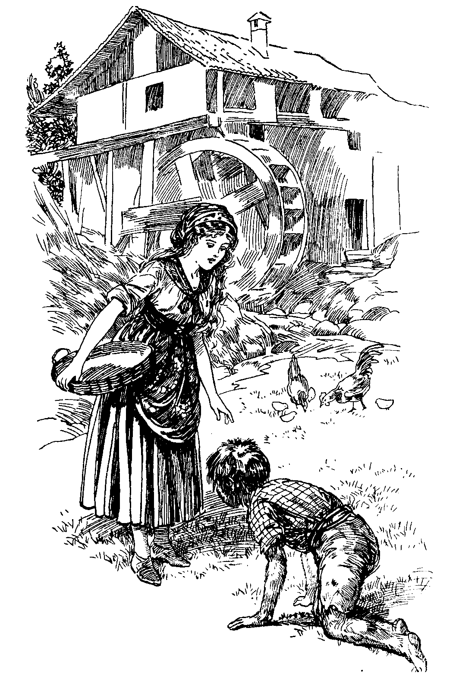
王子浑身长满了毛

姑娘准备了七双铁鞋、七根铁拐杖，开始了艰难的寻找。姑娘走了快七年了，只剩下一双铁鞋在脚上和一根拐杖，泪水早已装满了七瓶。姑娘在一个树林的房子里问一个小矮人婆婆，见到一只金尾鸟没有。小矮人说自己丈夫可能知道，但他是食人魔，让她快走。姑娘请求在屋里躲一躲，便藏在酒桶里。
食人魔回来后在四处乱嗅。老婆婆说早上有人打听金尾鸟的事，食人魔说不知道，便拿出魔笛吹起来，使屋里的东西飞了起来。孚米娜躲在酒桶被撞得头昏脑胀。最后，食人魔睡了，第二天一早就出去打猎了。
老婆婆给了孚米娜一粒栗子，让她在困难时打开。姑娘走到另一座房子，结果和前一次一样，这次得到了一粒核桃。天黑时，她来到森林尽头的一幢房子。一个老巫婆赶她走，她问巫婆见没见过金尾鸟，并请求住一夜。
巫婆让她躲在地窖的垃圾和石块中间。食人魔回来后妻子问他金尾鸟的事，他说只有风之国王知道，就吹起了魔笛，孚米娜在地窖里被撞得鼻青脸肿。第二天食人魔走后，老婆婆让她顺着远方的大路去找风之国王，并给了她一颗长生果，让她在困难时打开。
孚米娜经过千辛万苦来到风之国的山下，歇了一会儿后来到山顶，一阵风把她推到一间大屋中。她问风金尾鸟在哪里，风说不知道，让她问东风，咆哮的东风又让她问温柔的南风。最后她遇到了冰冷的北风，北风告诉她，如果不害怕可以带她去。
她坐在风的背上穿云跨海，风吹日晒，她的面目变得憔悴，迅速衰老了。终于来到一座漂亮的城堡外面，风告诉她，金尾鸟就住在里面，现在已经是英俊的青年了！孚米娜朝城堡旁边的农庄走去，有人称她老婆婆。听了这话，她感到没法见杰旺尼诺，便说要找活干。于是，她被派去照料一群鹅。
她在小溪中照见自己的面容，觉得见杰旺尼诺已认不出她了。这时，鹅在旁边让把栗子剥开。孚米娜剥开栗子，里面有一套华丽的礼服。穿到身上，她立刻恢复了原来的模样。老女王过来，想把衣服据为己有，因为她想嫁给杰旺尼诺，但被她拒绝了。
孚米娜告诉老女王，如果让自己晚上在王子那里留宿，礼服就可以给她。老女王答应了，但在王子晚餐的葡萄酒里加了安眠药。王子在餐桌上睡着了，被抬上楼，孚米娜一晚上也没能和他说上一句话。
下午，孚米娜又把核桃打开，又一件更华丽的衣服在里面。老女王又用同样的条件得到了它。她又让人在王子的葡萄酒里放了安眠药。姑娘虽然伤心诉说着，可丈夫始终沉睡，一句话也没听到。一夜又过去了。
姑娘又打开长生果，里面的衣服比前两件更漂亮，老女王又同样得到了。孚米娜想，这是最后的机会，如果不行，自己将永远失去他。
晚餐时，王子问侍臣，自己怎么两次在餐桌上睡着了，侍臣让他留心酒。晚餐时，王子趁人不备把酒倒在桌下，然后便上了楼。孚米娜上楼来诉说着自己穿坏七双铁鞋的故事，王子知道她是谁了，把她抱在 怀里。
第二天早上他们下楼时，老女王气得倒在地上死了。孚米娜和王子成了美丽城堡的统治者，举行了盛大的婚礼，过着幸福的生活。

here was once upon a time, in the Kingdom of San Fiaschetto, a Queen who was as proud and disagreeable as she was beautiful.
T
One day, as she was driving about her kingdom, she saw at the door of a poor cottage a little lame and humpbacked boy. The wicked Queen, who hated the sight of ugly things, began laughing scornfully, so that the boy began to weep; and the boy’s mother, who was inside the cottage, feeling very miserable and vexed, went to the fairies, complaining of the bad Queen who had laughed at a poor cripple.
“The Queen shall know all about this,” said the fairies.
Now, the Queen had an only son, called Giovannino, of whom she was exceedingly proud, because he was the handsomest young man of all the country for miles around. A few days after this had happened, Giovannino began to grow hair all about his hands and face, and shortly after all over his body. Then, instead of walking on his feet, he began crawling on all fours. In fact, he was turned into a nasty-looking pig.
You may well imagine the horror of the Queen when she saw this! Weeping and sobbing, she ran to the fairies, and begged them to give the boy back his lovely features. But the fairies turned away murmuring incomprehensible words, and the Queen went back to the palace more unhappy than ever, to find Giovannino all dirty and disagreeable because he had been wallowing in the mud.
Yet Giovannino knew all about his own fate, because a fairy godmother had come to him in his sleep and told him. He knew that, unless a beautiful girl would fall in love with him and marry him, he would remain a grubby pig to the end of his life. One day he went wandering about in the country, and came to a mill where there lived a miller with his three daughters, the prettiest in all San Fiaschetto. On the doorstep stood the eldest, and Giovannino went up to her, but the girl pushed him off, saying: “Get away, you dirty pig !”
Poor Giovannino rolled down the steps, feeling very much humiliated. A Prince to be treated like that by a miller’s daughter! When he arrived at home, he shut himself up in his rooms and would neither eat nor drink for several days.

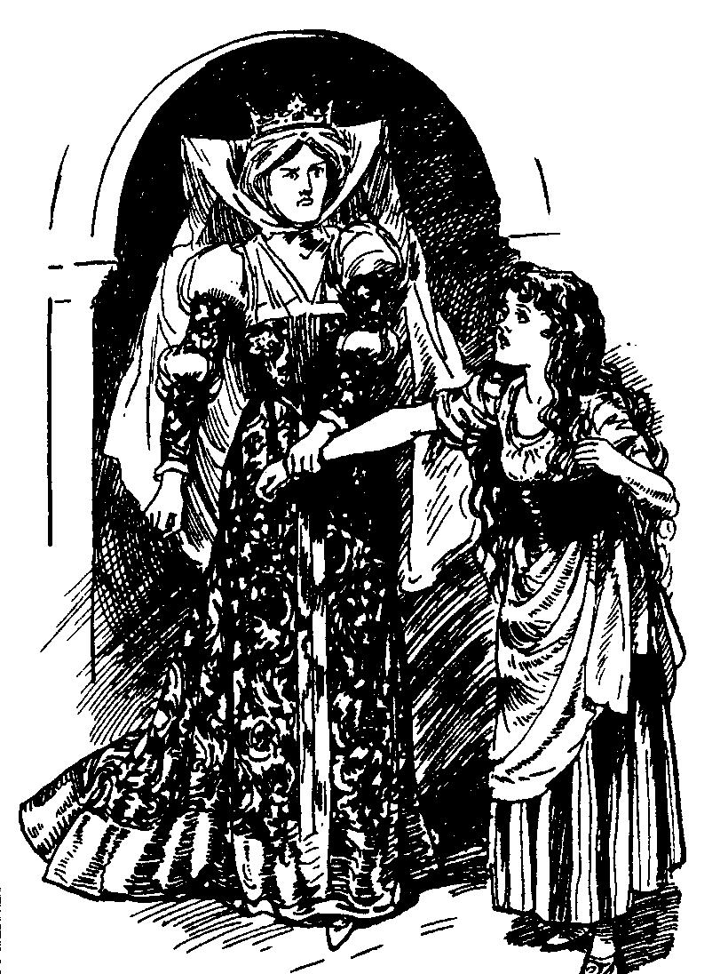
女王斥责孚米娜

Yet after a while he made up his mind to try his luck again, and back he went to the mill. The second daughter was sitting on the steps, but when Giovannino came near she kicked him, crying: “Off with you, you horrid pig!”
This was very sad indeed for Giovannino, who began to think that never, never in his life would he find a beautiful girl, not alone to marry him, but even to look at him, and that he would have to remain a pig to the end of his days. So he threw himself under his bed and would not budge for a long time.
At last, out he crawled again, and went trotting along until he came once more in sight of the mill. In the yard the youngest and prettiest of the miller’s daughters was very busy feeding the chickens.
“If she kicks me, I’ll kill myself and make an end of it,” said Giovannino to himself as he came nearer. He was looking rather unpleasant because, as there were several pools on the way from the palace, he had been wallowing in the mud. Yet he pulled himself together, and came very near little Firmina, who, instead of kicking him away, said in a kind voice: “You poor little beast!”
Giovannino, greatly encouraged, came nearer and whispered: “Tell me, pretty miller’s daughter, do you think you could love me?”
“Yes, I could, poor little beastie,” answered Firmina.
Giovannino at this answer felt bolder and bolder and stammered out: “Pretty miller’s daughter, would you marry me?”
“Yes, I would,” replied the girl.
Then the Prince-pig, almost beside himself with excitement, took his bride back to the palace: his people were delighted to know that he had found someone to marry him, ugly as he was, and there was a beautiful wedding.
When Giovannino was left alone with his bride, all of a sudden he was turned into the handsome young man he was before the accident, and to the delighted Firmina he said: “I shall always be like this if, for three months, three days, and three hours, nobody knows anything about it and nobody but you sees me.”
Of course Firmina promised that she would never whisper a word to anybody, and for two months they were very happy. But then people began to feel envious, because the miller’s daughter looked ever so happy and so much in love with her husband, in spite of his being a pig, and they whispered that either Firmina had married just for the sake of being a princess and that she hated Giovannino for all that, or that there was some secret and that the Prince was not really always a horrid pig.
All this came to the ears of the Queen, who was already a little suspicious, and she felt very jealous because she was almost sure there was something her daughter-in-law knew and she did not. So she began to worry the poor little thing, and one evening she called her up to her and said:
“Tell me, miller’s daughter, why did you marry my son?”
“Because I loved him.”
“Is it true, what I hear, that my son is at times changed into a fine young man?”
“It may be so, and it may not be so.”
“What is my son like when he is alone with you?”
“That I cannot tell.”
At this the Queen became more and more angry, and shouted out: “I’ll see my son when he is asleep.”
“That you shan’t,” said Firmina.

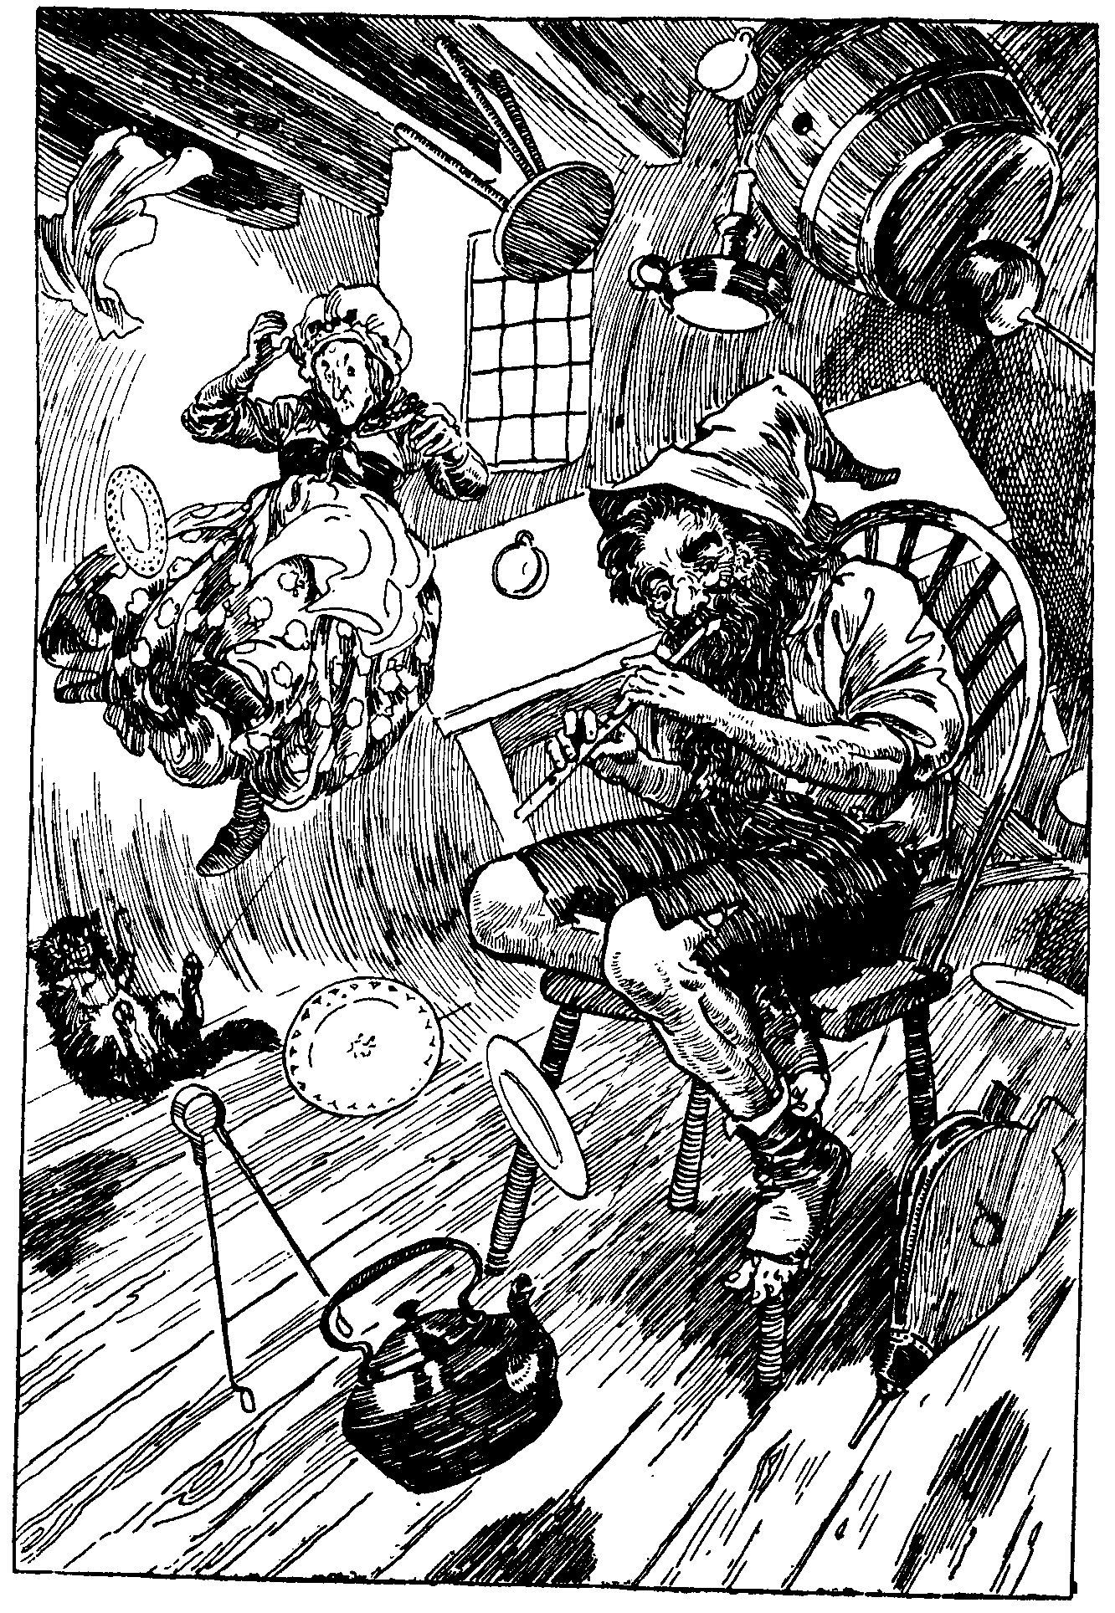
食人魔吹起了魔笛

“You impudent little minx!” cried the Queen, in a paroxysm of rage. “I’ll teach you to answer a Queen like that! I shall see my son whenever I please, whether you will or not. I am the Queen, and I alone command here. If you say one more word I’ll have your silly head cut off.”
“Very well,” sobbed out Firmina.
So that night when Giovannino was asleep Firmina unlocked the door and let the Queen in, and when the Queen saw her boy so handsome and young she cried out: “Oh, my son, how beautiful you are!” This woke up Giovannino, who was immediately changed into a bird with a fine golden tail, and he flew out of the window, saying to his wife: “In order to find me you must walk for seven years, wear out seven pairs of shoes made of iron, and fill seven flasks with your tears, when I shall be yours once more.”
And off he flew, leaving a golden trail behind him.
The poor little miller’s daughter sobbed her heart out when she realised that her Giovannino had really gone. But, remembering his parting words, she immediately procured for herself the seven pairs of iron shoes, and seven iron rods to lean upon on the way, and began her sad quest, willed by the fates. For months and months she travelled on, through mountains and plains, on stones and crags and rocks, tearing herself on thorny bushes, losing her way through unknown countries, asking everyone she met whether they had seen the Bird with the Golden Tail. But nobody had seen him.
One day, when she had walked for nearly seven years, and used up all the shoes but the pair she was wearing, all the rods but the one she was leaning upon, and had cried and wept so much that all the seven flasks had been filled and she had no more tears to shed, because they were all dried up, she came to a dark wood, and in a dusky corner she saw a house. A little old wrinkled woman was at the window, and Firmina called out to her: “Dear little woman, have you seen the Bird with the Golden Tail?”
“I have not seen him, my dear. Perhaps my husband has seen him, but you had better be off before he comes back, because he is an Ogre, and would eat you should he find you here. This is the country of the Ogres.”
“Pretty little Ogress, please let me hide in your house. Perhaps I may hear where my Giovannino is, and also I am so tired that I cannot walk another step to-night.”
The Ogress would not take her in at first because she was almost sure the Ogre would eat the poor little thing, and she felt so sorry for her. Yet after a while Firmina insisted so much that she was allowed to come in and was hid in an empty cask.
Presently the Ogre came home and began sniffing about. “I feel there is something to eat here. Where is it?”
“There is absolutely nothing here, you old stupid,” said his wife. “But some time this morning somebody came in and asked whether you had heard of a Bird with a Golden Tail.”
“I know nothing about the Bird with the Golden Tail,” growled the Ogre, “but I know there is something to eat in the house. I smell it!” And taking a magic whistle out of his pocket, he struck up a tune, so that presently everything in the house began to dance and kick about, and fly here and there and everywhere. You can imagine poor Firmina in the cask! She was all sore and knocked about, yet she did not utter a cry; and finally the Ogre, having satisfied himself that he could get hold of nothing to eat for the present, went to bed feeling cross and hungry, and early in the morning got up and went out hunting.

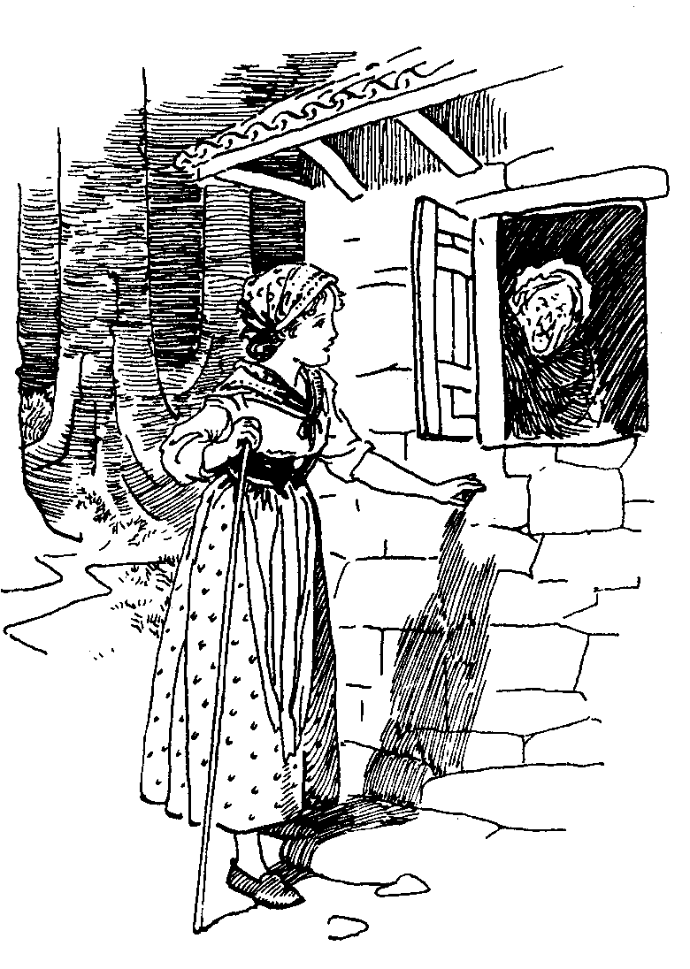
孚米娜问巫婆见没见过金尾鸟

As soon as he was out of sight, the Ogress came up to the cask and let the girl out, saying kindly: “My poor child, I am so sorry for you: there you are, all sore and hurt, and yet you know nothing about your bird. Take this chestnut and open it when you are in need.”
Off went Firmina, and all the day she roamed about in the wood, until at night she reached another house in a thick cluster of trees. Firmina knocked at the door and begged to be let in for the night.
“Get away as fast as you can, my daughter,” answered the woman who came to the door. “Don’t you know this is the country of the Ogres? The wood is full of them. If Malfatto finds you here when he comes home, he will eat you on the spot.”
“Dear little Ogress, I am looking for the Bird with the Golden Tail. If your husband is really an Ogre, he may know where the Bird is. Do let me in and have a chance.”
The kind Ogress at last let the girl in, and hid her in a pair of the Ogre’s shoes.
Presently Malfatto came in and began scenting the air.
“There is a human being in this house,” he said to his wife.
“Don’t you be an old idiot,” cried his wife. “There is nobody in the house now, but this morning a girl came along and asked whether we knew of a Bird with a Golden Tail.”
“I know nothing of the Bird with the Golden Tail,” roared Malfatto, “but if I find something hidden here, I’ll make you suffer for it.” Pulling out a whistle, he began whistling until everything in the house was set going; the chairs went up to the window-sill, the table hit the ceiling, and as for the shoes Firmina was hidden in, they went right up and then down again with a big thud on to the floor, so that Firmina thought she was going to die, and yet she had learnt nothing about Giovannino.
In the morning, after Malfatto had gone, his wife let the girl out and gave her a walnut, saying: “Open this when you are in need.”
The little miller’s daughter crawled out cautiously, feeling very weary and sad and sore. Yet she would not stop to rest, and at night she had reached another house at the very end of the wood. A hideous old hag was at the window, who, when she saw Firmina coming near, shouted in an angry voice: “Get off, you silly thing, or I’ll hit you.”
“Please, madam, tell me, have you seen the Bird with the Golden Tail?”
“Get off, you and your iron shoes! I know nothing of a Bird with a Golden Tail. I daresay my husband knows all about it, because he knows everything; but you may have heard of Mangialupi. If he sees you he will eat you, iron shoes and all. Ha, ha, ha!!!”
“Please, madam, please let me in for the night. I’d give anything for a chance of knowing where my little Bird has gone. Do let me hide in your house!”
“All right, if you want to be eaten, come in,” said the Ogress in a slightly less gruff voice. And pushing Firmina in, she hid her under a heap of rubbish and stones in a corner of the cellar.
At dusk Mangialupi came in, feeling very hungry and cross. As soon as he got to the house he began to sniff about and cry: “I smell some young meat.”
“Be quiet, you silly,” growled his wife; “but you might tell me, you old wretch, where the Bird with the Golden Tail is.”
“What do I know of your silly Bird? Am I the King of the Winds? Where did you hide that fresh meat?”
And as his wife, instead of giving him information, scolded him like an old trooper, he took out a whistle and started the usual Ogre tune. All the house went dancing about; the chairs, the stove, the cupboards, the tables, everything went whirling around, as if shaken by a hurricane and a wind combined. Even the poor old Ogress was shaken about and thrown against the window-panes and up to the ceiling.
As for the poor little miller’s daughter, who, as I have told you, was hiding in the cellar under a heap of rubbish and stones, you can easily guess how she was thrown against the walls and hurt by the stones that were supposed to hide her. By the time—and it was a long time!—that Mangialupi grew tired and stopped whistling and everything had gone to rest, the poor child was terribly bruised, she was bleeding sorely. Fortunately, Mangialupi could not see her, and he went to bed growling like a cross bear with a very sore head.
In the morning the Ogress went to Firmina to say that, as the Ogre had gone out, she might as well take her chance and flee. The poor old thing was very sore too, yet she seemed kinder towards the girl who was going through so much in order to find her lost love.
“Did you hear what Mangialupi said last night? It is not the Ogres you must ask for news of your little Bird. The only one who knows is the King of the Winds.”
“Thank you, madam,” cried Firmina, overjoyed at the thought of gaining information; “and pray tell me, where does the King of the Winds live?”
“See that highroad in the distance? They all live over there. Now go, or you’ll get me into trouble. Here is a peanut for you. Open it when you are in need.”

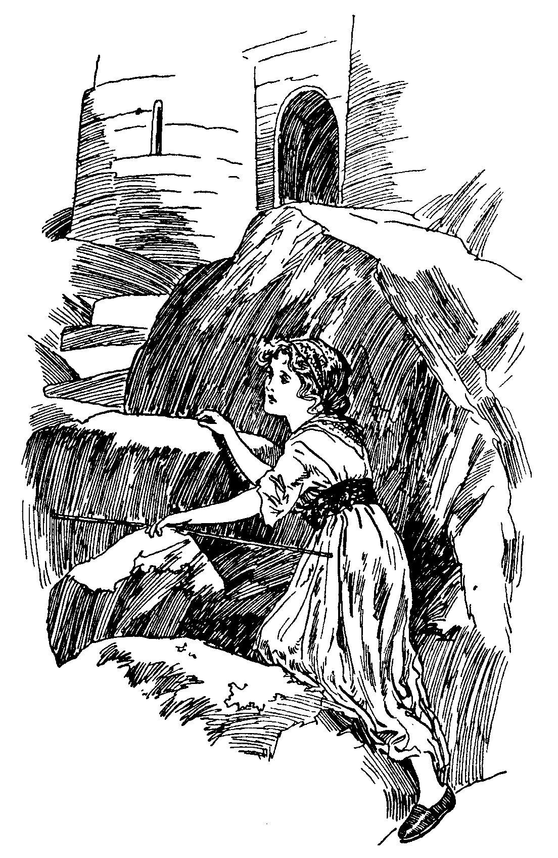
孚米娜爬上山顶

The miller’s daughter thanked the Ogress, who after all, in spite of her rudeness, had been so helpful to her, and ran along to seek the house of the King of the Winds.
On and on she tramped through forests dark and full of crawling beasts that filled her with fear, through swamps and marshes, through rivers she had to swim across, through thorns and prickly bushes that tore her hands and feet; but at last she arrived at the foot of the mountain on the top of which was the home of the Winds.
There she stopped for a few minutes, to get a little breath; then she began climbing the steep rocks, until at last she reached the top and stood before the open door of the stronghold, when a great gust of wind pushed her into a big vaulted room without any furniture, because all the furniture that there was had been smashed by the winds that blew in and out when and as they pleased.
“Please, kind Wind,” said Firmina to the Wind that was shaking her about, “tell me where is the Bird with the Golden Tail?”
“I don’t know, my child, but ask my brother the East Wind: he may know,” and the Wind blustered out of the room. Presently Firmina felt that something was pushing her violently against the walls, and she felt the East Wind blowing in like a fury. But the East Wind knew nothing about the Bird, and went out very cross, shaking her, and making her feel chilly and sore.
Then the Southern Wind blew in very gently, and said that he knew nothing about the Bird, but that the North Wind was sure to know. Off he went, leaving Firmina on the floor, because, although he pretended to be so gentle and calm, yet he blew strongly all the same.
The North Wind rushed in all of a sudden, and the room became almost frozen, and the miller’s daughter began shivering with cold. Blowing about so that the place was all shaken and poor Firmina quivering and quaking with cold fear, he asked in a gruff voice: “What do you want of me?”
“Kind Northern Wind, I want to get to the Bird with the Golden Tail.”
“The Bird with the Golden Tail is thousands of miles away from here. Of course I know where he is—the Northern Wind knows everything: if you are not frightened, jump on my back and I will take you to the spot.”
Firmina felt rather scared at the thought of going for so many thousand miles in the air on the back of a roaring Wind; but she did not say a word, and mounted bravely. The North Wind dashed out like a fury and darted off like lightning.
One moment he was tearing across the sea, the next he flew above the highest mountain of the earth, the following he was rolling in an abyss, up and down, here and there and everywhere, at the speed of a thousand miles an hour. The miller’s daughter on his back felt that her skin was growing weather-beaten and withered, and that she was rapidly getting older and older and very ugly. How tired she felt! The North Wind was flying so fast that she could hardly breathe, and she felt that she could endure it no longer. At last the Wind slowed down, and after a short while put her down on a fine lawn, outside a beautiful house.
“See that beautiful castle? It is there where your little Bird lives, but I warn you that from to-day he is no longer a little Bird but a handsome prince. Now good-bye, and good luck to you!” and saying so he darted off to the North Pole, to see what had happened to his kingdom during his absence.
As soon as the miller’s daughter had recovered a little of her breath, she went to the farm—she did not dare go to the front door of the house—and before she had time to say anything a man came out and asked in a kind voice: “What do you want, my poor little Grannie?”
Poor little Grannie, indeed! That was what she had come to, after so many years of suffering! How could she come to Giovannino, who was now a fine young man? He would never know her, the pretty little bride of seven years ago, and would have her thrown out of the house. Her eyes filled with tears, but she bravely kept them back and said to the farmer: “Please, kind farmer, I want some work to do.”
“Very well,” said the farmer; “we have just lost the girl who looked after the geese. If you like, you may take her job; I daresay it won’t be too much for you.”
So Firmina went to look after a big flock of geese, and when she came to a brook by a field she gazed at herself in the clear running water, and saw that she had been turned into an old hag, with a skin like that of a brown potato, ragged and dusty and slightly humpbacked.
“What is the good of my having done all this and gone through so much?” she cried in despair. “Now, even if I could see my Giovannino he would never know me. If only he were still a poor little pig as he was when I married him, it would not matter so much my being ugly. But he is a handsome prince, and he will have nothing whatever to do with me.”
As she was saying this, the geese began to cackle and shout: “Where is the chestnut?”
Then Firmina remembered the chestnut that had been given her by the first Ogress, and she immediately opened it. Out came a wonderful dress all made of silk of the finest texture, of the colour of the air, all embroidered with golden birds. The miller’s daughter put it on at once, and suddenly all her wrinkles disappeared as if by magic, her eyes became shining and blue and bright, her hair was again like lovely golden silk, her hands were white and smooth; in fact, she was even more beautiful than when Giovannino first met her at her father’s mill.
When the geese saw this, they immediately began to cry: “Oh, how beautiful our mistress is! How beautiful our mistress is!”
At the noise made by the geese the old Queen, who lived in the castle and was trying to get Giovannino to marry her, came along. The Prince had refused to marry her, first of all because she was old and wicked, and then because he still hoped that his Firmina would come and find him. So old Nasturzia kept him a prisoner in the castle and would never allow him out. Now when Nasturzia saw the beautiful dress she immediately wanted it, because she was as vain as she was ugly.
“You shall have it if you let me stay in the Prince’s apartments tonight,” said Firmina.
“All right, you shall be allowed in until the cock crows,” replied the Queen, and she took away the dress. But in the evening she ordered a sleeping draught to be put in the Prince’s wine at dinner, so that he fell asleep in the dining-room and had to be carried upstairs. Shortly after, Firmina came in and she began to cry and say: “Seven strong pairs of shoes, all made of iron, have I worn out to come and find my love! Seven strong rods, all made of purest iron, have I leant on in my journey to my love! Seven flasks with tears, bitter tears, have I filled, in seven long, cruel years; now I have found you, my love, my own darling, and you sleep on and will not heed my grief!”
All night she went on like this, weeping sadly and trying to waken her husband; but the draught was very strong, and Giovannino slept until the

