第一章
Chapter I
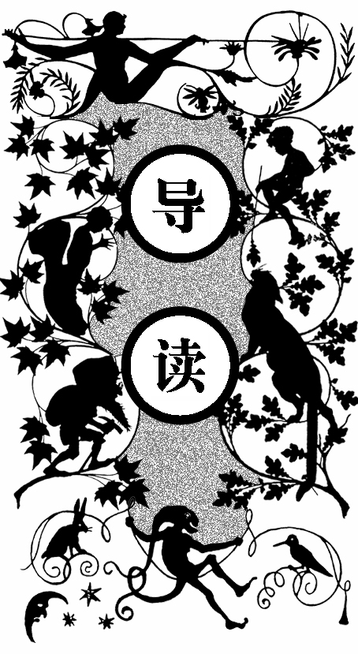
老太太喊着汤姆，可是一直没有回应。她仔细地环视了房子一圈，还是没有发现小汤姆。老太太有些生气了，边大声说着威胁的话边拿扫帚往床底下乱捅一气，却只赶出了一只猫。
老太太走到敞开的门口处，观察外面的园子，也没见着他。于是她再次提高音量叫喊，身后忽然传来细小的声音。她一转身正好逮住了想要偷偷溜走的小汤姆。那家伙衣服上的果酱暴露了他刚才做的好事，老太太气得拿起鞭子就要抽。老太太是汤姆的包莉姨妈。小汤姆灵机一动，骗姨妈说她身后有东西，趁着姨妈转身的工夫转眼便脚底抹油溜走了。
包莉姨妈对小汤姆的行为又恨又怜，因为那是她的亲外甥。她觉得是因为自己太溺爱他了，他才会这么顽皮。于是包莉姨妈决定如果小汤姆再逃学，就让他在周六干麻烦的活儿。
而汤姆又逃学去玩尽兴了才回家，正好碰上黑孩子杰姆在锯木材和劈引火柴，于是一边帮忙一边讲述他今天的冒险故事。汤姆的表弟锡德在一边捡劈柴碎片。他不爱说话，也不会因为调皮捣蛋而闯祸。
吃晚饭的时候，包莉姨妈开始盘问小汤姆。小家伙心里七上八下，嘴里却对答如流。正当他暗自得意时，锡德指出了问题，使得包莉姨妈肯定汤姆是逃学游泳去了。汤姆一见事情暴露，赶紧逃出门去并扬言要好好揍表弟一顿。

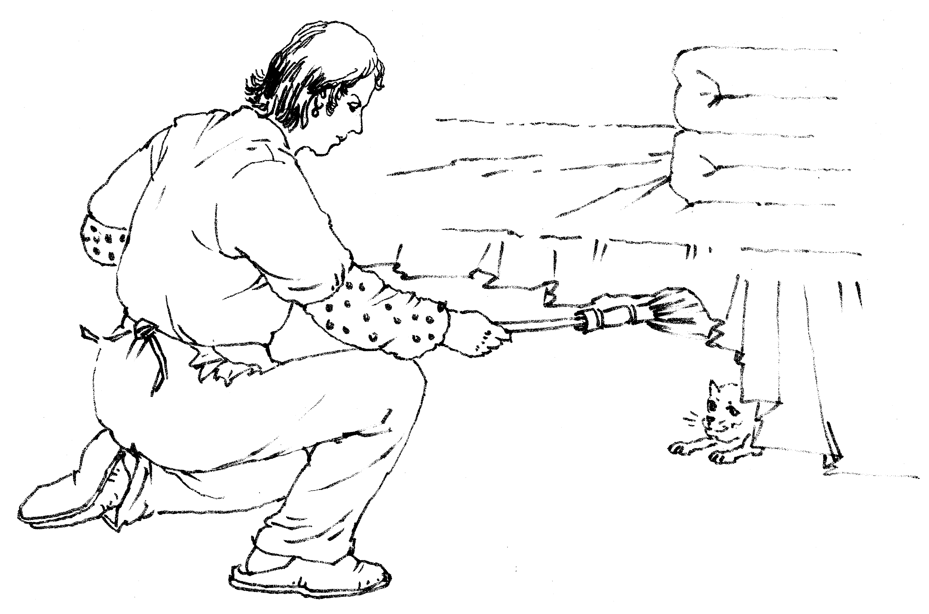
包莉姨妈拿扫帚往床下乱捅一气
可没过一会儿汤姆就忘记了他的烦恼，吹着口哨在街上闲逛着。忽然他遇到一个比他稍微大些的陌生男孩，衣着很体面。汤姆看不惯他自以为城里人的神气模样，便上去和他扭打成一团，最终那孩子哭着说饶命之后汤姆才放过他。哪知那孩子脱身后，捡起石子就往汤姆身上扔，然后逃之夭夭。愤怒的汤姆没追上那孩子，而他回到家时已经很晚了。看到汤姆玩得浑身脏兮兮的，包莉姨妈下定决心要让汤姆在周末干活了。

“T
OM!”
No answer.
“TOM!”
No answer.
“What’s gone with that boy, I wonder? You TOM!”
No answer.
The old lady pulled her spectacles down and looked over them about the room; then she put them up and looked out under them. She seldom or never looked through them for so small a thing as a boy; they were her state pair, the pride of her heart, and were built for “style”, not service —she could have seen through a pair of stove-lids just as well. She looked perplexed for a moment, and then said, not fiercely, but still loud enough for the furniture to hear:
“Well, I lay if I get hold of you, I’ll—”
She did not finish, for by this time she was bending down and punching under the bed with the broom, and so she needed breath to punctuate the punches with. She resurrected nothing but the cat.
“I never did see the beat of that boy !”
She went to the open door and stood in it, and looked out among the tomato vines and “jimpson” weeds that constituted the garden. No Tom. So she lifted up her voice at an angle calculated for distance and shouted:
“Y-o-u-u Tom!”
There was a slight noise behind her, and she turned just in time to seize a small boy by the slack of his roundabout and arrest his flight.
“There! I might ’a’ thought of that closet. What you been doing in there?”
“Nothing.”
“Nothing! Look at your hands, and look at your mouth. What is that truck?”
“I don’t know, aunt.”
“Well, I know. It’s jam, that’s what it is. Forty times I’ve said if you didn’t let that jam alone I’d skin you. Hand me that switch.”
The switch hovered in the air—the peril was desperate.
“My ! Look behind you, aunt !”
The old lady whirled round, and snatched her skirts out of danger. The lad fled, on the instant, scrambled up the high board-fence, and disappeared over it. His Aunt Polly stood surprised a moment, and then broke into a gentle laugh.
“Hang the boy, can’t I never learn anything? Ain’t he played me tricks enough like that for me to be looking out for him by this time? But old fools is the biggest fools there is. Can’t learn an old dog new tricks, as the saying is. But my goodness, he never plays them alike two days, and how is a body to know what’s coming? He ’pears to know just how long he can torment me before I get my dander up, and he knows if he can make out to put me off for a minute or make me laugh, it’s all down again, and I can’t hit him a lick. I ain’t doing my duty by that boy, and that’s the Lord’s truth, goodness knows. Spare the rod and spile the child, as the Good Book says. I’m a laying up sin and suffering for us both, I know. He’s full of the Old Scratch, but laws-a-me! he’s my own dead sister’s boy, poor thing, and I ain’t got the heart to lash him, somehow. Every time I let him off my conscience does hurt me so; and every time I hit him my old heart most breaks. Well-a-well, man that is born of woman is of few days and full of trouble, as the Scripture says, and I reckon it’s so. He’ll play hookey this evening, and I’ll just be obleeged to make him work, to-morrow, to punish him. It’s mighty hard to make him work Saturdays, when all the boys is having holiday, but he hates work more than he hates anything else, and I’ve got to do some of my duty by him, or I’ll be the ruination of the child.”
Tom did play hookey, and he had a very good time. He got back home barely in season to help Jim, the small coloured boy, saw nextday’s wood, and split the kindlings before supper—at least he was there in time to tell his adventures to Jim while Jim did three-fourths of the work. Tom’s younger brother (or rather-half-brother) Sid was already through with his part of the work ( picking up chips), for he was a quiet boy, and had no adventurous, troublesome ways. While Tom was eating his supper and stealing sugar as opportunity offered, Aunt Polly asked him questions that were full of guile, and very deep—for she wanted to trap him into damaging revealments. Like many other simple-hearted souls, it was her pet vanity to believe she was endowed with a talent for dark and mysterious diplomacy, and she loved to contemplate her most transparent devices as marvels of low cunning. Said she:
“Tom, it was middling warm in school, warn’t it?”
“Yes’m.”
“Powerful warm, warn’t it?”
“Yes’m.”
“Didn’t you want to go in a-swimming, Tom?”
A bit of a scare shot through Tom—a touch of uncomfortable suspicion. He searched Aunt Polly’s face, but it told him nothing. So he said:
“No’m—well, not very much.”
The old lady reached out her hand and felt Tom’s shirt, and said:
“But you ain’t too warm now, though.” And it flattered her to reflect that she had discovered that the shirt was dry without anybody knowing that that was what she had in her mind. But in spite of her, Tom knew where the wind lay now. So he forestalled what might be the next move:
“Some of us pumped on our heads—mine’s damp yet. See?”
Aunt Polly was vexed to think she had overlooked that bit of circumstantial evidence, and missed a trick. Then she had a new inspiration:
“Tom, you didn’t have to undo your shirt collar where I sewed it to pump on your head, did you? Unbutton your jacket!”
The trouble vanished out of Tom’s face. He opened his jacket. His shirt collar was securely sewed.
“Bother! Well, go ’long with you. I made sure you’d played hookey and been a-swimming. But I forgive ye, Tom. I reckon you’re a kind of a singed cat, as the saying is – better’n you look this time.”
She was half sorry her sagacity had miscarried, and half glad that Tom had stumbled into obedient conduct for once.
But Sidney said:
“Well, now, if I didn’t think you sewed his collar with white thread, but it’s black.”
“Why, I did sew it with white! Tom!”
But Tom did not wait for the rest. As he went out at the door, he said:
“Siddy, I’ll lick you for that.”
In a safe place Tom examined two large needles which were thrust into the lapels of his jacket—and had thread bound about them—one needle carried white thread and the other black. He said:
“She’d never noticed if it hadn’t been for Sid. Confound it! sometimes she sews it with white, and sometimes she sews it with black. I wish to geeminy she’d stick to one or t’other—I can’t keep the run of ’em. But I bet you I’ll lam Sid for that. I’ll learn him!”
He was not the Model Boy of the village. He knew the model boy very well though—and loathed him.
Within two minutes, or even less, he had forgotten all his troubles. Not because his troubles were one whit less heavy and bitter to him than a man’s are to a man, but because a new and powerful interest bore them down and drove them out of his mind for the time—just as man’s misfortunes are forgotten in the excitement of new enterprises. This new interest was a valued novelty in whistling, which he had just acquired from a negro, and he was suffering to practise it undisturbed. It consisted in a peculiar bird-like turn, a sort of liquid warble, produced by touching the tongue to the roof of the mouth at short intervals in the midst of the music. The reader probably remembers how to do it if he has ever been a boy. Diligence and attention soon gave him the knack of it, and he strode down the street with his mouth full of harmony and his soul full of gratitude. He felt much as an astronomer feels who has discovered a new planet. No doubt, as far as strong, deep, unalloyed pleasure is concerned, the advantage was with the boy, not the astronomer.
The summer evenings were long. It was not dark yet. Presently Tom checked his whistle. A stranger was before him—a boy a shade larger than himself. A newcomer of any age or either sex was an impressive curiosity in the poor little shabby village of St. Petersburg. This boy was well-dressed, too—well-dressed on a week-day. This was simply astounding. His cap was a dainty thing, his close-buttoned blue cloth roundabout was new and natty, and so were his pantaloons. He had shoes on—and yet it was only Friday. He even wore a necktie, a bright bit of ribbon. He had a citified air about him that ate into Tom’s vitals. The more Tom stared at the splendid marvel, the higher he turned up his nose at his finery, and the shabbier and shabbier his own outfit seemed to him to grow. Neither boy spoke. If one moved, the other moved—but only sideways, in a circle; they kept face to face and eye to eye all the time. Finally, Tom said:
“I can lick you!”
“I’d like to see you try it.”
“Well, I can do it.”
“No, you can’t, either.”
“Yes, I can.”
“No, you can’t.”
“I can.”
“You can’t.”
“Can!”
“Can’t!”
An uncomfortable pause. Then Tom said:
“What’s your name?”
“’Tisn’t any of your business, maybe.”
“Well I ’low I’ll make it my business.”
“Well, why don’t you?”
“If you say much I will.”
“Much—much—much. There, now.”
“Oh, you think you’re mighty smart, don’t you.? I could lick you with one hand tied behind me, if I wanted to.”
“Well, why don’t you do it? You say you can do it.”
“Well, I will, if you fool with me.”
“Oh, yes—I’ve seen whole families in the same fix.”
“Smarty! You think you’re some now, don’t you? Oh, what a hat!”
“You can lump that hat if you don’t like it. I dare you to knock it off; and anybody that’ll take a dare will suck eggs.”
“You’re a liar!”
“You’re another.”
“You’re a fighting liar, and dasn’t take it up.”
“Aw—take a walk!”
“Say—if you give me much more of your sass, I’ll take and bounce a rock off’n your head.”
“Oh, of course you will.”
“Well, I will.”
“Well, why don’t you do it, then? What do you keep saying you will for? Why don’t you do it? It’s because you’re afraid.”
“I ain’t afraid.”
“You are.”
“I ain’t.”
“You are.”
Another pause, and more eyeing and sidling around each other. Presently they were shoulder to shoulder. Tom said:
“Get away from here!”
“Go away yourself!”
“I won’t.”
“I won’t either.”
So they stood, each with a foot placed at an angle as a brace, and both shoving with might and main, and glowering at each other with hate. But neither could get an advantage. After struggling till both were hot and flushed, each relaxed his strain with watchful caution, and Tom said:
“You’re a coward and a pup. I’ll tell my big brother on you, and he can thrash you with his little finger, and I’ll make him do it, too.”
“What do I care for your big brother? I’ve got a brother that’s bigger than he is; and, what’s more, he can throw him over that fence, too.” [ Both brothers were imaginary.]
“That’s a lie.”
“Your saying so don’t make it so.”
Tom drew a line in the dust with his big toe, and said:
“I dare you to step over that, and I’ll lick you till you can’t stand up. Anybody that’ll take a dare will steal sheep.”
The new boy stepped over promptly, and said:
“Now you said you’d do it, now let’s see you do it.”
“Don’t you crowd me, now; you better look out.”
“Well, you said you’d do it—why don’t you do it?”
“By jingo! for two cents I will do it.”
The new boy took two broad coppers out of his pocket, and held them out with derision. Tom struck them to the ground. In an instant both boys were rolling and tumbling in the dirt, gripped together like cats; and for the space of a minute they tugged and tore at each other’s hair and clothes, punched and scratched each other’s nose, and covered themselves with dust and glory. Presently the confusion took form, and through the fog of battle Tom appeared, seated astride the new boy, and pounding him with his fists.
“Holler ’nuff!” said he.
The boy only struggled to free himself. He was crying—mainly from rage.
“Holler ’nuff!”—and the pounding went on.
At last the stranger got out a smothered “’Nuff!” and Tom let him up, and said:
“Now that’ll learn you. Better look out who you’re fooling with next time.”
The new boy went off brushing the dust from his clothes, sobbing, snuffling, and occasionally looking back and shaking his head, and threatening what he would do to Tom the next time he caught him out”. To which Tom responded with jeers, and started off in high feather; and as soon as his back was turned the new boy snatched up a stone, threw it, and hit him between the shoulders, and then turned tail and ran like an antelope. Tom chased the traitor home, and thus found out where he lived. He then held a position at the gate for some time, dating the enemy to come outside; but the enemy only made faces at him through the window, and declined. At last the enemy’s mother appeared, and called Tom a bad, vicious, vulgar child, and ordered him away. So he went away, but he said he “’lowed” to “lay” for that boy.
He got home pretty late that night, and when he climbed cautiously in at the window, he uncovered an ambuscade in the person of his aunt; and when she saw the state his clothes were in, her resolution to turn his Saturday holiday into captivity at hard labour became adamantine in its firmness.

第二章
Chapter II
星期六的早晨清新美丽，而汤姆却不得不提着石灰水，拿着长柄刷子去刷篱笆。
篱笆有三十码长，九英尺高。面对这浩大而无聊透顶的工程，小家伙非常沮丧。这时杰姆提着一只小铁桶，哼着歌从大门出来。汤姆向杰姆提出交换工作的建议。杰姆拒绝了，因为包莉姨妈早就吩咐他不要理会汤姆。汤姆把交换的筹码再加上一颗白弹珠子，并许诺让杰姆看他受伤的脚大拇指。杰姆正要答应时，包莉姨妈出现了。结果杰姆背部挨了重重一下，飞也似地打水去了，而汤姆又开始卖力地刷篱笆。
不多久，汤姆卖力的劲头儿就消失了。他想着伙伴们欢快玩耍的情景，觉得他们一定会笑话他做刷篱笆这种无聊的事情，心情变得更加郁闷。但突然他想到一个绝妙的主意，于是又开始认真地刷篱笆。
过了一会儿，汤姆最厌恶的本·罗求斯来了。他边吃苹果边模仿“大米苏里号”在水中航行，发出各种各样的声音。另一边，汤姆继续认真地刷篱笆，对本·罗求斯这只轮船置之不理。本故意刺激汤姆，说他要去游泳。汤姆却显得毫不在乎，还说他是包莉阿姨精挑细选出来刷篱笆的。被选出来刷篱笆是很难得的机会，他刷得非常开心。看着汤姆刷篱笆的兴奋劲儿，本心里痒痒起来，央求汤姆让他刷一会儿。汤姆故意不答应。最后本答应把整个苹果给汤姆，汤姆才很不情愿地把刷子递给他。

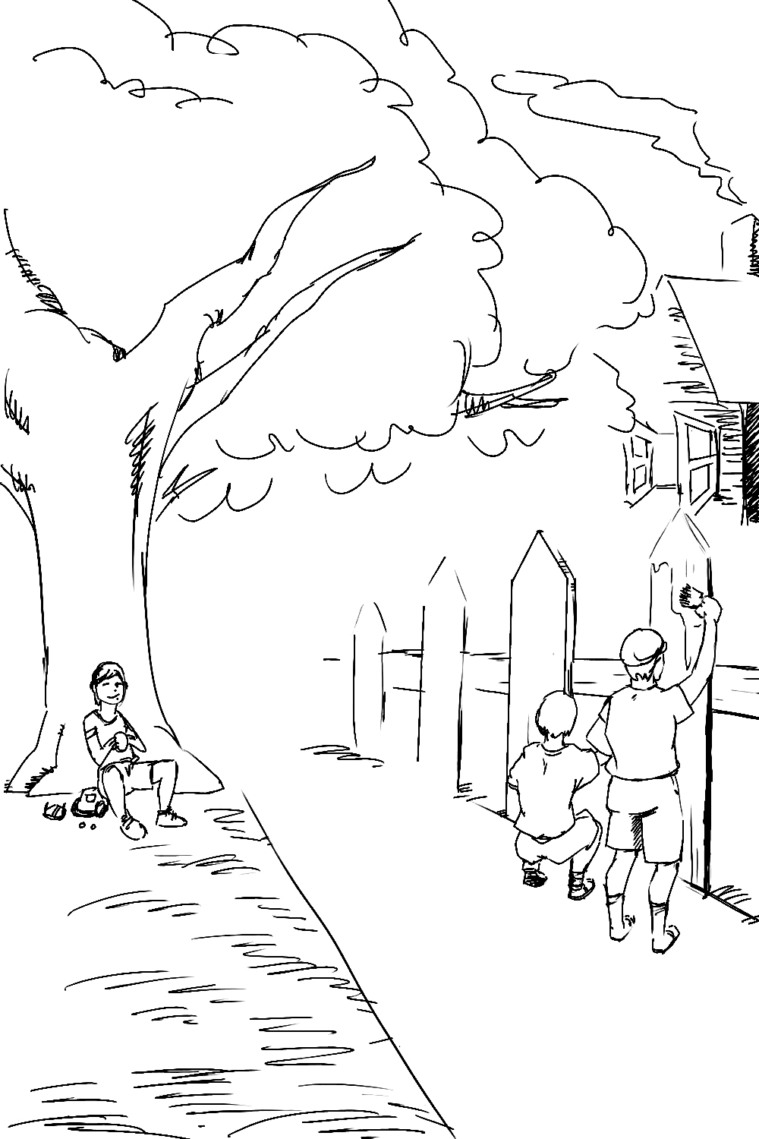
汤姆坐在树下看着小伙伴们帮他刷篱笆
在本卖力地在烈日下刷篱笆时，汤姆坐在树荫底下，一边啃着甜甜的苹果，一边盘算怎么再多宰几个像本这样的傻家伙。结果傻家伙还是很多的。在汤姆的表演吸引下，每一个路过的孩子都对刷篱笆产生了浓厚兴趣，愿意用自己的宝贝玩意交换这工作。于是在下午快过去一半的时候，汤姆不仅把篱笆刷好了，还获得了一大堆其他男孩珍藏的玩意儿。汤姆把他计谋的成功归功于人们的空虚，然后就去向包莉姨妈报告工作情况了。

S
aturday morning was come, and all the summer world was bright and fresh, and brimming with life. There was a song in every heart; and if the heart was young the music issued at the lips. There was cheer in every face, and a spring in every step. The locusttrees were in bloom, and the fragrance of the blossoms filled the air. Cardiff Hill, beyond the village and above it, was green with vegetation, and it lay just far enough away to seem a Delectable Land, dreamy, reposeful, and inviting.
Tom appeared on the side-walk with a bucket of whitewash and a long-handled brush. He surveyed the fence, and all gladness left him, and a deep melancholy settled down upon his spirits. Thirty yards of board-fence nine feet high! Life to him seemed hollow, and existence but a burden. Sighing he dipped his brush and passed it along the topmost plank; repeated the operation; did it again; compared the insignificant whitewashed streak with the far-reaching continent of unwhitewashed fence, and sat down on a tree-box discouraged. Jim came skipping out at the gate with a tin pall, and singing “Buffalo Gals”. Bringing water from the town pump had always been hateful work in Tom’s eyes before, but now it did not strike him so. He remembered that there was company at the pump. White, mulatto, and negro boys and girls were always there waiting their turns, resting, trading playthings, quarrelling, fighting, skylarking. And he remembered that although the pump was only a hundred and fifty yards off, Jim never got back with a bucket of water under an hour; and even then somebody generally had to go after him. Tom said:
“Say, Jim; I’ll fetch the water if you’ll whitewash some.”
Jim shook his head and said:
“Can’t, Mars Tom. Ole missis, she tole me I got to go an git dis water an ’not stop foolin’ roun’ wid anybody. She say she spec ’Mars Tom gwine to ax me to whitewash, an’ so she tole me go ’long an’ ‘tend to my own business – she’ lowed she’d ‘tend to de whitewashin’.”
“Oh, never you mind what she said, Jim. That’s the way she always talks. Gimme the bucket—I won’t be gone only a minute. She won’t ever know.”
“Oh, I dasn’t, Mars Tom. Ole missis she’d take an‘ tar de head off’n me. ’Deed she would.”
“She! She never licks anybody—whacks ’em over the head with her thimble, and who cares for that, I’d like to know? She talks awful, but talk don’t hurt—anyways, it don’t if she don’t cry. Jim, I’ll give you a marvel. I’ll give you a white alley!”
Jim began to waver.
“White alley, Jim! And it’s a bully taw.”
“My! Dat’s a mighty gay marvel, I tell you! But, Mars Tom, I’s powerful ’fraid ole missis—”
“And besides, if you will I’ll show you my sore toe.”
Jim was only human—this attraction was too much for him. He put down his pail, took the white alley, and bent over the toe with absorbing interest while the bandage was being unwound. In another moment he was flying down the street with his pail and a tingling rear, Tom was whitewashing with vigour, and Aunt Polly was retiring from the field with a slipper in her hand and triumph in her eye.
But Tom’s energy did not last. He began to think of the fun he had planned for this day, and his sorrows multiplied. Soon the free boys would come tripping along on all sorts of delicious expeditions, and they would make a world of fun of him for having to work—the very thought of it burnt him like fire. He got out his worldly wealth and examined it—bits of toys, marbles and trash; enough to buy an exchange of work, maybe, but not half enough to buy so much as half an hour of pure freedom. So he returned his straitened means to his pocket, and gave up the idea of trying to buy the boys. At this dark and hopeless moment an inspiration burst upon him! Nothing less than a great, magnificent inspiration.
He took up his brush and went tranquilly to work. Ben Rogers hove in sight presently—the very boy, of all boys, whose ridicule he had been dreading. Ben’s gait was the hop-skip-and-jump—proof enough that his heart was light and his anticipations high. He was eating an apple, and giving a long, melodious whoop at intervals, followed by a deeptoned ding-dong-dong, ding-dong-dong, for he was personating a steamboat. As he drew near he slackened speed, took the middle of the street, leaned far over to starboard, and rounded to ponderously and with laborious pomp and circumstance—for he was personating the “Big missouri”, and considered himself to be drawing nine feet of water. He was boat, and captain, and engine-bells combined, so he had to imagine himself standing on his own hurricanedeck giving the orders and executing them:
“Stop her, sir! Ting-a-ling-ling !” The headway ran almost out, and he drew up slowly toward the sidewalk.
“Ship up to back! Ting-a-ling-ling!” His arms straightened and stiffened down his sides.
“Set her back on the stabboard! Ting-a-ling-ling ! Chow! Ch-chow-wow! Chow!” His right hand meantime describing stately circles, for it was representing a forty-foot wheel.
“Let her go back on the labboard! Ting-a-ling-ling! Chow-ch-chow- chow!” The left hand began to describe circles.
“Stop the stabboard ! Ting-a-ling-ling! Stop the labboard! Come ahead on the stabboard! Stop her! Let your outside turn over slow! Ting-a-ling-ling! Chow-ow-ow! Get out that head-line! Lively now! Come—out with your spring-line—what’re you about there? Take a turn round that stump with the bight of it! Stand by that stage now—let her go! Done with the engines, sir! Ting-a-ling-ling! Sh’t! s’h’t! sh’t!” (trying the gauge-cocks).
Tom went on whitewashing—paid no attention to the steamboat. Ben stared a moment, and then said:
“Hi-yi! You’re up a stump, ain’t you!”
No answer. Tom surveyed his last touch with the eye of an artist; then he gave his brush another gentle sweep, and surveyed the result, as before. Ben ranged up alongside of him. Tom’s mouth watered for the apple, but he stuck to his work. Ben said:
“Hello, old chap, you got to work, hey?”
Tom wheeled suddenly and said:
“Why, it’s you, Ben! I warn’t noticing.”
“Say—I’m going in a-swimming, I am. Don’t you wish you could? But of course you’d druther work—wouldn’t you? Course you would!”
Tom contemplated the boy a bit, and said:
“What do you call work?”
“Why, ain’t that work?”
Tom resumed his whitewashing, and answered carelessly:
“Well, maybe it is, and maybe it ain’t. All I know is, it suits Tom Sawyer.”
“Oh, come now, you don’t mean to let on that you like it?”
The brush continued to move.
“Like it? Well, I don’t see why I oughtn’t to like it. Does a boy get a chance to whitewash a fence every day?”
That put the thing in a new light. Ben stopped nibbling his apple. Tom swept his brush daintily back and forth—stepped back to note the effect—added a touch here and there—criticised the effect again—Ben watching every move, and getting more and more interested, more and more absorbed.
Presently he said: “Say, Tom, let me whitewash a little.”
Tom considered—was about to consent; but he altered his mind:
“No, no; I reckon it wouldn’t hardly do, Ben. You see, Aunt Polly’s awful particular about this fence—right here on the street, you know—but if it was the back fence I wouldn’t mind, and she wouldn’t. Yes, she’s awful particular about this fence; it’s got to be done very careful; I reckon there ain’t one boy in a thousand, maybe two thousand, that can do it the way it’s got to be done.”
“No—is that so? Oh, come now; lemme just try. Only just a little. I’d let you, if you was me, Tom.”
“Ben, I’d like to, honest injun; but Aunt Polly—well, Jim wanted to do it, but she wouldn’t let him. Sid wanted to do it, and she wouldn’t let Sid. Now, don’t you see how I’m fixed? If you was to tackle this fence, and anything was to happen to it—”
“Oh, shucks; I’ll be just as careful. Now lemme try. Say—I’ll give you the core of my apple.”
“Well, here—No, Ben; now don’t. I’m afeard—”
“I’ll give you all of it!”
Tom gave up the brush with reluctance in his face but alacrity in his heart. And while the late steamer “Big Missouri” worked and sweated in the sun, the retired artist sat on a barrel in the shade close by, dangled his legs, munched his apple, and planned the slaughter of more innocents. There was no lack of material; boys happened along every little while; they came to jeer, but remained to whitewash. By the time Ben was fagged out, Tom had traded the next chance to Billy Fisher for a kite, in good repair; and when he played out, Johnny Miller bought in for a dead rat and a string to swing it with; and so on, and so on, hour after hour. And when the middle of the afternoon came, from being a poor poverty-stricken boy in the morning, Tom was literally rolling in wealth. He had, besides the things before mentioned, twelve marbles, part of a jews-harp, a piece of blue bottle-glass to look through, a spool cannon, a key that wouldn’t unlock anything, a fragment of chalk, a glass Stopper of a decanter, a tin soldier, a couple of tadpoles, six fire-crackers, a kitten with only one eye, a brass door-knob, a dog-collar—but no dog—the handle of a knife, four pieces of orange-peel, and a dilapidated old window-sash. He had had a nice, good, idle time all the while—plenty of company—and the fence had three coats of white-wash, on it! If he hadn’t run out of whitewash, he would have bankrupted every boy in the village.
Tom said to himself that it was not such a hollow world, after all. He had discovered a great law of human action, without knowing it—namely, that in order to make a man or a boy covet a thing, it is only necessary to make the thing difficult to attain. If he had been a great and wise philosopher, like the writer of this book, he would now have comprehended that Work consists of whatever a body is obliged to do, and that Play consists of whatever a body is not obliged to do. And this would help him to understand why constructing artificial flowers or performing on a treadmill is work, while rolling ten-pins or climbing Mont Blanc is only amusement. There are wealthy gentlemen in England who drive four-horse passenger-coaches twenty or thirty miles on a daily line in the summer, because the privilege costs them considerable money; but if they were offered wages for the service, that would turn it into work, and then they would resign.
The boy mused a while over the substantial change which had taken place in his worldly circumstances, and then wended toward head-quarters to report.

第三章
Chapter III
姨妈原以为汤姆早丢下工作玩儿去了，可小家伙却出现在她面前，报告篱笆全刷好了。她大吃一惊，走出去看到篱笆确实刷得好极了，就奖励了汤姆一个苹果。小家伙又偷偷拿了一个炸面包圈，然后出去玩儿。他刚走出门就碰见锡德。想起上次的事儿，小家伙愤怒地捡起地上的小土块，疯狂地向表弟扔去。锡德措手不及。包莉姨妈闻声赶来，他急忙越过篱笆逃走了。
汤姆逃到安全的地方，然后急奔往镇里广场。广场已经聚集了两队“孩子大军”。一边的将军是乔·哈泼，他是汤姆的知心好友。另一边的将军就是汤姆。将军到位后就开始在后方指挥战斗，最后汤姆所率的部队大获全胜。两方清点死亡人数，交换战俘并商定了下次开战的日期，然后孩子们就各自回家了。
汤姆经过杰夫·撒切尔家花园时，看到一位陌生小姑娘。他立刻为她的美丽所倾倒。前些日子他刚追到的艾米·劳伦斯，此刻在他心里消失得无影无踪。汤姆开始做各种各样的高难度动作，借此表现自己。可她似乎并不领情。就在汤姆黯然伤神时，她把一朵紫罗兰扔到了篱笆外。汤姆高兴地朝花儿奔去，用脚趾夹着一蹦一跳地走了。不一会儿，汤姆又回来像刚才那样表现自己。可她一直到天黑都没有出现。汤姆只好回家了。
这个晚上汤姆总是兴高采烈的，也不计较因用土块扔锡德而挨的骂。姨妈发现汤姆又偷糖吃，就教训了他一顿，还叫他多向锡德学习。过了一

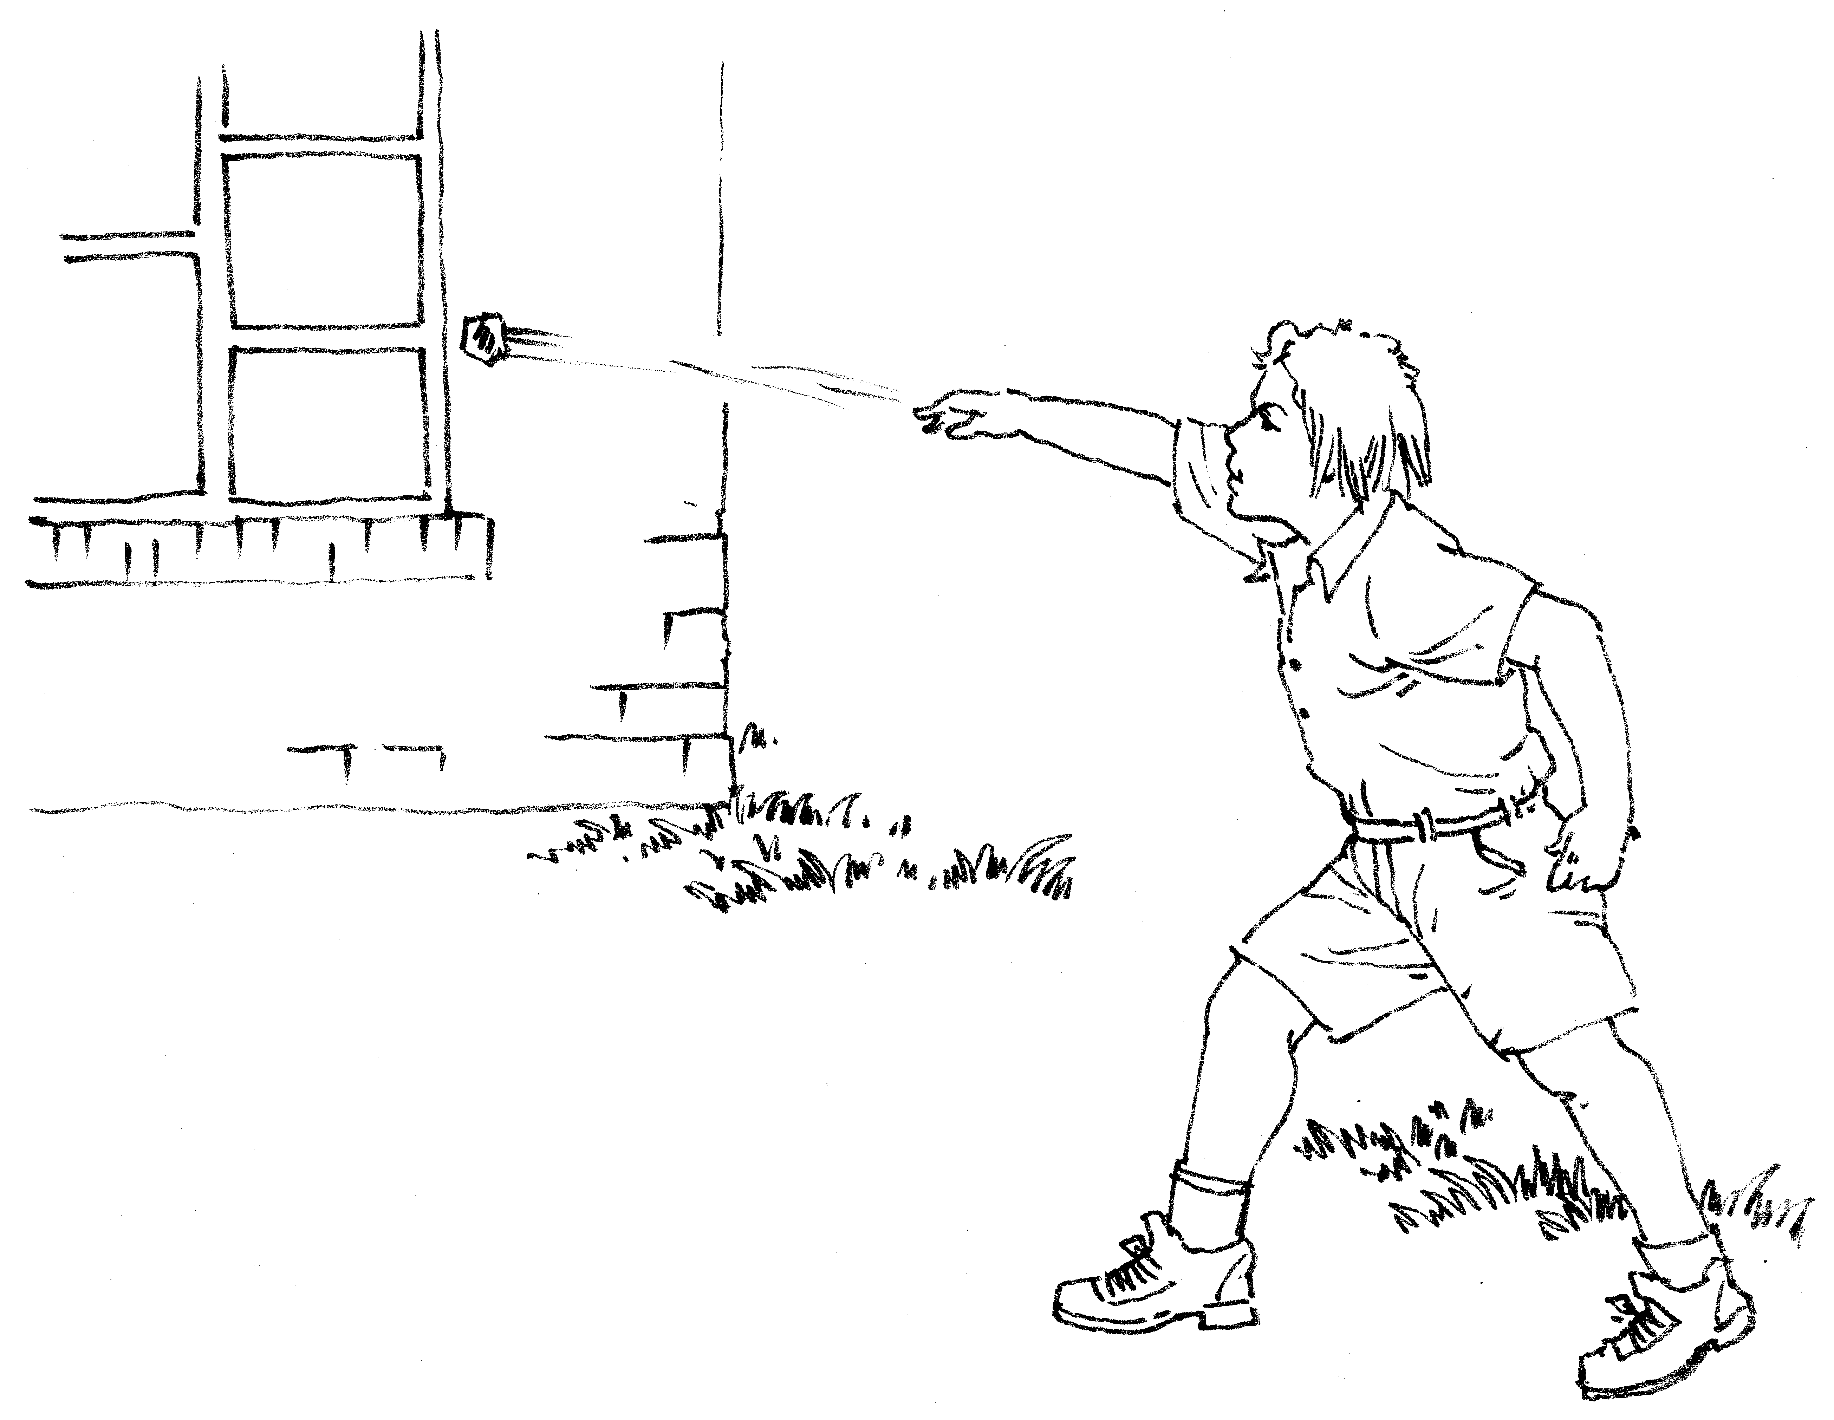
捡起个东西朝窗户扔去

