泄 密 的 心
The Tell-Tale Heart
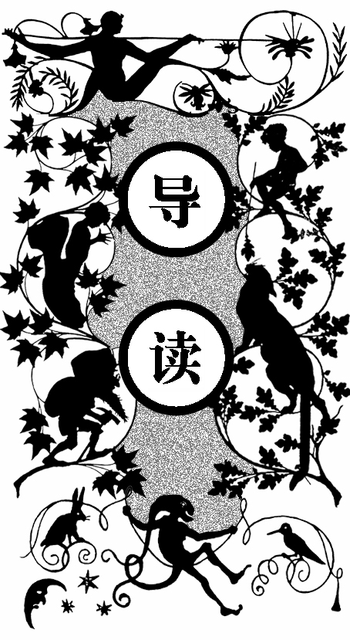
故事的主人公神经过敏，每当他看到与他无冤无仇的老头的那只浅蓝色的眼睛，他就心里发毛。渐渐地，他打定主意要害死老头。
动手的前一周，他每晚都会潜入老头的卧室。老头睡着了，看不见那令人讨厌的眼睛，他就无法下手。第八天晚上，主人公惊醒了老头。屋里很黑，老头看不见主人公，他吓得不敢睡觉。主人公一动不动地站了好久也没听见老头躺下，便把灯罩挑开一道缝，那光正照着他最讨厌的眼睛。同时主人公听见老头的心跳得越来越响，他再也受不了了，扑了过去，把床推翻压住了老头。心跳声慢慢变弱，最后消失了。
而后，主人公肢解了尸体，藏匿在地板下，清理了所有痕迹。
凌晨四点，警察就上门了，说听到了叫声，要求搜查。 主人公洋洋得意地搬了把椅子坐在了藏尸体的地板上方，神态自若地和警官聊着天。这时，他听到一阵有节奏的咚咚声，而且越来越响。主人公为了掩饰这声音，不断提高嗓门说话。后来咚咚声大得他只得歇斯底里地咆哮，可还是无法盖过那声音。警察对响声似乎没有察觉。最后，他彻底崩溃了，他对警察吼道：“不要再装蒜了，老

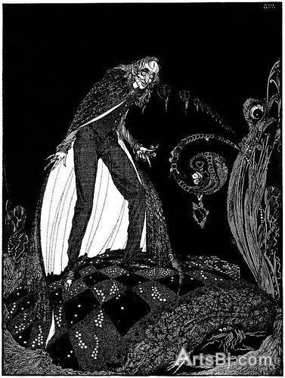
泄密的心
头的心就在这地板下跳呢！”

RUE! — nervous — very, very dreadfully nervous I had been and am; but why will you say that I am mad? The disease had sharpened my senses — not destroyed — not dulled them. Above all was the sense of hearing acute. I heard all things in the heaven and in the earth. I heard many things in hell. How, then, am I mad? Hearken! and observe how healthily — how calmly I can tell you the whole story.
T
It is impossible to say how first the idea entered my brain; but once conceived, it haunted me day and night. Object there was none. Passion there was none. I loved the old man. He had never wronged me. He had never given me insult. For his gold I had no desire. I think it was his eye! yes, it was this! He had the eye of a vulture — a pale blue eye, with a film over it. Whenever it fell upon me, my blood ran cold; and so by degrees — very gradually — I made up my mind to take the life of the old man, and thus rid myself of the eye forever.
Now this is the point. You fancy me mad. Madmen know nothing. But you should have seen me. You should have seen how wisely I proceeded — with what caution — with what foresight — with what dissimulation I went to work! I was never kinder to the old man than during the whole week before I killed him. And every night, about midnight, I turned the latch of his door and opened it — oh so gently! And then, when I had made an opening sufficient for my head, I put in a dark lantern, all closed, closed, that no light shone out, and then I thrust in my head. Oh, you would have laughed to see how cunningly I thrust it in! I moved it slowly — very, very slowly, so that I might not disturb the old man’s sleep. It took me an hour to place my whole head within the opening so far that I could see him as he lay upon his bed. Ha! would a madman have been so wise as this, And then, when my head was well in the room, I undid the lantern cautiously-oh, so cautiously — cautiously (for the hinges creaked) — I undid it just so much that a single thin ray fell upon the vulture eye. And this I did for seven long nights — every night just at midnight — but I found the eye always closed; and so it was impossible to do the work; for it was not the old man who vexed me, but his Evil Eye. And every morning, when the day broke, I went boldly into the chamber, and spoke courageously to him, calling him by name in a hearty tone, and inquiring how he has passed the night. So you see he would have been a very profound old man, indeed, to suspect that every night, just at twelve, I looked in upon him while he slept.
Upon the eighth night I was more than usually cautious in opening the door. A watch’s minute hand moves more quickly than did mine. Never before that night had I felt the extent of my own powers — of my sagacity. I could scarcely contain my feelings of triumph. To think that there I was, opening the door, little by little, and he not even to dream of my secret deeds or thoughts. I fairly chuckled at the idea; and perhaps he heard me; for he moved on the bed suddenly, as if startled. Now you may think that I drew back — but no. His room was as black as pitch with the thick darkness, (for the shutters were close fastened, through fear of robbers) and so I knew that he could not see the opening of the door, and I kept pushing it on steadily, steadily.
I had my head in, and was about to open the lantern, when my thumb slipped upon the tin fastening, and the old man sprang up in bed, crying out — “Who’s there?”
I kept quite still and said nothing. For a whole hour I did not move a muscle, and in the meantime I did not hear him lie down. He was still sitting up in the bed listening; — just as I have done, night after night, hearkening to the death watches in the wall.
Presently I heard a slight groan, and I knew it was the groan of mortal terror. It was not a groan of pain or of grief — oh, no! — it was the low stifled sound that arises from the bottom of the soul when overcharged with awe. I knew the sound well. Many a night, just at midnight, when all the world slept, it has welled up from my own bosom, deepening, with its dreadful echo, the terrors that distracted me. I say I knew it well. I knew what the old man felt, and pitied him, although I chuckled at heart. I knew that he had been lying awake ever since the first slight noise, when he had turned in the bed. His fears had been ever since growing upon him. He had been trying to fancy them causeless, but could not. He had been saying to himself — “It is nothing but the wind in the chimney — it is only a mouse crossing the floor,” or “It is merely a cricket which has made a single chirp.” Yes, he had been trying to comfort himself with these suppositions: but he had found all in vain. All in vain; because Death, in approaching him had stalked with his black shadow before him, and enveloped the victim. And it was the mournful influence of the unperceived shadow that caused him to feel — although he neither saw nor heard — to feel the presence of my head within the room.
When I had waited a long time, very patiently, without hearing him lie down, I resolved to open a little — a very, very little crevice in the lantern. So I opened it — you cannot imagine how stealthily, stealthily — until, at length a simple dim ray, like the thread of the spider, shot from out the crevice and fell full upon the vulture eye.
It was open — wide, wide open — and I grew furious as I gazed upon it. I saw it with perfect distinctness — all a dull blue, with a hideous veil over it that chilled the very marrow in my bones; but I could see nothing else of the old man’s face or person: for I had directed the ray as if by instinct, precisely upon the damned spot.
And have I not told you that what you mistake for madness is but over-acuteness of the sense? — now, I say, there came to my ears a low, dull, quick sound, such as a watch makes when enveloped in cotton. I knew that sound well, too. It was the beating of the old man’s heart. It increased my fury, as the beating of a drum stimulates the soldier into courage.
But even yet I refrained and kept still. I scarcely breathed. I held the lantern motionless. I tried how steadily I could maintain the ray upon the eye. Meantime the hellish tattoo of the heart increased. It grew quicker and quicker, and louder and louder every instant. The old man’s terror must have been extreme! It grew louder, I say, louder every moment! — do you mark me well I have told you that I am nervous: so I am. And now at the dead hour of the night, amid the dreadful silence of that old house, so strange a noise as this excited me to uncontrollable terror. Yet, for some minutes longer I refrained and stood still. But the beating grew louder, louder! I thought the heart must burst. And now a new anxiety seized me — the sound would be heard by a neighbour! The old man’s hour had come! With a loud yell, I threw open the lantern and leaped into the room. He shrieked once — once only. In an instant I dragged him to the floor, and pulled the heavy bed over him. I then smiled gaily, to find the deed so far done. But, for many minutes, the heart beat on with a muffled sound. This, however, did not vex me; it would not be heard through the wall. At length it ceased. The old man was dead. I removed the bed and examined the corpse. Yes, he was stone, stone dead. I placed my hand upon the heart and held it there many minutes. There was no pulsation. He was stone dead. His eye would trouble me no more.
If still you think me mad, you will think so no longer when I describe the wise precautions I took for the concealment of the body. The night waned, and I worked hastily, but in silence. First of all I dismembered the corpse. I cut off the head and the arms and the legs.
I then took up three planks from the flooring of the chamber, and deposited all between the scantlings. I then replaced the boards so cleverly, so cunningly, that no human eye — not even his — could have detected any thing wrong. There was nothing to wash out — no stain of any kind — no blood-spot whatever. I had been too wary for that. A tub had caught all — ha! ha!
When I had made an end of these labors, it was four o’clock — still dark as midnight. As the bell sounded the hour, there came a knocking at the street door. I went down to open it with a light heart, — for what had I now to fear? There entered three men, who introduced themselves, with perfect suavity, as officers of the police. A shriek had been heard by a neighbour during the night; suspicion of foul play had been aroused; information had been lodged at the police office, and they (the officers) had been deputed to search the premises.
I smiled, — for what had I to fear? I bade the gentlemen welcome. The shriek, I said, was my own in a dream. The old man, I mentioned, was absent in the country. I took my visitors all over the house. I bade them search — search well. I led them, at length, to his chamber. I showed them his treasures, secure, undisturbed. In the enthusiasm of my confidence, I brought chairs into the room, and desired them here to rest from their fatigues, while I myself, in the wild audacity of my perfect triumph, placed my own seat upon the very spot beneath which reposed the corpse of the victim.
The officers were satisfied. My manner had convinced them. I was singularly at ease. They sat, and while I answered cheerily, they chatted of familiar things. But, ere long, I felt myself getting pale and wished them gone. My head ached, and I fancied a ringing in my ears: but still they sat and still chatted. The ringing became more distinct: — It continued and became more distinct: I talked more freely to get rid of the feeling: but it continued and gained definiteness — until, at length, I found that the noise was not within my ears.
No doubt I now grew very pale; — but I talked more fluently, and with a heightened voice. Yet the sound increased — and what could I do? It was a low, dull, quick sound — much such a sound as a watch makes when enveloped in cotton. I gasped for breath — and yet the officers heard it not. I talked more quickly — more vehemently; but the noise steadily increased. I arose and argued about trifles, in a high key and with violent gesticulations; but the noise steadily increased. Why would they not be gone? I paced the floor to and fro with heavy strides, as if excited to fury by the observations of the men — but the noise steadily increased. Oh God! what could I do? I foamed — I raved — I swore! I swung the chair upon which I had been sitting, and grated it upon the boards, but the noise arose over all and continually increased. It grew louder — louder — louder! And still the men chatted pleasantly, and smiled. Was it possible they heard not? Almighty God! — no, no! They heard! — they suspected! — they knew! — they were making a mockery of my horror!-this I thought, and this I think. But anything was better than this agony! Anything was more tolerable than this derision! I could bear those hypocritical smiles no longer! I felt that I must scream or die! and now — again! — hark! louder! louder! louder! louder!
“Villains!” I shrieked, “dissemble no more! I admit the deed! — tear up the planks! here, here! — It is the beating of his hideous heart!”

绝 境
A Predicament
泽诺比阿小姐带着黑奴庞培和卷毛狗黛安娜逛街。庞培是个身材矮小的老头，却套了一件长大衣，所以他不得不用手提着衣服。这时小姐突然想到教堂的钟塔上去看看全城的景色。于是他们登上了旋转楼梯。途中黛安娜闻到了老鼠的味道。
泽诺比阿小姐首先登顶，庞培伸出手来请小姐拉他一把，可这下大衣便拖在了地上，他踩着了衣角，扑倒在小姐身上。小姐生气地扯掉他的假发扔在了地上。
后来他们又和好了。那钟塔只有一个高高的孔可以探出头去看全城的风景，小姐要求踩着庞培。风景果然很美。不一会儿庞培说他顶不住了。小姐骂了他，继续看着风景。她探头的地方是钟面上的一个孔，不久钟表的分针便架到了她的脖子上。她不能抽身，只有向庞培求救，可是庞培说他已伤透了心。而那条狗也帮不上忙，更何况她还命令它在角落里待着别动。
时间慢慢过去，分针压得越来越紧。小姐的眼珠被挤得凸出，最后双双掉了出来。而后，分针切掉了她的脑袋，她又自由了。她感觉自己并无不妥。她拿出了鼻烟壶，发现不能吸，就把鼻烟壶扔

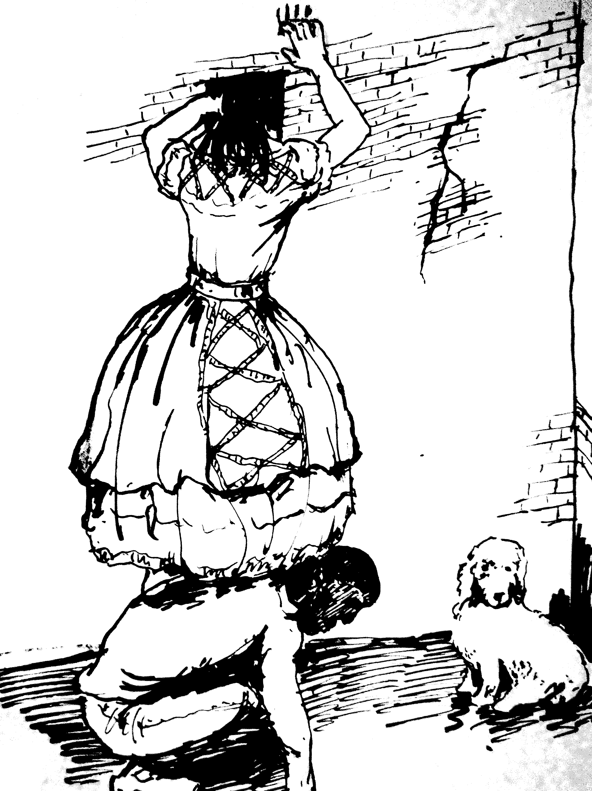
踩着庞培探出头看风景
给了脑袋，脑袋就快活地吸着。
庞培见她下来，吓得落荒而逃。她再转身看忠诚的黛安娜，它却只剩下一堆残骸——它被老鼠吃掉了。泽诺比阿小姐这才明白她完了。

hat chance, good lady, hath bereft you thus?—COMUS.
W
IT was a quiet and still afternoon when I strolled forth in the goodly city of Edina. The confusion and bustle in the streets were terrible. Men were talking. Women were screaming. Children were choking. Pigs were whistling. Carts they rattled. Bulls they bellowed. Cows they lowed. Horses they neighed. Cats they caterwauled. Dogs they danced. Danced! Could it then be possible? Danced! Alas, thought I, my dancing days are over! Thus it is ever. What a host of gloomy recollections will ever and anon be awakened in the mind of genius and imaginative contemplation, especially of a genius doomed to the everlasting and eternal, and continual, and, as one might say, the—continued—yes, the continued and continuous, bitter, harassing, disturbing, and, if I may be allowed the expression, the very disturbing influence of the serene, and godlike, and heavenly, and exalted, and elevated, and purifying effect of what may be rightly termed the most enviable, the most truly enviable—nay! the most benignly beautiful, the most deliciously ethereal, and, as it were, the most pretty (if I may use so bold an expression) thing (pardon me, gentle reader!) in the world—but I am always led away by my feelings. In such a mind, I repeat, what a host of recollections are stirred up by a trifle! The dogs danced! I—I could not! They frisked—I wept. They capered—I sobbed aloud. Touching circumstances! which cannot fail to bring to the recollection of the classical reader that exquisite passage in relation to the fitness of things, which is to be found in the commencement of the third volume of that admirable and venerable Chinese novel the Jo-Go-Slow.
In my solitary walk through, the city I had two humble but faithful companions. Diana, my poodle! sweetest of creatures! She had a quantity of hair over her one eye, and a blue ribband tied fashionably around her neck. Diana was not more than five inches in height, but her head was somewhat bigger than her body, and her tail being cut off exceedingly close, gave an air of injured innocence to the interesting animal which rendered her a favorite with all.
And Pompey, my negro!—sweet Pompey! how shall I ever forget thee? I had taken Pompey’s arm. He was three feet in height (I like to be particular) and about seventy, or perhaps eighty, years of age. He had bow-legs and was corpulent. His mouth should not be called small, nor his ears short. His teeth, however, were like pearl, and his large full eyes were deliciously white. Nature had endowed him with no neck, and had placed his ankles (as usual with that race) in the middle of the upper portion of the feet. He was clad with a striking simplicity. His sole garments were a stock of nine inches in height, and a nearly—new drab overcoat which had formerly been in the service of the tall, stately, and illustrious Dr. Moneypenny. It was a good overcoat. It was well cut. It was well made. The coat was nearly new. Pompey held it up out of the dirt with both hands.
There were three persons in our party, and two of them have already been the subject of remark. There was a third—that person was myself. I am the Signora Psyche Zenobia. I am not Suky Snobbs. My appearance is commanding. On the memorable occasion of which I speak I was habited in a crimson satin dress, with a sky-blue Arabian mantelet. And the dress had trimmings of green agraffes, and seven graceful flounces of the orange-colored auricula. I thus formed the third of the party. There was the poodle. There was Pompey. There was myself. We were three. Thus it is said there were originally but three Furies—Melty, Nimmy, and Hetty—Meditation, Memory, and Fiddling.
Leaning upon the arm of the gallant Pompey, and attended at a respectable distance by Diana, I proceeded down one of the populous and very pleasant streets of the now deserted Edina. On a sudden, there presented itself to view a church—a Gothic cathedral—vast, venerable, and with a tall steeple, which towered into the sky. What madness now possessed me? Why did I rush upon my fate? I was seized with an uncontrollable desire to ascend the giddy pinnacle, and then survey the immense extent of the city. The door of the cathedral stood invitingly open. My destiny prevailed. I entered the ominous archway. Where then was my guardian angel?—if indeed such angels there be. If! Distressing monosyllable! what world of mystery, and meaning, and doubt, and uncertainty is there involved in thy two letters! I entered the ominous archway! I entered; and, without injury to my orange- colored auriculas, I passed beneath the portal, and emerged within the vestibule. Thus it is said the immense river Alfred passed, unscathed, and unwetted, beneath the sea.
I thought the staircase would never have an end. Round! Yes, they went round and up, and round and up and round and up, until I could not help surmising, with the sagacious Pompey, upon whose supporting arm I leaned in all the confidence of early affection—I could not help surmising that the upper end of the continuous spiral ladder had been accidentally, or perhaps designedly, removed. I paused for breath; and, in the meantime, an accident occurred of too momentous a nature in a moral, and also in a metaphysical point of view, to be passed over without notice. It appeared to me—indeed I was quite confident of the fact—I could not be mistaken—no! I had, for some moments, carefully and anxiously observed the motions of my Diana—I say that I could not be mistaken—Diana smelt a rat! At once I called Pompey’s attention to the subject, and he—he agreed with me. There was then no longer any reasonable room for doubt. The rat had been smelled—and by Diana. Heavens! shall I ever forget the intense excitement of the moment? Alas! what is the boasted intellect of man? The rat!—it was there—that is to say, it was somewhere. Diana smelled the rat. I—I could not! Thus it is said the Prussian Isis has, for some persons, a sweet and very powerful perfume, while to others it is perfectly scentless.
The staircase had been surmounted, and there were now only three or four more upward steps intervening between us and the summit. We still ascended, and now only one step remained. One step! One little, little step! Upon one such little step in the great staircase of human life how vast a sum of human happiness or misery depends! I thought of myself, then of Pompey, and then of the mysterious and inexplicable destiny which surrounded us. I thought of Pompey!—alas, I thought of love! I thought of my many false steps which have been taken, and may be taken again. I resolved to be more cautious, more reserved. I abandoned the arm of Pompey, and, without his assistance, surmounted the one remaining step, and gained the chamber of the belfry. I was followed immediately afterward by my poodle. Pompey alone remained behind. I stood at the head of the staircase, and encouraged him to ascend. He stretched forth to me his hand, and unfortunately in so doing was forced to abandon his firm hold upon the overcoat. Will the gods never cease their persecution? The overcoat is dropped, and, with one of his feet, Pompey stepped upon the long and trailing skirt of the overcoat. He stumbled and fell—this consequence was inevitable. He fell forward, and, with his accursed head, striking me full in the—in the breast, precipitated me headlong, together with himself, upon the hard, filthy, and detestable floor of the belfry. But my revenge was sure, sudden, and complete. Seizing him furiously by the wool with both hands, I tore out a vast quantity of black, and crisp, and curling material, and tossed it from me with every manifestation of disdain. It fell among the ropes of the belfry and remained. Pompey arose, and said no word. But he regarded me piteously with his large eyes and—sighed. Ye Gods—that sigh! It sunk into my heart. And the hair—the wool! Could I have reached that wool I would have bathed it with my tears, in testimony of regret. But alas! it was now far beyond my grasp. As it dangled among the cordage of the bell, I fancied it alive. I fancied that it stood on end with indignation. Thus the happy-dandy Flos Aeris of Java bears, it is said, a beautiful flower, which will live when pulled up by the roots. The natives suspend it by a cord from the ceiling and enjoy its fragrance for years.
Our quarrel was now made up, and we looked about the room for an aperture through which to survey the city of Edina. Windows there were none. The sole light admitted into the gloomy chamber proceeded from a square opening, about a foot in diameter, at a height of about seven feet from the floor. Yet what will the energy of true genius not effect? I resolved to clamber up to this hole. A vast quantity of wheels, pinions, and other cabalistic—looking machinery stood opposite the hole, close to it; and through the hole there passed an iron rod from the machinery. Between the wheels and the wall where the hole lay there was barely room for my body—yet I was desperate, and determined to persevere. I called Pompey to my side.
“You perceive that aperture, Pompey. I wish to look through it. You will stand here just beneath the hole—so. Now, hold out one of your hands, Pompey, and let me step upon it—thus. Now, the other hand, Pompey, and with its aid I will get upon your shoulders.”
He did every thing I wished, and I found, upon getting up, that I could easily pass my head and neck through the aperture. The prospect was sublime. Nothing could be more magnificent. I merely paused a moment to bid Diana behave herself, and assure Pompey that I would be considerate and bear as lightly as possible upon his shoulders. I told him I would be tender of his feelings—ossi tender que beefsteak. Having done this justice to my faithful friend, I gave myself up with great zest and enthusiasm to the enjoyment of the scene which so obligingly spread itself out before my eyes.
Upon this subject, however, I shall forbear to dilate. I will not describe the city of Edinburgh. Every one has been to the city of Edinburgh. Every one has been to Edinburgh—the classic Edina. I will confine myself to the momentous details of my own lamentable adventure. Having, in some measure, satisfied my curiosity in regard to the extent, situation, and general appearance of the city, I had leisure to survey the church in which I was, and the delicate architecture of the steeple. I observed that the aperture through which I had thrust my head was an opening in the dial-plate of a gigantic clock, and must have appeared, from the street, as a large key-hole, such as we see in the face of the French watches. No doubt the true object was to admit the arm of an attendant, to adjust, when necessary, the hands of the clock from within. I observed also, with surprise, the immense size of these hands, the longest of which could not have been less than ten feet in length, and, where broadest, eight or nine inches in breadth. They were of solid steel apparently, and their edges appeared to be sharp. Having noticed these particulars, and some others, I again turned my eyes upon the glorious prospect below, and soon became absorbed in contemplation.
From this, after some minutes, I was aroused by the voice of Pompey, who declared that he could stand it no longer, and requested that I would be so kind as to come down. This was unreasonable, and I told him so in a speech of some length. He replied, but with an evident misunderstanding of my ideas upon the subject. I accordingly grew angry, and told him in plain words, that he was a fool, that he had committed an ignoramus e-clench-eye, that his notions were mere insommary Bovis, and his words little

