警察与颂歌
The Cop and the Anthem

冬天就要来临，穿着薄衣的苏比想到，抵御严寒的最好办法，是去南方的布莱克威尔岛上的监狱待三个月。为了实现目的，苏比必须想出办法让警察抓到自己。他首先想到去一家高级餐厅白吃一顿，可是刚进餐厅大门，看到苏比破旧的裤子的领班就把他轰了出来。他又朝一家商店的玻璃上砸了一块鹅卵石，没想到巡警放过苏比去追赶另一个与此无关的人。他又进了一家便宜餐厅吃了一顿，得知苏比没钱的服务员没有找警察，而是直接将苏比推到了门外。苏比又先后调戏妇女、扰乱治安、拿人财物，都失望地收了手。最后，苏比经过一座教堂时，听见了里面传来赞美诗的琴声，苏比受到感化，醒悟到要重新做一个正直的人，立志第二天就去找工作。这时，一个警察毫无理由地把比尔抓进警局，判处他在布莱克威尔岛上的监狱监禁三个月。

n his bench in Madison Square Soapy moved uneasily.
O

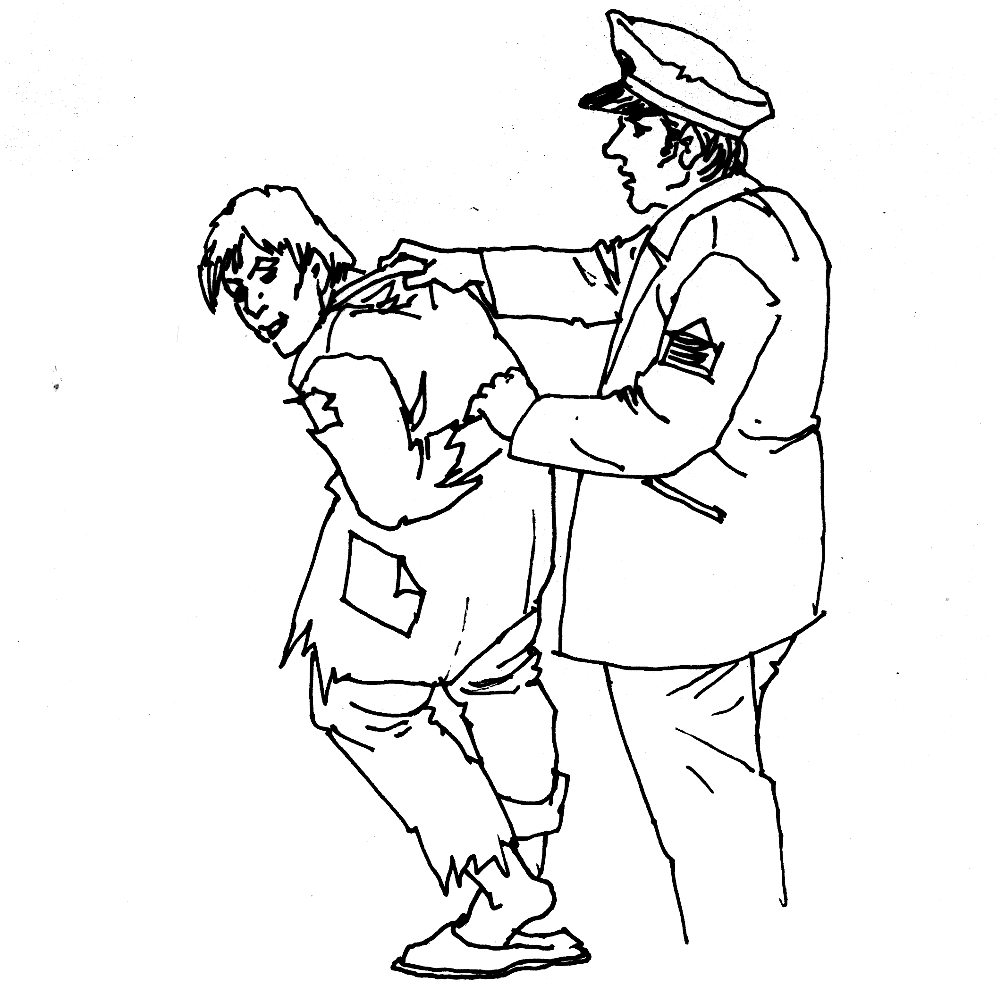
比尔被抓

When wild geese honk high of nights, and when women without sealskin coats grow kind to their husbands, and when Soapy moves uneasily on his bench in the park, you may know that winter is near at hand.
A dead leaf fell in Soapy’s lap. That was Jack Frost’s card. Jack is kind to the regular denizens of Madison Square, and gives fair warning of his annual call. At the corners of four streets he hands his pasteboard to the North Wind, footman of the mansion of All Outdoors, so that the inhabitants thereof may make ready.
Soapy’s mind became cognizant of the fact that the time had come for him to resolve himself into a singular Committee of Ways and Means to provide against the coming rigor. And therefore he moved uneasily on his bench.
The winter ambitions of Soapy were not of the highest. In them there were no considerations of Mediterranean cruises, of soporific Southern skies drifting in the Vesuvian Bay. Three months on the Island was what his soul craved. Three months of assured board and bed and congenial company, safe from Boreas and bluecoats, seemed to Soapy the essence of things desirable.
For years the hospitable Blackwell’s had been his winter quarters. Just as his more fortunate fellow New Yorkers had bought their tickets to Palm Beach and the Riviera each winter, so Soapy had made his humble arrangements for his annual hegira to the Island. And now the time was come. On the previous night three Sabbath newspapers, distributed beneath his coat, about his ankles and over his lap, had failed to repulse the cold as he slept on his bench near the spurting fountain in the ancient square. So the Island loomed big and timely in Soapy’s mind. He scorned the provisions made in the name of charity for the city’s dependents. In Soapy’s opinion the Law was more benign than Philanthropy. There was an endless round of institutions, municipal and eleemosynary, on which he might set out and receive lodging and food accordant with the simple life. But to one of Soapy’s proud spirit the gifts of charity are encumbered. If not in coin you must pay in humiliation of spirit for every benefit received at the hands of philanthropy. As Caesar had his Brutus, every bed of charity must have its toll of a bath, every loaf of bread its compensation of a private and personal inquisition. Wherefore it is better to be a guest of the law, which though conducted by rules, does not meddle unduly with a gentleman’s private affairs.
Soapy, having decided to go to the Island, at once set about accomplishing his desire. There were many easy ways of doing this. The pleasantest was to dine luxuriously at some expensive restaurant; and then, after declaring insolvency, be handed over quietly and without uproar to a policeman. An accommodating magistrate would do the rest.
Soapy left his bench and strolled out of the square and across the level sea of asphalt, where Broadway and Fifth Avenue flow together. Up Broadway he turned, and halted at a glittering cafe, where are gathered together nightly the choicest products of the grape, the silkworm and the protoplasm.
Soapy had confidence in himself from the lowest button of his vest upward. He was shaven, and his coat was decent and his neat black, ready-tied four-in-hand had been presented to him by a lady missionary on Thanksgiving Day. If he could reach a table in the restaurant unsuspected success would be his. The portion of him that would show above the table would raise no doubt in the waiter’s mind. A roasted mallard duck, thought Soapy, would be about the thing—with a bottle of Chablis, and then Camembert, a demi-tasse and a cigar. One dollar for the cigar would be enough. The total would not be so high as to call forth any supreme manifestation of revenge from the cafe management; and yet the meat would leave him filled and happy for the journey to his winter refuge.
But as Soapy set foot inside the restaurant door the head waiter’s eye fell upon his frayed trousers and decadent shoes. Strong and ready hands turned him about and conveyed him in silence and haste to the sidewalk and averted the ignoble fate of the menaced mallard.
Soapy turned off Broadway. It seemed that his route to the coveted island was not to be an epicurean one. Some other way of entering limbo must be thought of.
At a corner of Sixth Avenue electric lights and cunningly displayed wares behind plate-glass made a shop window conspicuous. Soapy took a cobblestone and dashed it through the glass. People came running around the corner, a policeman in the lead. Soapy stood still, with his hands in his pockets, and smiled at the sight of brass buttons.
“Where’s the man that done that?” inquired the officer excitedly.
“Don’t you figure out that I might have had something to do with it?” said Soapy, not without sarcasm, but friendly, as one greets good fortune.
The policeman’s mind refused to accept Soapy even as a clue. Men who smash windows do not remain to parley with the law’s minions. They take to their heels. The policeman saw a man half way down the block running to catch a car. With drawn club he joined in the pursuit. Soapy, with disgust in his heart, loafed along, twice unsuccessful.
On the opposite side of the street was a restaurant of no great pretensions. It catered to large appetites and modest purses. Its crockery and atmosphere were thick; its soup and napery thin. Into this place Soapy took his accusive shoes and telltale trousers without challenge. At a table he sat and consumed beefsteak, flapjacks, doughnuts and pie. And then to the waiter be betrayed the fact that the minutest coin and himself were strangers.
“Now, get busy and call a cop,” said Soapy. “And don’t keep a gentleman waiting.”
“No cop for youse,” said the waiter, with a voice like butter cakes and an eye like the cherry in a Manhattan cocktail. “Hey, Con!”
Neatly upon his left ear on the callous pavement two waiters pitched Soapy. He arose, joint by joint, as a carpenter’s rule opens, and beat the dust from his clothes. Arrest seemed but a rosy dream. The Island seemed very far away. A policeman who stood before a drug store two doors away laughed and walked down the street.
Five blocks Soapy traveled before his courage permitted him to woo capture again. This time the opportunity presented what he fatuously termed to himself a “cinch.” A young woman of a modest and pleasing guise was standing before a show window gazing with sprightly interest at its display of shaving mugs and inkstands, and two yards from the window a large policeman of severe demeanor leaned against a water plug.
It was Soapy’s design to assume the role of the despicable and execrated “masher.” The refined and elegant appearance of his victim and the contiguity of the conscientious cop encouraged him to believe that he would soon feel the pleasant official clutch upon his arm that would insure his winter quarters on the right little, tight little isle.
Soapy straightened the lady missionary’s readymade tie, dragged his shrinking cuffs into the open, set his hat at a killing cant and sidled toward the young woman. He made eyes at her, was taken with sudden coughs and “hems”, smiled, smirked and went brazenly through the impudent and contemptible litany of the “masher”. With half an eye Soapy saw that the policeman was watching him fixedly. The young woman moved away a few steps, and again bestowed her absorbed attention upon the shaving mugs. Soapy followed, boldly stepping to her side, raised his hat and said:
“Ah there, Bedelia! Don’t you want to come and play in my yard?”
The policeman was still looking. The persecuted young woman had but to beckon a finger and Soapy would be practically en route for his insular haven. Already he imagined he could feel the cozy warmth of the station-house. The young woman faced him and, stretching out a hand, caught Soapy’s coat sleeve.
“Sure, Mike,” she said joyfully, “if you’ll blow me to a pail of suds. I’d have spoke to you sooner, but the cop was watching.”
With the young woman playing the clinging ivy to his oak Soapy walked past the policeman overcome with gloom. He seemed doomed to liberty.
At the next corner he shook off his companion and ran. He halted in the district where by night are found the lightest streets, hearts, vows and librettos.
Women in furs and men in greatcoats moved gaily in the wintry air. A sudden fear seized Soapy that some dreadful enchantment had rendered him immune to arrest. The thought brought a little of panic upon it, and when he came upon another policeman lounging grandly in front of a transplendent theatre he caught at the immediate straw of “disorderly conduct.”
On the sidewalk Soapy began to yell drunken gibberish at the top of his harsh voice. He danced, howled, raved and otherwise disturbed the welkin.
The policeman twirled his club, turned his back to Soapy and remarked to a citizen.
“’Tis one of them Yale lads celebratin’ the goose egg they give to the Hartford College. Noisy; but no harm. We’ve instructions to lave them be.”
Disconsolate, Soapy ceased his unavailing racket. Would never a policeman lay hands on him? In his fancy the Island seemed an unattainable Arcadia. He buttoned his thin coat against the chilling wind.
In a cigar store he saw a well-dressed man lighting a cigar at a swinging light. His silk umbrella he had set by the door on entering. Soapy stepped inside, secured the umbrella and sauntered off with it slowly. The man at the cigar light followed hastily.
“My umbrella,” he said, sternly.
“Oh, is it?” sneered Soapy, adding insult to petit larceny. “Well, why don’t you call a policeman? I took it. Your umbrella! Why don’t you call a cop? There stands one on the corner.”
The umbrella owner slowed his steps. Soapy did likewise, with a presentiment that luck would again run against him. The policeman looked at the two curiously.
“Of course,” said the umbrella man—“that is—well, you know how these mistakes occur—I—if it’s your umbrella I hope you’ll excuse me—I picked it up this morning in a restaurant—If you recognize it as yours, why—I hope you’ll—”
“Of course it’s mine,” said Soapy, viciously.
The ex-umbrella man retreated. The policeman hurried to assist a tall blonde in an opera cloak across the street in front of a street car that was approaching two blocks away.
Soapy walked eastward through a street damaged by improvements. He hurled the umbrella wrathfully into an excavation. He muttered against the men who wear helmets and carry clubs. Because he wanted to fall into their clutches, they seemed to regard him as a king who could do no wrong.
At length Soapy reached one of the avenues to the east where the glitter and turmoil was but faint. He set his face down this toward Madison Square, for the homing instinct survives even when the home is a park bench.
But on an unusually quiet corner Soapy came to a standstill. Here was an old church, quaint and rambling and gabled. Through one violet-stained window a soft light glowed, where, no doubt, the organist loitered over the keys, making sure of his mastery of the coming Sabbath anthem. For there drifted out to Soapy’s ears sweet music that caught and held him transfixed against the convolutions of the iron fence.
The moon was above, lustrous and serene; vehicles and pedestrians were few; sparrows twittered sleepily in the eaves—for a little while the scene might have been a country churchyard. And the anthem that the organist played cemented Soapy to the iron fence, for he had known it well in the days when his life contained such things as mothers and roses and ambitions and friends and immaculate thoughts and collars.
The conjunction of Soapy’s receptive state of mind and the influences about the old church wrought a sudden and wonderful change in his soul. He viewed with swift horror the pit into which he had tumbled, the degraded days, unworthy desires, dead hopes, wrecked faculties and base motives that made up his existence.
And also in a moment his heart responded thrillingly to this novel mood. An instantaneous and strong impulse moved him to battle with his desperate fate. He would pull himself out of the mire; he would make a man of himself again; he would conquer the evil that had taken possession of him. There was time; he was comparatively young yet; he would resurrect his old eager ambitions and pursue them without faltering. Those solemn but sweet organ notes had set up a revolution in him. Tomorrow he would go into the roaring downtown district and find work. A fur importer had once offered him a place as driver. He would find him tomorrow and ask for the position. He would be somebody in the world. He would—
Soapy felt a hand laid on his arm. He looked quickly around into the broad face of a policeman.
“What are you doin’ here?” asked the officer.
“Nothin’,” said Soapy.
“Then come along,” said the policeman.
“Three months on the Island,” said the Magistrate in the Police Court the next morning.

爱 的 奉 献
A Service of Love
乔来自中西部平原，热爱绘画；德丽雅来自南方小村，喜欢音乐。他们都离开家乡，来到纽约。他们相识、恋爱、结婚了。他们在各自的老师那里学习，回到家便一起讨论艺术，生活十分幸福。没多久钱就花完了，两人不得不出去挣钱。德丽雅称自己找到了一份家教工作，还向乔描述了她所在的家庭和她所教的学生。德丽雅拿出钱来供乔继续学习。一周后，乔也称他的画被人买去，挣得了更多的钱，又供应德丽雅学习。又一个周末，乔先带着十几块钱回家，德丽雅半个小时后带着受伤的右手回了家，德丽雅说这是她在那个学生家里不小心烫到了。在乔和德丽雅互相询问下，他们才分别承认没有找到理想的工作。真实的情况是，德丽雅在一家洗衣店里烫衣服，乔在那家洗衣店里烧锅炉。

hen one loves one’s Art no service seems too hard.
W
That is our premise. This story shall draw a conclusion from it, and show at the same time that the premise is incorrect. That will be

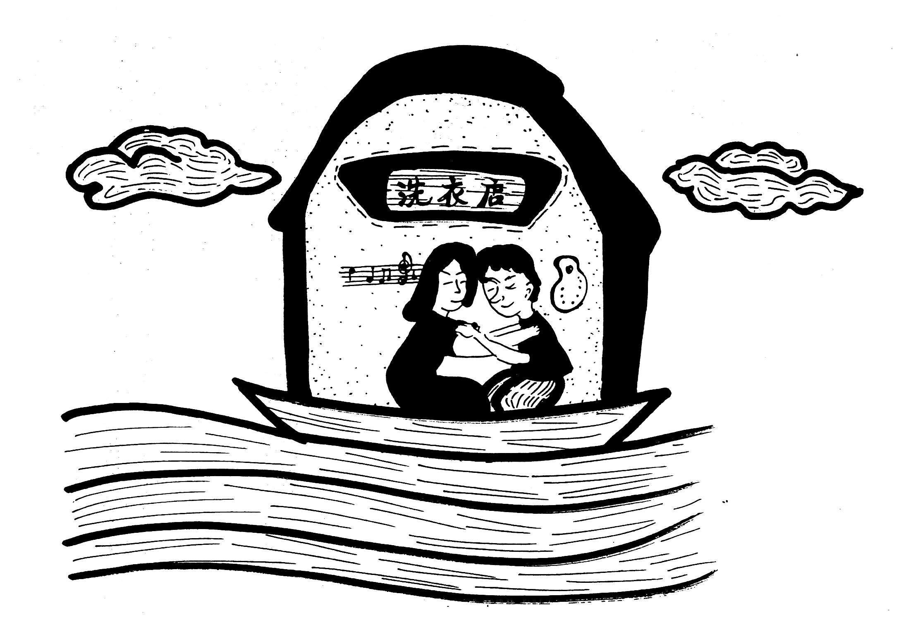
两人都在洗衣店工作

a new thing in logic, and a feat in story-telling somewhat older than the great wall of China.
Joe Larrabee came out of the post-oak flats of the Middle West pulsing with a genius for pictorial art. At six he drew a picture of the town pump with a prominent citizen passing it hastily. This effort was framed and hung in the drug store window by the side of the ear of corn with an uneven number of rows. At twenty he left for New York with a flowing necktie and a capital tied up somewhat closer.
Delia Caruthers did things in six octaves so promisingly in a pine-tree village in the South that her relatives chipped in enough in her chip hat for her to go “North” and “finish.” They could not see her—, but that is our story.
Joe and Delia met in an atelier where a number of art and music students had gathered to discuss chiaroscuro, Wagner, music, Rembrandt’s works, pictures, Waldteufel, wall paper, Chopin and Oolong.
Joe and Delia became enamored one of the other, or each of the other, as you please, and in a short time were married—for (see above), when one loves one’s Art no service seems too hard.
Mr. and Mrs. Larrabee began housekeeping in a flat. It was a lonesome flat—something like the A sharp way down at the left-hand end of the keyboard. And they were happy; for they had their Art, and they had each other. And my advice to the rich young man would be—sell all thou hast, and give it to the poor—janitor for the privilege of living in a flat with your Art and your Delia.
Flat-dwellers shall indorse my dictum that theirs is the only true happiness. If a home is happy it cannot fit too close—let the dresser collapse and become a billiard table; let the mantel turn to a rowing machine, the escritoire to a spare bedchamber, the washstand to an upright piano; let the four walls come together, if they will, so you and your Delia are between. But if home be the other kind, let it be wide and long—enter you at the Golden Gate, hang your hat on Hatteras, your cape on Cape Horn and go out by the Labrador.
Joe was painting in the class of the great Magister—you know his fame. His fees are high; his lessons are light—his high-lights have brought him renown. Delia was studying under Rosenstock—you know his repute as a disturber of the piano keys.
They were mighty happy as long as their money lasted. So is every—but I will not be cynical. Their aims were very clear and defined. Joe was to become capable very soon of turning out pictures that old gentlemen with thin side-whiskers and thick pocketbooks would sandbag one another in his studio for the privilege of buying. Delia was to become familiar and then contemptuous with Music, so that when she saw the orchestra seats and boxes unsold she could have sore throat and lobster in a private dining-room and refuse to go on the stage.
But the best, in my opinion, was the home life in the little flat—the ardent, voluble chats after the day’s study; the cozy dinners and fresh, light breakfasts; the interchange of ambitions—ambitions interwoven each with the other’s or else inconsiderable— the mutual help and inspiration; and—overlook my artlessness—stuffed olives and cheese sandwiches at 11 p.m.
But after a while Art flagged. It sometimes does, even if some switchman doesn’t flag it. Everything going out and nothing coming in, as the vulgarians say. Money was lacking to pay Mr. Magister and Herr Rosenstock their prices. When one loves one’s Art no service seems too hard. So, Delia said she must give music lessons to keep the chafing dish bubbling.
For two or three days she went out canvassing for pupils. One evening she came home elated.
“Joe, dear,” she said, gleefully, “I’ve a pupil. And, oh, the loveliest people! General—General A. B. Pinkney’s daughter—on Seventy-first street. Such a splendid house, Joe—you ought to see the front door! Byzantine I think you would call it. And inside! Oh, Joe, I never saw anything like it before.
“My pupil is his daughter Clementina. I dearly love her already. She’s a delicate thing-dresses always in white; and the sweetest, simplest manners! Only eighteen years old. I’m to give three lessons a week; and, just think, Joe! $5 a lesson. I don’t mind it a bit; for when I get two or three more pupils I can resume my lessons with Herr Rosenstock. Now, smooth out that wrinkle between your brows, dear, and let’s have a nice supper.”
“That’s all right for you, Dele,” said Joe, attacking a can of peas with a carving knife and a hatchet, “but how about me? Do you think I’m going to let you hustle for wages while I philander in the regions of high art? Not by the bones of Benvenuto Cellini! I guess I can sell papers or lay cobblestones, and bring in a dollar or two.”
Delia came and hung about his neck.
“Joe, dear, you are silly. You must keep on at your studies. It is not as if I had quit my music and gone to work at something else. While I teach I learn. I am always with my music. And we can live as happily as millionaires on $15 a week. You mustn’t think of leaving Mr. Magister.”
“All right,” said Joe, reaching for the blue scalloped vegetable dish. “But I hate for you to be giving lessons. It isn’t Art. But you’re a trump and a dear to do it.”
“When one loves one’s Art no service seems too hard,” said Delia.
“Magister praised the sky in that sketch I made in the park,” said Joe. “And Tinkle gave me permission to hang two of them in his window. I may sell one if the right kind of a moneyed idiot sees them.”
“I’m sure you will,” said Delia, sweetly. “And now let’s be thankful for Gen. Pinkney and this veal roast.”
During all of the next week the Larrabees had an early breakfast. Joe was enthusiastic about some morning-effect sketches he was doing in Central Park, and Delia packed him off breakfasted, coddled, praised and kissed at 7 o’clock. Art is an engaging mistress. It was most times 7 o’clock when he returned in the evening.
At the end of the week Delia, sweetly proud but languid, triumphantly tossed three five-dollar bills on the 8×10 (inches) centre table of the 8×10 (feet) flat parlor.
“Sometimes,” she said, a little wearily, “Clementina tries me. I’m afraid she doesn’t practice enough, and I have to tell her the same things so often. And then she always dresses entirely in white, and that does get monotonous. But Gen. Pinkney is the dearest old man! I wish you could know him, Joe. He comes in sometimes when I am with Clementina at the piano—he is a widower, you know—and stands there pulling his white goatee. ‘And how are the semiquavers and the demisemiquavers progressing?’ he always asks.
“I wish you could see the wainscoting in that drawing-room, Joe! And those Astrakhan rug portieres. And Clementina has such a funny little cough. I hope she is stronger than she looks. Oh, I really am getting attached to her, she is so gentle and high bred. Gen. Pinkney’s brother was once Minister to Bolivia.”
And then Joe, with the air of a Monte Cristo, drew forth a ten, a five, a two and a one—all legal tender notes—and laid them beside Delia’s earnings.
“Sold that watercolor of the obelisk to a man from Peoria,” he announced overwhelmingly.
“Don’t joke with me,” said Delia, “not from Peoria!”
“All the way. I wish you could see him, Dele. Fat man with a woolen muffler and a quill toothpick. He saw the sketch in Tinkle’s window and thought it was a windmill at first, he was game, though, and bought it anyhow. He ordered another—an oil sketch of the Lackawanna freight depot—to take back with him. Music lessons! Oh, I guess Art is still in it.”
“I’m so glad you’ve kept on,” said Delia, heartily. “You’re bound to win, dear. Thirty-three dollars! We never had so much to spend before. We’ll have oysters tonight.”
“And filet mignon with champignons,” said Joe. “Where is the olive fork?”
On the next Saturday evening Joe reached home first. He spread his $18 on the parlor table and washed what seemed to be a great deal of dark paint from his hands.
Half an hour later Delia arrived, her right hand tied up in a shapeless bundle of wraps and bandages.
“How is this?” asked Joe after the usual greetings. Delia laughed, but not very joyously.
“Clementina,” she explained, “insisted upon a Welsh rabbit after her lesson. She is such a queer girl. Welsh rabbits at 5 in the

