瓢 虫
The Ladybird
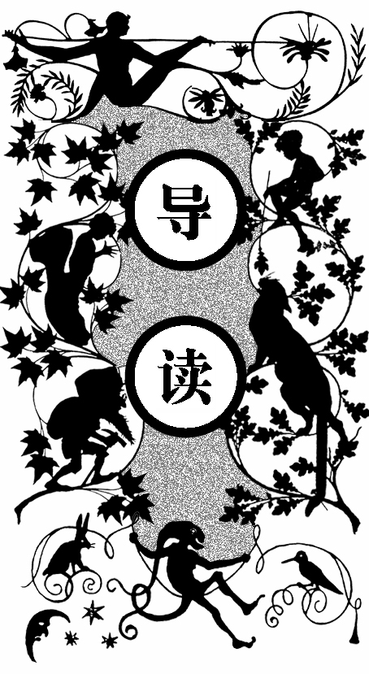
贝弗利奇夫人出身于英国一个古老、忠诚的贵族家族，她和上议院、内阁中的许多领袖都是密友，在英国政坛颇有影响。贝弗利奇夫人在一战期间经历了数次丧失亲人的巨大悲痛——她的儿子们和兄弟们全部阵亡了。但这反而使得她更加坚强了起来，她决心要做一个仁慈而充满怜悯之心的人，用博爱的态度对待所有人，哪怕是那些被迫参战的敌人。
一九一七年冬天，她收到小儿子阵亡的噩耗时，丧子的痛苦令她备受折磨，患病不起，一度她认为自己就该这么死去，但她又想到了和她儿子一样的被卷入战争的那些无辜的士兵，他们也是一样的痛苦。于是她决定去赫斯特街的那家医院探望一下受伤的战俘 官兵。
医院住满了伤员，拥挤的人群中弥漫着一种绝望、消沉的气息。矮小、瘦弱的贝弗利奇夫人虚弱地在病床间走来走去，询问伤员自己能为他们做些什么，并把他们的请求一一记在本子上。
此时，贝弗利奇夫人注意到了一个伤员，他小脸盘，脸色土黄，留着一把黑胡须，闭着眼一动不动地躺着，看上去就像死了一样。

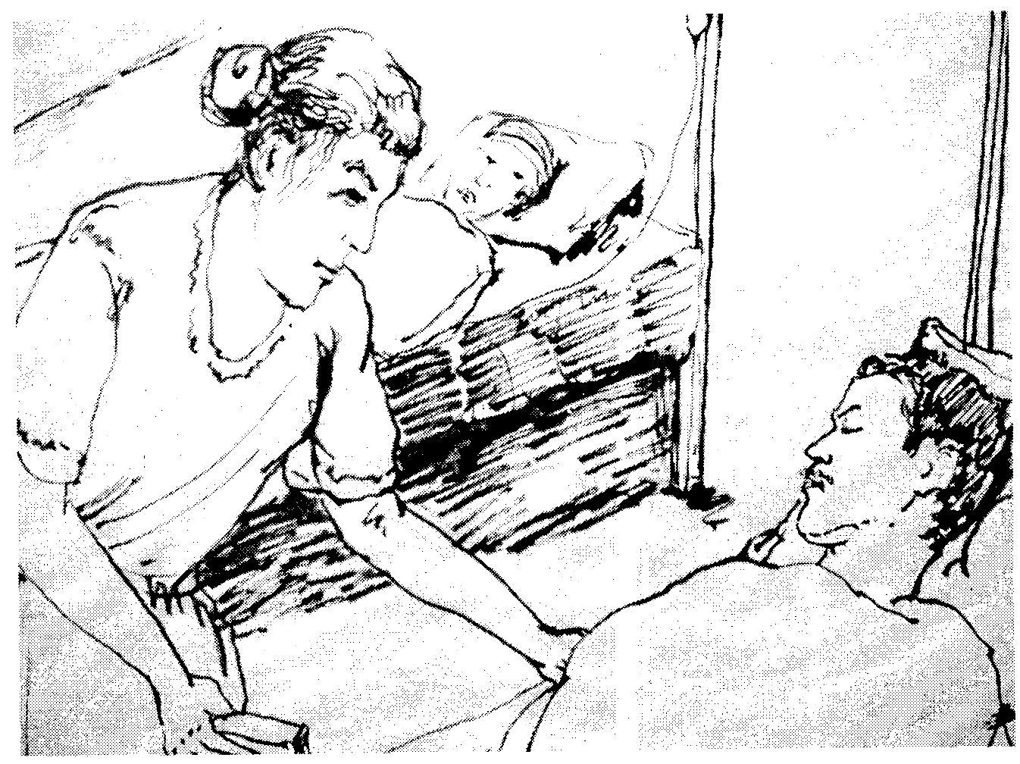
探望伤员

贝弗利奇夫人认出了他，他便是波希米亚人约翰·迪奥尼斯·普萨内克伯爵。于是她赶忙呼唤他，和他打招呼。伯爵是贝弗利奇夫人家的朋友，早年还曾携妻子到贝弗利奇夫人家在莱斯特郡的乡间别墅拜访过。伯爵住院已有五日，他身中两弹，胸膛被一颗子弹打穿，另一颗则打断了他的一根肋骨。
伯爵听到呼唤，缓缓张开了眼睛。他身材瘦小，几乎像个孩子，但外形却很匀称，并且富有活力。但此时这种活力似乎早已枯萎。他一直两眼空洞地望着，好一会儿，才认出贝弗利奇夫人，他不能发声，只是嘴唇动了动，勉强算是回应了一下。夫人很难过，询问伯爵自己有什么可以帮他做的，但伯爵却表现出一种疲倦的、谢绝的神色，眼皮也没有精神地垂了下去。
看到此般情景，贝弗利奇夫人甚是伤感，交代了护士长几句，便起身告辞了。
她来到了海德公园附近女儿的公寓。贝弗利奇夫人的女儿名叫达芙妮，她的丈夫是英格兰最著名的一位政治家的儿子，是一位真正值得尊敬的人，但他却没有钱，而贝弗利奇伯爵也把财产大部分挥霍一空，没有给女儿什么财产。因此达芙妮婚后的生活很穷。达芙妮只有二十五岁，身材高挑，有着雪白的细颈和一张可爱、妩媚的脸，是一位美人。但她的美貌并没有给她带来成功，尽管嫁入了名门，可是她并没有钱；她身体虚弱，随时有患上肺结核的危险；她同时还继承了父亲那种奔放、鲁莽的性情，因此，找不到一个发泄口能够宣泄自己那种充满失意与愤怒的激情也常令她备感痛苦。
她的丈夫巴兹尔也上前线打仗去了。母亲问女儿有没有巴兹尔的消息。关于巴兹尔的消息倒是有，说是被送到土耳其去了，这种模模糊糊、捉摸不定的消息反而比阵亡的消息还要折磨人。母亲与女儿寒暄了一阵，又问了问她近来的身体和睡眠情况，随后便对她提起在医院偶遇迪奥尼斯伯爵的事。贝弗利奇夫人感叹着：尽管伯爵脸色苍白、神情恍惚，但他长长的、卷曲的睫毛和黑黑的眼睛看上去仍然是那么的漂亮。达芙妮当然记得伯爵，她对他颇有好感，还回忆起十七岁生日时，伯爵曾送给她一枚奇特的针箍。
第二天，达芙妮就打电话给赫斯特街的医院，询问伯爵的身体状况，但几乎和前一天差不多糟糕。此后，达芙妮每天都打电话去询问，后来听说他的情况好点了。
有一天，达芙妮接到消息说她的丈夫在土耳其做了俘虏，受了伤，但就快痊愈了。这一天，她忘了打电话询问伯爵的情况。第二天，她便想去赫斯特街的医院探望伯爵。
于是她和母亲两人来到了伯爵所在的医院。医院沉闷的气氛令达芙妮感到厌恶和不适。伯爵见到达芙妮，用古怪的眼神望着她，就好似看一个怪物。起初他装作没有认出她的样子，达芙妮以为自己打扰到了他，便想告辞，这时他突然说达芙妮居然身材这么高，神情还有些惊慌。当达芙妮给他祝福时，他却说宁愿自己已经死了。达芙妮于是坐下来安慰他，叫他打消这种悲观厌世的念头。可他却依然固执而厌世，还说他厌恶自己的名字，说它已经随战争死掉了，现在他想给自己取一个新名字。旋即伯爵又觉得自己有些失态，便不安地向达芙妮说自己说的话很蠢，但却没办法阻止自己说这些蠢话，还说希望自己能够深深地藏起来。
之后，他恢复了平静。达芙妮便起身走开了。
又过了十天，达芙妮又到医院去，本来她已经不想去了，她想把他忘记，但却没法忘记。伯爵的身体显得好些了，但情绪依然悲观，而且不喜欢达芙妮给他带来的花。达芙妮跟他谈起他的家人时，他也显得漠然，甚至愤怒，只说妻子在战乱中带着两个孩子去了匈牙利，离开了他，而他也希望她们离开他，还说希望自己已经死了，并且痛恨令自己活下来的那个魔鬼。
伯爵的思想很古怪，但他似乎突然一下进入了她的心里，达芙妮更加无法将他忘掉了。有一次，伯爵知道了达芙妮已经有了丈夫，并且丈夫不久就要回来团聚的事，居然说她病得不轻，说她脸上的愁容就像是有什么打到她脸上了似的。还有一次，伯爵说他想要让阳光照耀着自己的脸，于是在二月一个阳光灿烂的上午，达芙妮去医院看望他时，叫护士把他的床搬到阳光可以照射到的地方。伯爵晒着太阳，纹丝不动。他说，阳光使愤怒舒展，还说自己是个拜火教徒，是太阳的臣民，而太阳不属于任何一个国家。他还说炮弹把灵魂从身上赶跑了，他现在是一个没有灵魂的人，而她的灵魂却是安静而高尚的。又有一次，伯爵问达芙妮的丈夫是否温柔，待她是否好，达芙妮给了他肯定的答复，但很不高兴他提出这样的问题。后来，伯爵又发了一通古怪的言论，说一切事物都在寻找它的伴侣，不是只有温和柔善的动物才有伴侣，貂、臭鼬、秃鹰，它们都有自己的伴侣。
三月间，伯爵已经能够起床了。他理了发，剃了胡须，加上瘦小的个子，显得精干了许多。但他依然傲慢冷漠，除了和达芙妮有说有笑，对其他人一概不理。
有一次，伯爵问起了达芙妮当年他送给她的那枚针箍，还向她讲述了自己家族的历史。那枚针箍正面有一个绿宝石做的瓢虫，那是他们家族的族徽。他们家族所有男性的衬衫都由本族女人做，直至结婚后，则由自己的妻子做，因此他婚前的衬衫都是母亲和姨母做的。现在伯爵没有了妻子，于是他请求达芙妮给自己做一件衬衫，而且要她亲手做，不要女仆代劳，还要绣上他的名字缩写和族徽瓢虫。达芙妮认为他们家族的人居然迷恋瓢虫，简直是十足的疯子，但却将做衬衫的事答应了下来。
第一件衬衫做好了。她去探望他时，他照旧对着附近的一排排红砖房大发感慨，说他渴望自由，并且突然发起怒来。这次以后，达芙妮决心再也不去看他了。第二件衬衫做好送去时，伯爵已经转院了，于是她便搭火车赶去沃伊尼克府探望他。这次他的心情似乎变好了一些，怒气也消散了。一见到他，达芙妮就能感受到他的沉默所产生的那种微妙的影响力。沉默时，他们之间会涌起一股奇怪而秘密的冲动。
伯爵告诉了达芙妮一个秘密，说他参加了一个古老的秘密团体，这个团体的教义认为，看得见的阳光和火焰，都不过是灰蒙蒙的外衣，而真正的阳光和火是黑暗的，爱也是这样，洁白的爱只是反面，它粉饰了真爱的墓穴，真爱是黑的，在暗夜里涌动着。达芙妮迟钝地说自己不懂他所说的这些，但当她注视着伯爵的眼睛时，仿佛看到了黑暗在他眼里闪动。
之后他们便没有了联系。这段时间，达芙妮忙于迎接丈夫的归来。她尽力不去想伯爵这个傲慢无礼的小个子，而要自己想想丈夫：那个高大的、有教养的、皮肤白皙、英俊潇洒的英国人。她期待着丈夫的归来，同时想要做点什么迎接他。她想到既然已经为伯爵做了衬衫，不妨也为丈夫做做吧。她依旧用伯爵送的那只针箍为丈夫做衬衫。由于思念，她还写了一首小诗，抒发情怀，说她愿变成一只小鸟，飞到他那儿去。
期间，她丈夫的姐姐宾厄姆夫人来过一次。她称赞了达芙妮的针线活儿，但却说她应该做的不是做衬衫，而是打扮自己，然后又叫她一同去吃茶点。
之后达芙妮再想继续做时，却找不到针箍了，于是这事就搁置了起来。但是丢失了针箍的达芙妮却感到万分失落，它就像一枚护身符。此刻，她好像感到了迪奥尼斯伯爵正在身后指责她似的。于是，她便鬼使神差地去了沃伊尼克府探望伯爵。伯爵碰巧在花园里四处收集栗子吃，当达芙妮问他现在是否快乐时，出人意料的是，他的答案居然是肯定的。因为他认为要破坏山一样巨大的人类世界，虽然要用很长时间，但总是能够实现的，因此他又显得很乐观。此刻，他又希望他能活得足够长，因为这样他便可以不停地捶打、破坏这个人类世界。达芙妮默不作声地离开了。
从此，她就只让自己的心里充满着丈夫巴兹尔。他就要回来了，他是一个崭新的人，一个浴火重生的人。巴兹尔回来之前和达芙妮通了电话，他熟悉的嗓音却让达芙妮感到惧怕和冰冷。当他终于到家时，两人都显得有些局促和惊慌。但是巴兹尔十分热情，他由衷地赞美达芙妮的美丽，握着她的手促膝长谈。面对他热切的目光，她居然一阵眩晕。巴兹尔以为是自己脸上的伤疤惊吓了达芙妮，但是达芙妮给他的回答是，自己比以前更爱他了。于是巴兹尔跪地亲吻着她的脚，说他对她的感情已经超越了爱，而是崇拜。
巴兹尔坐回沙发上，双手往沙发缝里伸的时候，掏出来一件东西，拿出来一看，正是失踪的那只针箍，针箍里还卷着一张蓝色小纸片。巴兹尔打开小纸片读了上面写的小诗，看到达芙妮如此想念自己，由衷地感动。之后他便问起针箍的事情来。于是达芙妮告诉了他迪奥尼斯伯爵的事，还有正在为巴兹尔做衬衫的事。巴兹尔听说妻子如此贤德，激动地不住地夸赞她如女神一样圣洁。
丈夫的归来并没有使达芙妮感到舒服，丈夫那种可怕的、热情洋溢的欲望令她想要退缩，想要大哭一场，她知道自己不是丈夫认为的那个出色女人，但是这种心情又没法请求丈夫的帮助，于是终日焦躁烦闷。
一日，她对丈夫说要去看望迪奥尼斯伯爵。巴兹尔欣然同意，并要求同行。两个男人见面后，互相彬彬有礼。迪奥尼斯伯爵那种古怪的激情仿佛把巴兹尔给迷住了，使他几乎忘记了达芙妮。达芙妮感觉到这位黝黑、瘦小的伯爵并不喜欢自己那高大的丈夫。两个男人开始讨论哲学。巴兹尔认为民主政治能够使人行使自己的权利，给人自由，是神圣的，在将来的和平社会是必定会实现的；而伯爵则认为所谓的民主不过是让人们主动挑选了一些新的主子、老爷，然后强加到自己身上而已，真正的民主不会实现。他们辩论得十分激烈，以致完全忽略了达芙妮，这令达芙妮感到有些不高兴。
冬天快过去了，战争结束了，德国战败，民主和平时期到来了。伯爵被押送回国之前，巴兹尔邀请他到托雷斯韦做客两周。在托雷斯韦的宅子里，伯爵见到了达芙妮的父亲贝弗利奇伯爵，当然还有达芙妮的母亲、她本人及其丈夫。席间，他与众人聊了起来，当被问及他对战争的看法时，偏执的伯爵认为不仅是德国，整个欧洲都战败了，这是一场自杀的战争。为使谈话内容轻松起来，巴兹尔询问伯爵他们家族的族徽为何是一只瓢虫，而迪奥尼斯伯爵则表现出了对这一点的自豪。
第二天，达芙妮的父母离开了宅子，只剩下了年轻夫妇和伯爵三人。这宅子是达芙妮从小长大的地方，是一处古老的、富有魅力的庄园。伯爵喜欢独自一人坐在屋顶俯瞰花园和草地，晚上，他则会轻声哼起童年的歌谣。他住在东厢房，离其他人的房间很远，所以大家并未发觉。一天晚上，达芙妮去楼下找东西时听到了伯爵那像小蝙蝠般的哼唱。这声音仿佛魔法般，将达芙妮钉在原地，使她忘却了一切。打这以后，她便每天都等着听他唱歌，几乎着了迷。这歌声令她忘却了自我，精神得到了超脱；这歌声像一种召唤，她感觉自己的心灵飞了出去，走出了父母、丈夫、国家和这个人世，走到了召唤她的地方——在那儿，是伯爵在召唤。有伯爵哼唱的夜晚，达芙妮便感觉全身轻松舒爽、呼吸畅快。伯爵有三个晚上没有唱歌，达芙妮便心神恍惚。夜晚又来临了，歌声出现了，但是越唱越像是死亡之声，那低缓、阴沉的声调，令人毛骨悚然。她不禁跑到伯爵门前敲门，想要看看发生了什么事。
进屋后，伯爵给她讲述了这首歌的大意，是讲一个女人，是天鹅变的，她爱上了猎人，于是嫁给了他，为他生了三个孩子。但有一天，天鹅之王快死了，召唤她回去，她便只好离开了猎人和儿女。达芙妮在一种迷醉的心态中，感觉黑暗的房间里似乎涌流着血液一样的、富有活力的爱。忽然，达芙妮的双手从他的身上滑下去，落在他的脚踝上，紧紧地抱住了它们，用脸贴着他的脚踝。她的泪水沾湿了伯爵的脚踝，伯爵内心踟蹰着：他在这世上没有前途，他应当一个人生活，但是，面对她主动献给自己的灵魂，为何不接受呢？他是她的主宰啊！于是伯爵温柔地对达芙妮说，现在，她是他的了，白天她不属于他，但是在夜晚、在黑暗中，甚至她死后，都是属于他的，她是瓢虫夜晚的妻子。
第二天，两人都有了一种平静、安宁的神情，达芙妮也不再忧伤、烦躁了。细心敏感的巴兹尔注意到了这一点，他便问达芙妮在想些什么，她没有回答。他注意到了当她和伯爵在一起时那种温柔娇媚的神态和那种处女般平静的气质，他感到了羞愧。晚间他终于问妻子是否爱上了伯爵。达芙妮柔和的眼神和低垂的头发，让巴兹尔的性欲完全消失了，他觉得达芙妮就像是他的妹妹一样，以后他不应该再碰她了。达芙妮只是对巴兹尔说不要跟她生气，并说自己永远是他的妻子，永远顺从巴兹尔的愿望。但她眼中流露出的那种警告，使得巴兹尔只亲了一下她的手，便赶紧离开了。
离别的日子终于到了。上车之前，伯爵请求达芙妮永远不要忘记他。巴兹尔负责送行，他和伯爵一路交谈着，他说他觉得妻子自从伯爵来以后，改变了许多，变得平静了，而伯爵则认为达芙妮和

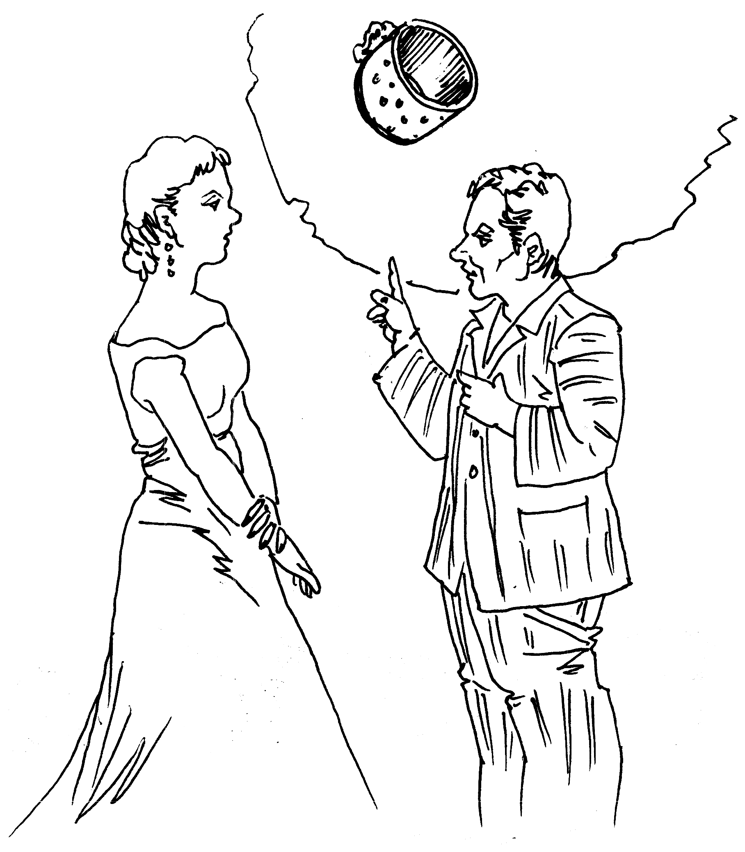
伯爵讲起了那枚针箍的来历
他早先认识的那个十七岁的姑娘没什么变化。之后两人还探讨了战争中丧失的那些莫名的东西，以及爱需不需要激烈的行动的问题。伯爵的回答处处体现着玄机。

ow many swords had Lady Beveridge in her pierced heart! Yet there always seemed room for another. Since she had determined that her heart of pity and kindness should never die. If it had not been for this determination she herself might have died of sheer agony, in the years 1916 and 1917, when her boys were killed, and her brother, and death seemed to be mowing with wide swaths through her family. But let us forget.
H
Lady Beveridge loved humanity, and come what might, she would continue to love it. Nay, in the human sense, she would love her enemies. Not the criminals among the enemy, the men who committed atrocities. But the men who were enemies through no choice of their own. She would be swept into no general hate.
Somebody had called her the soul of England. It was not ill said, though she was half Irish. But of an old, aristocratic, loyal family famous for its brilliant men. And she, Lady Beveridge, had for years as much influence on the tone of English politics as any individual alive. The close friend of the real leaders in the House of Lords and in the Cabinet, she was content that the men should act, so long as they breathed from her as from the rose of life the pure fragrance of truth and genuine love. She had no misgiving regarding her own spirit.
She, she would never lower her delicate silken flag. For instance, throughout all the agony of the war she never forgot the enemy prisoners; she was determined to do her best for them. During the first years she still had influence. But during the last years of the war power slipped out of the hands of her and her sort, and she found she could do nothing any more: almost nothing. Then it seemed as if the many swords had gone home into the heart of this little, unyielding Mater Dolorosa. The new generation jeered at her. She was a shabby, old-fashioned little aristocrat, and her drawing-room was out of date.
But we anticipate. The years 1916 and 1917 were the years when the old spirit died for ever in England. But Lady Beveridge struggled on. She was being beaten.
It was in the winter of 1917 — or in the late autumn. She had been for a fortnight sick, stricken, paralysed by the fearful death of her youngest boy. She felt she must give in, and just die. And then she remembered how many others were lying in agony.
So she rose, trembling, frail, to pay a visit to the hospital where lay the enemy sick and wounded, near London. Countess Beveridge was still a privileged woman. Society was beginning to jeer at this little, worn bird of an out-of-date righteousness and aesthetic. But they dared not think ill of her.
She ordered the car and went alone. The Earl, her husband, had taken his gloom to Scotland. So, on a sunny, wan November morning Lady Beveridge descended at the hospital, Hurst Place. The guard knew her, and saluted as she passed. Ah, she was used to such deep respect! It was strange that she felt it so bitterly, when the respect became shallower. But she did. It was the beginning of the end to her.
The matron went with her into the ward. Alas, the beds were all full, and men were even lying on pallets on the floor. There was a desperate, crowded dreariness and helplessness in the place: as if nobody wanted to make a sound or utter a word. Many of the men were haggard and unshaven, one was delirious, and talking fitfully in the Saxon dialect. It went to Lady Beveridge’s heart. She had been educated in Dresden, and had had many dear friendships in the city. Her children also had been educated there. She heard the Saxon dialect with pain.
She was a little, frail, bird-like woman, elegant, but with that touch of the blue-stocking of the nineties which was unmistakable. She fluttered delicately from bed to bed, speaking in perfect German, but with a thin, English intonation: and always asking if there was anything she could do. The men were mostly officers and gentlemen. They made little requests which she wrote down in a book. Her long, pale, rather worn face, and her nervous little gestures somehow inspired confidence.
One man lay quite still, with his eyes shut. He had a black beard. His face was rather small and sallow. He might be dead. Lady Beveridge looked at him earnestly, and fear came into her face.
“Why, Count Dionys!” she said, fluttered. “Are you asleep?”
It was Count Johann Dionys Psanek, a Bohemian. She had known him when he was a boy, and only in the spring of 1914 he and his wife had stayed with Lady Beveridge in her country house in Leicestershire.
His black eyes opened: large, black, unseeing eyes, with curved black lashes. He was a small man, small as a boy, and his face too was rather small. But all the lines were fine, as if they had been fired with a keen male energy. Now the yellowish swarthy paste of his flesh seemed dead, and the fine black brows seemed drawn on the face of one dead. The eyes, however, were alive: but only just alive, unseeing and unknowing.
“You know me, Count Dionys? You know me, don’t you?” said Lady Beveridge, bending forward over the bed.
There was no reply for some time. Then the black eyes gathered a look of recognition, and there came the ghost of a polite smile.
“Lady Beveridge.” The lips formed the words. There was practically no sound.
“I am so glad you can recognize me. And I am so sorry you are hurt. I am so sorry.”
The black eyes watched her from that terrible remoteness of death, without changing.
“There is nothing I can do for you? Nothing at all?” she said, always speaking German.
And after a time, and from a distance, came the answer from his eyes, a look of weariness, of refusal, and a wish to be left alone; he was unable to strain himself into consciousness. His eyelids dropped.
“I am so sorry,” she said. “If ever there is anything I can do —”
The eyes opened again, looking at her. He seemed at last to hear, and it was as if his eyes made the last weary gesture of a polite bow. Then slowly his eyelids closed again.
Poor Lady Beveridge felt another sword-thrust of sorrow in her heart, as she stood looking down at the motionless face, and at the black fine beard. The black hairs came out of his skin thin and fine, not very close together. A queer, dark, aboriginal little face he had, with a fine little nose: not an Aryan, surely. And he was going to die.
He had a bullet through the upper part of his chest, and another bullet had broken one of his ribs. He had been in hospital five days.
Lady Beveridge asked the matron to ring her up if anything happened. Then she drove away, saddened. Instead of going to Beveridge House, she went to her daughter’s flat near the park — near Hyde Park. Lady Daphne was poor. She had married a commoner, son of one of the most famous politicians in England, but a man with no money. And Earl Beveridge had wasted most of the large fortune that had come to him, so that the daughter had very little, comparatively.
Lady Beveridge suffered, going in the narrow doorway into the rather ugly flat. Lady Daphne was sitting by the electric fire in the small yellow drawing-room, talking to a visitor. She rose at once, seeing her little mother.
“Why, mother, ought you to be out? I’m sure not.”
“Yes, Daphne darling. Of course I ought to be out.”
“How are you?” The daughter’s voice was slow and sonorous, protective, sad. Lady Daphne was tall, only twenty-five years old. She had been one of the beauties, when the war broke out, and her father had hoped she would make a splendid match. Truly, she had married fame: but without money. Now, sorrow, pain, thwarted passion had done her great damage. Her husband was missing in the East. Her baby had been born dead. Her two darling brothers were dead. And she was ill, always ill.
A tall, beautifully-built girl, she had the fine stature of her father. Her shoulders were still straight. But how thin her white throat! She wore a simple black frock stitched with coloured wool round the top, and held in a loose coloured girdle: otherwise no ornaments. And her face was lovely, fair, with a soft exotic white complexion and delicate pink cheeks. Her hair was soft and heavy, of a lovely pallid gold colour, ash-blond. Her hair, her complexion were so perfectly cared for as to be almost artificial, like a hot-house flower.
But alas, her beauty was a failure. She was threatened with phthisis, and was far too thin. Her eyes were the saddest part of her. They had slightly reddened rims, nerve-worn, with heavy, veined lids that seemed as if they did not want to keep up. The eyes themselves were large and of a beautiful green-blue colour. But they were full, languid, almost glaucous.
Standing as she was, a tall, finely-built girl, looking down with affectionate care on her mother, she filled the heart with ashes. The little pathetic mother, so wonderful in her way, was not really to be pitied for all her sorrow. Her life was in her sorrows, and her efforts on behalf of the sorrows of others. But Daphne was not born for grief and philanthropy. With her splendid frame, and her lovely, long, strong legs, she was Artemis or Atalanta rather than Daphne. There was a certain width of brow and even of chin that spoke a strong, reckless nature, and the curious, distraught slant of her eyes told of a wild energy dammed up inside her.
That was what ailed her: her own wild energy. She had it from her father, and from her father’s desperate race. The earldom had begun with a riotous, dare-devil border soldier, and this was the blood that flowed on. And alas, what was to be done with it?
Daphne had married an adorable husband: truly an adorable husband. Whereas she needed a dare-devil. But in her mind she hated all dare-devils: she had been brought up by her mother to admire only the good.
So, her reckless, anti-philanthropic passion could find no outlet — and should find no outlet, she thought. So her own blood turned against her, beat on her own nerves, and destroyed her. It was nothing but frustration and anger which made her ill, and made the doctors fear consumption. There it was, drawn on her rather wide mouth: frustration, anger, bitterness. There it was the same in the roll of her green-blue eyes, a slanting, averted look: the same anger furtively turning back on itself. This anger reddened her eyes and shattered her nerves. And yet her whole will was fixed in her adoption of her mother’s creed, and in condemnation of her handsome, proud, brutal father, who had made so much misery in the family. Yes, her will was fixed in the determination that life should be gentle and good and benevolent. Whereas her blood was reckless, the blood of daredevils. Her will was the stronger of the two. But her blood had its revenge on her. So it is with strong natures today: shattered from the inside.
“You have no news, darling?” asked the mother.
“No. My father-in-law had information that British prisoners had been brought into Hasrun, and that details would be forwarded by the Turks. And there was a rumour from some Arab prisoners that Basil was one of the British brought in wounded.”
“When did you hear this?”
“Primrose came in this morning.”
“Then we can hope, dear.”
“Yes.”
Never was anything more dull and bitter than Daphne’s affirmative of hope. Hope had become almost a curse to her. She wished there need be no such thing. Ha, the torment of hoping, and the insult to one’s soul. Like the importunate widow dunning for her deserts. Why could it not all be just clean disaster, and have done with it? This dilly-dallying with despair was worse than despair. She had hoped so much: ah, for her darling brothers she had hoped with such anguish. And the two she loved best were dead. So were most others she had hoped for, dead. Only this uncertainty about her husband still rankling.
“You feel better, dear?” said the little, unquenched mother.
“Rather better,” came the resentful answer.
“And your night?”
“No better.”
There was a pause.
“You are coming to lunch with me, Daphne darling?”
“No, mother dear. I promised to lunch at the Howards with Primrose. But I needn’t go for a quarter of an hour. Do sit down.”
Both women seated themselves near the electric fire. There was that bitter pause, neither knowing what to say. Then Daphne roused herself to look at her mother.
“Are you sure you were fit to go out?” she said. “What took you out so suddenly?”
“I went to Hurst Place, dear. I had the men on my mind, after the way the newspapers had been talking.”
“Why ever do you read the newspapers!” blurted Daphne, with a certain burning, acid anger. “Well,” she said, more composed. “And do you feel better now you’ve been?”
“So many people suffer besides ourselves, darling.”
“I know they do. Makes it all the worse. It wouldn’t matter if it were only just us. At least, it would matter, but one could bear it more easily. To be just one of a crowd all in the same state.”
“And some even worse, dear.”
“Oh, quite! And the worse it is for all, the worse it is for one.”
“Is that so, darling? Try not to see too darkly. I feel if I can give just a little bit of myself to help the others — you know — it alleviates me. I feel that what I can give to the men lying there, Daphne, I give to my own boys. I can only help them now through helping others. But I can still do that, Daphne, my girl.”
And the mother put her little white hand into the long, white cold hand of her daughter. Tears came to Daphne’s eyes, and a fearful stony grimace to her mouth.
“It’s so wonderful of you that you can feel like that,” she said.

