Part Ⅱ

Conversations Onboard

Unit 2 Service Onboard(机上服务)

2.1 Greeting and Assisting to the Seat(登机引导)
1. Good afternoon, sir. Welcome aboard. Would you like me to take you to your seat?
2. Good morning, Madam. How are you today? Would you like me to show you to your seat?
3. It’s a pleasure to see you again. May I show you to your seat?
4. Good afternoon, Madam. It’s nice to see you again. May I assist you to your seat?

2.2 Jackets or Coats(挂衣服)
1. May I assist you with your jacket, sir?
2. Sir, may I hang your jacket in the closet?
3. Excuse me, sir, would you like me to take your coat?
4. Are there any valuable items in the pockets that you would like to keep with you?
5. I will bring it back to you before landing.

2.3 Hot Towel(热毛巾)
1. Excuse me, sir, would you care for a hot towel? ...Here you are. Please be careful, it’s hot.
2. Sorry to disturb you, sir. May I offer you a hot towel? The towel is quite hot. Please be careful.

2.4 Drinks(迎宾饮料)
1. Excuse me, sir, welcome aboard. Would you care for a drink? (Would you like something to drink?) Today we have orange juice, mineral water and champagne.
2. (旅客选好饮料后) A glass of champagne, certainly.
3. It’s nice to see you on board today, sir. May I offer you a drink? Would you like a glass of chilled champagne, orange juice, mineral water, or would you prefer to try one of our (specially made) cocktails?
4. I hope you enjoy your drink.

2.5 Offering Pajamas, Slippers and Amenity Kits

(提供休闲服、拖鞋、盥洗包)
1. Sir, we have prepared pajamas for you in order to make you feel more comfortable on this flight.
2. Sir, here is our new casual wear for you. What size do you prefer?
3. Sir, I'm sorry, that size is not available. May I offer you a ...(size)… instead?
4. Sir, we have prepared slippers for you to make you feel more comfortable during the flight. May I open it for you now?
5. Well then, I’11 put the slippers into the seat pocket in front of you for your convenience.
6. Madam, would you care for a L’OCCITANE amenity kit?
7. Madam, may I present you with a complimentary amenity kit by L’OCCITANE?

2.6 Newspaper (送报纸)
1. Excuse me, sir, we have a wide selection. Would you like…
2. Sir. may I offer you a newspaper or a magazine? We have…
3. Excuse me, sir, would you care for a newspaper? We have Economics Daily and China Daily. Besides newspapers, we have a selection of magazines as well.

2.7 Menu Introduction(介绍餐谱)
Sir, my name is Jerry. I’m glad to be at your service. Here is the menu, wine list and tea list. Three main course options are shown on this page. Please take a look at the menu first. I will be back to take your order later.

2.8 Drinks Offer(侍酒饮)
1. Sir, may I offer you a cocktail or perhaps a glass of wine?
2. I’m sorry to disturb you, sir. Would you like a drink? We have a selection of alcoholic and non-alcoholic beverages.
3. Excuse me, sir, may I offer you something to drink? We have a selection of wine, cocktails, and soft drinks.
4. Would you like a cocktail, sir? I’d like to recommend our signature cocktails, the Dream of Jiangnan and the Dancing Phoenix with Auspicious Clouds. We also have champagne and a wide selection of wine.
5. Sir, may I offer you a glass of wine to accompany your fried cod fish?
6. Would you care for a glass of wine with your lunch, sir? We have a selection of white and red wine to compliment your meal.
7. May I offer you a glass of wine to go with your dinner? We have a fine selection of red and white wines.
8. May I offer you another glass of Spirit of Nature?
9. Sir, would you like to continue with your wine or another selection?
10. Excuse me, sir, would you like to taste this wine?
11. Thank you, may I top up for you?

2.9 Clearing Glasses(收杯子)
1. Excuse me, sir, how was your cocktail?
2. Excuse me, sir, did you enjoy your cocktail? I’m glad you enjoyed it.
3. I’m happy to hear you like the wine.
4. It is a popular choice.
5. Would you care for another glass?
6. May I clear your glass?
7. May I clear your table?
8. May I prepare your table for dinner?
9. May I lay the linen for you now?
10. I will come back in a moment to prepare your table for dinner.
11. I will serve your drink as soon as possible.

2.10 If a Passenger Doesn’t Like the Wine

(如果旅客不喜欢这款酒)
1. I’m sorry it’s not to your liking. Would you like to select another one?
2. May I show you the wine list again to get another selection?
3. I’m sorry you don’t like this wine. Would you like to try a new bottle or a different selection?
4. I’m sorry you don’t like this choice. May I offer you Petit Chablis from the north of Burgundy instead?

2.11 Table Preparation(摆餐桌)
1. Sir, may I prepare your table now? Thank you.
2. Sir, we are about to start the dinner service. May I prepare your table?
3. Sir, may I lay your table for the dinner service?
4. Sir, may I dress your table for lunch?
5. May I layout your cutlery now?

2.12 Meals(供餐)
1. Madam, may I serve you the main course now?
2. Sir, did you enjoy your fried cod fish?
3. Thank you. Shall I prepare your table for cheese and dessert?
4. I’m happy /glad to hear that. Would you like to continue with cheese and dessert?
5. We will be serving cheese and fruit soon. Perhaps you’d like that?

2.13 Closure (开餐结束语)
1. Enjoy your meal / lunch / dinner please.
2. I hope you enjoy your lunch, sir.
3. Bon appetite. / Good appetite.

2.14 Tray Collection(收餐盘)
1. Was the meal to your liking, sir? May I prepare your table for cheese and dessert?
2. Excuse me, Ms. Ana, how was your dinner?

2.15 Collection (整理餐桌)
1. Sir, may I offer you another cup of coffee or tea?
2. Sir, did you enjoy your dessert?
3. Thank you. May I clear your table?
4. Excuse me, sir, how was your orange chocolate mousse cake?
5. I’m glad you enjoyed it. Please excuse me while I clear your table.

2.16 In-flight Refreshments (点心服务)
Snacks are available throughout the flight. Anytime you need them, just let me know.

2.17 Headsets(娱乐系统/耳机)
1. Excuse me sir, here is the entertainment system guide. May I offer you a headset?
2. Hope you’ll enjoy our in-flight programs.

2.18 Turnover(铺床)
1. Sir, would you like to have a rest now? Let me make the bed for you.
2. Here is the quilt which will make you feel warm and comfortable.
3. Sir, may I help you make your bed now or later?
4. Have a good rest / night.

2.19 Communication after the Rest(醒后沟通)
1. Good morning, sir, how was your rest? Here is the hot towel. Would you like some iced orange juice or mineral water to refresh yourself ?
2. Good morning. Did you have a good sleep, sir? May I offer you something to drink?
3. Good morning, madam. Did you have a good rest? We have prepared toothpaste and mouthwash for you in the amenity kit.

2.20 Offering CIQ Forms(提供CIQ表格)
1. Excuse me, sir, may I offer you a landing card /an arrival form? Thank you.
2. May I offer you a landing card? Thank you.

Words and Expressions

mineral [ˈmɪnərəl] n. 矿物；矿石；矿物质；汽水
adj. 矿物的，似矿物的
champagne [ʃæmˈpeɪn] n. 香槟酒；香槟酒色
pajama [pə'dʒɑ:mə] n. 睡衣，宽长裤
available [əˈveɪləbl] adj. 可获得的；有空的；可购得的；能找到的
slipper [ˈslɪpə(r)] n. 拖鞋，(室内)便鞋
convenience [kənˈvi:niəns] n. 方便，便利；便利设施；个人的舒适或利益；(公共)厕所
L'OCCITANE 欧舒丹，是一家专门制造及售卖个人护理产品的国际零售企业，主要生产基地设于法国马诺斯克(Manosque)。
amenity [əˈmi:nəti] n. 愉快；礼仪，举止；(环境等的)舒适；便利设施
kit [kɪt] n. 衣物和装备；成套用品；配套元件
complimentary [ˌkɒmplɪˈmentri] adj. 表示敬意的；赞美的；恭维的；赠送的
option[ˈɒpʃn] n. 选择(的自由)；选项；选择权；选择能力
alcoholic [ˌælkəˈhɒlɪk] adj. 酒精的，含酒精的；酒精中毒的
non-alcoholic adj. 不含酒精的
beverage [ˈbevərɪdʒ] n. 饮料
cocktail [ˈkɒkteɪl] n. 鸡尾酒；餐前开胃菜；混合物
recommend [ˌrekəˈmend] vt. 推荐；劝告
signature[ˈsɪgnətʃə(r)] n. 签名；署名；识别标志，鲜明特征
auspicious [ɔ:ˈspɪʃəs] adj. 有前途的；有希望的；有利的；吉利的
accompany [əˈkʌmpəni] vt. 陪伴，陪同；附加，补充；与……共存
compliment [ˈkɒmplɪmənt] n. 恭维；敬意；道贺，贺词；致意
vt. 向……道贺；称赞；向……致意
clearing [ˈklɪərɪŋ] n. 小块空地，林中空地；结算；清扫
top up vt. 给……加满
Burgundy ['bɜ:ɡəndɪ] n. 勃艮第(法国东南部地方的地名，该地产的红葡萄酒)
dessert [dɪˈzɜ:t] n. 餐后甜食；甜点
refreshment [rɪˈfreʃmənt] n. 提神，精神恢复；提神物；点心，茶点
cutlery [ˈkʌtləri] n. 刀具，刀叉
closure [ˈkləʊʒə(r)] n. 关闭；结束
mousse [mu:s] n. 奶油冻
in-flight adj. 在飞行中的
headset [ˈhedset] n. (头戴式)耳机，耳麦
entertainment [ˌentəˈteɪnmənt] n. 娱乐，消遣
turnover [ˈtɜ:nəʊvə(r)] n. 翻滚，翻倒，弄翻，逆转
quilt [kwɪlt] n. 被子，棉被
mouthwash [ˈmaʊθwɒʃ] n. 漱口水
CIQ abbr. custom, immigration, quarantine 海关，移民局和检疫
Practice

Ⅰ. Look and Say

Tell the names of the items according to the given pictures, both in English and in Chinese.

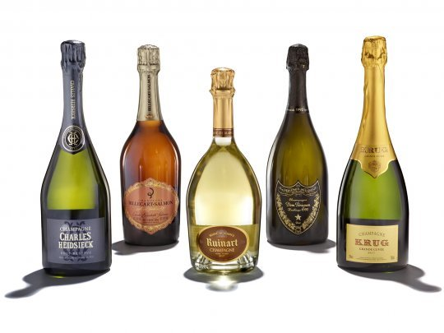 | 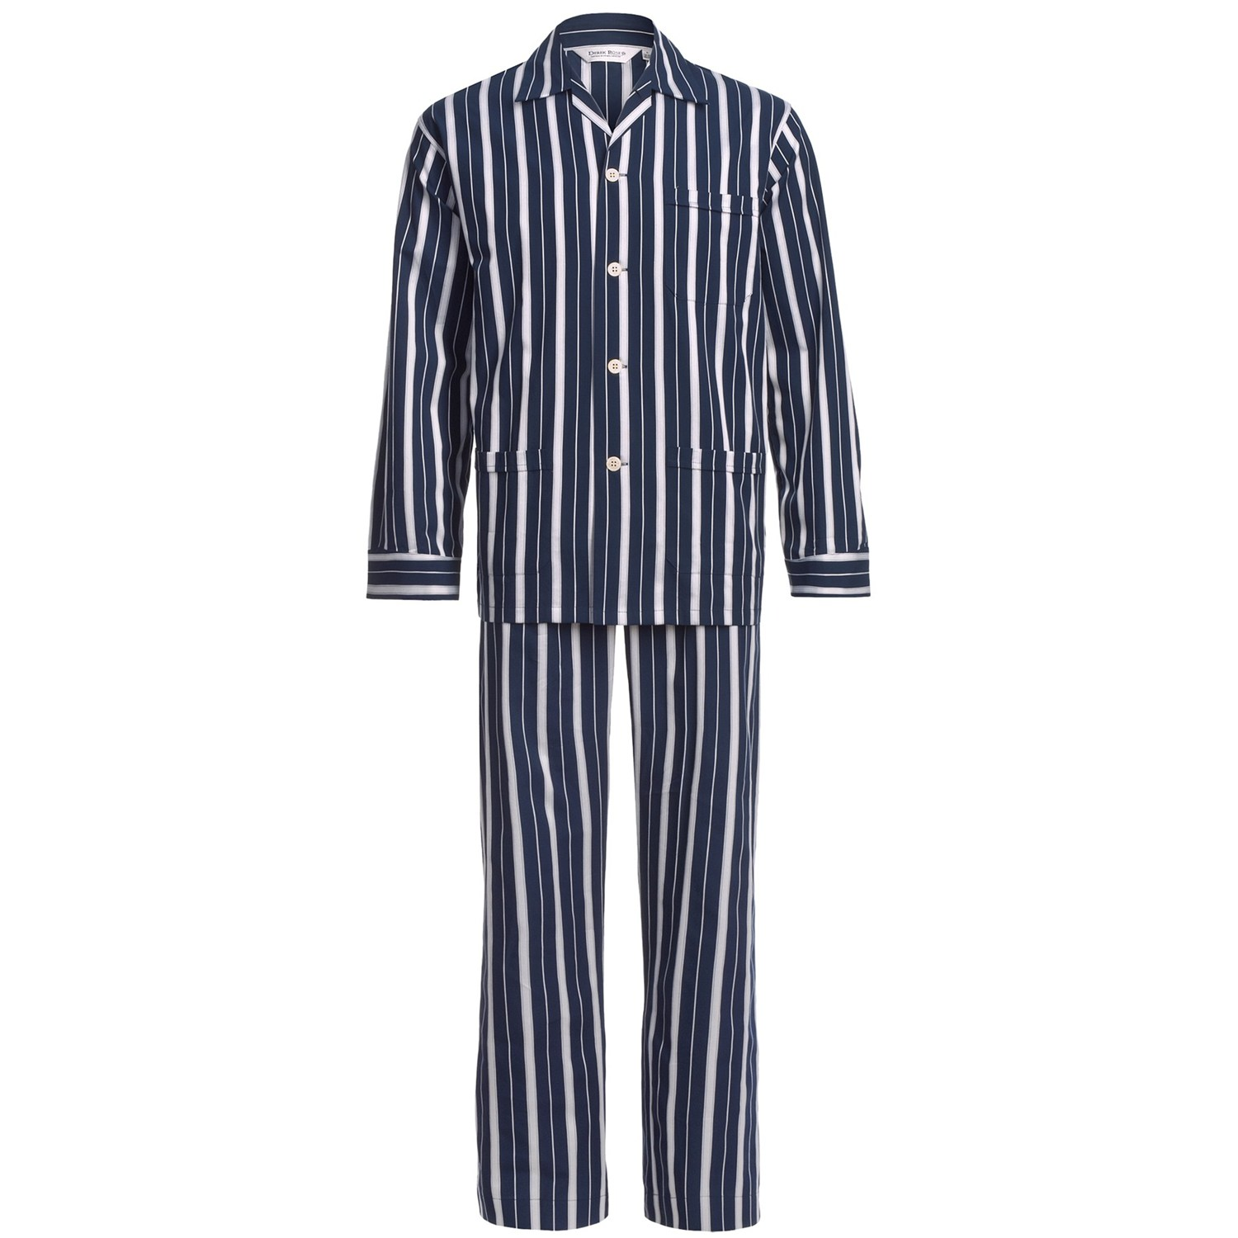 | 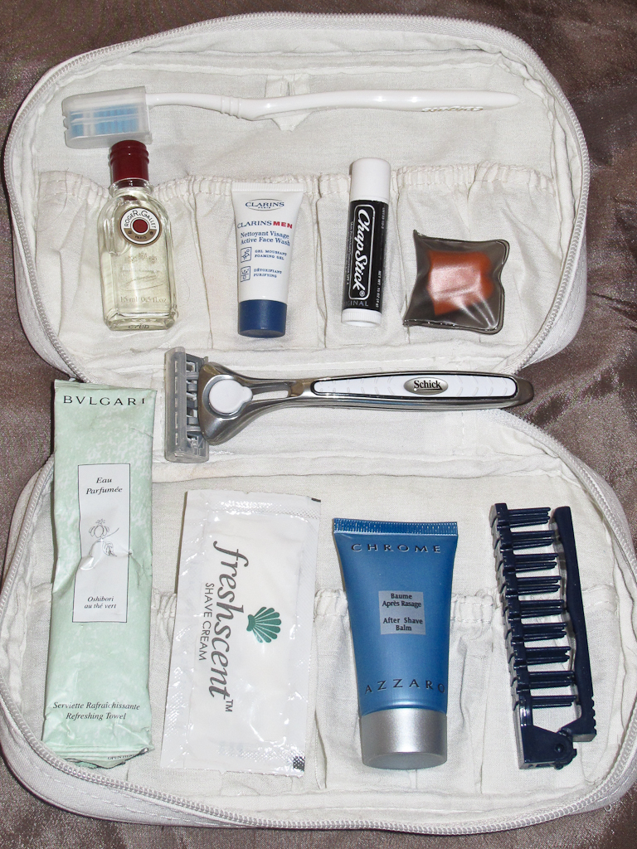
1 | 2 | 3

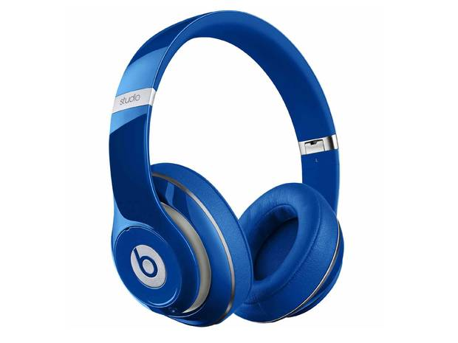 | 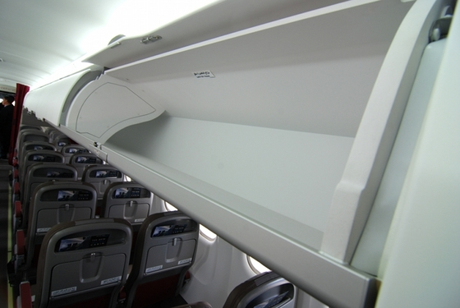 | 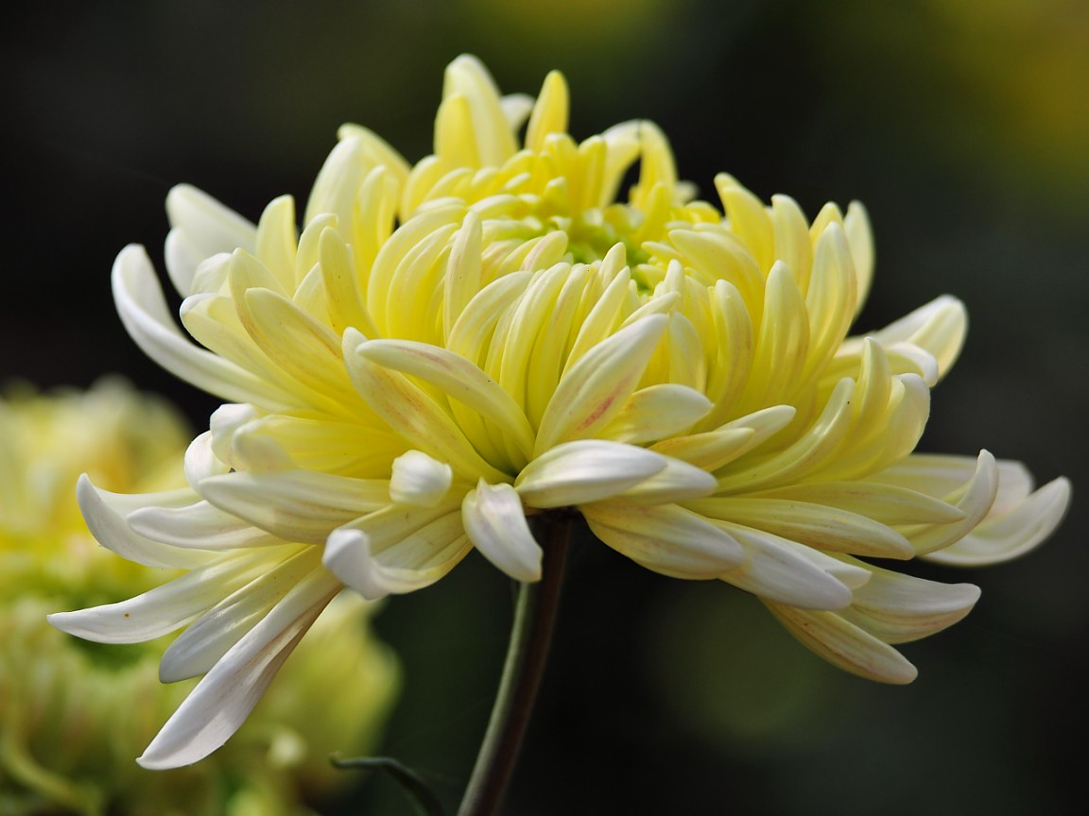
4 | 5 | 6

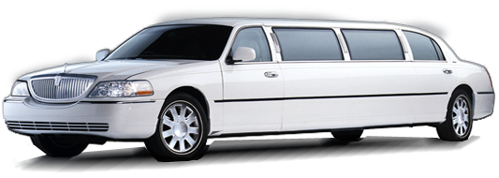
7
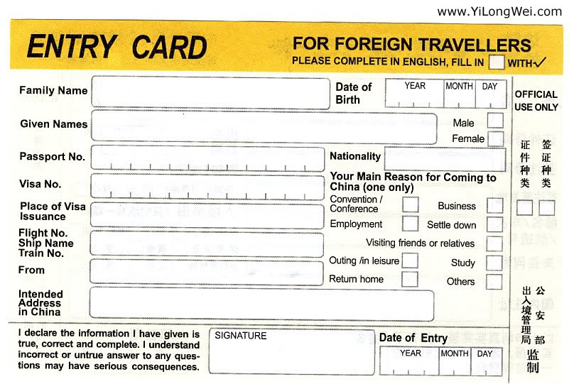
8
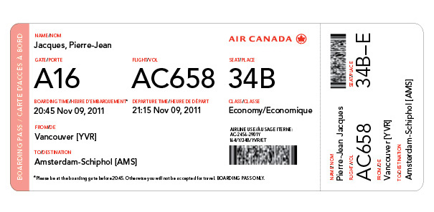
9

Ⅱ. Word Matching

Match the words in Column A with their interpretations in Column B.

 | Column B
Column A  option  assist  available  beverage  auspicious  complimentary  alcoholic  convenience  Amenity  recommend | (1) to give help or support to, especially as a subordinate or supplement; aid (给……帮助或支持，尤指作为隶属或补充)  (2) present and ready for use; at hand; accessible(可用的；现实可用的；手边的；可获得的)  (3) the quality of being suitable to one’s comfort, purposes, or needs(适合某人的舒适、目的或需要的性质)  (4) the quality of being pleasant or attractive; agreeab-leness(使人愉快或吸引人的性质；使人愉快)  (5) expressing, using, or resembling a compliment(表达、运用或类似赞美方式的)  (6) the act of choosing(选择的行为)  (7) related to or resulting from alcohol(与酒精有关的或由酒精制成的)  (8) any one of various liquids for drinking, usually excluding water(任一种饮用的液体，通常不包括水在内)  (9) to praise or commend (one) to another as being worthy or desirable; endorse(向另外一个人称赞或推荐(某人或物)，认为其有价值或合人心意)  (10) attended by favorable circumstances; propitious (伴随着有利情况的；有利的)

Ⅲ. Dialogue Completion

In the following dialogues, some sentences have been removed. Choose the most suitable one from the list to fit into each of the numbered blank, and then work in pairs and act as the passenger and the crew according to the dialogue.

Dialogue 1
A. Thank you.
B. And our menu offers a selection of Asian and Western cuisine.
C. May I offer you the menu and wine list now?

Crew: Excuse me, sir, I’m sorry to disturb you. (1)
Passenger: Yes，sure.
Crew: Thank you. Here is our wine list which features a wide selection of fine international wines. (2)
Passenger: Great, thank you.
Crew: Please take a look at it first and I will come back to take your order later. (3)

Dialogue 2
A. Which one would you prefer?
B. Would you care to sample the wine, sir?
C. Sir, may I offer you something to drink? We have wine, cocktails, fresh juices, and soft drinks.
D. Please enjoy your drink, sir.

Crew: Excuse me, (1)
Passenger: Yes, I’ll have a glass of white wine please.
Crew: Certainly. For white wine, one selection is from Languedoc, the other one is from Bordeaux, (2)
Passenger: The Bordeaux, thanks.
Crew: That would be Chateau Jacquet 2008. (While pouring a little wine in the passenger’s glass) (3)
Passenger: Thank you. (After a sip)It’s very nice.
Crew: I’m glad you like it. It’s a popular choice. (4)

Dialogue 3

A. May I prepare your table for dinner?

B. Would you care for another glass?
C. Sir, how was your cocktail?

Crew: Excuse me, (1)
Passenger: It’s very nice
Crew: Thank you. (2)
Passenger: No, thank you.
Crew: Certainly, (3)
Passenger: Yes, please. I am hungry.
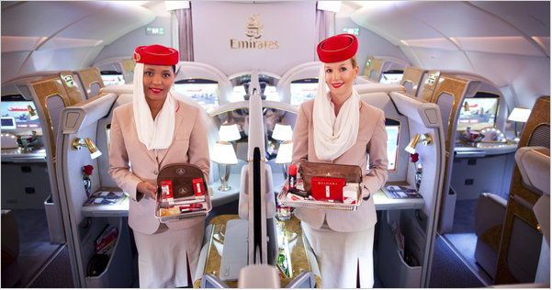

Ⅳ. Translation and Practice

1. Translate the following sentences into English.
(1) 根据您选择的主菜，特别向您推荐最新的几款优质法国葡萄酒。这是今年特别聘请法国最知名的3位品酒师为头等舱旅客精选的法国AOC级的葡萄酒。
____________________________________________________________________
____________________________________________________________________
____________________________________________________________________
____________________________________________________________________
____________________________________________________________________
(2) 先生，我们今天配备了两款进口的白葡萄酒，都产自法国。一款是产自朗格多克区的自然之春干白，一款是产自波尔多区的雅戈酒庄2008干白，您看您选用哪种呢？
____________________________________________________________________
____________________________________________________________________
____________________________________________________________________
____________________________________________________________________
____________________________________________________________________
(3) 先生，今天我们为您准备了两种霞多丽葡萄酒，它们都产自法国的勃良第地区。这瓶是产自勃良第南部马丁酒庄的勃良第一级佳酿2008干白，这瓶是产自勃良第北部地区的小夏布利干白。
____________________________________________________________________
____________________________________________________________________
____________________________________________________________________
____________________________________________________________________
(4) 先生，您选的这款小夏布利干白曾在2009年伦敦德康特世界葡萄酒大赛中获得过铜奖。伦敦德康特世界葡萄酒大赛是全世界最重要的葡萄酒大赛之一，尤其偏重白葡萄酒，因此这是一款不可多得的好酒。
____________________________________________________________________
____________________________________________________________________
____________________________________________________________________
____________________________________________________________________
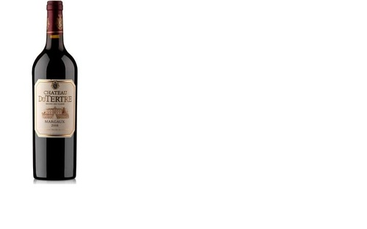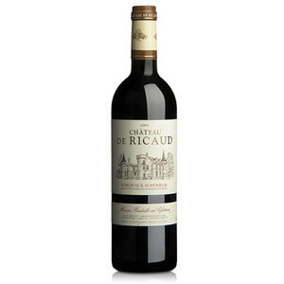

2. Now, check your answers, and then practice with your partner to make up short dialogues according to the translated sentences.
(1) May I recommend the wine to go with your main course? We have a variety of AOC level French wine that are selected for our distinguished first class passengers by three wine tasters.
(2) Mr. we have two kinds of French white wine. One is Spirit of Nature produced in the Domaine de Petit Roubie in Languedoc, and the other is Bordeaux Blanc, Chateau Jacquet 2008. Which one would you prefer?
(3) Mr. we have two kinds of wine made of Chardonnay, which are both produced in Burgundy. One is Bourgogne Premiere Cuvee, Domaine Martin 2008 from the south of Burgundy, and the other is Petit Chablis White Wine from the north of Burgundy.
(4) Mr. Petit Chablis won Bronze at Decanter World Wine Awards in London in 2009, which is one of the most important international wine awards, especially for white wine. Therefore, it’s a superb wine and really worth tasting.


Ⅴ. Individual Work

Figure out the meaning of words that you don’t know in the following CIQ forms and try to complete them.
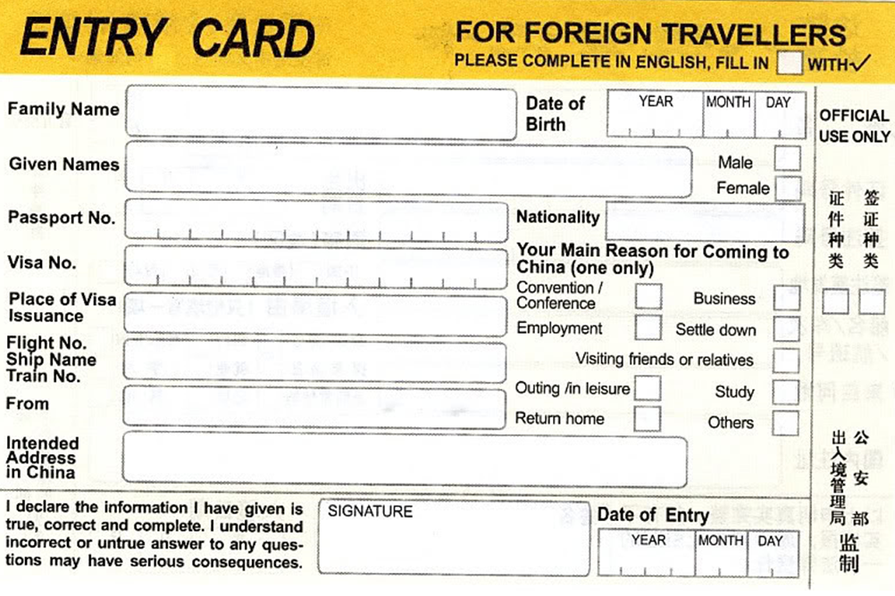
1
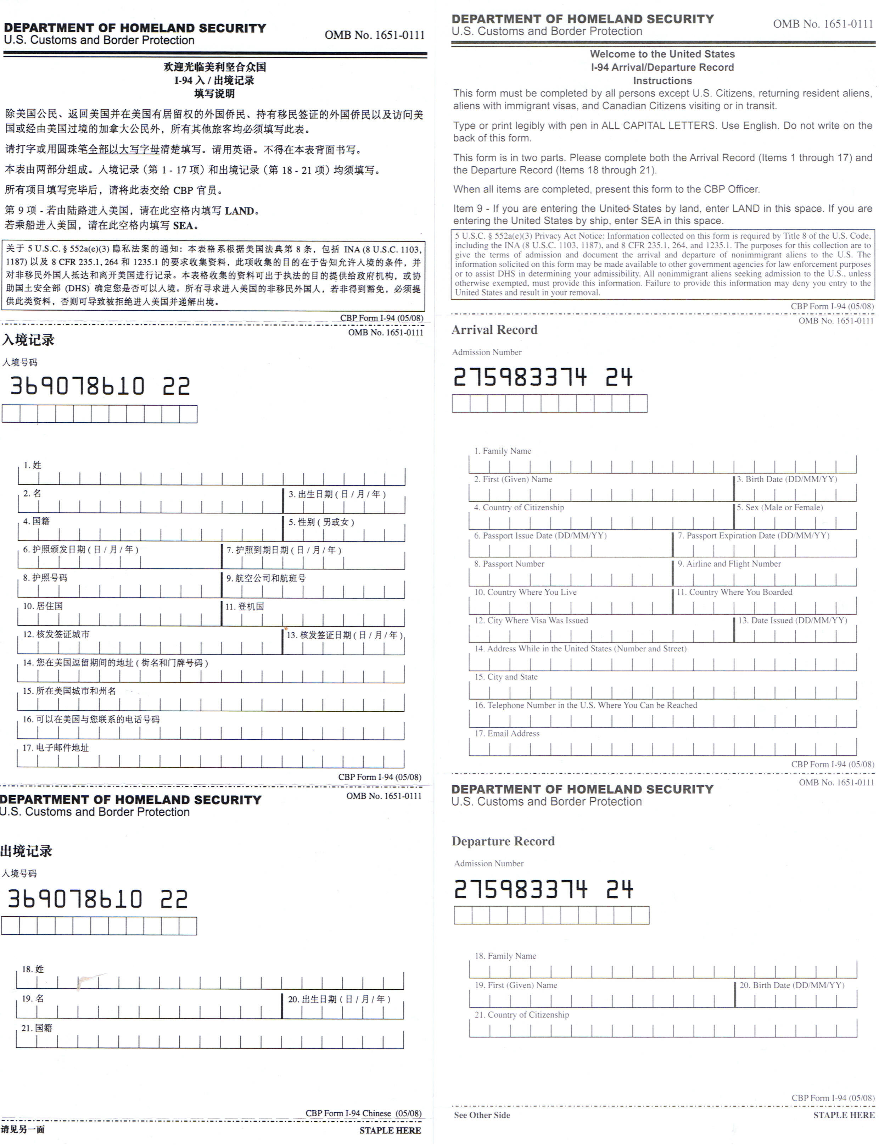
2
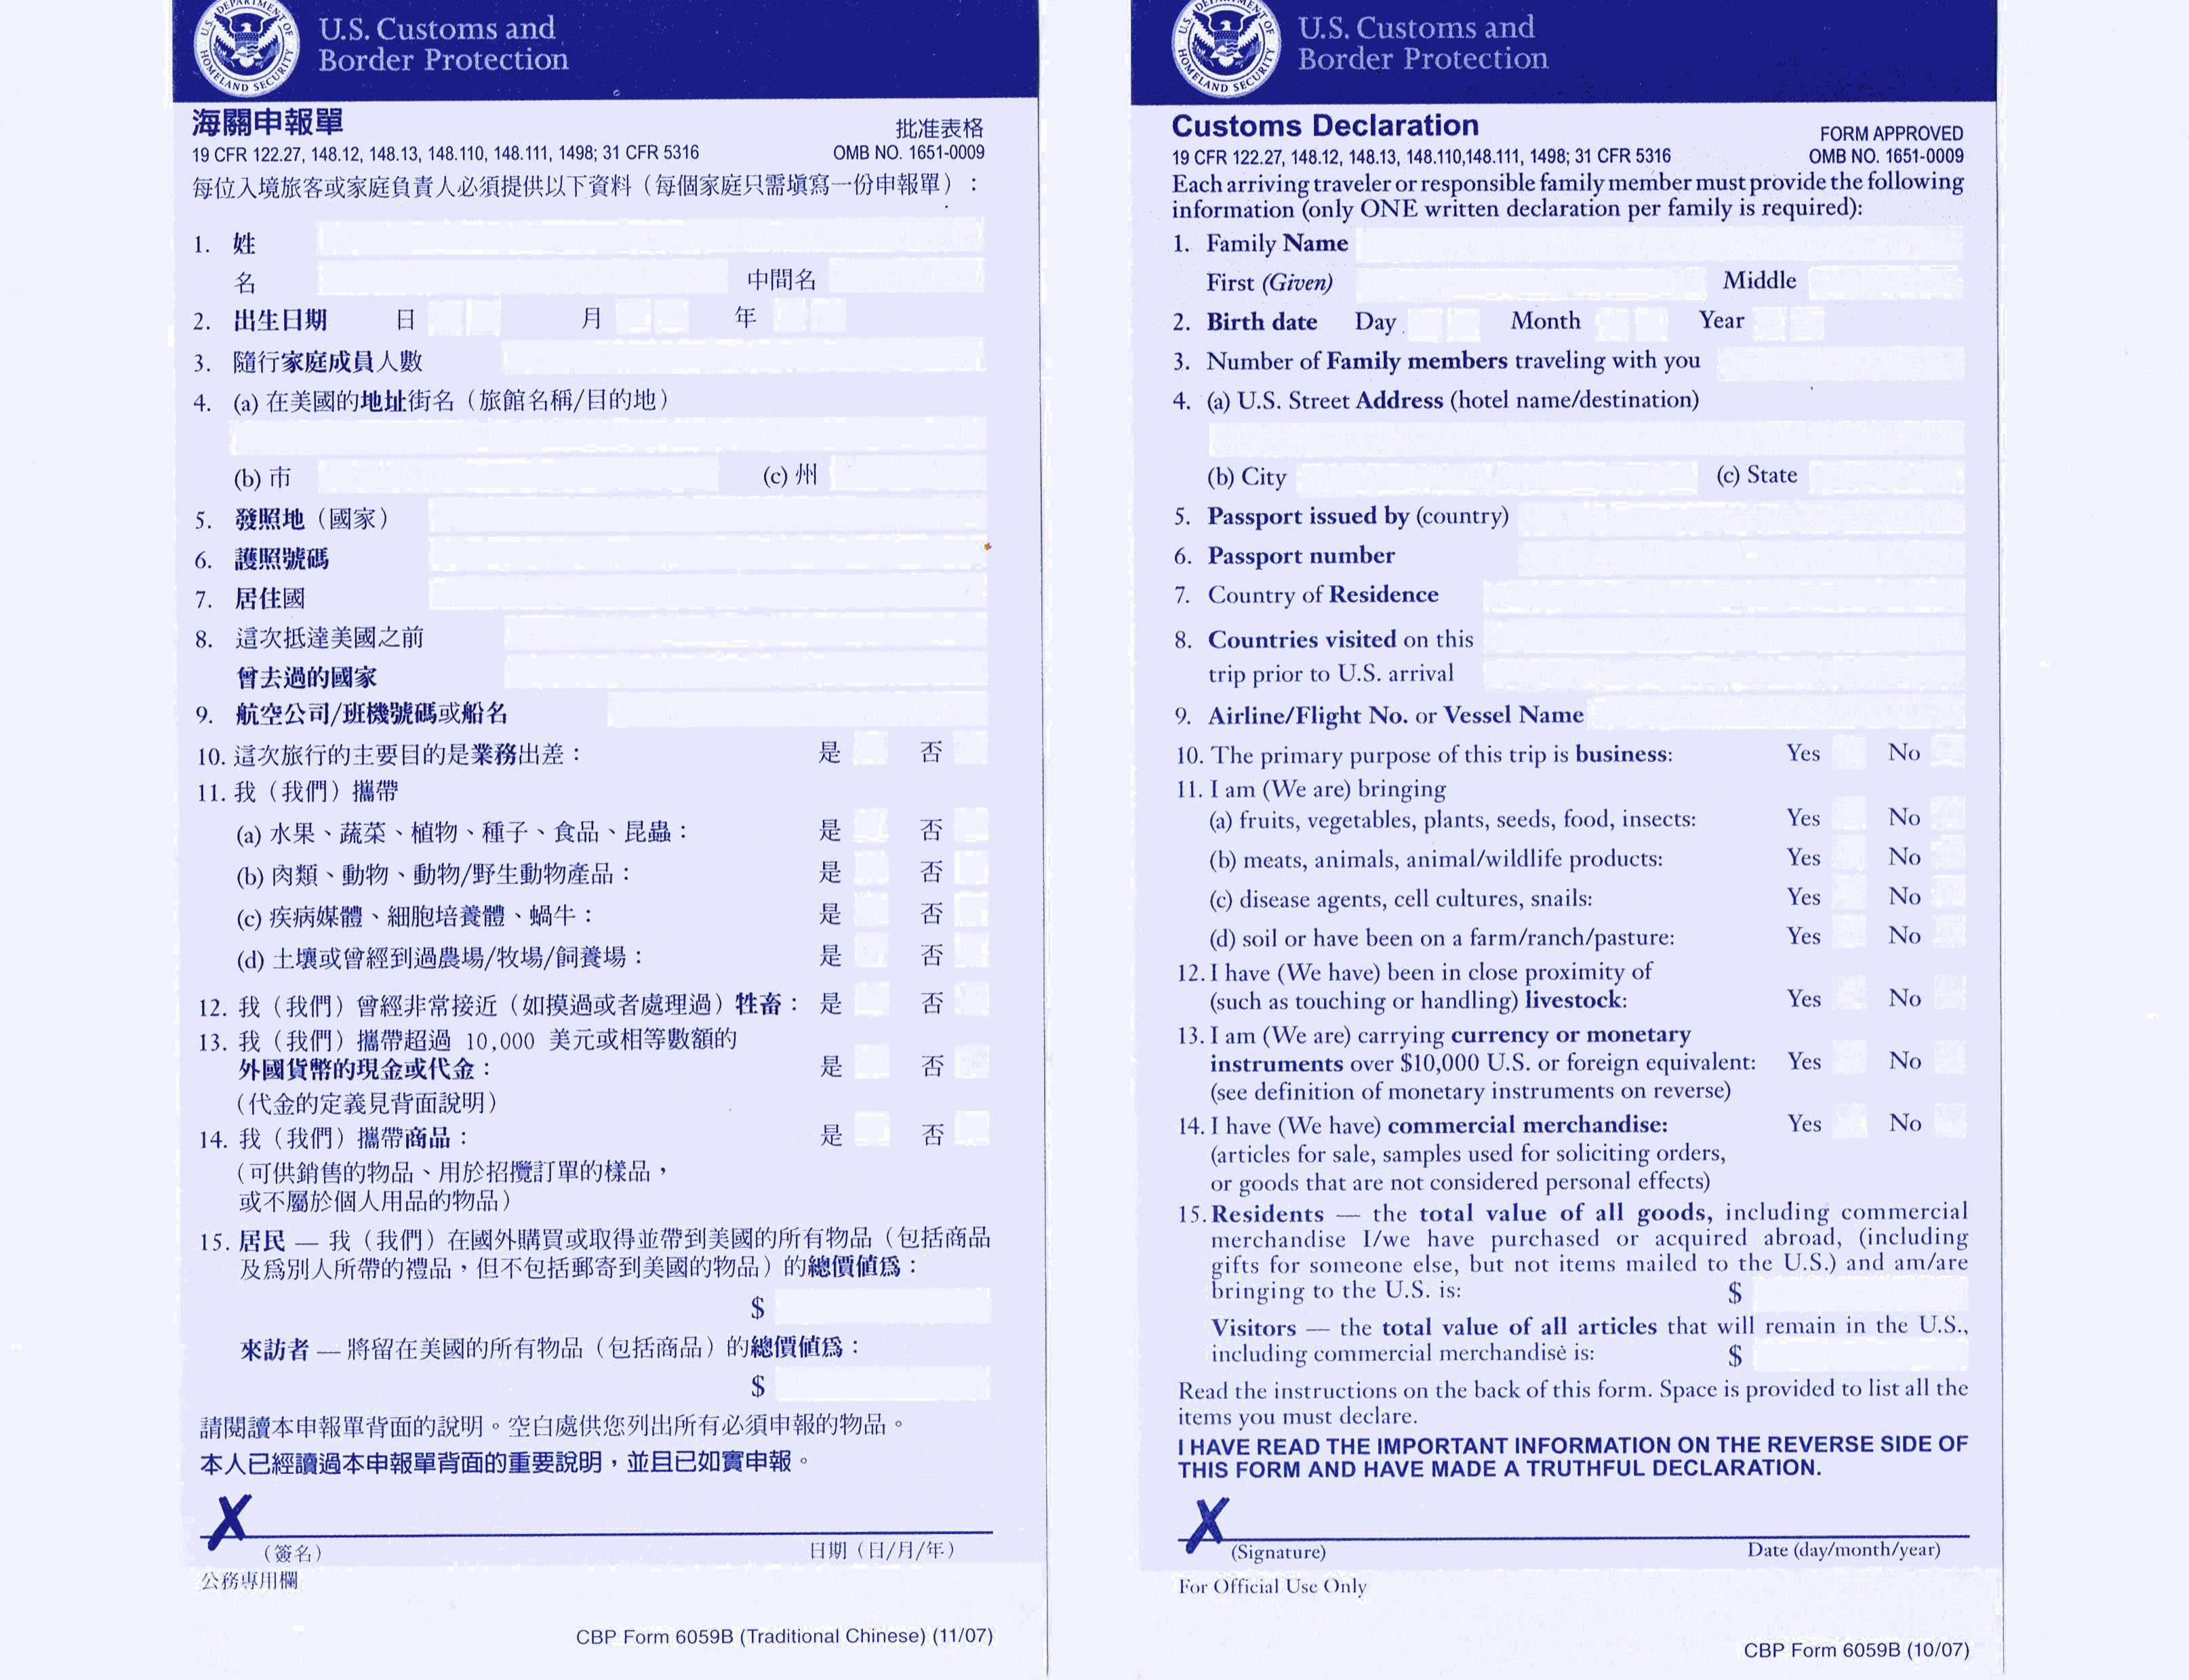
3

Ⅵ. Further Study

霞多丽葡萄酒
霞多丽(Chardonnay)葡萄，是白葡萄中的皇后。它的魅力在于其多变的风格和广泛的适应性，在任何气候条件下，它的质量始终如一。从寒凉的法国北部的Chablis到炎热的阿根廷的Mendoza和南澳大利亚的Barossa Valley，霞多丽呈现出从带有柑橘类水果到充满热带水果和异国情调的不同风姿。它也是香槟酒和起泡酒调和成分中最重要的一分子。霞多丽具有特制的香气。在寒凉的产地它的酸度较高，因而呈现出柠檬、橙子等柑橘类水果的香气。随着气候的变暖，它会有桃、梨、杏等的香气，以至于在炎热的气候出现菠萝、芒果等热带水果的香气。
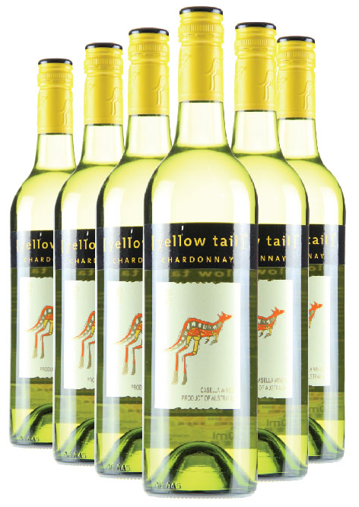
霞多丽是世界上风格最多样，种植范围最广泛的酿酒葡萄。从80年代末期在国际上开始流行，不仅仅是因其非常容易种植，长势旺盛，酿成的酒相对温和、圆润的特点，酸度不是很高，容易被消费者接受。
它可以用来酿制风格多样的葡萄酒，从酒体丰满浓郁的索诺玛葡萄酒，到酒体轻盈剔透的白中白香槟，都是它的杰作。
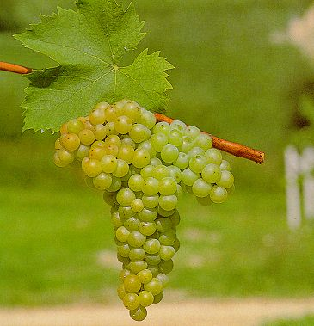
Unit 3 Dealing with Special Situation
(特殊情况处理)

3.1 Case Analysis : The Crew Seems to Be Ignoring Me!

(个案分析：乘务员忽略我！)
How would you like to deal with the following situation?
Passenger: I’m really disappointed with your service. I have asked for a drink 3 times and I’m still waiting. The crew seems to be ignoring me!
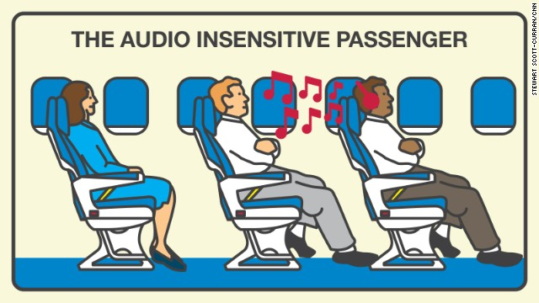
Communication is a process that you can learn to master and be more effective at carrying out. Understanding the steps of the communication process is essential to became a better communicator. Once you understand the basic steps in the process, you can make a conscious effort to communicate more effectively. While there are differing opinions as how many steps there are in the communication process, a basic five-step communication process is the most useful and easiest to understand.
There are five steps of communication:
(1) Adjust Your Mindset;
(2) Listen Actively;
(3) Repeat Their Concerns, Show Empathy and Acknowledge anger and Apologize;
(4) Present a Solution/Option and Appreciate Feedback;
(5) Take Action and Follow-up Assurance.
Possible solutions to the complaint：

Step 1: Adjust Your Mindset
Once you’re aware that your passenger is unhappy then your first priority is to put yourself into a customer service mindset.
This means that you set aside any feelings you might have that the situation isn’t your fault, or that your passenger has made a mistake, or that he or she is giving you unfair criticism.
All that matters is that you realize that your passenger is upset, and that it’s up to you to solve the problem. Adjust your mindset so that you’re giving 100 percent of your focus to your passenger, and to the current situation.

Step 2: Listen Actively
The most important step in the whole of this process is listening actively to what your passenger is saying — he wants to be heard, and to air his grievances.
Start the dialogue with a neutral statement, such as, “Let’s go over what happened,” or “Please tell me why you’re upset.” This subtly creates a partnership between you and your passenger, and lets him know that you’re ready to listen.
Resist the temptation to try to solve the situation right away, or to jump to conclusions about what happened. Instead, let your passenger tell you his or her story. As he’s talking, don’t plan out what you’re going to say when he’s done ——this isn’t active listening!
Also, don’t allow anything to interrupt this conversation. Give your passenger all of your attention.

Step 3: Repeat Their Concerns, Show Empathy and Acknowledge anger and Apologize
Once he’s had time to explain why he’s upset, repeat his concerns so you’re sure that you’re addressing the right issue. If you need to, ask questions to make sure that you’ve identified the problem correctly.
Use calm, objective wording. For example, “As I understand it, you are, quite rightly, upset because we didn’t deliver the food that we should have delivered to you on time.”
Repeating the problem shows the passenger you were listening, which can help lower his anger and stress levels. More than this, it helps you agree on the problem that needs to be solved.
What’s more, you can show your empathy and acknowledgement to the passenger. For example,
—Mr. Leeds, I can appreciate this must be very disappointing for you.
—I can understand why you are feeling so upset.
—I agree that it’s not acceptable to be kept waiting for such a long time.
—I understand why you’re upset. I would be too. I’m very sorry that we didn’t get the in-fight food to you on time, especially since it’s caused these problems."
—Mr. Leeds, I’m terribly sorry to hear that you are disappointed with our service today.
—I apologize that we’ve kept you waiting, Mr. Leeds.
—Mr. Leeds, I am very sorry that our in-flight service today has not met your expectations.

Step 4: Present a Solution/Option and Appreciate Feedback
Now you need to present the passenger with a solution.
—I will be back with your drink as soon as I can. Would you like some warm nuts to accompany your drink?
—May I know what drink you have requested and I’ll be back with it immediately. May I also offer you some cheese and fruit to go with your drink?
Thank passenger for their feedback:
—Thank you for bringing this to my attention. We do appreciate your feedback.
—Thank you for letting me know. We always like to hear comments from our passengers.
Then you could say, “If my solution doesn’t work for you, I’d love to hear what will make you happy. If it’s in my power I’ll get it done, and if it’s not possible, we can work on another solution together.”

Step 5: Take Action and Follow-up Assurance
Once you’ve both agreed on a solution, you need to take action immediately. Explain every step that you’re going to take to fix the problem to your passenger.
Once the situation has been resolved, follow up with your passenger over the next few hours to make sure that he or she is happy with the resolution. Whenever you can, go above and beyond his or her expectations. For instance, you can send her a hand-written apology，or you can express your follow-up assurance:
—We will do whatever we can to ensure that the rest of your flight is pleasurable.
—I will share your comments with the crew and if there is anything else we can do for you, please do not hesitate to press the call button.
—On behalf of the team, I can assure you that we’ll do our best to make this journey pleasant for you. Please let us know if there is anything else we can assist you with during the flight.

Further Tips
It’s important to handle difficult customers professionally. Learning how to stay calm and how to stay cool under pressure can help you get through challenging situations with grace and professionalism.
If your passenger is especially angry, then talk slowly and calmly, and use a low tone of voice. This will subtly help lower the tension, and ensure that you don’t escalate the situation by visibly getting stressed or upset yourself.

3.2 Case Analysis: I can’t Sit by My Colleague!
(个案分析：我不能和同事坐在一起！)
How would you like to deal with the following condition?
Passenger: I have been flying Air China for years and now I find I can’t sit by my colleague. We were expecting to get a lot of work done on this flight.

Possible solution to the complaint：
1. Acknowledgement
—Mr. Freeman, thank you very much for your support over the years. We appreciate that you’ve chosen to fly with us.
—It’s a pleasure to see you again, Mr. Freeman and I’m sorry for this inconvenience.
2. Empathy
—I can see why you would find it frustrating if you were expecting to be sitting next to your colleague.
—I understand that the discussion is very important to you.
3. Solutions
I will look around the cabin to see if there are two vacant seats together.
—Thank you very much for your feedback, Mr. Freeman, we do appreciate your comments
4. Assurance of service
—If there is anything we can do for you, please don’t hesitate to let us know.

3.3 Case Analysis: The Service on this Flight is Terrible!

(个案分析：这个飞机上的服务太糟糕了！)
How would you like to deal with the following condition?
Passenger: The service on this flight is terrible. The dinner service was very rushed and none of the crew smiled once. I may as well be in Economy Class!
Possible solution to the Complaint：

1. Acknowledgement
Mr. Paul, please accept my apologies. I am sorry to hear that our service is not up to standard.

2. Empathy
—I can understand that you feel quite disappointed about the service.
—I can feel that you are very upset about the service.

3. Options/Alternatives
—May I ask if there is anything else you would care to try?
—Would you care for another…

4. Thank passenger for their feedback
—I appreciate your comments regarding the service today.
—Thank you very much for taking the time to share your concerns for the service today, we do appreciate your feedback.

5. Assurance of service
—Mr. Paul, if there is anything else we can do for you, please do not hesitate to let us know.

6. Follow up service
—Excuse me, we will be starting our breakfast service shortly. May I reserve the meal for you first?
Words and Expressions
mindset ['maɪndset] n. 心态；倾向；习惯；精神状态
priority [praɪ'ɒrɪtɪ] n. 优先；优先权；优先考虑的事
unfair [ʌn'feə] adj. 不公平的，不公正的
criticism ['krɪtɪsɪz(ə)m] n. 批评；考证；苛求
grievance ['griːv(ə)ns] n. 不满，不平；委屈；冤情
temptation [tem(p)'teɪʃ(ə)n] n. 引诱；诱惑物
objective [əb'dʒektɪv] adj. 客观的；目标的；宾格的
wording ['wɜːdɪŋ] n. 措辞；用语；语法
subtly ['sʌtli] adv. 精细地；巧妙地；敏锐地
partnership ['pɑːtnəʃɪp] n. 合伙；合伙企业；合作关系；合伙契约
resist [rɪ'zɪst] vi. 抵抗，抗拒；忍耐 vt. 抵抗；忍耐，忍住
rightly ['raɪtlɪ] adv. 正确地；恰当地；公正地；合适地
option ['ɒpʃ(ə)n]z n. [计] 选项；选择权；买卖的特权
assurance [ə'ʃʊər(ə)ns] n.保证，担保；(人寿)保险；确信
resolution [rezə'luːʃ(ə)n] n.决议；解决；决心
expectation [ˌekspekˈteɪʃn] n.期待；预期；指望
grace [greɪs] n.优雅；恩惠魅力；慈悲
subtly ['sʌtli] adv. 精细地；巧妙地；敏锐地
tension ['tenʃ(ə)n] n. 张力，拉力；紧张，不安
Practice

How would you like to deal with the following condition?
Work in groups, and discuss the following issues given to find the solutions. Thereafter each group shares their result with the class, and other groups can supplement with new ideas. Play the roles of the flight attendant and the passenger respectively.
1. You are supposed to be a flight attendant, and a passenger was complaining loudly, “The food on this flight is disgusting！I should have taken another flight!” How would you like to deal with the following condition?
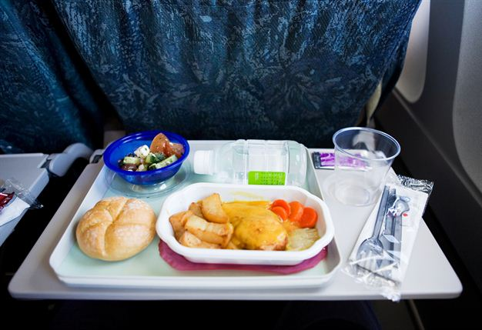
2. You are supposed to be a flight attendant. A man complains he hasn’t been served any drinks. The fact is that he was sleeping while you served. How would you like to explain to him? How would you like to deal with the following condition?
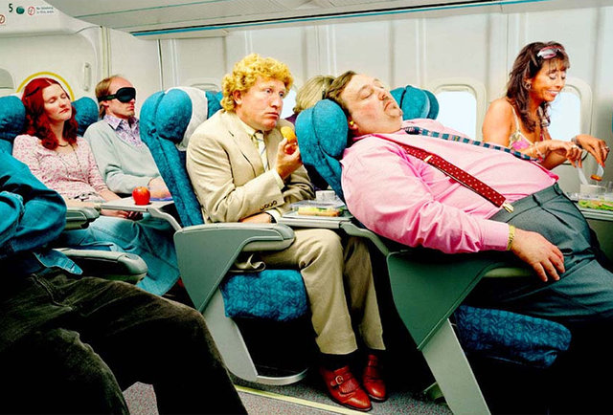
3. You are supposed to be a flight attendant. A lady asks for hot drinks but there are no hot drinks on board because the water system is out of order. How would you like to explain to her? How would you like to deal with the following condition?

