
Part 1 Basics of Business Communication

Living in an increasingly globalized and connected world, we have a great many ways to communicate with friends, loved ones, colleagues, customer service reps, business partners, government officials, shop assistants, passengers on the same bus, diners on the same table, and anyone who could step into your life expectedly or, more often than not, unexpectedly. To make it more complicated, these people may even come from different cultural backgrounds. Communicating smoothly with them could help you establish new connections, settle conflicts efficiently, open up new possibilities, and bring about a success to your professional life.
In Chapter 1, we will start from the fundamentals of communication by looking into the basic elements of communication, the typical communication process, and different ways of classifying communication. The general understanding of communication prepares us to get close to business communication against a theoretical framework, that is, the classification between verbal communication and non-verbal communication. Outside of this framework, another type of communication is gaining great momentum and playing a more and more important role in sales and marketing circumstances. It is visual communication, a critical part of content marketing. Visual communication is the outcome of prospering art industry boosted by computer technology, and is also an extremely effective way of grasping young customers’ attention, and more importantly, their loyalty.
Chapter 2 mainly focuses on intercultural communication with reference to Hofstede’s cultural dimensions and its applications in business occasions. It also introduces ways of overcoming cultural barriers and reaching mutual understanding across cultures.
The skills and tips you learn from this part will be helpful for your daily communication and become valuable soft skills, whatever career path you will choose to go.

Chapter 1 Understanding Business Communication


After studying this chapter, you will be able to
- master fundamentals of communication;
- understand business communication;
- develop effective verbal and non-verbal communication.

1.1 Introduction to Communication

1.1.1 Definition of Communication
The word “communication” derived from the Latin word “communicare”, which means to share, or to make common. Communication is a process by which information is exchanged between individuals through a common system of symbols, signs, or behavior. It is a process of exchange of facts, ideas, and opinions so that individuals or organizations can share meaning and understanding with one another.
American Management Association defines, “Communication is any behavior that results in an exchange of meaning.” Communication is also defined as the process of understanding and sharing meaning. A process is a dynamic activity which may change at any time. For example, when you talk with your friend and a stranger unknown to you joins in the talk, what will be changed? You may be more selective about what you are saying. Understanding involves relating what you perceive to what you already know. In communication, sharing not only means doing things together with other people, but also means conveying your thoughts, feeling, and ideas to others. Meaning involves thoughts, ideas, and understandings shared through communication.

1.1.2 Elements of the Communication Process
In order to better understand the communication process, we can break it down into eight essential components. Each component serves a function.

1. Sender
The sender is the origin of information. The sender transmits the information so it is best understood by the receiver. That could involve speaking in person or over the phone, communicating via e-mail or interacting through a video chat.

2. Encoding
This is the process of transferring the information in a proper way to make it understood by the recipient. The message can be shown by way of symbols, languages, and pictures.

3. Message
The message includes all information provided from the sender to the recipient. It can be verbal or non-verbal. When you give a speech or write a report, your message is not only the words you choose. The message also consists of the way you say it. In a speech, your tone of voice, your body language, and your appearance also convey information. And in a report, your writing style, punctuation, and the formatting are also messages.

4. Channel
The channel is the appropriate medium used to transmit the message from the sender to the recipient. Spoken channels include face-to-face conversations, speeches, telephone conversations and voice mail messages. Written channels include letters, memorandums, purchase orders, invoices, newspaper and magazine articles, blogs, e-mail, text messages, and so forth.

5. Decoding
Once the message is received, the recipient begins to translate the message in a way he or she can understand. During person-to-person conversations, we can do this in a second.

6. Receiver
The receiver is the person who receives the message. As a receiver you listen, see, touch, smell, and/or taste to receive a message. Even the non-verbal responses of your listeners can serve as clues on how to adjust your words. Effective communication can take place only when the receiver’s reaction is what the sender expected.

7. Feedback
Feedback is the response the receiver gives to the sender. Verbal or non-verbal feedback allows the sender to see how well the message is received. Feedback also provides an opportunity for the receiver to ask for clarification, or to agree or disagree. As the amount of feedback increases, the accuracy of communication also increases. The communication process ends with the feedback stage.

8. Noise
The communication process can be influenced by noise. This may include a phone call during a conversation. Or if a receiver who doesn’t pay enough attention to the message, he or she cannot fully understand the message. Not all noise is bad, but noise interferes with the communication process.
The process can be summarized as Figure 1-1. At first, the sender has an idea and coverts the idea into a message of words and gestures. Then, the message travels through a certain channel. When receiving the message, the receiver decodes it and responds to the sender. The process may repeat several rounds.
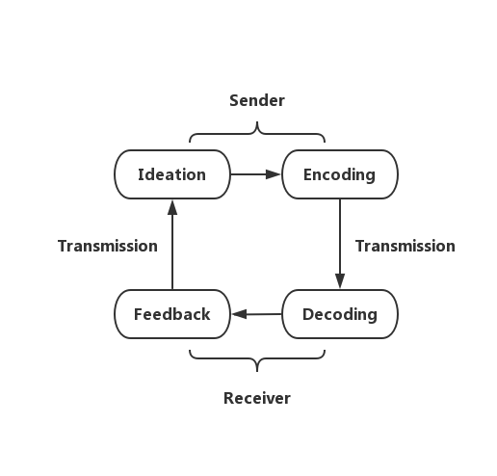

Figure 1-1 Communication Process
To bear these elements in mind can help communicate with others more effectively, but the reality is that perfect communication is impossible. Two persons involved in an interaction could not perceive the exact same meaning from a message. Barriers of communication are always there: lack of planning, cultural differences, lack of confidence, language barriers, wrong choice of channel, mistrust, bias, to name just a few. Some of the barriers will get addressed in the book.

1.1.3 Classification of Communication
According to the number of persons who receive the message, communication can be classified into intrapersonal communication, interpersonal communication, group communication and mass communication.
(1) Intrapersonal communication is talking to oneself in one’s own mind.
(2) Interpersonal communication is the exchange of messages between two people. Examples are conversations, dialogues, or interviews in which two persons interact. A letter is also an example of interpersonal communication between the writer and the receiver of the letter.
(3) Group communication can be among small or large groups, such as an organization, club, or classroom.
(4) Mass communication is when a message is sent to large groups of people, such as by newspaper, radio, or television. In this process, each receiver is an individual with almost no opportunity for response.
Communication can also be classified on the basis of the medium.
(1) Verbal communication means communicating with words, oral or written. Verbal communication consists of speaking, listening, writing, reading, and thinking.
Oral communication is the communication where the message is exchanged by spoken words. It can be done by both face to face and mechanical devices.
Written communication is the communication where the message is exchanged by written words. Letter, fax, e-mail and text message are examples of written communication. Written communication guarantees that everyone concerned has the same information. It provides a record of communication.
Non-verbal communication includes the use of pictures, signs, gestures, and facial expressions for exchanging information.
(2) Non-verbal communication includes the use of pictures, signs, gestures, and facial expressions for exchanging information. Non-verbal communication is a wordless message conveyed through gestures, movements, clothes, and so on.
Speech may also contain non-verbal elements, including voice quality, emotion and speaking style, as well as features such as rhythm, intonation and stress. Likewise, written texts have non-verbal elements, such as handwriting style, spatial arrangement of words, or the use of emotions. We shall discuss both verbal and non-verbal communication in detail in the latter part of this chapter.

1.2 Introduction to Business Communication

1.2.1 Business Communication Definition
Business communication involves all messages that we send and receive for purposes like running a business, managing an organization, conducting formal affairs of a company, and so on. It covers a variety of topics: consumer behavior, advertising, public relations, corporate communication, research and measurement, reputation management, and event management. It is marked by formality as against personal and social communication.
Why is business communication so important? According to Forbes, businesses lose $62 billion each year because of poor customer support. When a customer has a problem with his or her purchase, they may contact the business for a solution. If the business doesn’t resolve the problem, that customer may stop buying its products or services.
Business communication also allows organizations to increase productivity. Research shows that most workers are only productive for about three hours a day. In an eight-hour day, that means five hours are wasted. The right communications, however, can encourage higher productivity levels by motivating workers.

1.2.2 Effective Business Communication
In business, communication helps in promoting a service, a product, or an organization, with the intention of completing a sale. Businesses use a variety of media for communication, including radio, outdoor ads, television, print, the Internet and spoken words. Communication skills have been highly valued in business etiquette and interpersonal skills. Employees and managers in every organization practice their communication skills for a better mutual understanding, not only for internal affairs, but for customers or partners outside as well.
Effective communication (both sender and receiver must understand the communication) helps the companies to keep the company healthy, maximizes its profits, and not only keeps its employees engaged, but also helps them to focus on their job for achieving the company’s goals. An effective communication demands two-way communication.


Communicating Effectively
Being an active listener: Learn to concentrate on what the speaker is saying, expect to learn something by listening and keep an open mind.
Being clear about message: Facts, ideas, opinion in the mind of communicator should be made clear before communicating.
Keeping consistency of message: The communicator keeps in his mind the objective policies and program of the enterprise. It should not conflict with the previous communications.
Providing feedback: Feedback provides proper understanding of the message to the receiver.
Being flexible with techniques: The communication system should be flexible enough to adjust to the changing requirements. It should be open to new techniques of communication.


1.3 Verbal and Non-verbal
Communication in Business
In the section of 1.1.3, we classify communication on the basis of the number of persons who receive the message and the media of communication. Based on the media, communication can be classified into verbal communication and non-verbal communication, as shown in Figure 1-2.

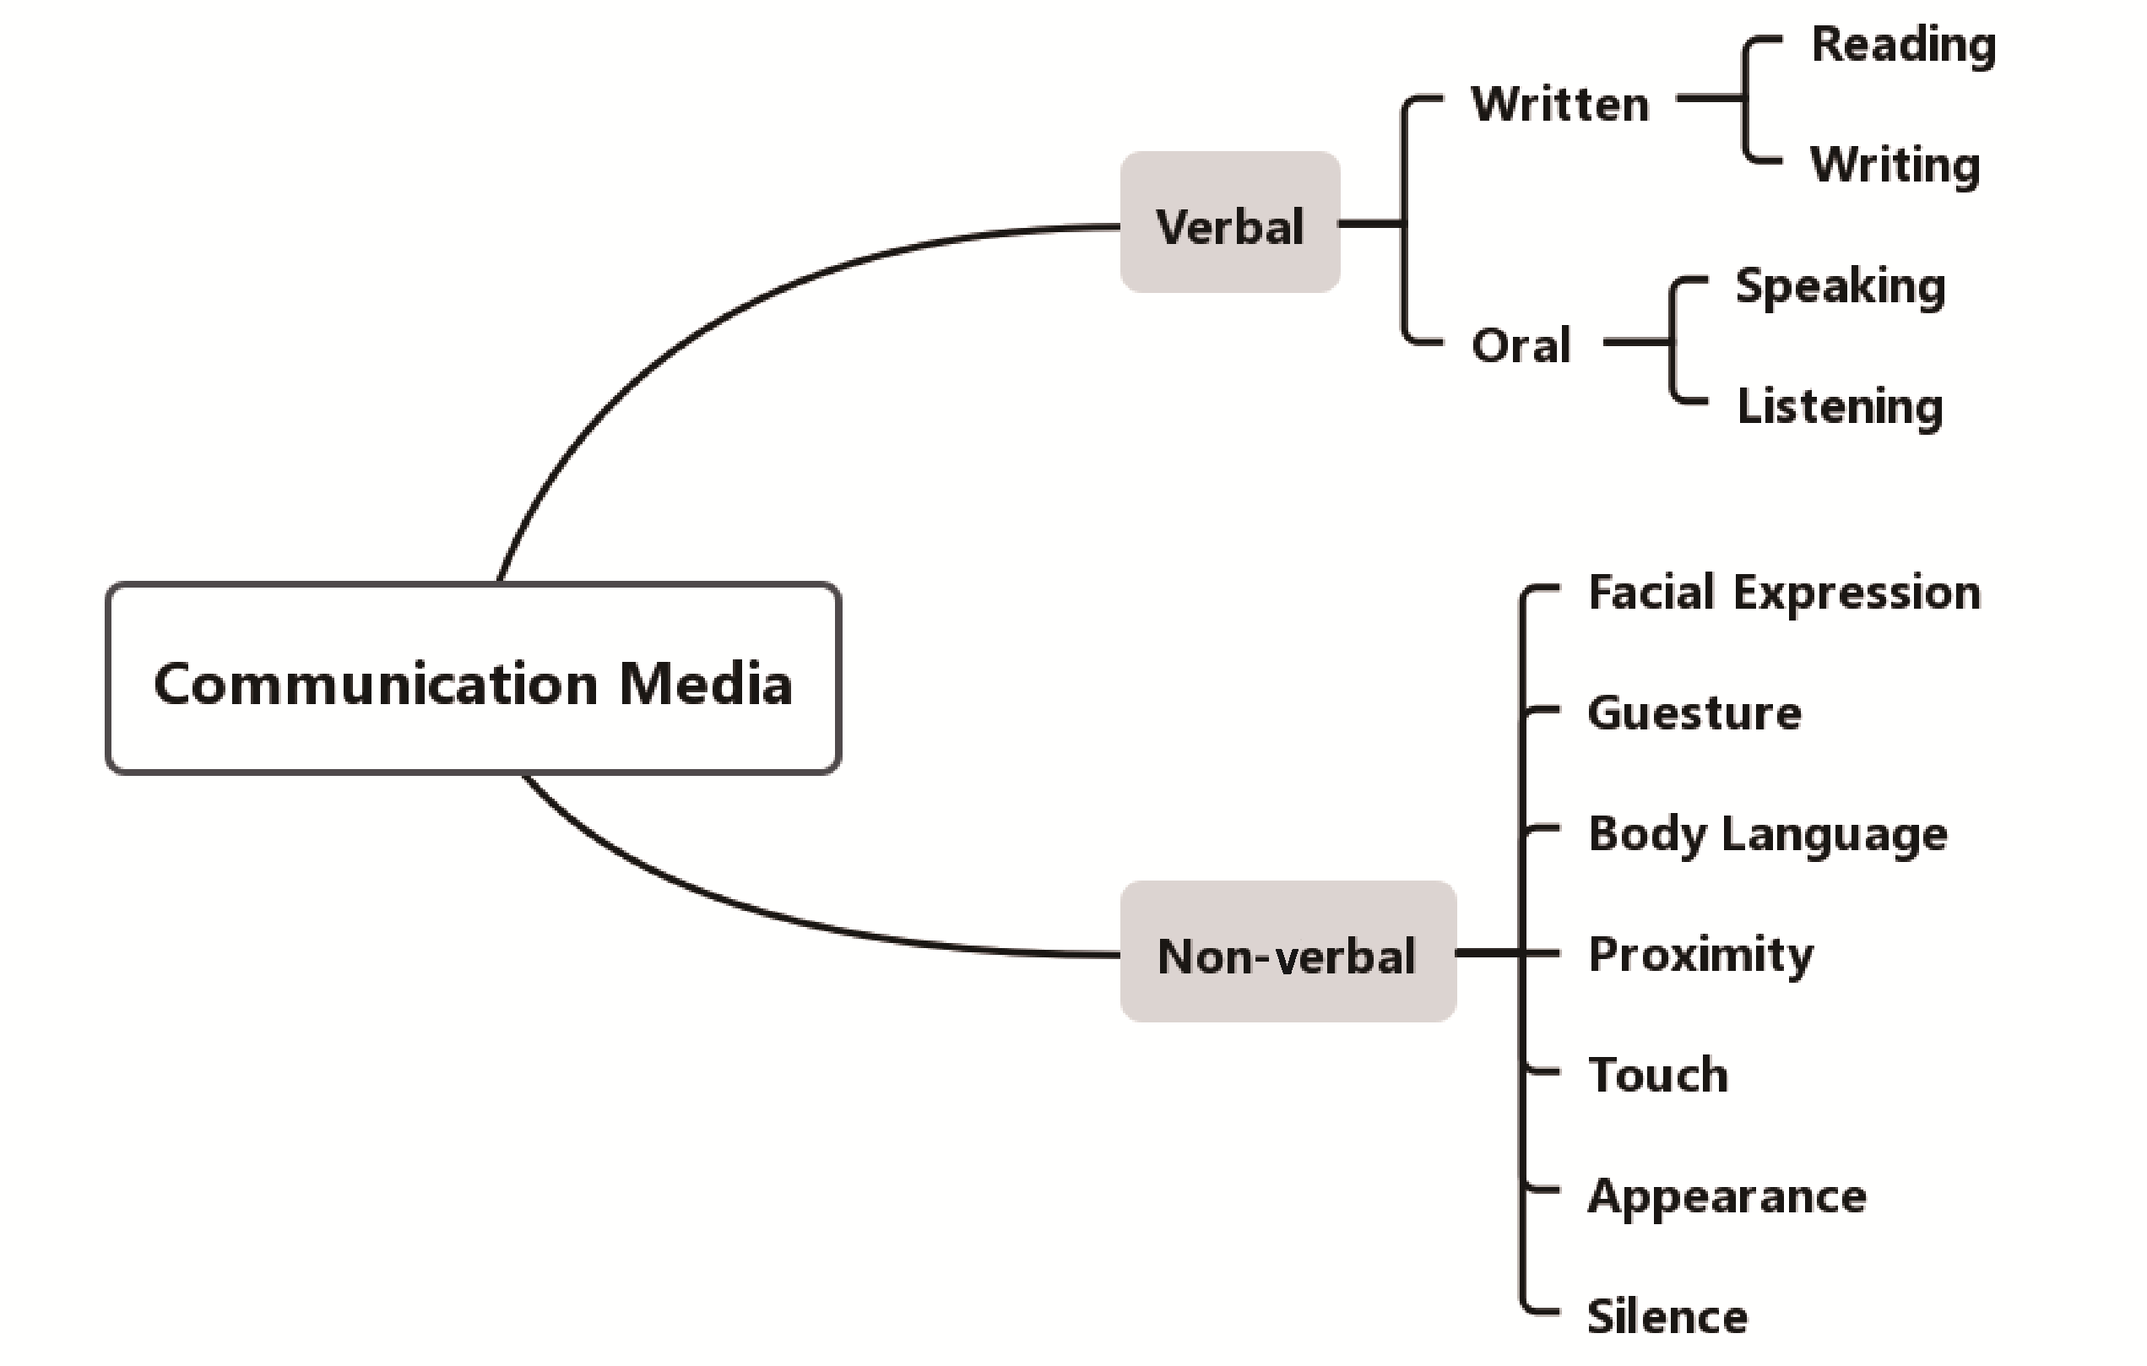

Figure 1-2 Categorization of Communication Based on Media

1.3.1 Verbal Communication

1. Written Communication
Written communication ensures that everyone concerned has the same information. It provides a permanent record of communication for future reference. In an organization, it may take the following forms: letters, e-mails, minutes, memoranda, reports, circulars, manuals, diagrams, graphs, agreements, rules, orders, instructions, notice boards, electronic messages (text messaging), etc. Figure 1-3 shows the types of Written Communication. Here we mainly focus on formal business writing.
A business letter is a formal document sent from one company to another company, or to its clients, employees, and stakeholders. A properly formatted business letter should have your name and contact information, date, recipient’s contact information, salutation, body, complementary close and signature.
Your e-mail message should be formatted like a typical business letter, with spaces between paragraphs and with no grammatical errors. An e-mail usually has the receiver’s e-mail address following the word “To” and the subject. Sometimes, an e-mail may have another e-mail address following the abbreviation “cc”, meaning a third party will also receive the e-mail. Figure 1-5 shows the typical format of e-mails.
Minutes can be defined as the official records kept by an organization. These records are taken accurately since they are a legal record of the actions as well as the proceedings of a given organization. They serve as an outline, a written record for anyone unable to attend, and to use for future reference. Figure 1-6 shows the typical format of meeting minutes.
A memorandum or “memo” is a message used for internal communication. Businesses often use it to update employees and internal stakeholders about company policies, procedures, projects, events and team activities. There are different types of memos, such as information request, confirmation, periodic report, suggestion and study results memos. Figure 1-7 shows the typical format of memos.
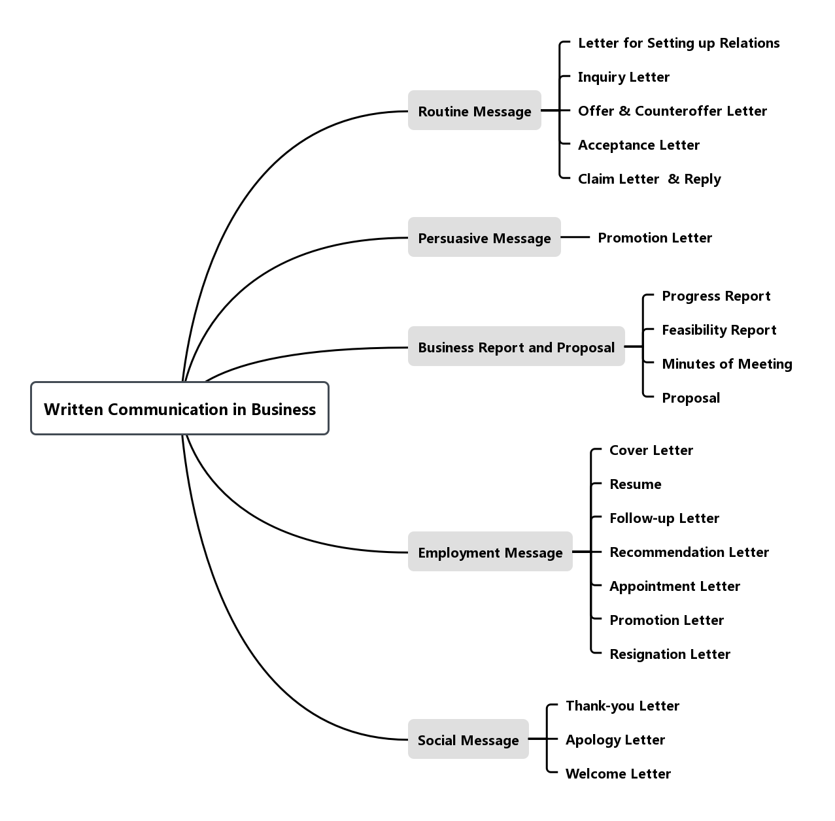

Figure 1-3 Types of Written Communication
A business report is a form of writing that provides information for a specific audience. It is based on researched facts or on accurate details of a situation or event, not just on the writer’s own knowledge. The purpose of a business report is to convey essential information that is accurate, clear and concise. Business writing should be brief and to the point. The business-style report is prepared to help in decision-making, outline changes needed, give solutions to problems, etc. It defines a problem or issue, presents data to analyze the problem or issue, draws conclusions, and makes recommendations. Business-style reports are organized with the summary at the beginning. The reports are presented to busy people. Many executives read only the executive summary or abstract of the report.
Written communication of different types take different formats. Figure 1-4～Figure 1-8 show the typical formats of business letters, e-mails, minutes, memos and business reports respectively.

Company, Inc.
Building 6, No. 8 Renmin Road, Shanghai, P. R. China 200000
400-500-6000 www.example.com

May 1, 2020

John Smith
Director of Operations
AAA Corporation
10 Marine Ave.
Berkeley, CA 94700

Dear Mr. Smith:

I’m writing today to invite you to speak at the annual Metropolitan Business Conference, which will be held at North Branch Hotel, September 15 - 18, 2020.

The theme of our upcoming conference is finding and hiring employees who fit company culture. With the growth that your company has seen in the past five years, I believe you would have much to offer our audience.

As part of the speaker’s package, we offer a modest honorarium and a table for six at the Saturday night dinner.

If you have any questions or wish to know more about the speaking opportunity, please let me know. I look forward to hearing from you. Thank you for your consideration.

Yours Sincerely,

(Signature)

Sam Zhu
President of Company, Inc.
862511111111
s.zhu@companyinc.com

Heading

Date
Inside
name & address

Salutation

Body

Complimentary Close
Signature
in ink

Signature
block

Figure 1-4 Format of Business Letter

To: smithby@gmail.com

Cc: jasonmk@126.com

Subject: Invitation to Metropolitan Business Conference

Dear Mr. Smith:

I’m writing today to invite you to speak at the annual Metropolitan Business Conference, which will be held at North Branch Hotel, September 15 - 18, 2020.

The theme of our upcoming conference is finding and hiring employees who fit company culture. With the growth that your company has seen in the past five years, I believe you would have much to offer our audience.

As part of the speaker’s package, we offer a modest honorarium and a table for six at the Saturday night dinner.

If you have any questions or wish to know more about the speaking opportunity, please let me know. I look forward to hearing from you. Thank you for your consideration.

Yours Sincerely,

Sam Brown
Vice President of Company, Inc.
862511111111 ​
s.brown@companyinc.com

Figure 1-5 Format of E-mails

Figure 1-6 Format of Meeting Minutes
Meeting Minutes For XY Company

Ⅰ. Meeting Details
Chairperson:
Secretary:
Date:
Time:
Location:
Ⅱ. Roll Call
Present:
Absent:
Ⅲ. Call to Order
Previous Meeting Minutes –
All attendees unanimously approved previous meeting minutes.
Approval of Current Agenda –
Attendees were given copies of the current agenda and unanimously approved.
Ⅳ. Old Business

Ⅴ. New Business

Ⅵ. Other Items

Ⅶ. Adjournment

Minutes submitted by: ______________________ Print Name:
Approved by: ______________________ Print Name:

Memorandum
To: All Employees
From: CEO/Business Owner
Subject: New Recycling at Work Initiative
Date: Month Day, Year

I am pleased to announce [company or organization’s name] is a new Pledge Partner of Recycling at Work, a national voluntary initiative by Keep World Beautiful (KWB) to increase recycling in the workplace.

As a Pledge Partner we are committed to:

    - Increasing our employees’ awareness of the availability of recyclable services and benefits of recycling in our workplace;

    - Enhancing our infrastructure and communications to enable greater recycling in our workplace;

    - Identifying cost-effective opportunities to incorporate consideration of end-of-life recyclability and increased recycled content into the products purchased;

    - Tracking our progress and recycling achievements;

    - Encouraging other organizations to take the Recycle at Work pledge.

Over the coming weeks and months, our volunteer Recycling Team will lead us in making some changes to improve and enhance our current recycling program.

[Insert photo and/or list members of the team]

Figure 1-7 Format of Memos

Business Report Template

1.1 Introduction
    - Name of your company & outline your business idea

1.2 Summary
A summary of your business including:
    - Was your choice of product/service a good one?
    - Where did you get your idea from?
    - What skills did you already have and what skills did you have to learn?
    - Who were your customers?
    - How did you promote your product/service?
    - What risk, if any, did you take?
    - What difficulties did you have to overcome?
    - Did you make a profit or a loss?

1.3 Business Structure
In this section you should:
    - Identify all the members of your team,
    - Explain who did what roles in your company,
    - Include an organization chart.

1.4 Review/Conclusion
    - How did you get on as a team?
    - Did you have to overcome any difficulties while working as a team?
    - How did you solve any conflicts that arose?
    - Did you develop new skills? Give examples.
    - Will your business continue trading?
    - What was the best advice you were given during this process?

Figure 1-8 Format of Business Report

2. Oral Communication
Oral communication is the exchange of information and ideas through spoken words. It includes face to face interaction, calls, video calls, interviews, presentations, recorded messages, teleconferences, and etc. It can be directly in person, in a face-to-face interaction or through an electronic device such as a phone or radio.
The ability to communicate effectively through speaking is highly valued in business. Oral communication helps to build trust and reliability. The process of oral communication is more effective than an e-mail or a text message. For important and sensitive conversations—such as salary negotiations and even conflict resolutions, you can rely on oral communication to get your point across, avoid misunderstandings and minimize confusion. Here are some benefits of oral communication:
- It saves time by letting you convey your message directly to the other person.
- It’s the most secure form of communication for critical issues and important information.
- It helps to resolve conflicts with face-to-face communication.
- It’s a more transparent form of communication.
Good oral communicators produce valuable results because they know how to convey important information to others, influence others, and inspire people to take action. To achieve effective oral communication, a communicator should keep in mind the following tips:
- Consider the objective.
- Think about the interest level of the receiver.
- Be sincere.
- Use simple language and familiar words.
- Be brief and precise.
- Avoid vagueness and generalities.
- Give full facts.
- Assume nothing.
- Use polite words and tone.
- Eliminate insulting implications.
- Include some information that is interesting and pleasing to the recipient.
- Allow time to respond.
7 ways to practice your communication skills
1. Read books on presentation skills. You can refer to the following sources: 10 Days to More Confident Public Speaking by the Princeton Language Institute, The Art of Public Speaking by Stephen E. Lucas, The Quick and Easy Way to Effective Public Speaking by Dale Carnegie, and Influence: The Psychology of Persuasion by Robert B. Cialdini.
2. Take an online learning course on oral communication. For example, the “Making a Presentation” module in the Harvard Manage Mentor series, developed by Harvard Business School Publishing.
3. Consult an expert. Find someone who you view as a talented oral communicator. Ask this person how he or she has strengthened this skill.
4. Attend a workshop or course in business communication, public speaking, or presentation skills. Some continuing education programs may offer such workshops and courses.

5. Join a public-speaking group. Examples include Toastmasters, a large organization that has clubs in many cities and companies. Through attending regular Toastmasters meetings, you learn how to prepare and deliver presentations to audiences.
6. Analyze effective speeches. Attend or watch videos of speeches delivered by skilled presenters. Notice how they use body language, voice tone, eye contact, and other tools to present a compelling speech. Also notice how they structure the content of their speech and how they use visual aids to enhance that content.
7. Videotape yourself giving a speech or presenting an idea. This practice can help you identify and eradicate flaws in your delivery, such as nervous fidgeting, inadequate voice volume, lack of eye contact, or a confused line of argument.

1.3.2 Non-verbal Communication

1. Understanding non-verbal communication
As we know from the previous learning, any communication made between two or more persons through the use of facial expressions, hand movements, body language, postures, and gestures is called non-verbal communication. Unlike the verbal communication, it helps in establishing and maintaining the interpersonal relationships. Also, it regulates the flow of communication. For example, a person can give signals to convey that he has finished speaking.
Non-verbal act is often unconscious. It transmits unstated attitudes and hidden intentions. Non-verbal signs offer clues to the receiver, and help the receiver understand and correctly perceive the total meaning of the message.
There are different types of non-verbal communication, including kinesis, paralanguage, chronemics, artefacts, proxemics and haptics.
Kinesis refers to interactions through facial expressions, body language, eye contact, gestures, postures, dressing style, and etc.
Paralanguage is the way we speak, i.e. tone, volume, pitch, and etc. Speech breakers such as “er”, “ah”, and “uh” are also included.
Artefacts include the appearance, personality, dressing sense and presentability of a person.
Chronemics is the timing, punctuality, pause etc. while speaking.
Proxemics is the distance which a person maintains while communicating with others.
Lastly, haptics or the touch informs about the feelings of a person.
Here are some non-verbal clues:
Nervousness:
putting hands in one’s pockets, scratching, clearing the throat too often, sitting on the edge of the chair, straightening one’s tie, fixing one’s hair, speaking too fast or too haltingly, adjusting one’s glasses, blinking excessively
Rudeness:
shaking hands too firmly, standing too close, whispering at a social gathering, sending text messages in meetings, yawning, glancing at the clock frequently during a conversation, gathering papers before the meeting is over
Sense of superiority:
not responding to the other’s greeting, standing too close, sitting on someone’s desk, continuing to work when others address you, reclining in the chair with hands folded behind the head
Note: the understanding of non-verbal clues differs from person to person and the same gestures may be interpreted differently under different situations.

2. Skills of non-verbal communication
Non-verbal communication plays an important role in how we convey information to others, as well as how we interpret the actions of those around us. What a person actually says along with his or her expressions, appearance, and tone of voice might tell you a great deal about what the person is really trying to say. Here are some guidelines you can follow in non-verbal communication:
- Establish and maintain eye contact. In North America appropriate eye contact signals interest, attentiveness, and credibility.
- Use posture to show interest. Encourage interaction by leaning forward, sitting or standing erect, and looking alert.
- Reduce or eliminate physical barriers. Move out from behind a desk; arrange meeting chairs in a circle.
- Improve your decoding skills. Watch facial expressions and body language to understand the complete verbal and non-verbal messages being communicated.
- Ask for more information. When you perceive non-verbal cues that contradict verbal meanings, politely seek additional cues (“I’m not sure I understand…”, “Please tell me more about…”, or “Do you mean that …”).
- Associate with people from diverse cultures. Learn about other cultures to widen your knowledge and tolerance of intercultural non-verbal messages.
- Appreciate the power of appearance. The appearance of your business documents, your business space, and yourself sends positive or negative messages to receivers.
- Observe yourself on video. Ensure that your verbal and non-verbal messages are in sync by recording and evaluating yourself making a presentation.
- Enlist friends and families. Ask friends and families to monitor your body movements and gestures to help you become an effective communicator.
Non-verbal communication skills can make it easier to convey your point and to read what others are trying to tell you. Some people seem to master these skills quite naturally, but anyone can improve his or her non-verbal skills with practice.

1.4 Visual Communication

Visual communication is the practice of using visual elements to convey a message, inspire change, or evoke emotion. Of the total sense receptors in the human body, 70% reside in our eyes. Visual communication is primarily presented or expressed with images, including: signs, drawings, graphics, illustrations, video, abstracts, color, photographs, maps, symbols and electronic resources. Effective visual communication should be appealing and informative. Visual com- munication is about picking the right elements (usually text, icons, shapes, imagery and data visualizations) to create meaning for your audience. Some common visual communication strategies include:
- Using data visualization
- Using shapes and lines to outline relationships, processes, and flows
- Using symbols and icons to make information more memorable
- Using visuals and data to tell stories
- Using color to indicate importance and draw attention
Some common types of visual communications in the workplace include:
- Infographics
- Process Diagrams
- Flow Charts
- Roadmaps
- Charts and Graphs
- Visual Reports
- Mind Maps
Table 1-1 shows forms of visual aids, their advantages and disadvantages.

Table 1-1 Forms of Visual Aid
Type | Form | Main advantages | Main disadvantages
Visual representations of numerical data | Tables, charts and graphs | • Can summarize a lot of data very effectively  • Can show trends | • Audience must have sufficient technical know-  ledge to interpret them
Schematic presentations | Diagrams, signs, flow  charts, organization charts,  algorithms | • Can convey information more efficiently than text | • May rely on implicit knowledge which audience may not share
Pictorial presentations | Drawings, photographs, artistic illustrations, maps | • Realistic representations | • Can be expensive to produce
Adapted from: Hartley, Peter and Clive G. Bruckmann. Business communication. New York: Routledge, 2002: 198.

- Infographics
An infographic, as shown in Figure 1-9, is a collection of imagery, charts, and minimal text that gives an easy-to-understand overview of a topic. According to Jaime Serra, an infographic is “a form of communication that uses visual language and text. Both languages are complementary, part of a whole, and therefore can’t be understood when separate”. Infographics can improve cognition by using graphics to enhance viewers’ ability to see patterns and trends and create a unique, informative experience for them. They have evolved rapidly in recent years to be widely used in mass communication.
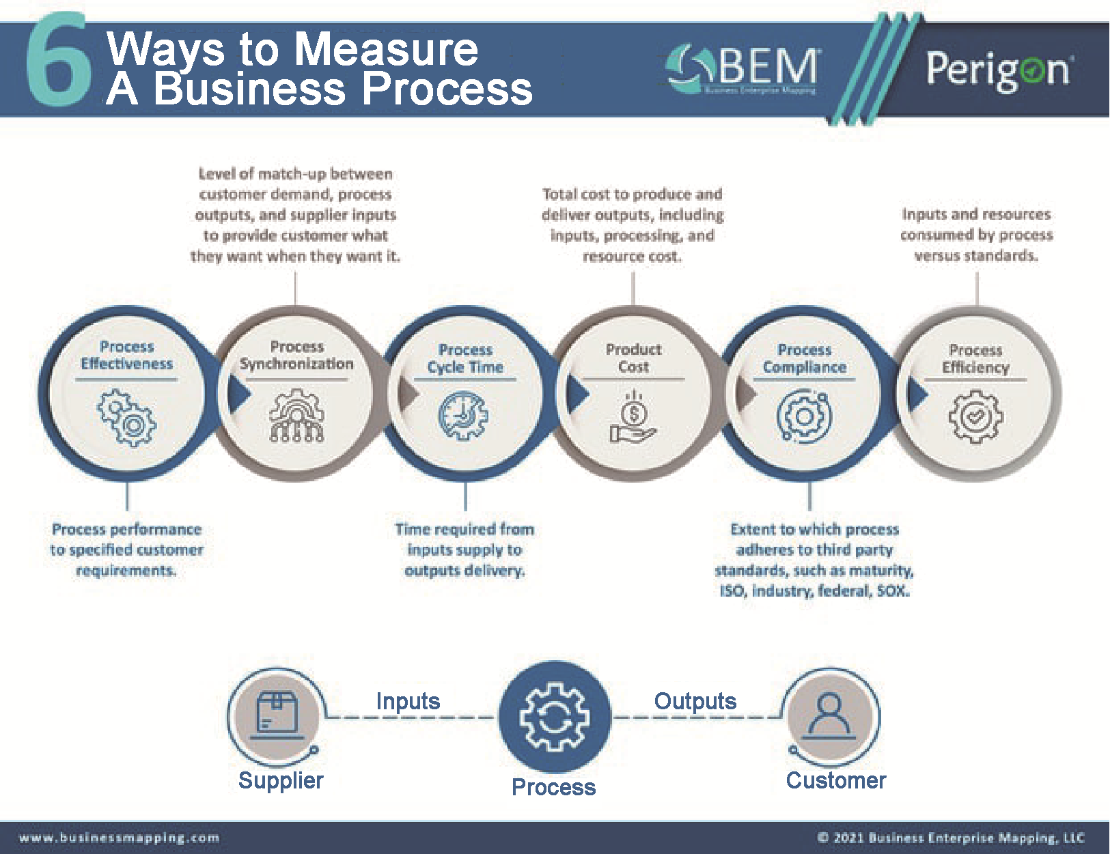

Figure 1-9 Infographics
(From: https://www.businessmapping.com/wp-content/uploads/2021/10/6-Ways-to-Measure-a-
Business-Process-3.0.jpeg)

- Process Diagram
Process diagrams (or process flows), as shown in Figure 1-10, provide a visual overview or workflow diagram of all the tasks and relationships involved in a process.
- Flow Chart
A flowchart, as shown in Figure 1-11, is a type of diagram that represents a workflow or process. Flowcharts are used in analyzing, designing, documenting or managing a process in various fields.
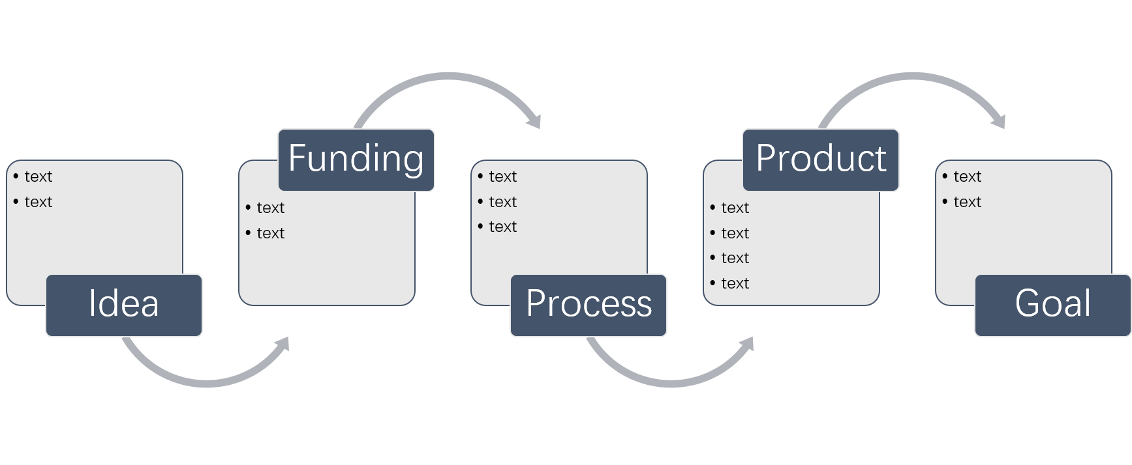

Figure 1-10 Process Diagram
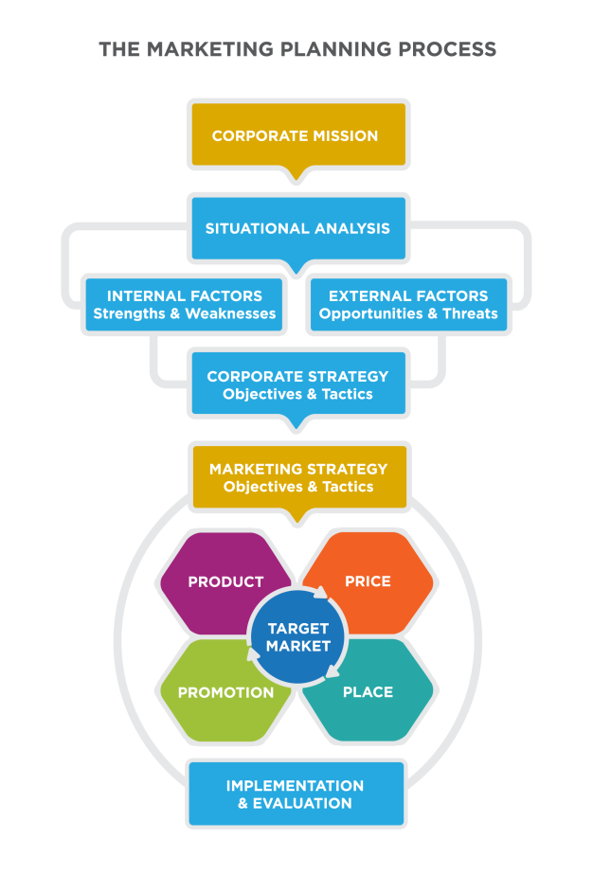

Figure 1-11 Flowchart
(From: https://courses.lumenlearning.com/marketing-spring2016/chapter/
reading-components-of-the-marketing-strategy/)

- Road map
A business road map, as shown in Figure 1-12, provides a clear overview of your strategic steps and helps you picture a long-term plan for your goals. A visual road map is extremely useful in high-level meetings with clients and executives. Road map designers must have professional knowledge of the business areas, must be able to accurately summarize large quantities of information, must have graphic design abilities and must have excellent communication skills.
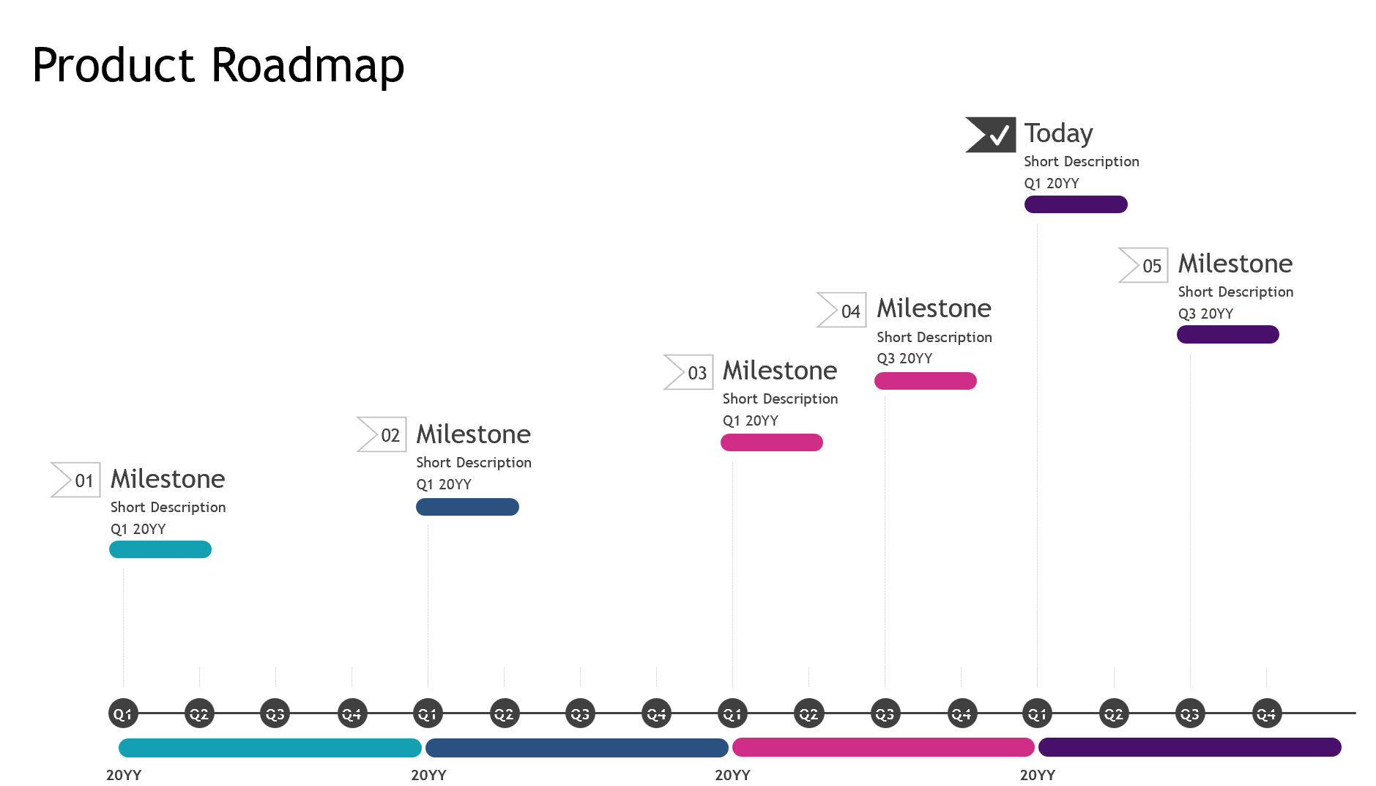

Figure 1-12 Road Map
(From: https://templates.office.com/en-US/Roadmap-timeline-light-TM16411196)

- Chart
A chart, as shown in Figure 1-13, is a graphical representation of data (often numerical) or a sketch representing an ordered process. Some charts we use daily are pie charts, line graphs, bar charts, flow charts and organizational charts. Among them, pie charts compare the parts to the whole and visually display percentages and proportions.
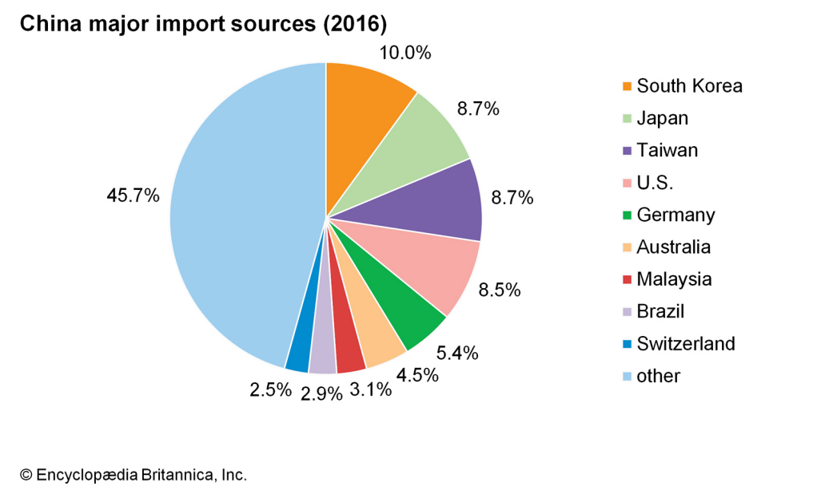

Figure 1-13 Pie Chart
(From: https://www.britannica.com/place/China/Trade)

- Visual Report
Report visualisation, along with the advancement of multimedia technology, has become a very powerful mean of sharing business performance, which can be easily digested by the reader. It is the process of presenting report formats that represent data and information in a graphical format that helps the receiver to understand the content more easily. Visual data reporting has gained solid footing in B2B business processes. Figure 1-14 shows an example of the visual report.
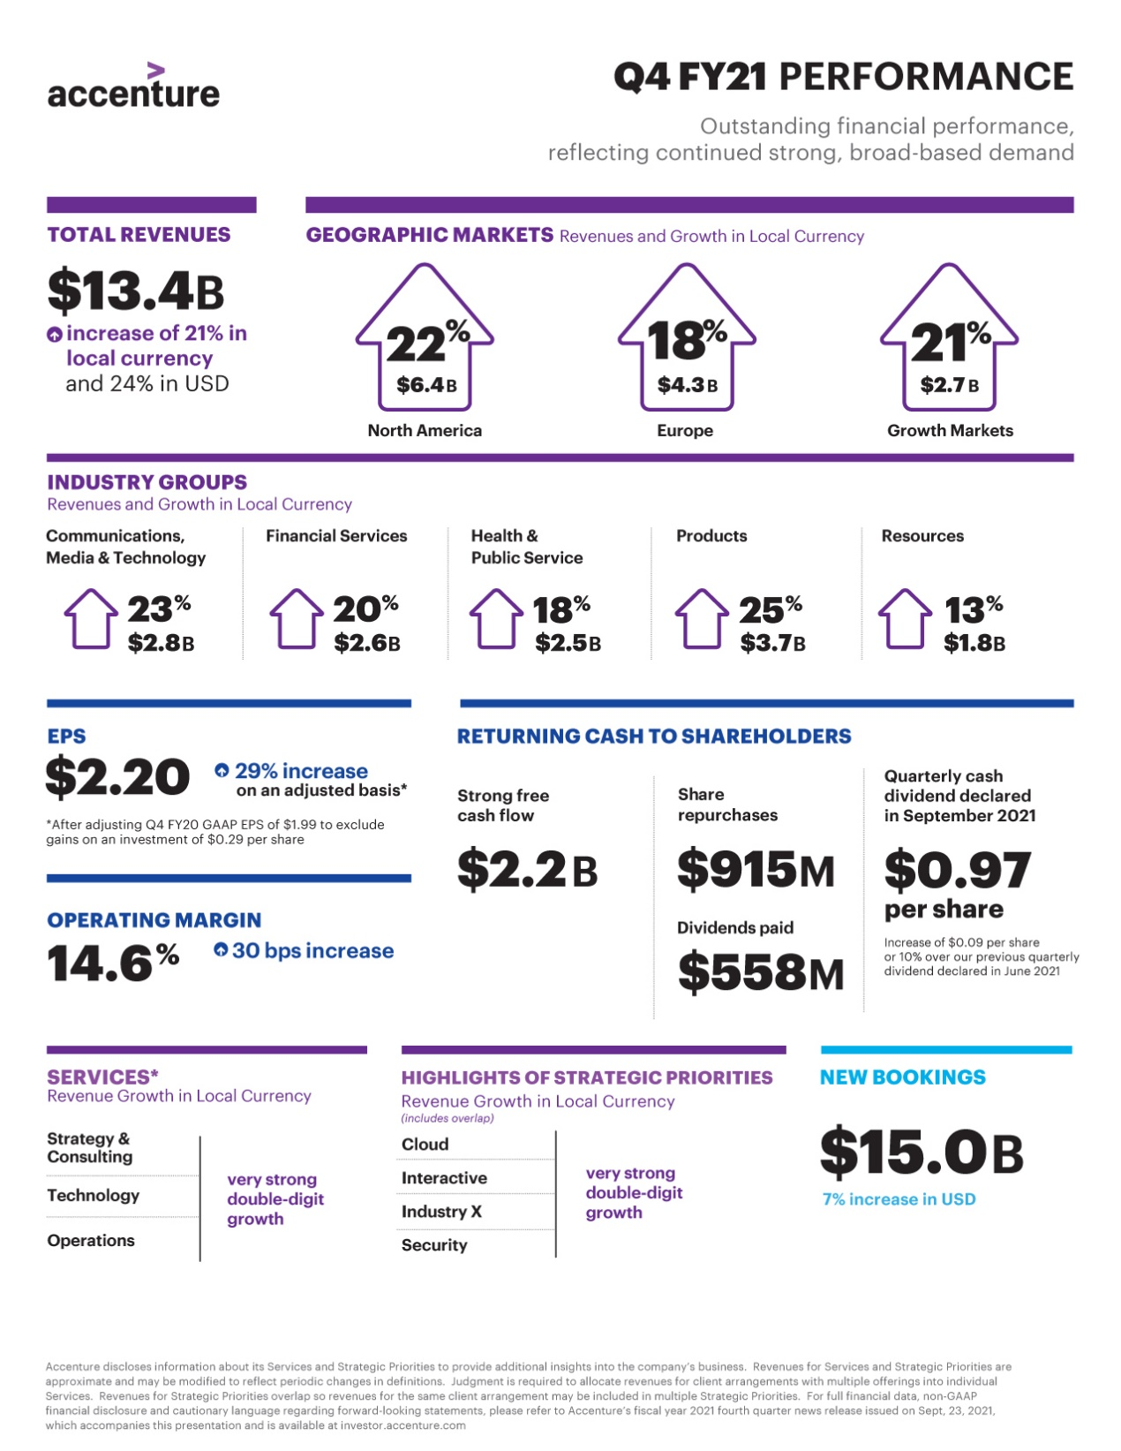

Figure 1-14 Visual Report
(From: https://www.businesswire.com/news/home/20210923005360/en/Accenture-Reports-
Very-Strong-Fourth-Quarter-and-Full-Year-Fiscal-2021-Results)

- Mind Map
A mind map, as shown in Figure 1-15, is a diagram used to visually organize information. A survey by mind mapping expert Chuck Frey, shows that business users of mind mapping find their productivity has increased on average by 25%.
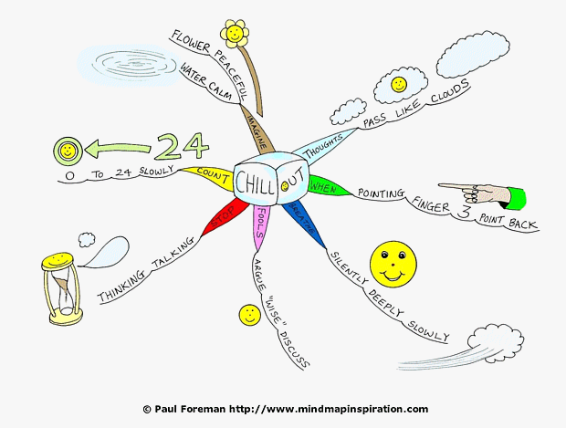

Figure 1-15 Mind Map
(From: http://www.mindmapinspiration.com/chill-out-mind-map-and-toddler-tantrums/)

It is often created around a central theme, drawn as an image or a word in the center of a blank page, to which images and words are added. From the central theme, associations radiate out. A mind map can have many first level associations, but the mind can only grasp about a maximum of 7. Usually only single keywords, instead of sentences, are used. Mind maps can also be drawn by hand. And they are considered to be a type of spider diagram.
Human eyes process visual messages much faster than process texts. Visual communication is now predominant in the advertisement of companies. It is also a key element in marketing, say, content creation. Presentations and reports can also become much richer and easier to understand when composed of visual elements. We will go back to the discussion about visual com- munication with more details in the following several parts of the book.

Exercises

I. Open questions
1. How do you understand and define communication?
2. Why is communication so important in business?
3. Why does communication is a two-way process?
4. What are the essential components of communication?
5. What are the 7Cs of business communication?
6. Can you name at least 10 types of verbal business communication?
7. What are the advantages and disadvantages of oral communication?
8. What is non-verbal communication? What are the clues to it?
9. What are the benefits of visual communication?

II. Please match the terms with the definitions
intrapersonal communication | A. communicating with words, oral or written
interpersonal communication | B. communication with the use of pictures, signs, gestures, and facial expressions for exchanging information
non-verbal communication | C. messages sent to large groups of people, for example by newspaper, radio, or television
mass communication | D. the exchange of messages between two people
verbal communication | E. talking to oneself in one’s own mind

III. True or false
1. Verbal communication is better than non-verbal communication.
2. Business communication is marked by its informality.
3. Business communication follows strictly a set of rules, which cannot be easily changed by new techniques.
4. One’s appearance is a part of non-verbal communication.
5. Written business communication allows grammatical errors only if the message is fully understood by the receiver.
6. Business message must be as detailed as possible to avoid misunderstanding.
7. We should avoid bias in business communication, for example, gender bias or age bias.
8. In internal communication, there is no need to show courtesy or politeness to your co- workers.
9. Meeting minutes are records kept by an organization. They cannot be used as evidence in lawsuits.
10. A memo can be open to the public.
11. Business report is based on the writer’s own experience and knowledge.
12. Oral communication is less effective than a written message.
13. Non-verbal communication can help establish interpersonal relationships.
14. In non-verbal communication, it is impolite to have eye contact with the listeners.
15. Your appearance and business space can send messages to receivers.
16. The purpose of visual communication is mainly to appeal to receivers with bright colors and attractive images.

IV. Case study
1. Most of us have ever experienced such a situation: you talked to someone and thought you were perfectly clear, but he or she didn’t get it. How could you explain the ineffective com- munication like this?
2. In small groups, examine each case by thinking about the following questions and present your findings in a brief, informal presentation to the class.
- Who is communicating to whom about what, how, and why?
- What is the goal of the communication in each case?
- Are the failures due to poor task or incomplete audience analysis?
- Do the writers use inappropriate language or style?
- Is there poor organization or formatting of information?
- What costs/losses are incurred?
- What are the possible solutions that would have prevented the problem?
- What benefits would be achieved from preventing the problem?

CASE 1: The unaccepted current regulator proposal
The Acme Electric Company worked day and night to develop a new current regulator designed to cut the electric power consumption in aluminum plants by 35%. They knew that, although the competition was fierce, their regulator could be produced more cheaply, was more reliable, and worked more efficiently than the competitors’ products.
The owner, eager to capture the market, personally but somewhat hastily put together a 120-page proposal to the three major aluminum manufacturers, recommending that their regulators be installed at all company plants.
She devoted the first 87 pages of the proposal to the mathematical theory and engineering design behind his new regulator, and the next 32 to descriptions of the new assembly line she planned to set up to produce regulators quickly. Buried in an appendix were the test results that compared her regulator’s performance with present models, and a poorly drawn graph showed how much the dollar savings would be.
Acme Electric didn’t get the contracts, despite having the best product. Six months later, the company filed for bankruptcy.

CASE 2: One garbled memo — 26 baffled phone calls
Joanne supervised 36 professionals in 6 city libraries. To cut the costs of unnecessary overtime, she issued this one-sentence memo to her staff:

When workloads increase to a level requiring hours in excess of an employee’s regular duty assignment, and when such work is estimated to require a full shift of eight (8) hours or more on two (2) or more consecutive days, even though unscheduled days intervene, an employee’s tour of duty shall be altered so as to include the hours when such work must be done, unless an adverse impact would result from such employee’s absence from his previously scheduled assignment.

After the 36 copies were sent out, Joanne’s office received 26 phone calls asking what the memo meant. What the 10 people who didn’t call about the memo thought is uncertain. It took a week to clarify the new policy.

(Adapted from T. M. Georges’ Analytical Writing for Science and Technology.)

V. Extensive reading
Please read the following passage and use the following questions as a guide.
1. Does English fluency really matter so much in international communication?
2. How did Lenovo CEO, Yang Yuanqing(杨元庆), as a non-native English speaker, communicate effectively with audience from English-speaking countries and make himself attractive? How did he take advantage of his background as a non-native speaker?
3. Please spot the non-verbal elements Yang Yuanqing adopt in his oral communication.
4. Increasing number of Chinese executives “risk embarrassment trying to communicate in a universal business language.” Why? What can you learn from them?

Chinese executives learning to talk the business talk — in English
Chang Jun, 14 June 2016

Chinese products and brands ruling the world are not news anymore. However, the hurdles that the enterprises and their executives face in the English-speaking global marketplace still exist. English proficiency is not an easy task.
Tech giant Lenovo’s Tech World 2016 last week impressed me not only for its launch of two cloud devices but for the effort that CEO and Chairman Yang Yuanqing has made over the years to attract international consumers, including his adoption of English as his international work language.
Dressed in a typical tech workforce outfit — shirt, khaki pants and sneakers — Yang looked like a Silicon Valley engineer until he took center stage and started talking.
“They (assistants/organizing committee) told me in San Francisco to use the word ‘pitch’, not to ‘give a speech’,” Yang said, adding that he also was advised on what to wear.
The audience of Lenovo fans, industry leaders and analysts at the packed Masonic Auditorium burst into laughter and gave the boss a rousing welcome.
Yang reportedly hardly spoke a word of English until he turned 40, when Lenovo bought IBM’s personal computer division in 2005.
Hopeful of honing his English, Yang moved his family to North Carolina (the location of Lenovo’s US headquarters), hired a native tutor and spent hours watching TV news.
His efforts apparently yielded fruit. Whether presiding over board meetings with global stakeholders or answering questions raised by Western media, he is able to conduct all of his business in English.
Not many Chinese executives speak English. They usually can be seen using interpreters or showing Power Point slides with English subtitles while speaking in Mandarin.
The situation is changing, though. A growing number of multinationals with headquarters in China are expanding internationally and have made English their official language.
In April 2015, when Lei Jun, chairman and CEO of smartphone producer Xiaomi, spoke at a news conference in New Delhi to announce the launch of a new product, he stumbled through his speech. It was his first time using English overseas.
“Hello, how are you,” the billionaire greeted the Indian audience. “I’m very happy to be in China,” he said before correcting himself - “to be in India”.
Seeking to generate enthusiasm by shouting, Lei announced a free Xiaomi smart wristband for each attendee and asked the public, “Are you OK?”
Amused by his heavy accent and clumsy vocabulary, Chinese social media users tuned his “Are you OK?” phrase into an overnight meme. Many posts made fun of Lei’s speech; others, however, supported the attempt and his courage for trying English.
Both Yang and Lei and any Chinese executives trying to communicate in English deserve respect for their gutsy efforts.
First, it shows commitment and dedication to customers. Their presentations are not perfect, and they have more work to do on their speechmaking.
However, I don’t think audiences would have difficulty understanding what the Chinese executives meant.
Speaking English is more than a friendly gesture; it indicates how much the Chinese enterprises care about the international market in that executives would risk embarrassment trying to communicate in a universal business language.
Second, adopting English is an important strategy for Chinese companies going global. In 2015, Chinese investment in the US reached $22 billion, with diversified allocations across industries including finance, agriculture, tourism and consumer-oriented businesses.
Chinese enterprises will continue their acquisitions, according to a forecast by the American Enterprise Institute. Using English as working language will make it easier for pioneering companies to recruit overseas talent, including board members. It also will help them reach a broader world market and complete international mergers and acquisitions according to global standard and customs.
In short, speak to your customers in their own languages; it’s rewarding even when you make mistakes on the road to globalization.
Lei Jun, in response to his speech in India going viral, wrote on his social media account: “There are more and more international Xiaomi fans. Indeed, I should learn English well and not let you down.”
(From: https://www.chinadaily.com.cn/world/2016-06/14/content_25763546.htm)

Chapter 2 Intercultural Business Communication
After studying this chapter, you will be able to
- understand cultural differences and non-verbal differences;
- know fundamentals of intercultural communication;
- develop intercultural communication skills in the workplace.


2.1 Introduction to Intercultural
Communication

2.1.1 Understanding Cultural Differences
Before talking about culture differences, the first thing we need to do is to know what is a culture. British writer Raymond Williams wrote that culture “is one of the two or three most complicated words in the English language.” In 1951, Kluckhohn explained culture as sharing a pattern of thinking, feeling, reacting, and problem-solving. Edgar Schein (2010) described a culture as “shared beliefs, values, and assumptions of a group of people who learn from one another and teach to others that their behaviors, attitudes, and perspectives are the correct ways to think, act, and feel.” It is also a way of life of a group of people passed along by communication and imitation from one generation to the next. Fons Trompenaars reveals the meaning of culture in a vivid way: “A fish only discovers its need for water when it is no longer in it. Our own culture is like water to a fish. It sustains us. We live and breathe through it. What one culture may regard as essential, a certain level of material wealth, for example, may not be so vital to other cultures.”
American psychologists Edward T. Hall and Mildred R. Hall established intercultural communication as a research discipline. The Halls analyzed the cultural differences between US and European companies and employees in a book entitled The Silent Language in 1959. They examined the different communication styles and behavior when people do business with those from different cultures. The Halls identified two styles of communication in international business, called high-context and low-context communication.
High-context refers to societies or groups where people have close connections over a long period of time. Many aspects of culture are not made clear because most members know what to do. High-context cultures will use communication that focuses on underlying context, meaning, and tone in the message, and not just the words themselves. Countries that fall into this categorization are Japan, China, France, Spain, Brazil, and more.
Low-context refers to societies where people have many connections but of shorter duration. In these societies, cultural behavior and beliefs need to be made clear so that a cultural outsider knows how to communicate. If a message isn’t clear enough, it will slow down the process of communication. Some cultures that fall into low-context communication are Western cultures like the UK, Australia and the United States.
Figure 2-1 graphs the general categories within which different countries lie.
LOW-CONTEXT
HIGH-CONTEXT
U.S. Germany Spain France China Japan
U.K. Mexico ArabsIndians

What one says is what one means.
One should read between the lines.

Figure 2-1 Low-context Culture vs High-context Culture
It is important for a multinational to know the differences between high and low context cultures in order to communicate effectively and avoid making embarrassing mistakes. Will a company in Japan accept the practice of getting right to the point? Will a German company get bored if you talk around a subject, instead of directly addressing it? You need to first know your audience’s cultural standing and differences, and then get your message decoded effectively.
The best-known framework for cultural differences is Geert Hofstede’s Cultural Dimensions. Dr. Hofstede, a Dutch social psychologist, devised six dimensions of cultural differences.

1. Power Distance Index (PDI)
PDI measures the degree of inequality that exists in a society. A higher PDI indicates that hierarchy is clearly established in society. A lower PDI signifies that people question authority.
PDI shows very high scores for Latin American and Asian countries, African areas and the Arab world. On the other hand, Germanic countries, including Anglophone countries, have a lower power distance. China ranks 80 on PDI which is very high. Hence China is a country with big power distance as compared to the West where the power distance is small.

2. Uncertainty Avoidance Index (UAI)
UAI measures the extent to which a society feels threatened by uncertain situations. Societies that score a high degree in this index prefer stiff codes of behavior, guidelines, and laws. A lower degree in this index shows more acceptance of differing ideas.
Germany scores a high UAI (65) and Belgium even more (94) compared to Sweden (29) or Denmark (23). However, few countries have very low UAI. China ranks 40, meaning Chinese people accept ambiguous situations.

3. Individualism (IDV) VS Collectivism
IDV measures the extent to which a society is individualistic. Individualism refers to a loosely knit social framework in which people take care of themselves and their immediate families only. The other end of the spectrum would be collectivism in which there is a tight social framework. The in-groups support each other when a conflict arises with another in-group.
Individualism (IDV) is high in the US (91), Australia (90), and Great Britain (89). Serbia (25), Malaysia (26), and Portugal (27) are considered to be collectivist. China ranks 91 on IDV, meaning that Chinese are highly collectivistic and think as a group.

4. Masculinity (MAS) VS Femininity
In this dimension, masculinity is defined as “a preference in society for achievement, heroism, assertiveness and material rewards for success”. The other end of the spectrum would be femininity (relationship), representing “a preference for cooperation, modesty, caring for the weak and quality of life”.
Masculinity is extremely low in Nordic countries: Norway scores 8 and Sweden only 5. In contrast, masculinity is very high in Japan (95). In the Anglo world, masculinity scores are relatively high with 66 for the United Kingdom. China ranks 66 for this dimension, meaning Chinese are very driven by competitions and achievements. They often put work before families or leisurely activities.

5. Long-Term Orientation (LTO) VS Short-Term Orientation
“Long-Term Orientation stands for the fostering of virtues oriented towards future rewards, in particular perseverance and thrift. It’s opposite pole, Short Term Orientation stands for the fostering of virtues related to the past and present, in particular, respect for tradition, preservation of ‘face’ and fulfilling social obligations.” (Hofstede) A lower degree of this index (short-term) indicates that traditions are honored. Countries that score high on this dimension take a more pragmatic approach.
High long-term orientation scores are found in East Asia, with South Korea having the score of 100 and Japan 88. They are moderate in Eastern and Western Europe, and low in the Anglo countries, Africa and in Latin America. Chinese rank extremely high on long term orientation at 118, meaning they focus on long term orientation that allows to overcome obstacles over a period of time.

6. Indulgence (IND) VS Restraint
The indulgence dimension is a relatively new dimension. This dimension refers to the degree of freedom that societal norms give to citizens in fulfilling their desires. It is defined as the extent to which people try to control their desires and impulses. Relatively weak control is called Indulgence and relatively strong control is called Restraint.
Indulgence scores are the highest in Latin America, parts of Africa, the Anglo world and Nordic Europe; restraint is mostly found in East Asia and Eastern Europe. China, with a very low score of 24, displays that they are used to refusing the temptations of immediate satisfaction, while believing firmly that hard work, perseverance, and good planning will bring about a future with the fruits of their labor.
Figure 2-2 summarizes the Hofstede’s Cultural Dimensions.

0 HOFSTEDE’S CULTURAL DIMENSIONS 100
Equal distribution of power | PDI | Hierarchical order
Collectivist | IDV | Individualist
Modesty, cooperation | MAS | Heroism, achievement
Comfortable with uncertainty | UAI | Uncomfortable with uncertainty
Traditional and short-term | LTO | Futuristic and long-term
Suppress needs with strict norms | IND | Enjoy life and have fun

Figure 2-2 Hofstede’s Cultural Dimensions
Hofstede’s model gives a general understanding of other cultures, and insights about how to communicate with groups from other countries. Intercultural communication requires awareness of cultural differences because what may be considered acceptable and natural in one country, can be confusing or even offensive in another. Business communication is affected by cultural dimensions: verbals (words and language itself), non-verbals (body language, gestures) and etiquette do’s and don’ts (clothing, gift-giving, dining, customs and protocol).

2.1.2 Cultural Differences in Non-verbal Communication
Non-verbal signals vary from culture to culture. There are many types of non-verbal communications like eye contact, gestures, physical space, touch, and etc.

1. Eye Contact
Eye contact is an essential form of communication around the world. 65% of all communication is done through eye contact. However, using eye contact can mean very different things in different countries, cultures, and religions. Western cultures mostly consider eye contact to be a good gesture. It shows attentiveness, confidence and honesty. In many Asian, African and Latin American cultures, extended eye contact can be taken as a challenge of authority. It is often considered more polite to have only brief eye contact. For example, if a Japanese woman avoids looking someone in the eyes, she is not showing a lack of interest; instead, she is being polite and respectful.

2. Gestures
Gestures can be the most effective non-verbal tools to express meaning, and many people make use of them to supplement verbal communication, or simply to express themselves silently. For example, “thumbs up” is a very common hand gesture in European and American cultures as a sign of approval. The gesture is commonly used in social media and customer service ratings to indicate satisfaction. However, in many Islamic and Asian countries, it is considered an insult. In Australia, the gesture also means all is fine. But when the user moves a thumb up and down, it transfers the gesture to an insult. Nodding one’s head in Canada means “yes”, while nodding one’s head in Bulgaria means “no”.

3. Physical Space
Physical space between people, or proxemics (coined by Edward Hall), is another form of non-verbal communication. Hall defines four distance zones: intimate distance, personal distance, social distance (for business and social discourse) and public distance. Unconsciously, we all keep a comfortable distance around us when we interact with other people. This distance can be called “personal space,” “interpersonal distance,” “comfort zone,” and “body bubble.” People in different cultures have various levels of tolerance for physical space. In many cultures, people are uncomfortable with close proximity to others and prefer a more social distance (four to seven feet) when communicating. According to a study, Brits like to keep a metre from a stranger, 80cm from an acquaintance and just over 50cm from a close friend. For Americans, the usual distance in social conversation ranges from about an arm’s length to four feet. Less space in the American culture may be associated with either greater intimacy or aggressive behavior. However, in the Middle East, social distance is much closer than it is in the United States for Arabs prefer to stand close enough to touch and smell the other person.

4. Touches
Touches are taken as rudeness in most cultures. Shaking hands is considered to be acceptable in many cultures. Similarly, acceptability of kissing, hugs, and many other touches are different in different cultures. People in Asia are more conservative in these types of non-verbal com- munication. For example, in the US or the UK, a handshake may be considered appropriate for meeting someone new. Whereas in France, a kiss on both cheeks is common. If a child is touched on the head in North America, that would be seen as fine. However, the head is considered sacred in Asia and this would be disrespectful.
Figure 2-3 compares cultural differences in non-verbal communication.

Channel | Type of Culture
Channel | Western culture | Chinese culture
Eye contact | Expected in the West; sign of attentiveness | Embarrassed by stare; avoid direct eye contact to show respect
Gestures | Large motions; rich hand gestures | Limited motions; less gestures
Physical space | Closer distance in interaction | Farther distance in interaction
Touches | More likely to touch | Little physical contact

Figure 2-3 Cultural Differences in Non-verbal Communication
Much misunderstanding can occur in cross-cultural communication if communicators fail to give due attention to all cues. In order to minimize misunderstandings, the cross-cultural communicator should make efforts to listen with his ears, his eyes, and his heart.

2.1.3 Definition of Intercultural Communication
Intercultural communication is about the way people from different cultures communicate via spoken and written language, body language and the language of etiquette or protocol. It is related to some other disciplines like anthropology, linguistics, philosophy, psychology, and etc. In the mid-twentieth century, intercultural communication developed as a discipline in the U.S. to help train government and business personnel involved in the overseas activities. The early researchers in this field were mostly anthropologists and linguists. Among them, anthropologists mainly focused on the economic, government, kinship, and religious practices of a cultural group, while the linguists focused on the micro elements of language and language training.
Intercultural communication is a discipline that studies communication across different cultures and social groups. It describes communication processes and problems that appear within an organization made up of individuals from different religious, social, ethnic, and educational backgrounds. It seeks to understand how people from different countries act, communicate and perceive the world. By understanding the theories, people can understand certain norms when adapting to new cultures. The theories also prevent people from disrespecting the people from other cultures, and thus enhance cultural diversity. Many people in intercultural business communication find that culture determines how individuals encode messages, what medium they choose, and the way messages are interpreted.
Why is intercultural communication important? First of all, effective intercultural communication is an essential skill for anyone working across different countries in order to establish harmonious relationships. It is important to accurately transfer information across countries and cultures. Executives in multinational companies especially benefit from intercultural communication skills to engage with international clients and employees. Similarly, intercultural communication is also crucial for anyone working with people from other cultures to avoid misunderstandings. It’s fair to say that intercultural communication is the foundation for successful international business in today’s globalized world.


2.2 Intercultural Communication
Skills in Workplace

2.2.1 Barriers to Intercultural Business Communication
Intercultural communication plays a critical role in successfully carrying out business in a global economy. Besides the obvious difficulty in understanding different languages, there are other factors that challenge people who try to cooperate with others of a different culture. People from different cultures have different frames of reference, and they may display emotions and behaviors differently. Managers have to understand various cultural barriers of their team and find a solution to communicate well. Here are some major sources of cultural barriers.

1. Language Barriers
Language is considered as the most obvious barrier in cross-cultural communication. People who are less fluent in English tend to withdraw from communication, which means the team may not get fully the input from them. Besides, it can be confusing if people speak with accents or use too many slangs. Language barrier also might influence how people’s abilities and performance are recognized or evaluated. Non-English native speakers usually feel that their career progression opportunities are not the same as for English native speakers. Some multinational corporations hire specialists and organize special training programs to improve language fluency of the non-English native speakers. This is how language barriers can be minimized for effective intercultural communication.

2. Ethnocentrism
Ethnocentrism is the belief that one’s own culture is superior to others. When such individuals interact with a person of another culture, they refuse to agree with the opinion of that person. As a result, they perceive others’ behaviors as strange and improper. A form of ethnocentrism is called cultural nearsightedness, or taking one’s own culture for granted and neglecting other cultures. For example, people in the United States often use the word “Americans” to refer to U.S. citizens, but in fact, it can refer to all people in North and South America. The careless use of “Americans” is a form of ethnocentrism. In some rare cases, ethnocentrism is related to racism. Ethnocentrism also creates an “us versus them” mentality that can be very harmful. Respecting the differences of cultures can significantly reduce the feeling of ethnocentrism. The following step is raising awareness among people of different cultures. To avoid it, one needs to understand how the understanding of a message changes depending on the culturally determined viewpoint.

3. Cultural Stereotypes
A stereotype is a fixed general image that a lot of people believe represent a particular type of person. In his 1922 book Public Opinion, journalist Walter Lippmann introduced the word “stereotype” as a metaphor for a mental picture based on people’s cultural notions. For example, Chinese are hard-working, Americans innovative and Italians expressive. The main purpose of stereotypes is to help us when we are dealing with a culture we do not know and to give us a predictable pattern and thus know how to react to any given cross-cultural situation. For instance, when doing business in Italy we might expect Italians to be late for a meeting whereas a Germany would always be punctual.
While this is a normal human process, it causes problems in the workplace. Cultural stereotypes affect employee productivity. If a manager sees an employee as an Asian person who is good with numbers but not people, the latter may never be given the opportunity to develop his organizational skills and he may eventually leave the company due to lack of opportunities. Stereotypes also lead to dissatisfied customers and reduced revenues. They hinder open communication and teamwork and lead to a perception of “us and them”. Thus, the company’s creativity, problem solving and competitive abilities are all limited.
Cultural audits allow a business to examine cultural stereotypes. A cultural audit examines the company’s attitude toward its employees, clients and stakeholders; and the effect of team work; employee and management accountability, trust, inclusion and respect. It gathers feedbacks from employees about their perceptions and invites suggestions. Audit results show areas for change and provide cultural awareness training program.

4. Conflicting Values
Each culture holds its own values, meanings and norms different from another. Cultural clashes happen when other people’s behavior does not conform to our own values. Here are 4 common conflicting cultural values.
- Task-oriented vs relationship-oriented
In task-oriented cultures, such as Australia, Germany, the Netherlands, and the U.S., the primary means of achieving one’s goals is through skillfully managing tasks and time. The ability to work independently is highly valued.
Relationship-oriented cultures include most of Latin America, eastern and southern Europe, Africa and the Middle East, and nearly all of Asia. In this type of system, goals are accomplished via relationships. Social skills and loyalty to the team are of high importance. The path to success is through cooperating with one’s group. Making decisions on one’s own is not appreciated.
- Direct vs indirect communication
In cultures with direct communication style, such as U.S. Americans, Australians, Germans, and Canadians, truthfulness and efficiency in communication are highly valued, especially in a business setting. Saying “No” or “I don’t know” is considered both honest and respectful. In countries like Germany, it is a sign of professionalism to speak clearly and leave no room for misinterpretation.
In indirect cultures, on the other hand (Japanese, Chinese, Indians, Saudi Arabians, for example), directly communicating negative information is seen as impolite. In these situations, polite excuses are given. Problems are felt to be solved more productively if they are handled strategically or diplomatically. In countries like Korea, people prefer to communicate indirectly and solve problems through vague references.
- Structured vs flexible scheduling
In some cultures, people strictly follow a schedule, whereas in others, they treat it as a suggestion. Cultures that are urgent about time (U.S. Americans, for example) usually feel a need to complete one step of a process or one topic of a discussion before moving on. Cultures who are more relaxed about time (South Asia, most of Africa, eastern and southern Europe, and most of Latin America) find the relaxed style normal. For some, “five minutes” could mean half an hour, and “tomorrow” could mean the next few days. In Brazil, it’s hard to start a meeting exactly on time. In the UK, not starting a meeting on time might be considered disrespectful towards those who attend the meeting on time.
- Egalitarian vs hierarchical
Team members from more egalitarian countries, such as Sweden, may be accustomed to voicing their opinions and ideas freely, while those from more hierarchical cultures tend to speak up only after more senior colleagues have expressed their views. It is easy for an American to give his opinion even to his boss whereas opinions are seldom expressed in the presence of elders and seniors in Japan. About this conflict, Hofstede coined the concept of power distance and defined it as “the extent to which the less powerful members of organizations accept and expect that power is distributed unequally.”

2.2.2 Effective Intercultural Communication in Business

1. Cultural Competence
Working in a global society requires the ability to establish and maintain relationships with people who are different from yourself. Thus, in today’s workplace, being culturally competent is critical not only to your success, but to the success of your organization. Williams (2001) defined cultural competence as “the ability of individuals and systems to work or respond effectively across cultures in a way that acknowledges and respects the culture of the person or organization being served.” Deardorff (2006) defined competence as “the ability to communicate effectively and appropriately in intercultural situations based on one’s intercultural knowledge, skills, and attitudes.” Muzychenko (2008) defined it as the appropriateness and effectiveness of one’s behavior in an alien cultural environment. To a larger extent, cultural competence involves understanding of the combination of a lot of cultural variables: ability, age, beliefs, ethnicity, experience, gender, linguistic background, national origin, race, religion, socioeconomic status, and so on.
Cultural competence covers from linguistic aspects to social and cultural conventions. Linguistic differences can make it challenging for global companies to create suitable brand names for their target markets that don’t cause offense. For example, in 1928, when Coca-Cola entered the Chinese market, it had no official name in Chinese. So they translated it into Ke-kou-ke-la, which sounded like “bite the wax tadpole”(蝌蚪啃蜡) in Chinese. Coke then finally found a close phonetic equivalent, “ke-kou-ke-le,” which could be translated as “happiness in the mouth.”
Aside from language differences, each culture has different social conventions. American business partners prefer small talk to build a relationship first, whereas British people may try humor, and Germans tend to get straight to the point. Thais, on the other hand, may ask rather personal questions, for example, about your marital status or job. Similarly, Americans like to use first names when addressing others, while in Austria, titles should be used to avoid sounding disrespectful. Germans will want to shake hands, while people in Thailand place their palms together at chest and bow instead.
It is widely recognized that cultural differences act as invisible barriers in international business communication. Understanding them is one of the most significant skills for firms to have a competitive advantage in international business. Failing to understand cultural diversity may impact policies, strategy decisions, advertising, business management, international marketing, international negotiation, staffing, interpersonal relationships, and teambuilding.

2. Developing Cultural Competence
Effective intercultural communication strategies prepare people to live or work in other countries, help business departments understand each other better or prepare a company for a merger or acquisition. By developing cultural competence, productivity and efficiency in the workplace may increase and in turn one’s business skills are improved. The barriers to inter- cultural communication, such as anxiety, stereotyping, ethnocentrism, and value conflicts are caused by the lack of cultural knowledge and related skills. There are several ways by which we can increase our capacity of intercultural communication.
- Increasing cultural knowledge
Cultural knowledge is the awareness of existing cultural preferences, values, and behaviors. An individual, when attempting to understand them, can generate cross-cultural competence and decrease discomfort, and then increase respect for other cultures as a result. Becoming culturally aware means observing your own behaviors, challenging all assumptions, and understanding others’ boundaries. For example, it is a well-known cultural fact that the number “4” is considered negatively to Chinese people because it is pronounced the same as the Chinese word for death.
- Overcoming bias
Admitting that we all have biases and hold stereotypes is the first step in cultural competence. Our biases may come from our backgrounds, experiences, or personal demographics, and these biases exist unconsciously. Our interactions and perceptions of others may be influenced by our biases. However, if we are aware of our biases, we can work to diminish our own prejudices.
- Listening actively
Active listening is about listening with sincerity and sensitivity and creating a climate of equality, freedom, permissiveness, understanding, acceptance and warmth (Rogers & Farson 1987). Actively listening to an individual allows you to learn about that person’s culture and experiences. You should listen for total meaning by focusing on the content that is being given. Active listening helps one think about the feelings behind the content, which give evidence of the real intent of the conversation. In addition to listening for total meaning, you should also listen with focusing on how it is being said. Lastly, make sure you ask careful questions and check to make sure you have fully understood. Do not jump directly to giving people advice or offering solutions. When confronted with differences, try to find an underlying logic that may be shaping the attitudes and behavior of those involved.
For example, British speakers tend to use fewer absolute adjectives (for example, perfect, free, ideal, and ultimate) than their counterparts in the US. So an American may mistakenly infer that their British colleague is not enthusiastic about the project because they haven’t sounded as positive as expected. In addition, nodding in Japanese culture simply means that one is listening rather than agreeing with what is being said.
- Cultivating intercultural empathy
In Tim Cook’s 2017 MIT commencement address, he warned graduates, “People will try to convince you that you should keep empathy out of your career. Don’t accept this false premise.” Empathy is the ability to step into the shoes of another, so that we can understand others’ thoughts, feel others’ emotions, and enter others’ world without prejudice. Cultural empathy is not agreement with nor identification with a specific culture. Rather, it is the appropriate under- standing of another culture’s values and beliefs. The Italian researcher Daniele Trevisani identified four dimensions of cultural empathy: behavioral empathy, emotional empathy, relational empathy, and cognitive empathy.
Cultural empathy requires us to have our hearts softened and our minds broadened to the diversity of people and situations in the world. It helps us to recognize a different culture based on evaluation of situations rather than prejudices or stereotypes, and to connect with others at a person-to-person level.
Practicing cultural empathy requires openness, curiosity, suspension of judgements and patience. For example, it might be the first time using chopsticks for an American, and instead of placing them on the table, he may stick them into the rice, so that they stand up. In China, doing so means wishing death upon the hosts as the chopsticks in rice look like incenses burnt to pray to Chinese ancestors. If the American adjusts his behavior according to the needs of a different culture, then with empathy, both the host and the guest will be able to avoid misunderstanding or displeasure.
- Keeping open-minded
For intercultural competences, open-mindedness is another requirement. It can be defined as having an open attitude towards other cultural norms and values. It means the readiness to engage in the situation and to question one’s own action patterns and familiar viewpoints. Open- mindedness requires one to be receptive to possibilities, to share ideas and to consider differing perspectives. An open-minded person is willing to revise firmly-held views on the basis of evidence and show a respect for the opinions of other people.

Cross-cultural Communication
To avoid labeling interactions that you don’t understand as “abnormal,” “weird,” or “wrong.”
To explore cultural differences and similarities to increase your understanding and respect of other cultures.
To learn from generalizations about other cultures, but avoid using them to create stereotypes.
To understand that cultural norms don’t always apply to an individual’s behavior.
To treat others according to their cultural standards instead of yours and refrain from assuming your way of communicating is the right way to communicate.
To avoid letting your knowledge of cultural differences prevent you from recognizing the unifying similarities.
To rethink the idea of “common sense,” as what’s common sense in one culture may not be the case in another.
To always look for ways to improve communication, rather than trying to find someone to blame for any miscommunication.

“If we seek to understand a people, we have to try to put ourselves, as far as we can, in that particular historical and cultural background. One has to recognize that whatever the future may hold, countries and people differ in their approach to life and their ways of living and thinking. In order to understand them, we have to understand their way of life and approach. If we wish to convince them, we have to use their language as far as we can, not language in the narrow sense of the word, but the language of the mind.”

By Jawahar Lal Nehru, India’s first Prime Minister

Exercises

I. Open questions
1. What are the differences between high-context culture and low-context culture?
2. What are Hofstede’s dimensions of cultural differences about?
3. How do you understand intercultural communication in business?
4. What are the possible barriers to intercultural communication?
5. How to develop cultural competence?

II. True or false
1. Culture can be passed from one generation to the next with any changes.
2. High-context cultures focus on underlying meaning and tone in the message.
3. Asian countries show high scores in power distance index.
4. High-context culture is better than low-context culture.
5. The indulgence dimension is about the degree of freedom that societal norms give to citizens in fulfilling their desires.
6. Non-verbal signals are almost the same across cultures.
7. A Japanese woman avoids looking at someone in the eyes to indicate her impatience.
8. The gesture “thump up” is considered an insult in Islamic countries.
9. In the Middle East, social distance is much closer than it is in China.
10. Asian people are more conservative with physical contact than western people.
11. Intercultural communication as a discipline derives from anthropology and linguistics.
12. Managers in multinationals don’t need to understand cultural barriers for they can leave the work to professionals.
13. Ethnocentrism is the belief that each culture is equal.
14. A German would always be punctual.
15. Asian culture is relationship-oriented.
16. It is impolite to communicate negative messages directly in India.
17. Latin Americans are usually flexible about time.
18. Being culturally competent is critical to the success of an organization.

III. Case study
Read the following story by thinking about the questions:
1. How did Arjun work back in India?
2. Why was Arjun anxious and worried?
3. What cultural differences can you find from the story?
4. What do you suggest him to do?

Arjun, an Indian engineer who works for a high-tech company and travels regularly to the U.S., encountered challenges when he arrived in the U.S. for the first time. He had expected to receive the same guidance he got at home when he worked on assignments. Instead, he had to figure out the steps to take on his own. Since his style of working was to receive direct orders from his superiors, he was not used to the American standard that each individual needs to be self-motivated to get a job done. His experience in the U.S. left him feeling anxious and uncertain if he were doing the job appropriately.

IV. Extensive reading
Read the story about “a Community of Shared Future for Mankind”(人类命运共同体), an ideal proposed by President Xi Jinping. After your reading, please try to answer the following questions in relation to what you have learned about intercultural communication:
1. As introduced in this chapter, the study of intercultural communication was supported by the American government for the purpose of doing international business more smoothy and exerting diplomatic power over other countries more efficiently. How could Chinese government play a more important and helpful role on international stage with the proposal of “a Community of Shared Future for Mankind”?
2. To what extent could the ideal of “a Community of Shared Future for Mankind” address the bias, prejudices and stereotypes in intercultural communication?
3. How does this ideal help us overcome some of the barriers to intercultural communi- cation?
4. Can you relate this ideal to the Chinese wisdom about communicating with people from different backgrounds? For example, the Master said: “The gentleman agrees with others without being an echo. The small man echoes without being in agree.” (子曰：“君子和而不同，小人同而不和。”刘殿爵译)

A Community with a Shared Future for Mankind, a Bright Path for Humanity
Wang Lei

NOWADAYS, the world is at a crucial period of readjustment and major changes. The reform of global governance system and the international order have been accelerated. The instability and uncertainty of human society have been highlighted. Geopolitical conflicts have led to turmoil in several regions, and non-traditional security threats such as terrorism, climate change, and major contagious diseases continue to spread.
Today, humankind is faced with many challenges; the issue concerning the direction the international community is going in draws attention. Under this background, the role of major countries is particularly crucial. The international community calls for a leading force that advocates fairness and justice, promotes win-win cooperation, defends progress, unity, and common understanding. At this crossroads, humankind urgently needs to find ways to overcome the law of jungle, surpass confrontation, oppose estrangement, and advocate the whole world as one community.

Contributing Chinese Wisdom
“The whole world as one community,” this is a firm commitment and a strategic choice made by China, which is increasingly approaching the center of the world stage. “Building a harmonious world among people of various countries,” this is the Chinese wisdom that inherits the fine traditions of Chinese culture and reflects the universal aspirations of all human beings. It has outlined a beautiful blueprint for the development of the world and the future of humanity.
The concept of building a community with a shared future for mankind is the result of historical development. In March 2013, for the first time, the concept was formally put forward to the world by Chinese President Xi Jinping during his speech at the Moscow State Institute of International Relations. Since then, President Xi has explained this innovative thinking to the world in more than 100 momentous occasions, from the China-Africa Cooperation Forum to the Boao Forum for Asia, from Hangzhou G20 Summit to the Belt and Road Forum for International Cooperation in Beijing, from the UN headquarters in New York to the Palace of Nations in Geneva.
The concept has become a high-frequency term of China’s diplomacy. Its connotation, framework, and scope have also been gradually developed and improved. On October 18, 2017, President Xi proclaimed in the report to the 19th National Congress of the Communist Party of China (CPC): “China champions the development of a community with a shared future for mankind, and has encouraged the evolution of the global governance system… China has made great new contributions to global peace and development…and create a bright tomorrow for all of us.” Besides, “work to build a community with a shared future for mankind, and advance the building of a harmonious world of lasting peace and common prosperity” has been written into the CPC constitution.
In his keynote speech at the CPC in Dialogue with World Political Parties High-Level Meeting on December 1, 2017, President Xi elaborated the concept comprehensively and systematically, and put forward a Chinese proposal based on two questions — to build a what kind of world and how to build this world, and called on all humankind to work together to build a better world.

Rich Practices of China’s Diplomacy
The concept is not a castle in the air. Instead, it is firmly rooted in profound and excellent humanistic cultural thoughts and rich practices and innovations in China’s diplomacy.
The concept is based on outstanding cultural thoughts both at home and abroad and the universal value of humankind. It is based on the ideas of the community embodied in the fine traditional culture of China, such as coexistence, mutualism, harmony, and the common good, which give expression to the common values of humankind, including peace, development, justice, democracy, and freedom. The concept reflects the universal aspirations of all people of the world. Therefore, it can create broad and strong resonance in the international community and among people of all countries, becoming a powerful positive energy for promoting international coordination and cooperation.
The concept keeps a foothold on the rich practice of China’s diplomacy, and marks a new phase of innovative thinking in China’s diplomacy. Striving for the cause of human progress, the CPC has always regarded it as its mission to make new and greater contributions to humankind. Since the founding of the People’s Republic of China in 1949, the country has proposed and firmly pursued the Five Principles of Peaceful Coexistence, taken the path of peaceful development, promoted the construction of a more just and rational new international political and economic order, as well as been committed to building a world of peace, harmony, and security.
Since the 18th CPC National Congress, President Xi has been actively promoting the innovation of China’s diplomatic thinking and practices, actively participating in the improvement and constructive reform of the global governance system, and promoting the building of a new type of major-country relations. Notable achievements have been made in neighborhood diplomacy, major diplomatic events China hosted, and relations with other developing countries, with a series of innovative new ideas and concepts proposed, such as the Belt and Road Initiative, the concept of comprehensive security, the idea of upholding justice while pursuing shared interests, and the overture of a new type of globalization. The idea of building a community with a shared future for mankind is the core and essence of President Xi’s diplomatic thinking. It is the continuity of China’s diplomatic thinking and also the latest practice and development of China’s diplomacy.

Promoting Win-win Cooperation
The concept is not hollow diplomatic language, but a program of action and a guideline for China in actively promoting major-country diplomacy with Chinese characteristics in a new era.
China’s aspiration to promote the community with a shared future is sincere. In the new era, China continues to uphold the theme of the times of peace and development and advocate peace, development, and win-win cooperation. It does so through solid and concrete actions and practices to promote and lead the building of a community with a shared future for mankind, and will continue to contribute to lasting peace and stability of the world, common development and prosperity, and exchanges and mutual understanding of civilizations.
In the process of building a community with a shared future for mankind with all countries and peoples in the world, China has always been a builder of world peace, a contributor to global development, and a vindicator of international order. As a permanent member of the UN Security Council and a major country that is playing an increasingly important role in international affairs, China upholds the Five Principles of Peaceful Coexistence, and is the backbone of world peace and stability. As the largest developing country in the world, China has broadened the path for developing countries to modernization through its continuous development of socialist theory, system, and culture with Chinese characteristics. China’s wisdom and solutions have offered brand new choices for countries and peoples in the world who hope to accelerate their development and also wish to maintain their independence.
China welcomes all countries in the world, especially developing countries, to aboard the express train of China’s development, and actively promotes international cooperation under the Belt and Road Initiative to build a new type of global platform for international cooperation. China promised to increase assistance to other developing countries, especially the least developed ones, to narrow the North-South development gap. China’s advocacy of building a new type of international relations and continuous and steady promotion of the practice of building socialism with Chinese characteristics have become theoretical and practical support for China and other countries and peoples in building a community with a shared future for mankind.
President Xi pointed out at the CPC in Dialogue with World Political Parties High-Level Meeting that the concept of building a community with a shared future for mankind has gained increasing support and approval worldwide. It is being transformed from ideas into actions. In the process of building this community, China will actively lead the trend of the times and the progress of human civilization and make significant new contributions to world peace and development, which will further enhance China’s international influence and charisma.
With great progress made in building a community with a shared future for mankind, a prosperous, strong, democratic, culturally advanced, harmonious, and beautiful China will emerge in a beautiful world that has enduring peace, universal security, common prosperity, openness, and inclusiveness.
(From: http://www.chinatoday.com.cn/ctenglish/2018/commentaries/201804/t20180409_800126016.html)

