Lesson 1
I. Pronunciation
(1) Circle the words whose underlined letter “e” sounds like the “e” in we.
street theater museum see eat really people
(2) Circle the words whose underlined letter “u” sounds like the “u” in student.
II. Answer each of the following questions with the right word from the box.
park store bookstore museum street city restaurant movie theater
(1) Where do we eat? _____________________________________
(2) Where do we buy books? ________________________________
(3) Where do we see movies? ________________________________
(4) Where do we go shopping? _______________________________
(5) Where do we row a boat? ________________________________
(6) Where do we see dinosaur models? _________________________
(7) Where do we see tall buildings? ____________________________
(8) Where do police officers direct traffic? _______________________
III. Follow the instructions.
(1) A building is something that has a roof and walls. A farmhouse is a building. What other buildings do you know? Write their names on the line.
_________________________________________________
(2) Traffic refers to all the cars, buses, taxis, and trucks that go up and down the streets. When many cars, buses, taxis, or trucks are going up and down the streets, we say “There is heavy traffic in the streets.”
a. Where do you see heavy traffic, in the big cities, or in the countryside?
_________________________________________________
b. When do you see heavy traffic, in the morning when people go to work and children go to
school or when people go to sleep at night?
_________________________________________________
c. Do you like to have heavy traffic when you go to school? Why?
_________________________________________________
IV. Read the story about dinosaurs. Then write True or False beside each sentence.
Dinosaurs lived a long time ago. Many dinosaurs were very big and some were small. Some dinosaurs ran very fast and some walked slowly. Some dinosaurs lived in lakes and some lived in seas. Some dinosaurs ate plants and leaves on trees, and some ate meat.
We can not see dinosaurs at the zoo. We could only see their bones in the museums. We could see dinosaurs in movies and on TV. We could also see the pictures of dinosaurs. We could read stories about dinosaurs!
(1) There were different kinds of dinosaurs. _____________________
(2) All dinosaurs were very big. _______________________________
(3) Some dinosaurs lived in seas. ______________________________
(4) All dinosaurs ate meat. _________________________________

Lesson 2
I. Pronunciation
(1) Find the words in the text whose letter “e” sounds like the “e” in we. Write the words on the line.
________________________________________________
(2) Find the words in the text whose letter “u” sounds like the “u” in cup. Write the words on the line.
________________________________________________
(3) Circle the words whose underlined letter “o” sounds like the “o” in go.
know farmhouse cow rooster crow grow country
(4)）Circle the words whose letter “ou” or “ow” sounds like the “ou” in cloud.
farmhouse cow crow country know
II. Read the words in the word box. Write the words in the correct column.
foot children child goose tooth woman butterfly
strawberry feet mice leaves thief geese strawberries
butterflies leaf mouse thieves man teeth men women
One
________
________
________
________
________
________
________
________

More than one
________
________
________
________
________
________
________
________
III. Look at the picture of farm animals. Then follow the instructions.
A farm is a piece of land with farmhouses. Farmers live on the farms. They grow crops and raise animals on the farms. The animals on the farms are called farm animals.
(1) What farm animals can you see in the picture? Write their names on the line.
_________________________________________________
(2) What other farm animals do you know? Write their names on the line.
_________________________________________________
IV. Read the story about ducks. Then answer the questions.
Ducks are birds. They spend some time in water. Most ducks get their food from water or from the places near the water. Some ducks eat fish. Some ducks eat water plants and small water animals.
Ducks have soft feathers. These soft feathers are called down. Down keeps the ducks warm.
Do you know what we can do with down? Yes. We can use down to make quilts, pillows and winter coats! We call them down quilts, down pillows and down coats.
Farmers raise ducks for their eggs, meat and feathers. Ducks on the farms do not get their own food from water. The farmers feed them duck food.
(1) Where do ducks get their food? ____________________________
(2) What do ducks on the farm eat? ____________________________
(3) What can we do with down? _______________________________

Lesson 3
I. Pronunciation
(1) Circle the words whose underlined letter “e” sounds like the “e” in bed.
shell pebble people umbrella beach when seagull let sea
(2) Circle the words whose underlined letter “a” sounds like the “a” in cat.
sand and umbrella place can castle wave has starfish
(3) Circle the words whose underlined letter “i” sounds like the “i” in big.
ship sit is this build pick little starfish five sing listen swim like
II. Compound words: Some words are made by putting two words together. What compound
words can we make with the two words? Write them on the lines.
(1) sea + food _________
(2) sea + gull ________
(3) sea + horse _______
(4) sea + birds _______
(5) sea + bed _________
(6) sea + weed _______
(7) sea + shell ________
(8) sea + man ________
III. Read the story about the beach. Then follow the instructions.
The sun is shining. The sky is blue. It is a nice day for the beach. Cathy and her parents are going to the beach.
Cathy wears a T-shirt, a pair of shorts and a pair of sandals. She also wears a sunhat. Father brings a beach umbrella and a beach chair. He also brings a beach ball, a kite and his swimwear. Father puts on his sunglasses and his straw hat.
Mother is not here. She is still in the house. She is looking for her sunhat.
She never goes to the beach without a sunhat.
Cathy runs into the house to find her mother. “Mother, your sunhat is in the car.” Mother is happy to find her hat in the car. Now they are ready for the beach. Father drives the car. Mother and Cathy sit in the back of the car. They talk, sing and laugh.
Soon they come to the beach. There are many people at the beach. Father sets up the beach umbrella and the beach chair. Father, mother, and Cathy take off their shoes.
Father loves water and the kite. Cathy loves sand, shells, and starfish. Do you know what Mother loves? She loves the shade!
- Write True or False beside each sentence.
a. Cathy wears a T-shirt, a sunhat, a pair of shorts, and a pair of sandals. ___
b. Father brings a beach umbrella, a beach chair and two beach balls. ___
c. Mother finds her hat in the room. ___
d. The family takes a bus to the beach. ___
(2) Answer the question: What do you think Father, Mother and Cathy are going to do at the beach?
Father: ______________________________________________
Mother: ______________________________________________
Cathy: _______________________________________________

Lesson 4
I. Pronunciation
(1) Circle the words whose underlined letter “a” sounds like the “a” in cake.
favorite Sunday today want take travel space page
(2) Circle the words whose underlined letter “i” sounds like the “i” in bike.
science finish like pick dinosaur night different
II. Read the story about the first China’s man in space. Then answer the questions.
Yang Liwei is a Chinese astronaut. He was born on June 21, 1965.
Yang Liwei wanted to fly when he was a child. When he grewup, he became a pilot. He flew for 1, 350 hours safely before he was ready to travel in space in 2003.
It was October 15, 2003. The sky was clear blue. Yang Liwei traveled in space in a spacecraft called Shenzhou-5 spacecraft. The spacecraft with Yang
Liwei circled the planet 14 times. It came back to Earth after flying about 22 hours. Yang Liwei became China’s first man in space.
(1) What does Yang Liwei do?________________________________
(2) Which sentence in the story tells us that Yang Liwei is a good pilot?
_________________________________________________
(3) What was the weather like on the day Yang Liwei traveled in space?
_________________________________________________
(4) How long did the spacecraft Shenzhou-5 fly before it came back to Earth?
_________________________________________________
(5) Do you want to be an astronaut when you grow up? Why?
_________________________________________________
III. Read the story. Then write True or False beside each sentence.
Wangfujing Street is the biggest shopping center in Beijing. There are big shops and small shops along Wangfujing street. You can buy all you want to buy there. For books, you can go to Wangfujing Bookstore. You can buy science books of different kinds in Wangfujing Bookstore. You can also find many other kinds of books there.
Xidan Street is another big street in Beijing. There is a very large bookstore called Xidan Bookstore along this street. You can find different kinds of books there such as science books, storybooks and textbooks. You can find both Chinese books and English books there.
Many people come to the bookstores to buy books. Some people go to the bookstores to read books. On Saturdays and Sundays, you can see many people waiting for their turn to pay for the books they want to buy. You can also see some people sitting on the small chairs in the bookstores and reading the books they like. also see some people sitting on the small chairs in the bookstores and reading the books they like.
(1) You can find science books in both Wangfujing Bookstore and Xidan Bookstore. _________
(2) Wangfujing Bookstore and Xidan Bookstore are in the same street. _________
(3) All people come to the bookstores to buy books. _________
(4) There are many big shops and small shops along Xidan Street. _________

Lesson 5
I. Solve the riddle. Write the word on the line. Then draw a picture of me.
- I’m a toy. I may look like a girl, a boy, a cat, and a monkey. You can put your hand in my body. Then you move your fingers. I will move with your fingers. What am I?
I am a ______________.

- I’m a very big animal. I lived a very long time ago. No people have seen me. You can only see my models in the museums or in movies. You can see my picture, too. Many children love to read stories about me and look at pictures of me.
What am I? I am a ______________.
- I’m a picture. I am cut up into small pieces in different shapes. All the pieces are put in a box. You have to take out all the pieces and put them together. If there are not many pieces, you may put the pieces together very quickly. If there are many pieces, you may need several hours to put me together! Then you will see my picture. I can be a picture of anything. I can be a picture of a car, a ship, a beach, a forest or a dinosaur!
What am I? I am a ______________.
II. A survey
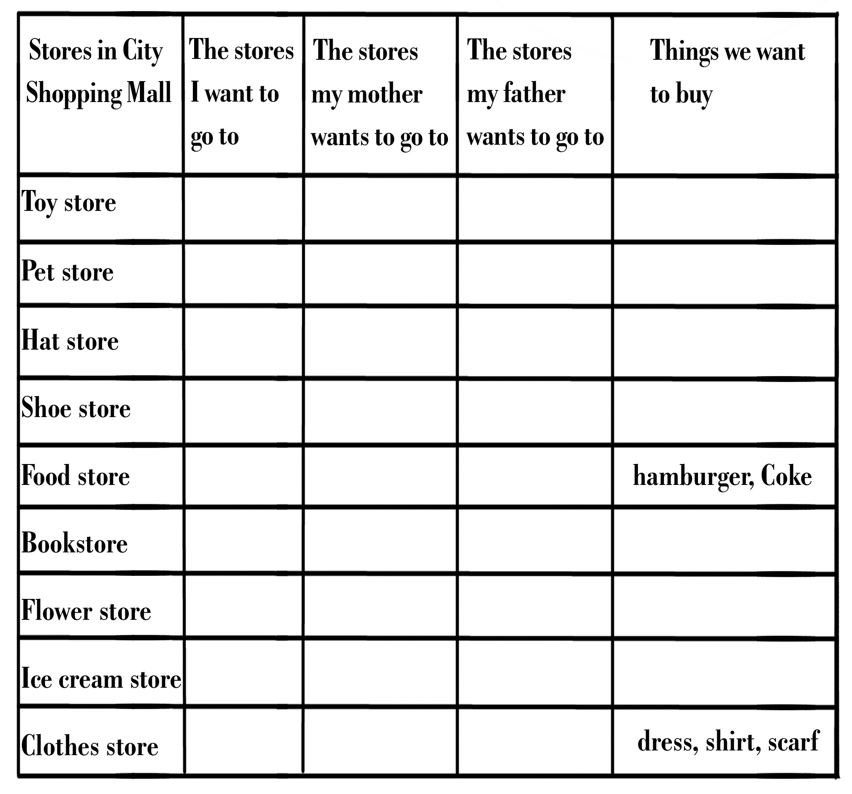
A shopping mall is a shopping center. There are many small stores in a shopping mall. People go to different stores to buy different kinds of things.
Here are the different stores in the Shopping Mall. Check the stores you, your father and your mother want to go to. Write what you want to buy in each store in the right column. One is done for you.

