麦琪的礼物
The Gift of the Magi
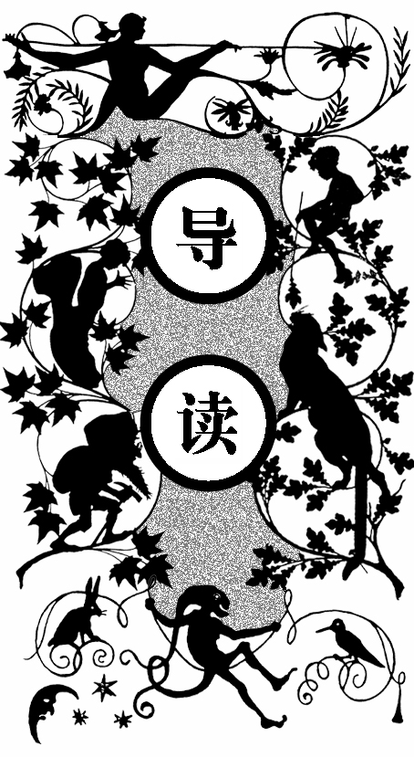
德拉和吉姆是对恩爱夫妻，眼下正在为圣诞节的礼物烦恼。在这个月租八美元的出租公寓里，夫妻俩除了两人各自的宝贝——德拉的一头让人羡慕的长发和吉姆的一块华丽的祖传金表，再没有其他值钱的东西了。那块金表配的是一条皮质旧表带，德拉决定卖掉自己的秀发，给丈夫物色一条闪闪发光的金表链，想象着这美丽精致的礼物给丈夫带来的狂喜。第二天，德拉忐忑不安地等待着丈夫，既高兴又害怕。吉姆进屋后大吃一惊，他把德拉抱在怀里，从口袋里掏出送给德拉的圣诞礼物——一套很久以前德拉就看中的梳子。德拉欣喜万分，继而流泪。吉姆告诉德拉，为了给德拉买礼物，已把金表卖了。

ne dollar and eighty-seven cents. That was all. And sixty cents of it was in pennies. Pennies saved one and two at a time by bulldozing the grocer and the vegetable man and the butcher until
O

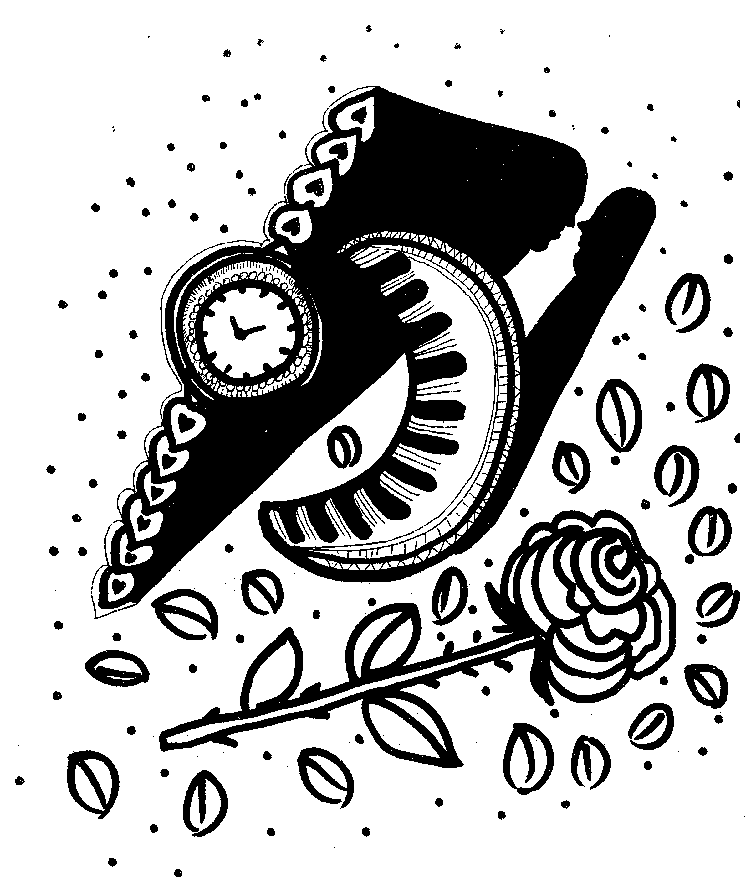
梳子和金表带

one’s cheeks burned with the silent imputation of parsimony that such close dealing implied. Three times Della counted it. One dollar and eighty-seven cents. And the next day would be Christmas.
There was clearly nothing to do but flop down on the shabby little couch and howl. So Della did it, which instigates the moral reflection that life is made up of sobs, sniffles, and smiles, with sniffles predominating.
While the mistress of the home is gradually subsiding from the first stage to the second, take a look at the home. A furnished flat at $8 per week. It did not exactly beggar description, but it certainly had that word on the lookout for the mendicancy squad. In the vestibule below was a letter-box into which no letter would go, and an electric button from which no mortal finger could coax a ring. Also appertaining thereunto was a card bearing the name “Mr. James Dillingham Young.” The “Dillingham” had been flung to the breeze during a former period of prosperity when its possessor was being paid $30 per week. Now, when the income was shrunk to $20, the letters of “Dillingham” looked blurred, as though they were thinking seriously of contracting to a modest and unassuming D. But whenever Mr. James Dillingham Young came home and reached his flat above he was called “Jim” and greatly hugged by Mrs. James Dillingham Young, already introduced to you as Della, which is all very good.
Della finished her cry and attended to her cheeks with the powder rag. She stood by the window and looked out dully at a grey cat walking a grey fence in a grey backyard. Tomorrow would be Christmas Day, and she had only $1.87 with which to buy Jim a present. She had been saving every penny she could for months, with this result. Twenty dollars a week doesn’t go far. Expenses had been greater than she had calculated. They always are. Only $1.87 to buy a present for Jim. Her Jim. Many a happy hour she had spent planning for something nice for him. Something fine and rare and sterling—something just a little bit near to being worthy of the honor of being owned by Jim.
There was a pier glass between the windows of the room. Perhaps you have seen a pier glass in an $8 flat. A very thin and very agile person may, by observing his reflection in a rapid sequence of longitudinal strips, obtain a fairly accurate conception of his looks. Della, being slender, had mastered the art.
Suddenly she whirled from the window and stood before the glass. Her eyes were shining brilliantly, but her face had lost its color within twenty seconds. Rapidly she pulled down her hair and let it fall to its full length.
Now, there were two possessions of the James Dillingham Youngs in which they both took a mighty pride. One was Jim’s gold watch that had been his father’s and his grandfather’s. The other was Delia’s hair. Had the Queen of Sheba lived in the flat across the airshaft, Della would have let her hair hang out the window some day to dry just to depreciate Her Majesty’s jewels and gifts. Had King Solomon been the janitor, with all his treasures piled up in the basement, Jim would have pulled out his watch every time he passed, just to see him pluck at his beard from envy.
So now Delia’s beautiful hair fell about her, rippling and shining like a cascade of brown waters. It reached below her knee and made itself almost a garment for her. And then she did it up again nervously and quickly. Once she faltered for a minute and stood still while a tear or two splashed on the worn red carpet.
On went her old brown jacket; on went her old brown hat. With a whirl of skirts and with the brilliant sparkle still in her eyes, she fluttered out the door and down the stairs to the street.
Where she stopped the sign read: “Mme. Sofronie. Hair Goods of All Kinds.” One flight up Della ran, and collected herself, panting.
Madame, large, too white, chilly, hardly looked the “Sofronie.”
“Will you buy my hair?” asked Della.
“I buy hair,” said Madame. “Take yer hat off and let’s have a sight at the looks of it.”
Down rippled the brown cascade. “Twenty dollars,” said Madame, lifting the mass with a practiced hand.
“Give it to me quick,” said Della.
Oh, and the next two hours tripped by on rosy wings. Forget the hashed metaphor. She was ransacking the stores for Jim’s present.
She found it at last. It surely had been made for Jim and no one else. There was no other like it in any of the stores, and she had turned all of them inside out. It was a platinum fob chain simple and chaste in design, properly proclaiming its value by substance alone and not by meretricious ornamentation—as all good things should do. It was even worthy of The Watch. As soon as she saw it she that it must be Jim’s. It was like him. Quietness and value—the description applied to both. Twenty-one dollars they took from her for it, and she hurried home with the 87 cents. With that chain on his watch Jim might be properly anxious about the time in any company. Grand as the watch was, he sometimes looked at it on the sly on account of the old leather strap that he used in place of a chain.
When Della reached home her intoxication gave way a little to prudence and reason. She got out her curling irons and lighted the gas and went to work repairing the ravages made by generosity added to love. Which is always a tremendous task, dear friends—a mammoth task.
Within forty minutes her head was covered with tiny, close-lying curls that made her look wonderfully like a truant schoolboy. She looked at her reflection in the mirror long, carefully, and critically.
“If Jim doesn’t kill me,” she said to herself, “before he takes a second look at me, he’ll say I look like a Coney Island Chorus girl. But what could I do—oh! What could I do with a dollar and eighty- seven cents?”
At 7 o’clock the coffee was made and the frying-pan was on the back of the stove hot and ready to cook the chops.
Jim was never late. Della doubled the fob chain in her hand and sat on the corner of the table near the door that he always entered. Then she heard his step on the stair away down on the first flight, and she turned white for just a moment. She had a habit for saying little silent prayers about the simplest everyday things, and now she whispered: “Please God, make him think I am still pretty.”
The door opened and Jim stepped in and closed it. He looked thin and very serious. Poor fellow, he was only twenty-two—and to be burdened with a family! He needed a new overcoat and he was without gloves.
Jim stopped inside the door, as immovable as a setter at the scent of quail. His eyes were fixed upon Della, and there was an expression in them that she could not read, and it terrified her. It was not anger, nor surprise, nor disapproval, nor horror, nor any of the sentiments that she had been prepared for. He simply stared at her fixedly with that peculiar expression on his face.
Della wriggled off the table and went for him.
“Jim, darling,” she cried, “don’t look at me that way. I had my hair cut off and sold because I couldn’t have lived through Christmas without giving you a present. It’ll grow out again—you won’t mind, will you? I just had to do it. My hair grows awfully fast. Say ‘Merry Christmas!’ Jim, and let’s be happy. You don’t know what a nice—what a beautiful, nice gift I’ve got for you.”
“You’ve cut off your hair?” asked Jim, laboriously, as if he had not arrived at that patent fact yet even after the hardest mental labor.
“Cut it off and sold it,” said Della. “Don’t you like me just as well, anyhow? I’m me without my hair, ain’t I?”
Jim looked about the room curiously.
“You say your hair is gone?” he said, with an air almost of idiocy.
“You needn’t look for it,” said Della. “It’s sold, I tell you—sold and gone, too. It’s Christmas Eve, boy. Be good to me, for it went for you. Maybe the hairs of my head were numbered,” she went on with sudden serious sweetness, “but nobody could ever count my love for you. Shall I put the chops on, Jim?”
Out of his trance Jim seemed quickly to wake. He enfolded his Della. For ten seconds let us regard with discreet scrutiny some inconsequential object in the other direction. Eight dollars a week or a million a year—what is the difference? A mathematician or a wit would give you the wrong answer. The Magi brought valuable gifts, but that was not among them. This dark assertion will be illuminated later on.
Jim drew a package from his overcoat pocket and threw it upon the table.
“Don’t make any mistake, Dell,” he said, “about me. I don’t think there’s anything in the way of a haircut or a shave or a shampoo that could make me like my girl any less. But if you’ll unwrap that package you may see why you had me going a while at first.”
White fingers and nimble tore at the string and paper. And then an ecstatic scream of joy; and then, alas! A quick feminine change to hysterical tears and wails, necessitating the immediate employment of all the comforting powers of the lord of the flat.
For there lay The Combs—the set of combs, side and back, that Della had worshipped long in a Broadway window. Beautiful combs, pure tortoise shell, with jeweled rims—just the shade to wear in the beautiful vanished hair. They were expensive combs, she knew, and her heart had simply craved and yearned over them without the least hope of possession. And now, they were hers, but the tresses that should have adorned the coveted adornments were gone.
But she hugged them to her bosom, and at length she was able to look up with dim eyes and a smile and say: “My hair grows so fast, Jim!”
And then Della leaped up like a little singed cat and cried, “Oh, oh!”
Jim had not yet seen his beautiful present. She held it out to him eagerly upon her open palm. The dull precious metal seemed to flash with a reflection of her bright and ardent spirit.
“Isn’t it a dandy, Jim? I hunted all over town to find it. You’ll have to look at the time a hundred times a day now. Give me your watch. I want to see how it looks on it.”
Instead of obeying, Jim tumbled down on the couch and put his hands under the back of his head and smiled.
“Dell,” said he, “let’s put our Christmas presents away and keep’ em a while. They’re too nice to use just at present. I sold the watch to get the money to buy your combs. And now suppose you put the chops on.”
The Magi, as you know, were wise men—wonderfully wise men—who brought gifts to the Babe in the manger. They invented the art of giving Christmas presents. Being wise, their gifts were no doubt wise ones, possibly bearing the privilege of exchange in case of duplication. And here I have lamely related to you the uneventful chronicle of two foolish children in a flat who most unwisely sacrificed for each other the greatest treasures of their house. But in a last word to the wise of these days let it be said that of all who give gifts these two were the wisest. Of all who give and receive gifts, such as they are wisest. Everywhere they are wisest. They are the Magi.

我们选择的路
The Roads We Take
落日号特快列车正在加水的时候发生了抢劫。鲍勃、多德森和老约翰这三个抢劫犯一起，先持枪威胁司机，让他待命，接着来到其中一个车厢，击晕不知情的押运员，抢走了三万美元的黄金和现钞。在他们正奔向火车头打算逃离时，被击晕的押运员醒了过来，一枪打死了老约翰。鲍勃和多德森丢下同伴乘着火车头去了两公里以外的地方，然后骑马来到一处适合休息的宁静峡谷。鲍勃的马跌断了前腿，鲍勃毫不留情地开枪将马打死，便坐下来与多德森一起打开抢来的口袋，打算分赃。正当鲍勃兴致勃勃地说着自己的构想时，多德森却说自己很为被打死的马难过，鲍勃不以为意，一心想着两个人骑一匹马就可以离开，中途再抢一匹马。多德森再一次强调一匹马载不动两个人，然后拿出枪对准鲍勃，不顾鲍勃与他出生入死的交情，毫不留情地击毙了鲍勃，风驰电掣地携带赃款离开了——华尔街经纪人、公司老板多德森醒来，说自己做了个奇怪的梦。这时，机要秘书走进来通知说，他的老朋友威廉斯打算结算XYZ股票，他的老朋友可能会倾家荡产，现在只有多德森能救他了。多德森不顾秘书的提醒，命令按照现在XYZ的超低价结算给他。然后独自

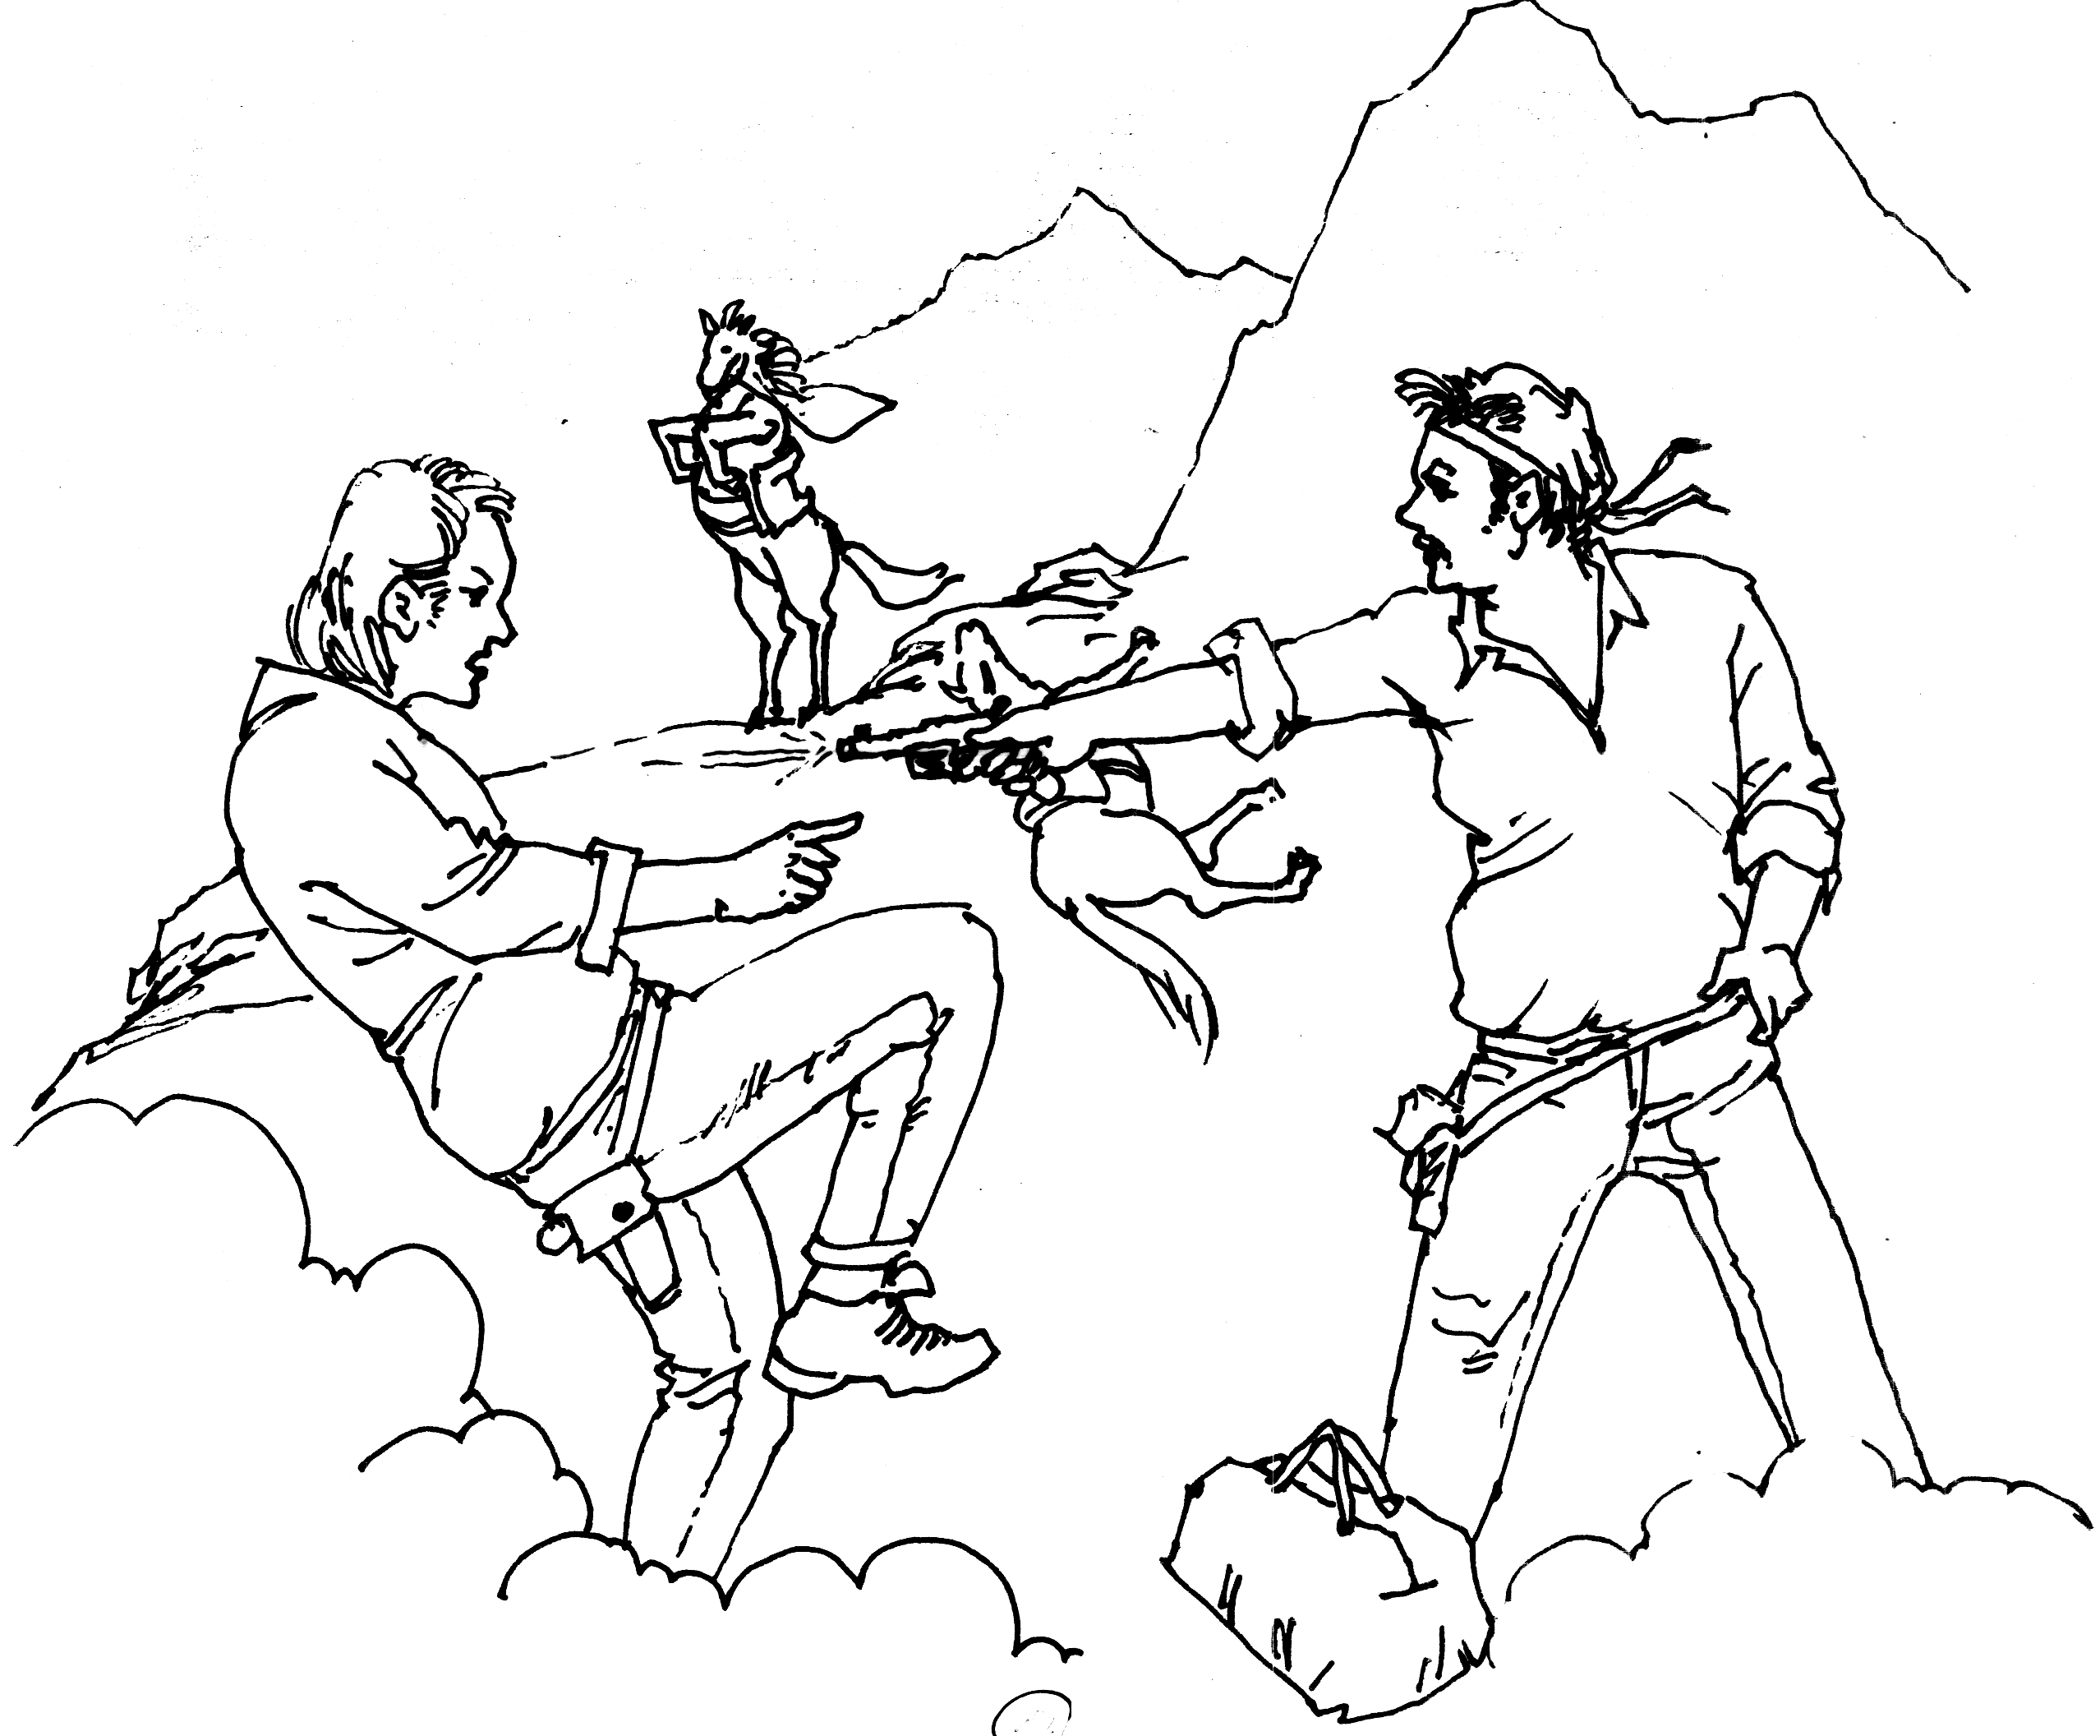
毫不留情地击毙了鲍勃

重复着梦里多德森的话说，一匹马载不动两个人。

wenty miles west of Tucson, the “Sunset Express” stopped at a tank to take on water. Besides the aqueous addition the engine of that famous flyer acquired some other things that were not good for it.
T
While the fireman was lowering the feeding hose, Bob Tidball, “Shark” Dodson and a quarter-bred Creek Indian called John Big Dog climbed on the engine and showed the engineer three round orifices in pieces of ordnance that they carried. These orifices so impressed the engineer with their possibilities that he raised both hands in a gesture such as accompanies the ejaculation “Do tell!”
At the crisp command of Shark Dodson, who was leader of the attacking force the engineer descended to the ground and uncoupled the engine and tender. Then John Big Dog, perched upon the coal, sportively held two guns upon the engine driver and the fireman, and suggested that they run the engine fifty yards away and there await further orders.
Shark Dodson and Bob Tidball, scorning to put such low-grade ore as the passengers through the mill, struck out for the rich pocket of the express car. They found the messenger serene in the belief that the “Sunset Express” was taking on nothing more stimulating and dangerous than aqua pura. While Bob was knocking this idea out of his head with the butt-end of his six-shooter Shark Dodson was already dosing the express-car safe with dynamite.
The safe exploded to the tune of $30,000, all gold and currency. The passengers thrust their heads casually out of the windows to look for the thunder-cloud. The conductor jerked at the bell-rope, which sagged down loose and unresisting, at his tug. Shark Dodson and Bob Tidball, with their booty in a stout canvas bag, tumbled out of the express car and ran awkwardly in their high-heeled boots to the engine.
The engineer, sullenly angry but wise, ran the engine, according to orders, rapidly away from the inert train. But before this was accomplished the express messenger, recovered from Bob Tidball’s persuader to neutrality, jumped out of his car with a Winchester rifle and took a trick in the game. Mr. John Big Dog, sitting on the coal tender, unwittingly made a wrong lead by giving an imitation of a target, and the messenger trumped him. With a ball exactly between his shoulder blades the Creek chevalier of industry rolled off to the ground, thus increasing the share of his comrades in the loot by one-sixth each.
Two miles from the tank the engineer was ordered to stop.
The robbers waved a defiant adieu and plunged down the steep slope into the thick woods that lined the track. Five minutes of crashing through a thicket of chaparral brought them to open woods, where three horses were tied to low-hanging branches. One was waiting for John Big Dog, who would never ride by night or day again. This animal the robbers divested of saddle and bridle and set free. They mounted the other two with the bag across one pommel, and rode fast and with discretion through the forest and up a primeval, lonely gorge. Here the animal that bore Bob Tidball slipped on a mossy boulder and broke a foreleg. They shot him through the head at once and sat down to hold a council of flight. Made secure for the present by the tortuous trail they had traveled, the question of time was no longer so big. Many miles and hours lay between them and the spryest posse that could follow. Shark Dodson’s horse, with trailing rope and dropped bridle, panted and cropped thankfully of the grass along the stream in the gorge. Bob Tidball opened the sack, drew out double handfuls of the neat packages of currency and the one sack of gold and chuckled with the glee of a child.
“Say, you old double-decked pirate,” he called joyfully to Dodson, “you said we could do it—you got a head for financing that knocks the horns off of anything in Arizona.”
“What are we going to do about a hoss for you, Bob? We ain’t got long to wait here. They’ll be on our trail before daylight in the mornin’.”
“Oh, I guess that cayuse of yourn’ll carry double for a while,” answered the sanguine Bob. “We’ll annex the first animal we come across. By jingoes, we made a haul, didn’t we? Accordin’ to the marks on this money there’s $30,000—$15,000 apiece!”
“It’s short of what I expected,” said Shark Dodson, kicking softly at the packages with the toe of his boot. And then he looked pensively at the wet sides of his tired horse.
“Old Bolivar’s mighty nigh played out,” he said, slowly. “I wish that sorrel of yours hadn’t got hurt.”
“So do I,” said Bob, heartily, “but it can’t be helped. Bolivar’s got plenty of bottom—he’ll get us both far enough to get fresh mounts. Dang it, Shark, I can’t help thinkin’ how funny it is that an Easterner like you can come out here and give us Western fellows cards and spades in the desperado business. What part of the East was you from, anyway?”
“New York State,” said Shark Dodson, sitting down on a boulder and chewing a twig. “I was born on a farm in Ulster County. I ran away from home when I was seventeen. It was an accident my coming West. I was walkin’ along the road with my clothes in a bundle, makin’ for New York City. I had an idea of goin’ there and makin’ lots of money. I always felt like I could do it. I came to a place one evenin’ where the road forked and I didn’t know which fork to take. I studied about it for half an hour, and then I took the left-hand. That night I run into the camp of a Wild West show that was travellin’ among the little towns, and I went West with it. I’ve often wondered if I wouldn’t have turned out different if I’d took the other road.”
“Oh, I reckon you’d have ended up about the same,” said Bob Tidball, cheerfully philosophical. “It ain’t the roads we take; it’s what’s inside of us that makes us turn out the way we do.”
Shark Dodson got up and leaned against a tree.
“I’d a good deal rather that sorrel of yourn hadn’t hurt himself, Bob,” he said again, almost pathetically.
“Same here,” agreed Bob; “he was sure a first-rate kind of a crow bait. But Bolivar, he’ll pull us through all right. Reckon we’d better be movin’ on, hadn’t we, Shark? I’ll bag this boodle again and we’ll hit the trail for higher timber.”
Bob Tidball replaced the spoil in the bag and tied the mouth of it tightly with a cord. When he looked up the most prominent object that he saw was the muzzle of Shark Dodson’s .45 held upon him without a waver.
“Stop your funnin’,” said Bob, with a grin. “We got to be hittin’ the breeze.”
“Set still,” said Shark. “You ain’t goin’ to hit no breeze, Bob. I hate to tell you, but there ain’t any chance for but one of us. Bolivar, he’s plenty tired, and he can’t carry double.”
“We been pards, me and you, Shark Dodson, for three year,” Bob said quietly. “We’ve risked our lives together time and again. I’ve always give you a square deal, and I thought you was a man. I’ve heard some queer stories about you shootin’ one or two men in a peculiar way, but I never believed ’em. Now if you’re just havin’ a little fun with me, Shark, put your gun up, and we’ll get on Bolivar and vamose. If you mean to shoot—shoot, you black hearted son of a tarantula!”
Shark Dodson’s face bore a deeply sorrowful look. “You don’t know how bad I feel,” he sighed, “about that sorrel of yourn breakin’ his leg, Bob.”
The expression on Dodson’s face changed in an instant to one of cold ferocity mingled with inexorable cupidity. The soul of the man showed itself for a moment like an evil face in the window of a reputable house.
Truly Bob Tidball was never to “hit the breeze” again. The deadly .45 of the false friend cracked and filled the gorge with a roar that the walls hurled back with indignant echoes. And Bolivar, unconscious accomplice, swiftly bore away the last of the holders-up of the “Sunset Express,” not put to the stress of “carrying double.”
But as “Shark” Dodson galloped away the woods seemed to fade from his view; the revolver in his right hand turned to the curved arm of a mahogany chair; his saddle was strangely upholstered, and he opened his eyes and saw his feet, not in stirrups, but resting quietly on the edge of a quartered-oak desk.
I am telling you that Dodson, of the firm of Dodson & Decker, Wall Street brokers, opened his eyes. Peabody, the confidential clerk, was standing by his chair, hesitating to speak. There was a confused hum of wheels below, and the sedative buzz of an electric fan.
“Ahem! Peabody,” said Dodson, blinking. “I must have fallen asleep. I had a most remarkable dream. What is it, Peabody?”
“Mr. Williams, sir, of Tracy & Williams, is outside. He has come to settle his deal in X. Y. Z. The market caught him short, sir, if you remember.”
“Yes, I remember. What is X. Y. Z. quoted at today, Peabody?”
“One eighty-five, sir.”
“Then that’s his price.”
“Excuse me,” said Peabody, rather nervously, “for speaking of it, but I’ve been talking to Williams. He’s an old friend of yours, Mr. Dodson, and you practically have a corner in X. Y. Z. I thought you might—that is, I thought you might not remember that he sold you the stock at 98. If he settles at the market price it will take every cent he has in the world and his home too to deliver the shares.”
The expression on Dodson’s face changed in an instant to one of cold ferocity mingled with inexorable cupidity. The soul of the man showed itself for a moment like an evil face in the window of a reputable house.
“He will settle at one eighty-five,” said Dodson. “Bolivar cannot carry double.”

艺术中的良知
Conscience in Art
安迪和我是诈骗行业里的老搭档，但我们有个根本的不同：尽管都是诈骗，安迪经常天马行空地骗钱，而我拿了钱以后总想奉还一些作为回报，好安抚自己的良心。一次，在安迪的提议下，我们俩决定离开乡下，到有钱人那里诈取更多的油水。我坚持要求必须要给被欺骗人一些实实在在的东西，安迪同意了。我们来到了匹兹堡，选中了“匹兹堡百万富翁”群，据安迪说他们是一群文化程度不高的人，诚恳单纯，容易相处。很快安迪物色到了一位富翁斯卡德，他绘声绘色地向我描述了在酒店认识、然后去他家的经过，渲染了他家的富丽堂皇，还有他正在搜求的古董。期间，斯卡德拿出一件古埃及的象牙莲花雕刻，告诉安迪原来有一对，另外的那个已经不知去向。第二天，安迪从外面拿出一件雕刻，与他描述的那位富翁所拥有的雕刻一模一样，说是从当铺便宜买来，让我去高价卖给斯卡德。在安迪的安排下，我伪装成一个教授的模样，以研究艺术的名义约出斯卡德，告诉斯卡德自己现在也有一个埃及象牙雕刻。斯卡德立即要求买下我手中的这个，交易以两千五百块现款成交。我回来后，安迪正在着急，要我与他马上去赶火车。我为此大惑不解，安迪这

